Table of Contents

Decision Trees 1

Advantages 1

Disadvantages 1

Decision Trees for Classification 1

Calculating Gini Impurity 3

Determining the Property for the Left Branch 4

Calculating the Gini Impurity before the Node is Separated 6

Calculating the Gini Impurity Index for Chest Pain 6

Visualizing the Decision Tree 9

About the Gini Index / Gini Split 10

Performing Linear Regression with a DecisionTreeRegressor 12

## Decision Trees

A decision tree is a supervised training algorithm for performing regression and classification.

The decision tree algorithm follows a decision path of an upside-down tree from the root to a leaf node.

### Advantages

Decision trees can be used to classify non-linearly separable data. They are very fast and easy to understand compared to KNN and other classification algorithms. They can also be useful for imputing data.

### Disadvantages

Decision trees can lead to over fitting. Decision trees also lose information when working with continuous variables.

## Decision Trees for Classification

This initial discussion covers how to manually create a decision tree with the guidance of the Gini impurity index. The discussion is based heavily on Josh Stormer’s video at:

<https://www.youtube.com/watch?v=7VeUPuFGJHk>

Example 1: Manually Building a Decision Tree

In this example we are building a best classifier to determine if a person has heart disease. We will not actually use a data set but we have a high-level look at how to build the tree. Figure 1 shows a snapshot of the data set.

Figure 1: Snapshot of the Heart Disease Dataset

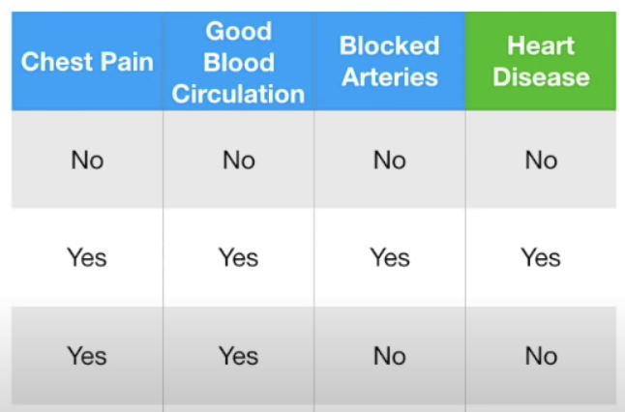

First, we will examine how to build a leaf node to classify heart disease with the ‘Chest Pain’ attribute (see Figure 2).

Figure 2: Calculating Heart Disease Classification with Chest Pain

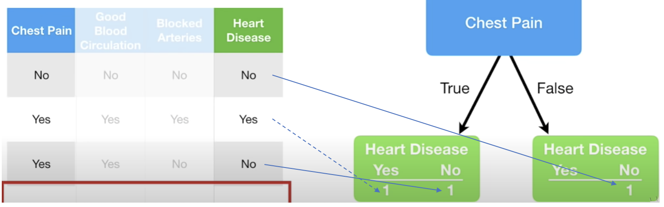

Exercise 1 (3 marks)

Given the data provided in Figure 2, add in the counts for categorizing heart disease based on Good Blood circulation. The numbers in the bottom row should add up to 3 if done correctly.

|  |  |  |  |
| --- | --- | --- | --- |
| Good Blood Circulation | | | |
| True | | False | |
| 1 | 1 | 0 | 1 |

While we do not have all of the data in the data set, if we did, the total sums of positive and negative heart disease diagnosis would appear in the leaves under the chest pain node in Figure 3.

Figure 3: Heart Disease Classifications with Chest Pain

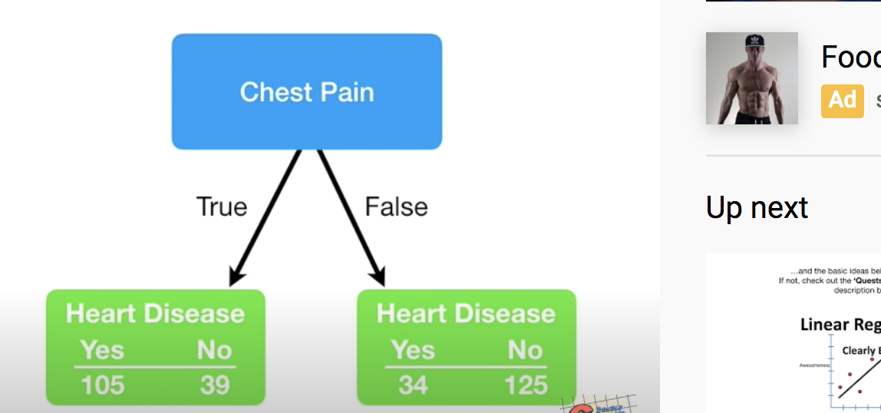

Similarly, we can calculate the heart disease classifications for blood circulation and blocked artery nodes like in Figure 4.

Figure 4: Heart Disease totals with Blood Circulation and Blocked Arteries

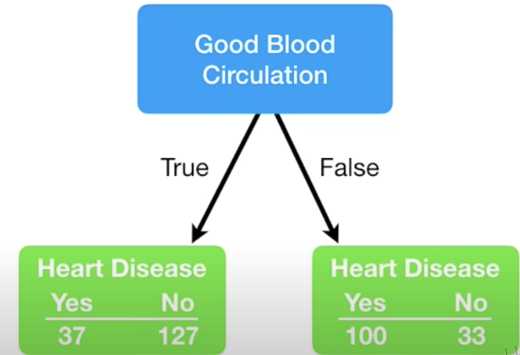 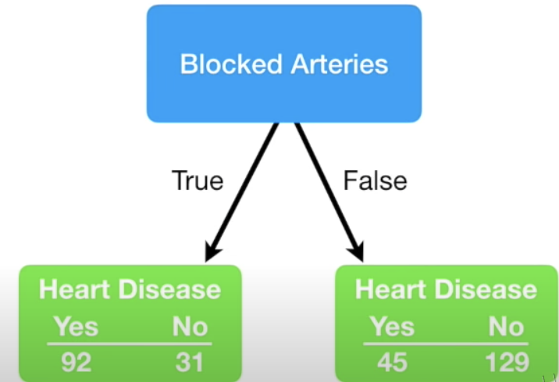

Based on the data provided for this problem, we can use chest pain, blood circulation and blocked arteries as classifying properties for heart disease. We now need to determine which property should be placed at the top of our tree. There are lots of ways to determine which property to select. We will use Gini impurity index to make this decision.

### Calculating Gini Impurity

The lowest Gini impurity index helps to locate the best attribute to place at the top node. The Gini index is calculated as 1 – (P+ P+ … + P). The data in Figure 5 sets up the calculation for the Chest Pain node.

Figure 5: Calculating Gini Impurity for Chest Pain

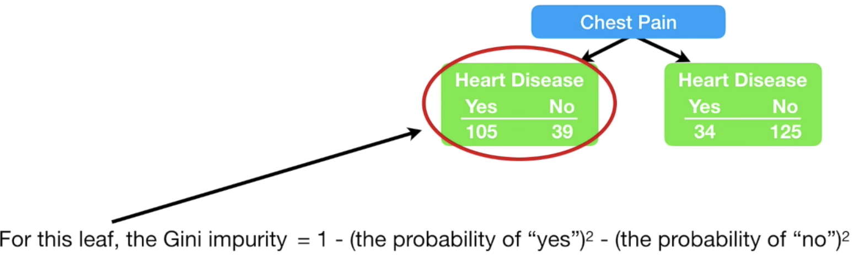

The Gini impurity for the leaf node on the left of Figure 5 is:

= 1 - - = 0.395

The Gini impurity for the leaf node on the right branch of Figure 5 is:

= 1 - - = 0.336

Next, we must add the weighted Gini impurity indexes for each branch. This calculation becomes:

Gini Impurity Index Chest Pain

= 0.395 + 0.336 = 0.395 + 0.336 = 0.36404

Figure 6: Gini Impurity Indexes for Chest Pain, Good Blood Circulation, Blocked Arteries

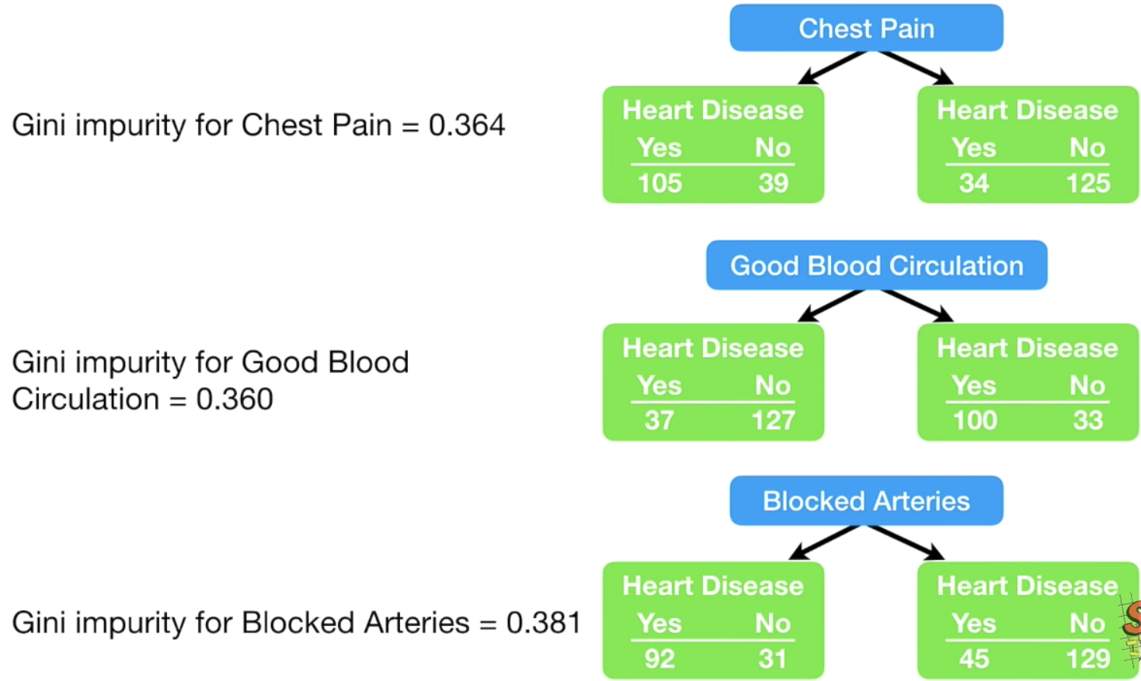

**Good Blood Circulation has the lowest Gini impurity**. It does the best job of separating candidates with or without heart disease. So, for this reason we will include good blood circulation at the top (root) of the decision tree.

Exercise 2 (8 marks)

Calculate the Gini impurity for good blood circulation. If done correctly the answer should be 0.360. Show your calculations here (you can take a screenshot if you prefer):

|  |
| --- |
|  |

### Determining the Property for the Left Branch

Since Good Blood Circulation has the lowest Gini Impurity index, it is placed at the root of the tree in Figure 7.

Figure 7: Viewing the Root and Two Branches

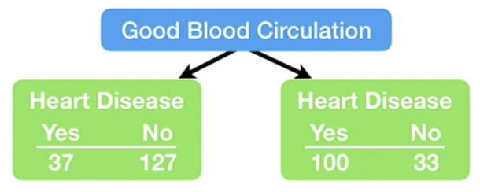

Since circulation is at the top of the tree, we need to figure out whether to use chest pain or blocked arteries to separate the leaf nodes in Figure 7. We will focus first on the left leaf node in Figure 7 to examine how to split it further. There are 164 rows of data to consider in the left branch. Figure 8 shows the Gini Impurity scores that would exist if we split the left node of Figure 7 either using chest pain or blocked arteries.

For the chest pain in Figure 8, the Gini impurity of the left node is calculated as

= 1 - - = 0.2068

For the chest pain in Figure 8, the Gini impurity of the right node is calculated as

= 1 - - = 0.49555

The weighted Gini impurity for chest pain in Figure 8 is:

0.2068 + 0.49555 = 0.2068 + 0.49555

= 0.1399683 + 0.1601473 = 0.30012

Figure 8: Examining the Gini Impurity Indexes for the left node of Figure 7.

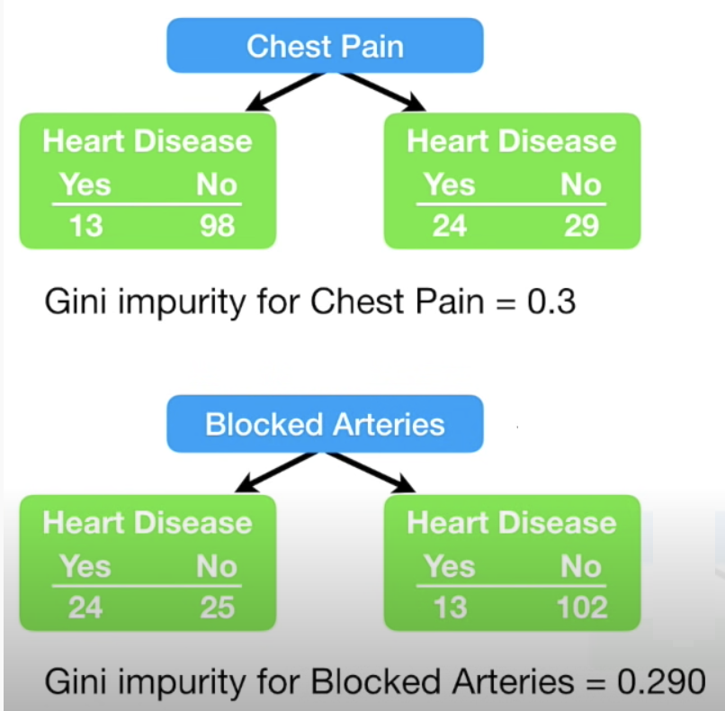

Since blocked arteries has the lowest Gini impurity index we will place it at the first left branch of the tree to separate patients (see Figure 9).

Figure 9: Good Blood Circulation as Root and Blocked Arteries in the Left Branch

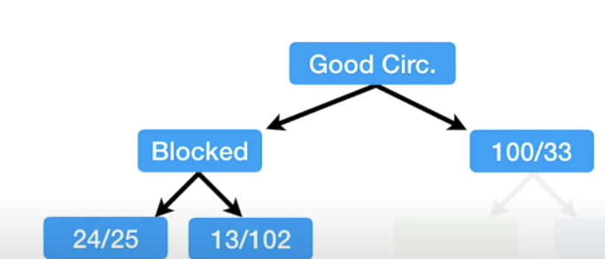

If we were to continue building the tree on the left we would only be able to consider if Chest Pain should be added as a branch under Blocked Artery to perform further classification of Heart Disease. See Figure 10.

Figure 10: Adding Chest Pain to the bottom left node of the tree

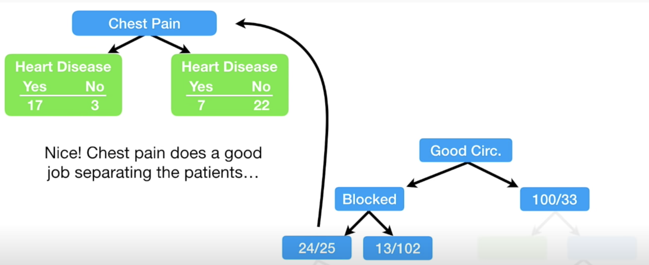

### Calculating the Gini Impurity before the Node is Separated

= 0.4998

### Calculating the Gini Impurity Index for Chest Pain

The Gini Impurity index for the left branch of Chest Pain in Figure 10 is:

= 0.255

The Gini Impurity index for the right branch of Chest Pain in Figure 10 is:

= 0.3662

The Gini Impurity index for Chest Pain is:

0.255 + 0.3662 = 0.3208

Since Chest Pain offers a lower Gini Impurity index we will add it to the left leaf of the tree as shown in Figure 11.

Figure 11: Building Out Nodes of the Tree

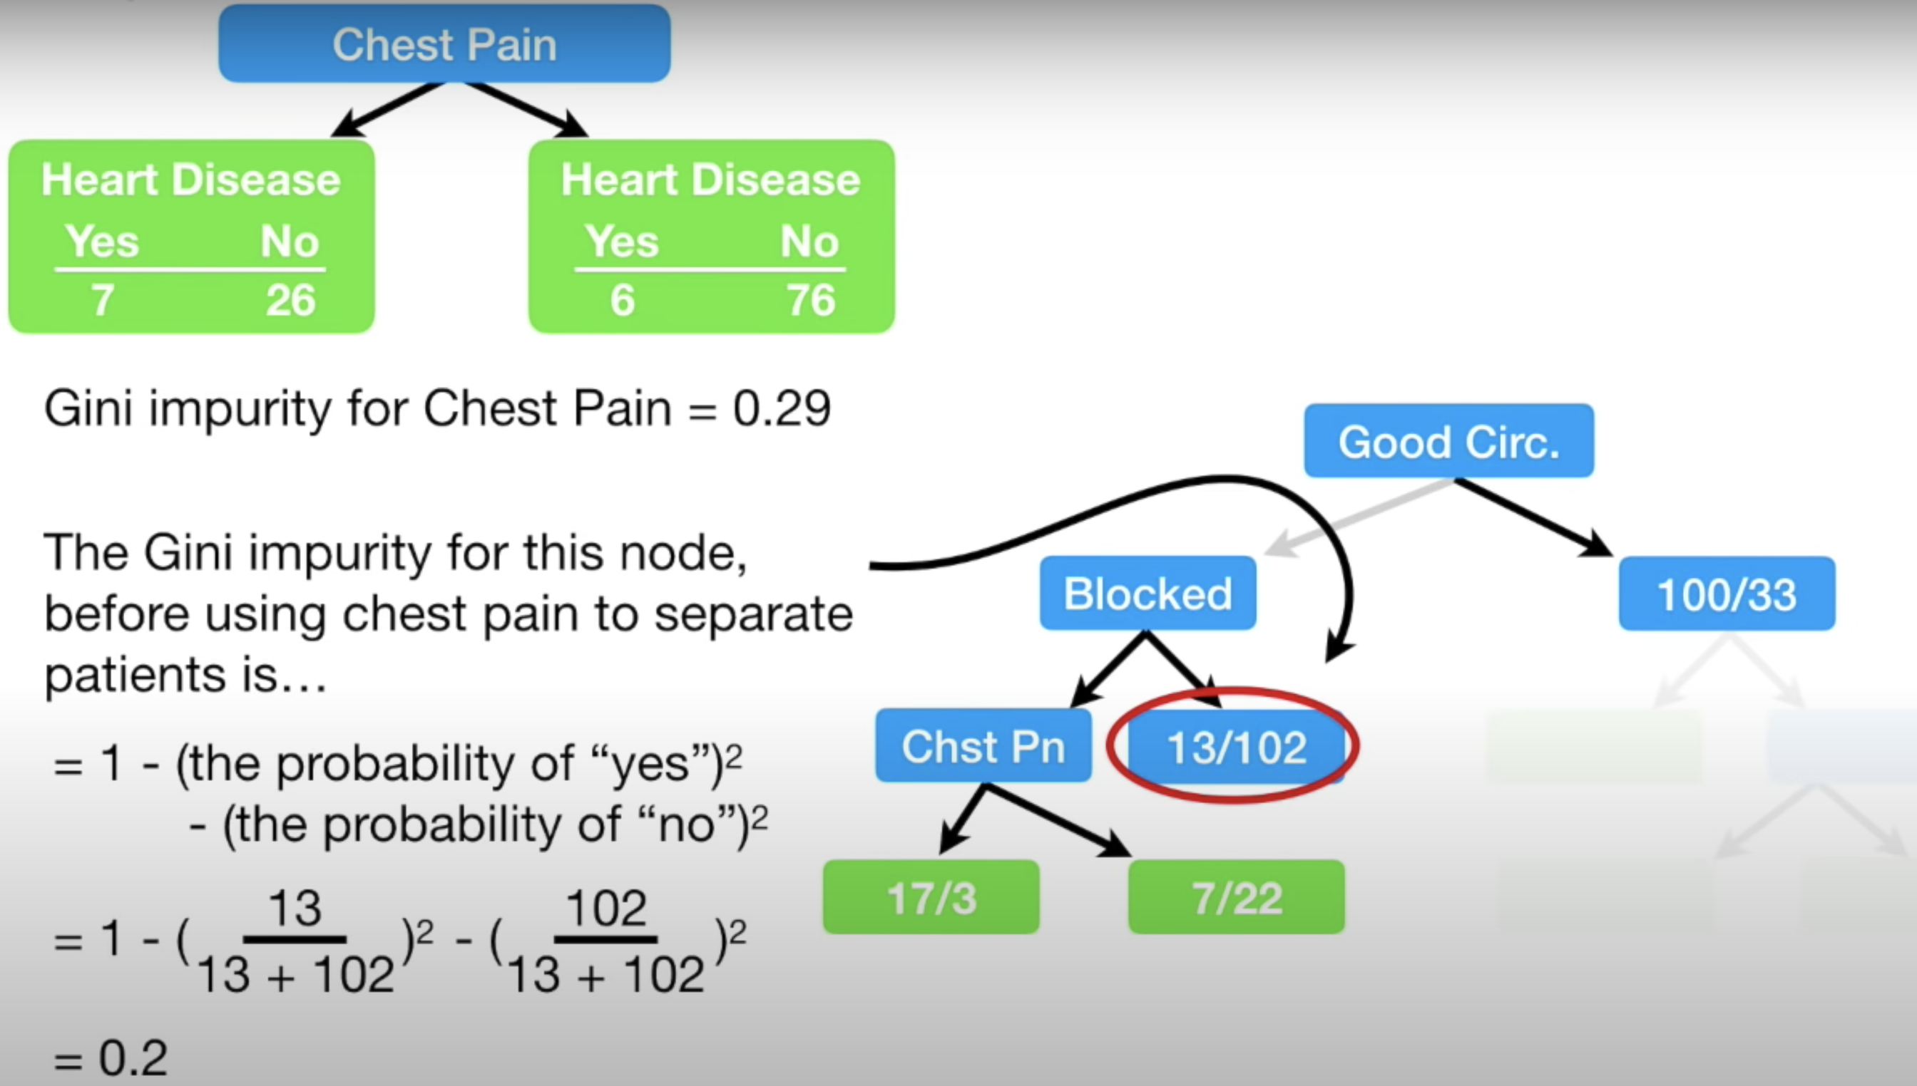

When calculating the Gini impurity index for the right side of the Blocked Artery node in Figure 11 we get 0.2. If we were to split on Chest Pain the Gini Impurity index would be 0.29 as shown in Figure 12. Since not splitting on Chest Pain offers a lower Gini Impurity index we will make the circled classification of heart disease in Figure 11 a leaf node.

Figure 12: Calculating the Gini Impurity index at the bottom right of Blocked Arteries

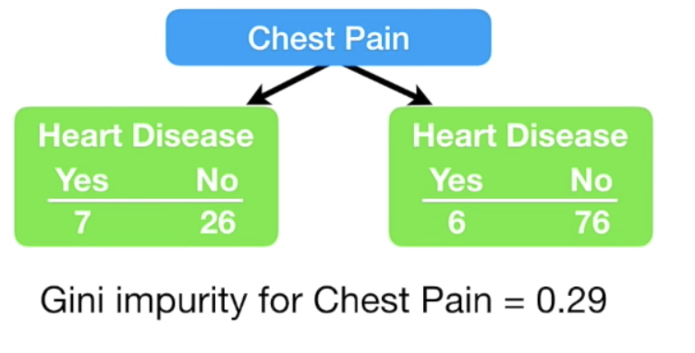

Figure 13 shows the completed tree.

Figure 13: Completed Tree

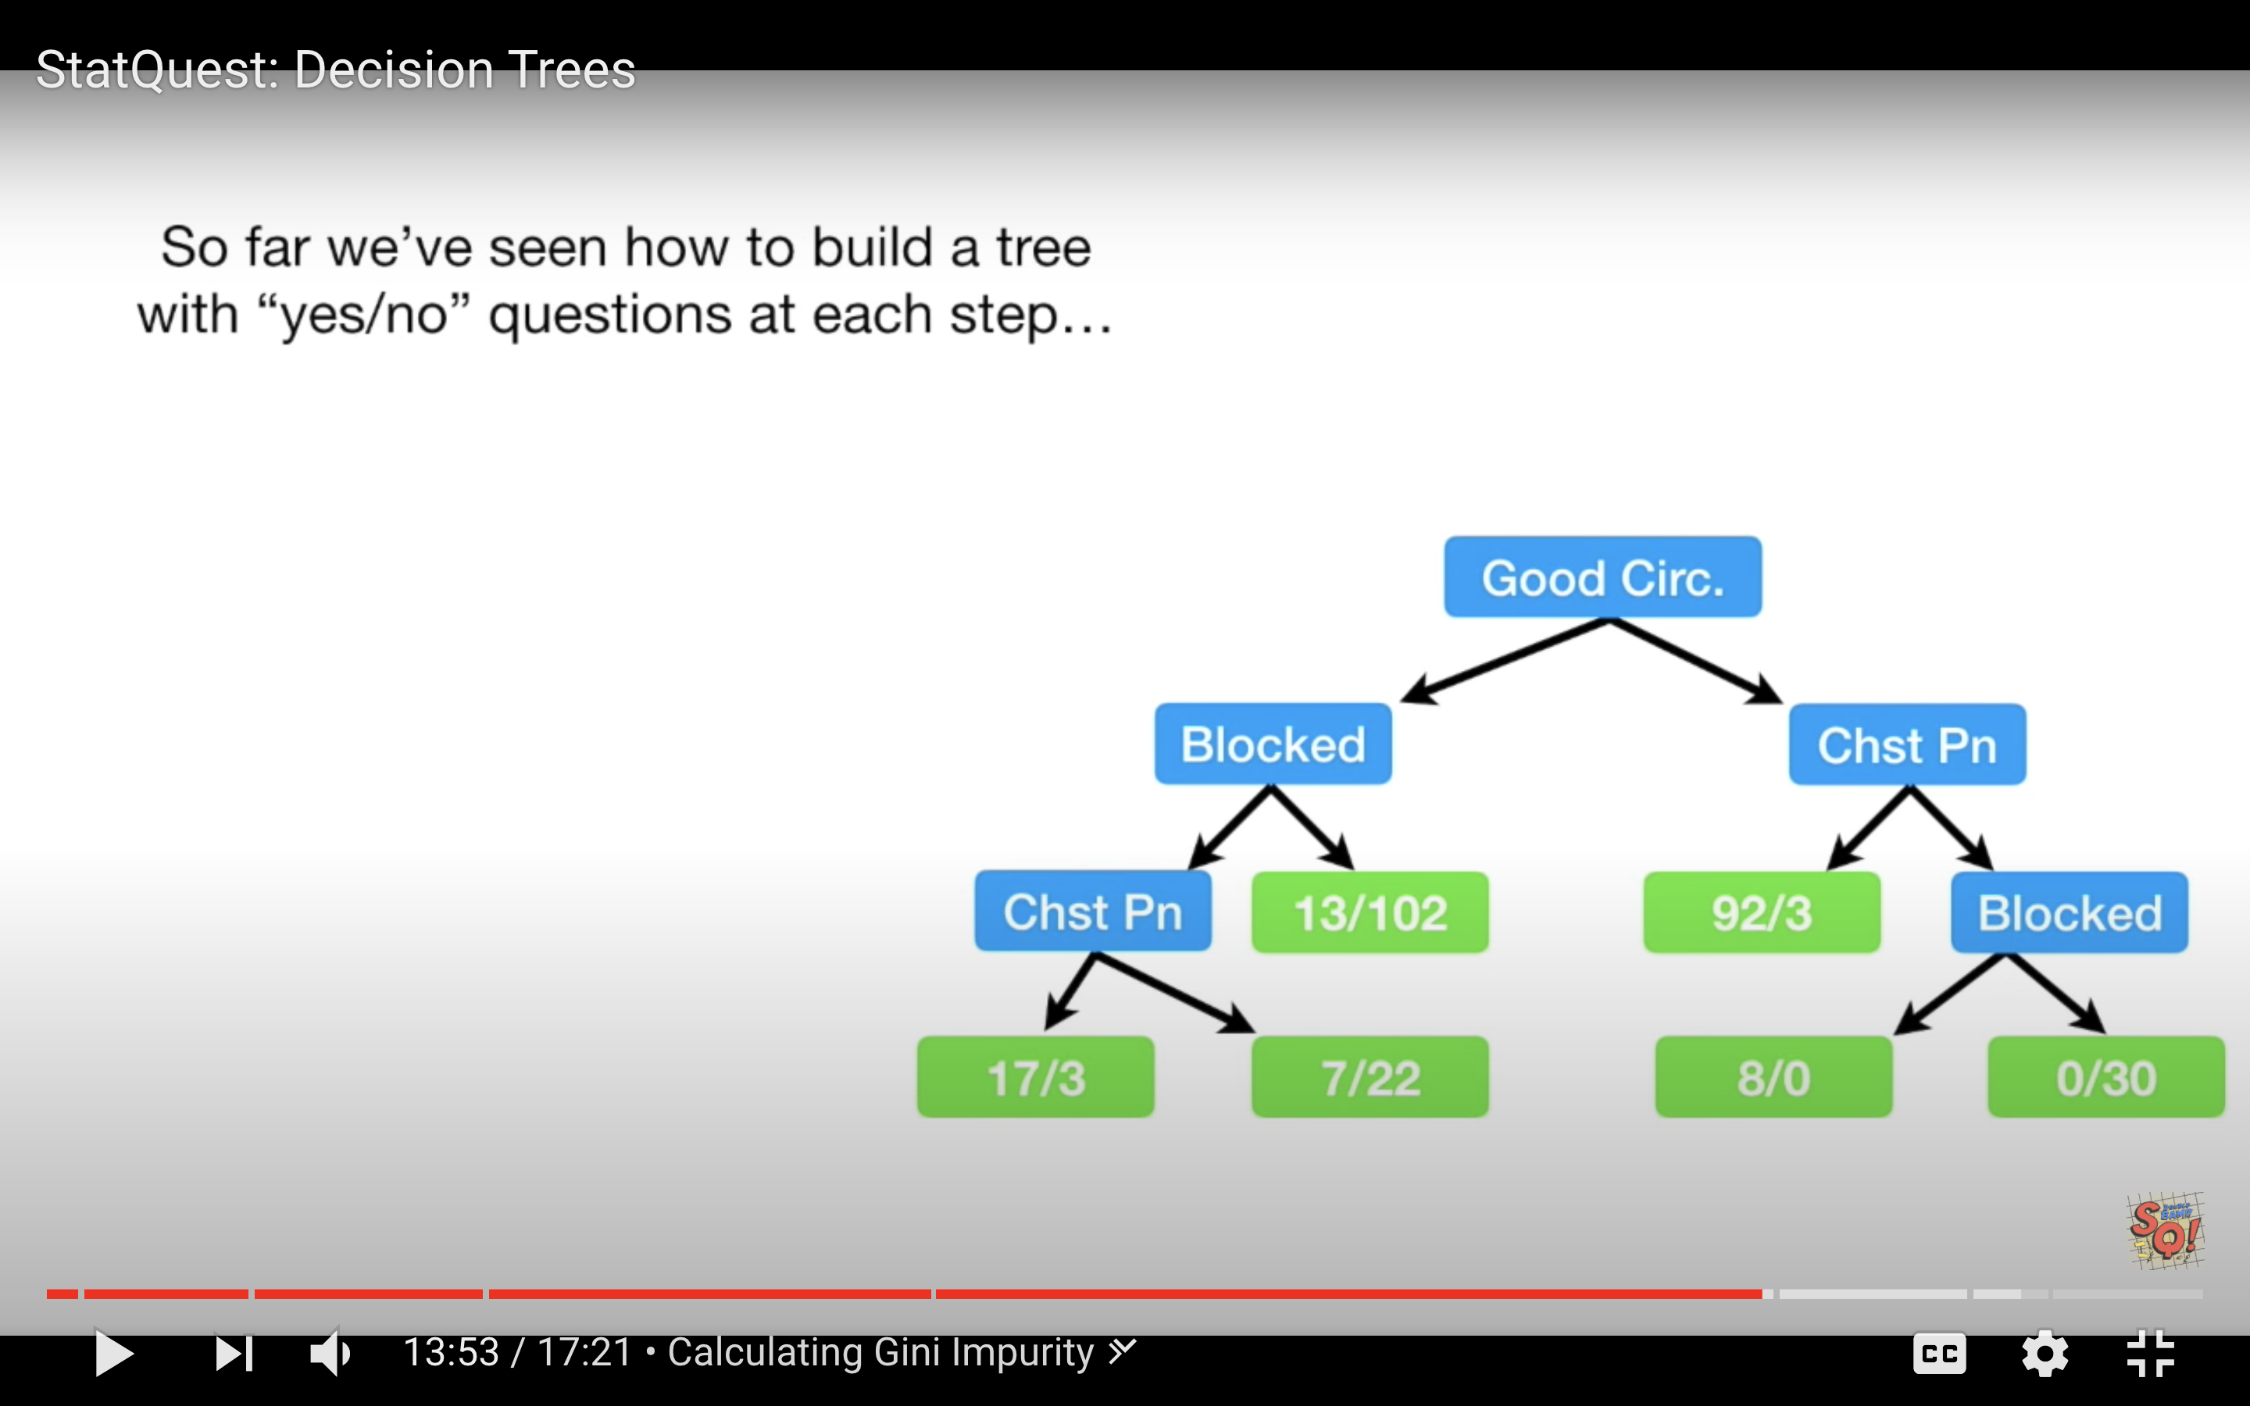

Example 2: Decision Tree for Classification

This example shows how to use decision trees to validate the authenticity of bank notes based on skewness of the wavelet transformed image, variance of the image, entropy of the image, and kurtosis of the image. Here is a sample of the data set:

|  |
| --- |
| Variance Skewness Kurtosis Entropy Class  0 3.62160 8.66610 -2.8073 -0.44699 0  1 4.54590 8.16740 -2.4586 -1.46210 0  ... ... ... ... ...  1367 0.40614 1.34920 -1.4501 -0.55949 1 |

By observing the scores in this case we can see the decision tree makes relatively accurate predictions.

|  |
| --- |
| Model Evaluation  [[146 11]  [ 14 104]]  Accuracy: 0.9090909090909091  Precision: 0.9043478260869565  Recall: 0.8813559322033898 |

Here is the code used the build **DecisionTreeClassifier** model to predict whether the bill is fraudulent or not. For this case we are setting the **max_depth** property to 2 so we can limit the depth of the tree.

|  |
| --- |
| import pandas as pd  import numpy as np  import matplotlib.pyplot as plt  PATH = "/Users/pm/Desktop/DayDocs/PythonForDataAnalytics/workingData/"  CSV = "bill_authentication.csv"  dataset = pd.read_csv(PATH + CSV)  X = dataset.drop('Class', axis=1)  y = dataset['Class']  print(dataset)  from sklearn.model_selection import train_test_split  X_train, X_test, y_train, y_test = train_test_split(X, y, test_size=0.20,  random_state=0)  from sklearn.tree import DecisionTreeClassifier  classifier = DecisionTreeClassifier(max_depth=2)  classifier.fit(X_train, y_train)  y_pred = classifier.predict(X_test)  from sklearn.metrics import classification_report, confusion_matrix  def showAccuracyScores(y_test, y_pred):  print("\nModel Evaluation")  cm = confusion_matrix(y_test, y_pred)  print(cm)  print("")  tn = cm[0][0]  fp = cm[0][1]  tp = cm[1][1]  fn = cm[1][0]  accuracy = (tp + tn)/(tn + fp + tp + fn)  precision = tp/(tp + fp)  recall = tp/(tp + fn)  print("Accuracy: " + str(accuracy))  print("Precision: " + str(precision))  print("Recall: " + str(recall))  showAccuracyScores(y_test, y_pred) |

### Visualizing the Decision Tree

Example 3: Visualizing the Decision Tree Model

This example adds a visualization to observe the tree that is generated by the code in Example 2. Figure 14 shows the tree model. The nodes at the bottom are the leaves. The blue leaves represent cases where fraud occurred.

When a sample is perfectly classified the Gini index is 0. When looking at the tree you will notice the Gini index is higher at the root node and it is lower at the leaf nodes.

Figure 14: Decision Tree for Predicting Fraud

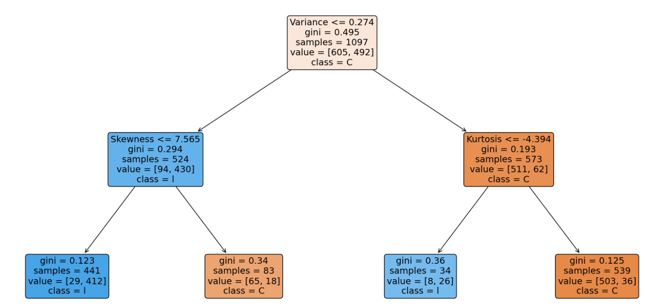

To build this example, add this code to the code in Example 2.

|  |
| --- |
| from sklearn.tree import plot_tree  fig, ax = plt.subplots(figsize=(20, 10))  plot_tree(classifier.fit(X_train, y_train), max_depth=4, fontsize=4)  a = plot_tree(classifier,  feature_names=['Variance', 'Skewness', 'Kurtosis', 'Entropy'],  class_names='Class',  filled=True,  rounded=True,  fontsize=14)  plt.show() |

Example 4: Manually Implementing the Model

When you examine the leaf nodes in Figure 14, keep in mind the blue nodes represent fraud and the orange nodes indicate that the bank note is valid.

Figure 15: Leaf Nodes for Counterfeit Bank Note Classification

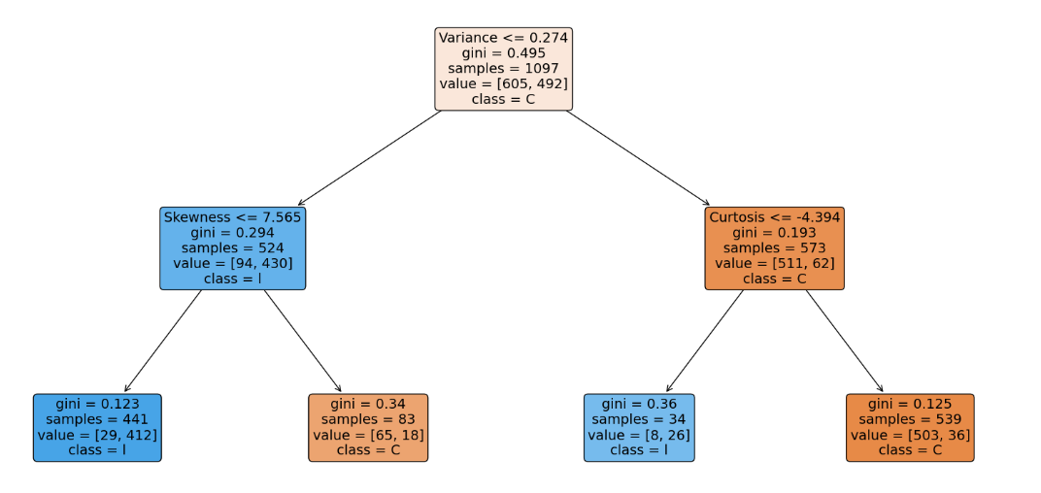

* The total number of fraudulent notes are 441 + 34 = 475.
* The total number of valid notes are 83 + 539 = 622

The information from the decision tree can be used to build the model. One way to verify the model is built correctly is to ensure the prediction counts from the training data match the summed prediction counts in the leaf nodes.

The following code reconstructs the tree manually and calculates the fraudulent and non-fraudulent counts with the training data. The output verifies the original predictions that are indicated in the decision tree output:

Zeros: 622

Ones: 475

|  |
| --- |
| import pandas as pd  PATH = "/Users/pm/Desktop/DayDocs/PythonForDataAnalytics/workingData/"  CSV = "bill_authentication.csv"  dataset = pd.read_csv(PATH + CSV)  X = dataset.drop('Class', axis=1)  y = dataset['Class']  from sklearn.model_selection import train_test_split  X_train, X_test, y_train, y_test = train_test_split(X, y,  test_size=0.20, random_state=0)  def manuallyClassify(X,y):  predictions=[]  ones = 0  zeros = 0  for i in range(0,len(X)):  if(X.iloc[i]['Variance'] <= 0.274): # Blue  if(X.iloc[i]['Skewness'] <= 7.565):  ones +=1 #Blue  else:  zeros +=1  else:  if(X.iloc[i]['Kurtosis'] <= -4.394):  ones += 1 # Blue  else:  zeros += 1  print("Zeros: " + str(zeros))  print("Ones: " + str(ones))  manuallyClassify(X_train,y_train)  print(len(X_train)) |

Exercise 3 (1 mark)

Is the Gini index in the leaf nodes higher or lower than the gini index in the nodes that are closer to the root?

1. Higher b) Lower

Exercise (10 marks)

Starting with the following code, build a decision tree to predict if breast cancer is malignant with a depth of 2. Output the decision tree plot and show the accuracy, precision and recall scores.

|  |
| --- |
| import sklearn.datasets as datasets  from sklearn.tree import DecisionTreeClassifier  from sklearn.tree import plot_tree  import matplotlib.pyplot as plt  # check for the sklearn version, it has to be 0.21  import sklearn  print(sklearn.__version__)  breast_cancer = datasets.load_breast_cancer()  from sklearn.model_selection import train_test_split  X_train, X_test, y_train, y_test = train_test_split(  breast_cancer.data, breast_cancer.target, test_size=0.20,  random_state=0) |

Show your code here:

|  |
| --- |
| import sklearn.datasets as datasets from sklearn.tree import DecisionTreeClassifier from sklearn.tree import plot_tree import matplotlib.pyplot as plt  # check for the sklearn version, it has to be 0.21 import sklearn print(sklearn.__version__) breast_cancer = datasets.load_breast_cancer()  import pandas as pd dfX = pd.DataFrame(breast_cancer.data, columns = breast_cancer.feature_names) dfy = breast_cancer.target print(dfX.head()) print(dfy)  from sklearn.model_selection import train_test_split X_train, X_test, y_train, y_test = train_test_split(  breast_cancer.data, breast_cancer.target, test_size=0.20,  random_state=0)  print(breast_cancer)  from sklearn.tree import DecisionTreeClassifier classifier = DecisionTreeClassifier(max_depth=2) classifier.fit(X_train, y_train)  y_pred = classifier.predict(X_test)  from sklearn.metrics import classification_report, confusion_matrix  def showAccuracyScores(y_test, y_pred):  print("\nModel Evaluation")  cm = confusion_matrix(y_test, y_pred)  print(cm)  print("")  tn = cm[0][0]  fp = cm[0][1]  tp = cm[1][1]  fn = cm[1][0]  accuracy = (tp + tn)/(tn + fp + tp + fn)  precision = tp/(tp + fp)  recall = tp/(tp + fn)  print("Accuracy: " + str(accuracy))  print("Precision: " + str(precision))  print("Recall: " + str(recall))  showAccuracyScores(y_test, y_pred)  from sklearn.tree import plot_tree fig, ax = plt.subplots(figsize=(20, 10))  plot_tree(classifier.fit(X_train, y_train), max_depth=2, fontsize=4) a = plot_tree(classifier,  feature_names=['mean radius', 'mean texture', 'worst symmetry', 'worst fractal dimension'],  class_names='Class',  filled=True,  rounded=True,  fontsize=14) plt.show() |

Show the accuracy, decision and recall scores here:

|  |
| --- |
|  |

Show the decision tree plot here:

|  |
| --- |
|  |

## Performing Linear Regression with a DecisionTreeRegressor

It is possible to perform regression with a DecisionTreeRegressor. This may not seem so interesting now but it will offer a useful approach that can compete with other algorithms. Next week we will examine how to implement decision trees in random forests.

Example 6: Decision Tree for Regression (Predicting Gas Consumption)

This example demonstrates how to use decision trees to predict gasoline consumption. This is a sample of the data set:

|  |
| --- |
| Petrol_tax Average_income Paved_Highways Population_Driver_licence(%) Petrol_Consumption  0 9.00 3571 1976 0.525 541  1 9.00 4092 1250 0.572 524 |

The output shows that the predictions have a relatively decent accuracy.

|  |
| --- |
| Actual versus predicted values  Actual Predicted  29 534 541.0  4 410 414.0  26 577 574.0  …  Mean Absolute Error: 50.8  Mean Squared Error: 5065.0  Root Mean Squared Error: 71.16881339463234 |

Here is the code:

|  |
| --- |
| import pandas as pd  import numpy as np  import matplotlib.pyplot as plt  PATH = "/Users/pm/Desktop/DayDocs/PythonForDataAnalytics/workingData/"  CSV = "petrol_consumption.csv"  df = pd.read_csv(PATH + CSV)  # Show all columns.  pd.set_option('display.max_columns', None)  # Increase number of columns that display on one line.  pd.set_option('display.width', 1000)  X = df.drop('Petrol_Consumption', axis=1)  y = df['Petrol_Consumption']  print(df)  from sklearn.model_selection import train_test_split  X_train, X_test, y_train, y_test = train_test_split(X, y, test_size=0.2, random_state=0)  from sklearn.tree import DecisionTreeRegressor  regressor = DecisionTreeRegressor()  regressor.fit(X_train, y_train)  y_pred = regressor.predict(X_test)  df=pd.DataFrame({'Actual':y_test, 'Predicted':y_pred})  print("\nActual versus predicted values")  print(df)  from sklearn import metrics  print('Mean Absolute Error:', metrics.mean_absolute_error(y_test, y_pred))  print('Mean Squared Error:', metrics.mean_squared_error(y_test, y_pred))  print('Root Mean Squared Error:',  np.sqrt(metrics.mean_squared_error(y_test, y_pred))) |

Table of Contents

PyCaret 1

Specifying the number of Folders 4

Plotting Feature Importance and Model Evaluation 5

Classification with Pycaret and Initial Conclusion 10

Searching Regression Models with PyCaret 11

Tuning a Top Model 12

Next Steps 14

## PyCaret

PyCaret automates the process to find an optimized data model. With parameter adjustments, PyCaret can grid search model configurations and features.

**Note:** PyCaret by default displays outputs more nicely in Jupyter Notebook compared to PyCharm. As a result, for this demonstration a Notebook is recommended.

Example : Beginner Classification

This example is the first in a series which shows how to use PyCaret to find an optimized algorithm to predict when a person will default on a loan default.

<https://github.com/pycaret/pycaret/blob/master/tutorials/Binary%20Classification%20Tutorial%20Level%20Beginner%20-%20%20CLF101.ipynb>

First install PyCaret with the command. I recommend using Amazon SageMaker Studio Lab since the install is a big one. It will take some time to install. In the Notebook be sure to use “!”.

|  |
| --- |
| !pip install pycaret |

This code loads the loan data. Notice that .T is being used to trop the dataframe so unsightly word wrap is not present.

|  |
| --- |
| from pycaret.datasets import get_data  import pandas as pd  import warnings  warnings.filterwarnings("ignore", category=FutureWarning)  # Show all columns in same row.  pd.set_option('display.max_columns', None)  pd.set_option('display.width', 1000)  dataset = get_data('credit')  display(dataset.head(4).T)  display(dataset.describe().T) |

Table 1 shows a summary of the loan default data that is used to create the classification model.

Table : View of First 5 Rows of the Loan Default Data Set

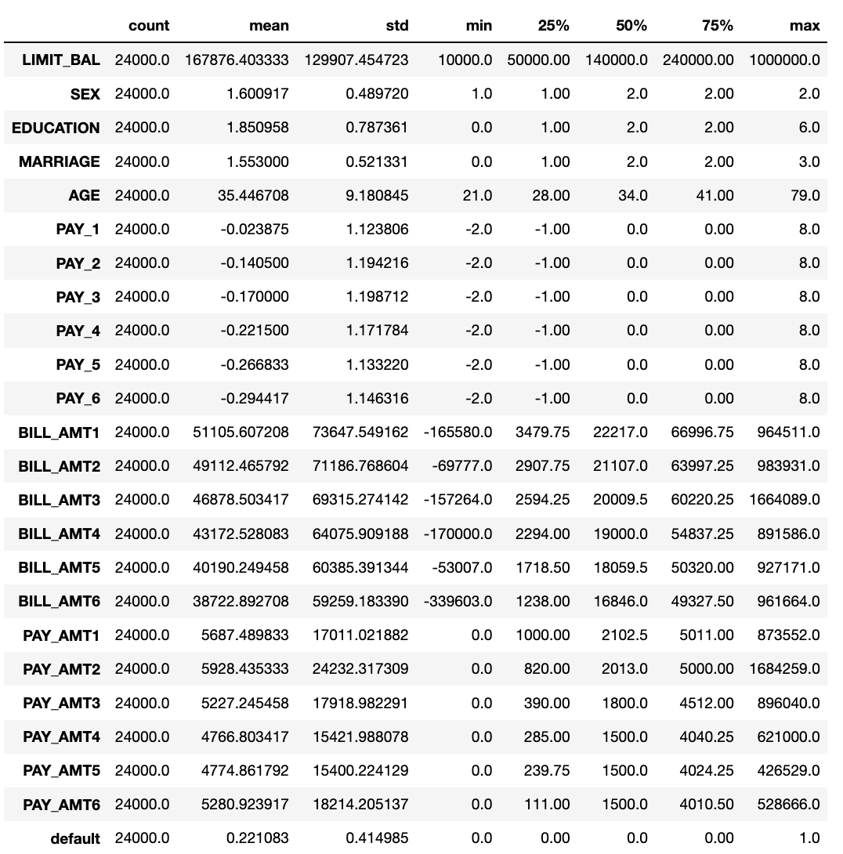

Example : Building a Model with PyCaret

This example continues from Example 1 to search for the best model. When running hardly any code at all you will notice that PyCaret identifies the RidgeClassifier as the best model.



**Note:** PyCaret will generate a lot of unnecessary output. If you use PyCaret, please do not blindly copy this output into your report since a lot of it does not really add any value to the report. Use proper care to ensure the data that you present is relevant to understanding the problem that is being solved.

The setup() function initializes the environment in pycaret and creates the transformation pipeline to prepare the data for modeling and deployment. setup() must be called before executing any other function in pycaret. It takes two mandatory parameters: a pandas dataframe and the name of the target column. All other parameters are optional and are used to customize the pre-processing pipeline (we will see them in later tutorials).

Unfortunately, the setup() function will not work with DataFrames so the code in this example uses a work around when splitting the data.

Note also that when running the setup() function you will be prompted to press enter but you could also type **quit** before pressing enter if you wish to stop the algorithm.



|  |
| --- |
| # Cannot use DataFrames with PyCaret's setup() function.  train = dataset.sample(frac=0.95, random_state=786)  test = dataset.drop(train.index)  train.reset_index(inplace=True, drop=True)  test.reset_index(inplace=True, drop=True)  print('Data for Modeling: ' + str(train.shape))  print('Unseen Data For Predictions: ' + str(test.shape))  # show data types.  from pycaret.classification import *  exp_clf101 = setup(data = train, target = 'default', session_id=123)  print(exp_clf101)  print("*** Showing best model")  best_model = compare_models()  print(best_model)  # Need this step for PyCharm  print("*** Showing best model")  regression_results = pull()  print(regression_results) |

Exercise (1 mark)

What are the two mandatory parameters of the PyCaret setup function?

|  |
| --- |
| Pandas dataframe and the target variable |

Exercise (2 marks)

For example compare_models(sort = 'Recall') will sort the grid by Recall instead of Accuracy. Show a screenshot of the output after sorting the results by recall.

|  |
| --- |
|  |

## Specifying the number of Folders

To save on processing time, when comparing multiple models, you can specify the total number of folds.

|  |
| --- |
| compare_models(fold = 5) |

If creating a single model you can also specify the number of folds for it.

|  |
| --- |
| ridge = create_model('ridge')  tuned_ridge = tune_model(ridge, fold=3) |

Example Creating and tuning a single model.

When a model is created using the create_model() function it uses the default hyperparameters to train the model. In order to tune hyperparameters, the tune_model() function is used. This function automatically tunes the hyperparameters of a model using Random Grid Search.

This example shows how to create and tune a single model. You can see the parameters of a suggested best model in the output.

|  |
| --- |
| RidgeClassifier(alpha=1, class_weight=None, copy_X=True, fit_intercept=False,  max_iter=None, normalize=True, random_state=123, solver='auto',  tol=0.001) |

Here is the full sample for tuning the RidgeClassifier model with PyCaret.

|  |
| --- |
| from sklearn.linear_model import RidgeClassifier  from pycaret.datasets import get_data  import pandas as pd  import warnings  warnings.filterwarnings("ignore", category=FutureWarning)  # Show all columns in same row.  pd.set_option('display.max_columns', None)  pd.set_option('display.width', 1000)  dataset = get_data('credit')  print(dataset.T) # Transpose for a reader-friendly display  # Redo this for test_train_split  data        = dataset.sample(frac=0.95, random_state=786)  data_unseen = dataset.drop(data.index)  data.reset_index(inplace=True, drop=True)  data_unseen.reset_index(inplace=True, drop=True)  print('Data for Modeling: ' + str(data.shape))  print('Unseen Data For Predictions: ' + str(data_unseen.shape))  ridge = RidgeClassifier(alpha=1.0, class_weight=None, copy_X=True, fit_intercept=True, max_iter=None, random_state=123, solver='auto',                  tol=0.001)  tuned_ridge = tune_model(ridge) |

## Plotting Feature Importance and Model Evaluation

PyCaret offers methods to help detect the best model features and to evaluate the model.

Example : Plotting Feature Importance and Model Evaluation

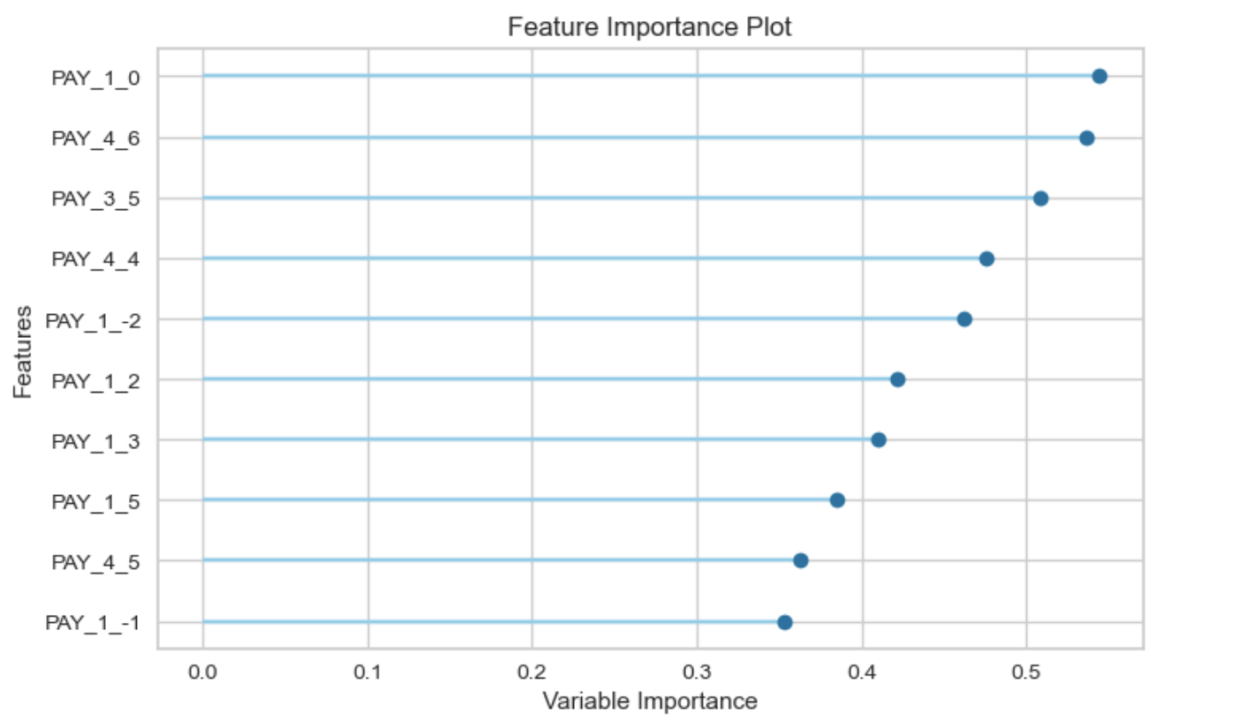

Here is the full program to draw the plot. To build this, add the following code in after the code from .

|  |
| --- |
| from pycaret.datasets import get_data  import pandas as pd  import warnings  warnings.filterwarnings("ignore", category=FutureWarning)  # Show all columns in same row.  pd.set_option('display.max_columns', None)  pd.set_option('display.width', 1000)  dataset = get_data('credit')  print(dataset) # Transpose for a reader-friendly display  # Redo this for test_train_split  data = dataset.sample(frac=0.95, random_state=786)  data_unseen = dataset.drop(data.index)  data.reset_index(inplace=True, drop=True)  data_unseen.reset_index(inplace=True, drop=True)  print('Data for Modeling: ' + str(data.shape))  print('Unseen Data For Predictions: ' + str(data_unseen.shape))  from pycaret.classification import *  exp_clf101 = setup(data = data, target = 'default', session_id=123)  print(exp_clf101)  ridge = create_model('ridge')  tuned_ridge = tune_model(ridge, fold=3)  #evaluate_model(tuned_ridge)  plot_model(tuned_ridge, plot='feature') |

To draw a confusion matrix add the following code to separate cell.

|  |
| --- |
| plot_model(tuned_ridge, plot = 'confusion_matrix') |

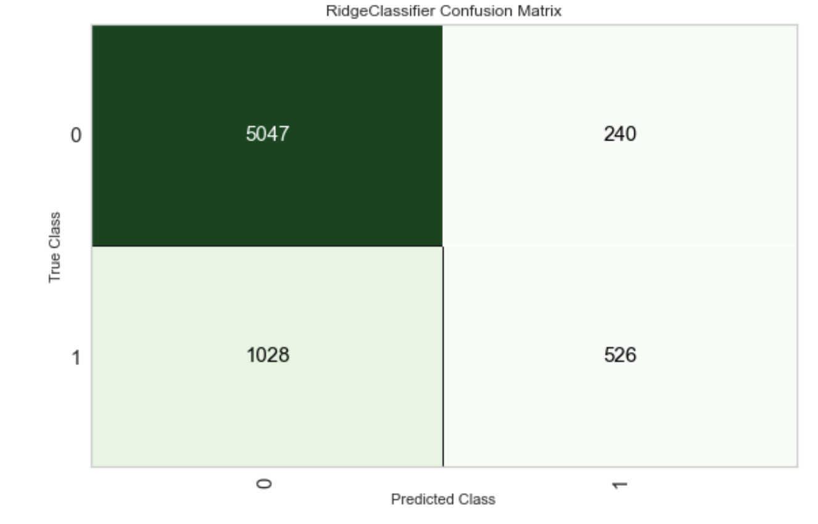

To display a precision-recall curve add the following code to a separate cell.

|  |
| --- |
| plot_model(tuned_ridge, plot = 'pr') |

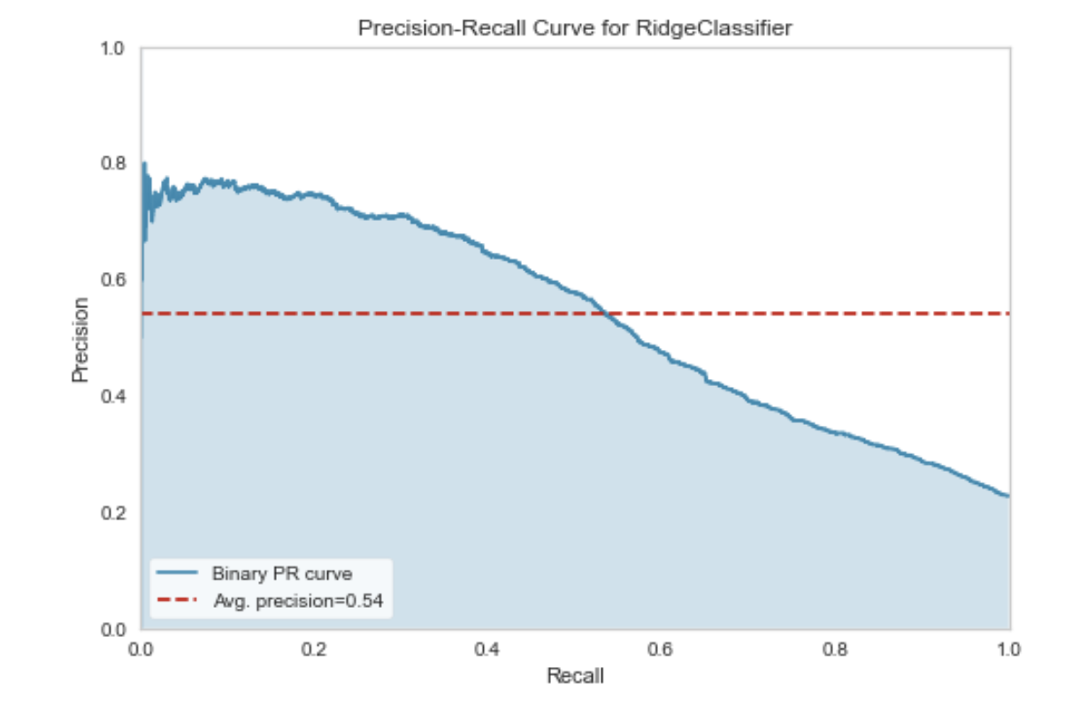

To detect the best set of hyperparameters for the ridge classifier, run the following instruction after running the code for Example 4.

|  |
| --- |
| evaluate_model(tuned_ridge) |

Selecting **Hyperparameters** option displays parameter values that are suggested to be used with the model.



This **Feature Importance** option gives a wider range of variable choices compared to the feature importance plot that was displayed earlier.



The **Feature Selection** option suggests that 25 features should be selected. Through experimentation I found that I could use about the top six or seven features and still get decent results.

Note: When clicking Feature Selection it will take quite a long time for the code to run. Be prepared to wait.



Example : Building the Recommended Model

After following the recommended model approach from PyCaret, I then built a model using the recommended hyper parameters and model type. Instead of using all 25 of the top features I used 11 of the top features.

The output shows:

|  |
| --- |
| precision recall f1-score support  0 0.85 0.96 0.90 948  1 0.71 0.35 0.46 252  accuracy 0.83 1200  macro avg 0.78 0.65 0.68 1200  weighted avg 0.82 0.83 0.81 1200  [[912 36]  [165 87]] |

This model recommendation from PyCaret can be implemented in PyCharm.

|  |
| --- |
| from sklearn.linear_model import RidgeClassifier  from sklearn.model_selection import train_test_split  from pycaret.datasets import get_data  import pandas as pd  import warnings  warnings.filterwarnings("ignore", category=FutureWarning)  from sklearn.metrics import classification_report, confusion_matrix  # Show all columns in same row.  pd.set_option('display.max_columns', None)  pd.set_option('display.width', 1000)  df = get_data('credit')  print(df)  from   sklearn.model_selection import train_test_split  # Re-assign X with significant columns only after chi-square test.  X = pd.get_dummies(df, columns=['PAY_1', 'PAY_2', 'PAY_3','PAY_4','PAY_5',                                  'PAY_6', 'MARRIAGE', 'EDUCATION'])  # show all rows.  pd.set_option('display.max_rows', None)  X = X[["PAY_1_0",  "PAY_4_6",  "PAY_3_5",  "PAY_4_4",  "PAY_1_-2",  "PAY_1_2",  "PAY_1_3",  "PAY_1_5",  "PAY_4_5",  "PAY_1_-1",  "MARRIAGE_0",  ]]  y = df['default']  # Split data.  X_train,X_test,y_train,y_test = train_test_split(X, y, test_size=0.05)  # Build logistic regression model and make predictions.  clfModel = RidgeClassifier(alpha=3.37, class_weight=None,                  copy_X=True, fit_intercept=False, max_iter=None, solver='auto', tol=0.001)  clfModel.fit(X_train,y_train)  y_pred=clfModel.predict(X_test)  print(classification_report(y_test, y_pred))  print(confusion_matrix(y_test, y_pred)) |

## Classification with Pycaret and Initial Conclusion

I think PyCaret is an excellent tool that helps to automate finding optimized models and top features. However, I also found that PyCaret is not perfect. It is still important to implement proper model validation and to experiment with other model types. Contrary to what PyCaret recommended; I could build a Logistic Regression model with the features that were recommended by PyCaret. The logistic regression model was competitive with the Ridge classifier model that was recommended by PyCaret.

Example : Building a Logistic Regression Model with the PyCaret Recommended Features

The Ridge model recommended by PyCaret does very well. However, this example shows that the logistic regression model is more competitive as a model than initially reported. Furthermore, results will vary over multiple runs so a proper validation process is required.

|  |  |
| --- | --- |
| Ridge Classifier | Logistic Regression |
| precision recall f1-score support  0 0.85 0.96 0.90 948  1 0.71 0.35 0.46 252  accuracy 0.83 1200  macro avg 0.78 0.65 0.68 1200  weighted avg 0.82 0.83 0.81 1200  [[912 36]  [165 87]] | precision recall f1-score support  0 0.83 0.96 0.89 933  1 0.68 0.31 0.43 267  accuracy 0.81 1200  macro avg 0.75 0.64 0.66 1200  weighted avg 0.80 0.81 0.79 1200  [[893 40]  [183 84]] |

To build this example, starting with , replace this line of code:

|  |
| --- |
| clfModel = RidgeClassifier(alpha=3.37, class_weight=None,  copy_X=True, fit_intercept=False, max_iter=None,  solver='auto', tol=0.001) |

with the following lines of code:

|  |
| --- |
| from sklearn.linear_model import LogisticRegression  # Build logistic regression model and make predictions.  clfModel = LogisticRegression(solver='liblinear') |

Exercise (2 marks)

Use PyCaret to search for the best model for the iris_v2.csv data set to predict flower type. Show a screenshot of the models and their metrics. Identify the top model (there is no perfect choice here but please use reasonable judgement) and ensure that it is in the screenshot.

|  |
| --- |
|  |

Exercise (3 marks)

Using PyCaret, identify the optimized hyper parameters for your selected model. Show a screenshot here.

|  |
| --- |
|  |

Exercise (3 marks)

Using PyCaret, identify the top features for your selected model. Show a screenshot here.

|  |
| --- |
|  |

## Searching Regression Models with PyCaret

Example : Searching for Regression Models

Running this code in Jupyter shows how PyCaret could be used to search for regression models.

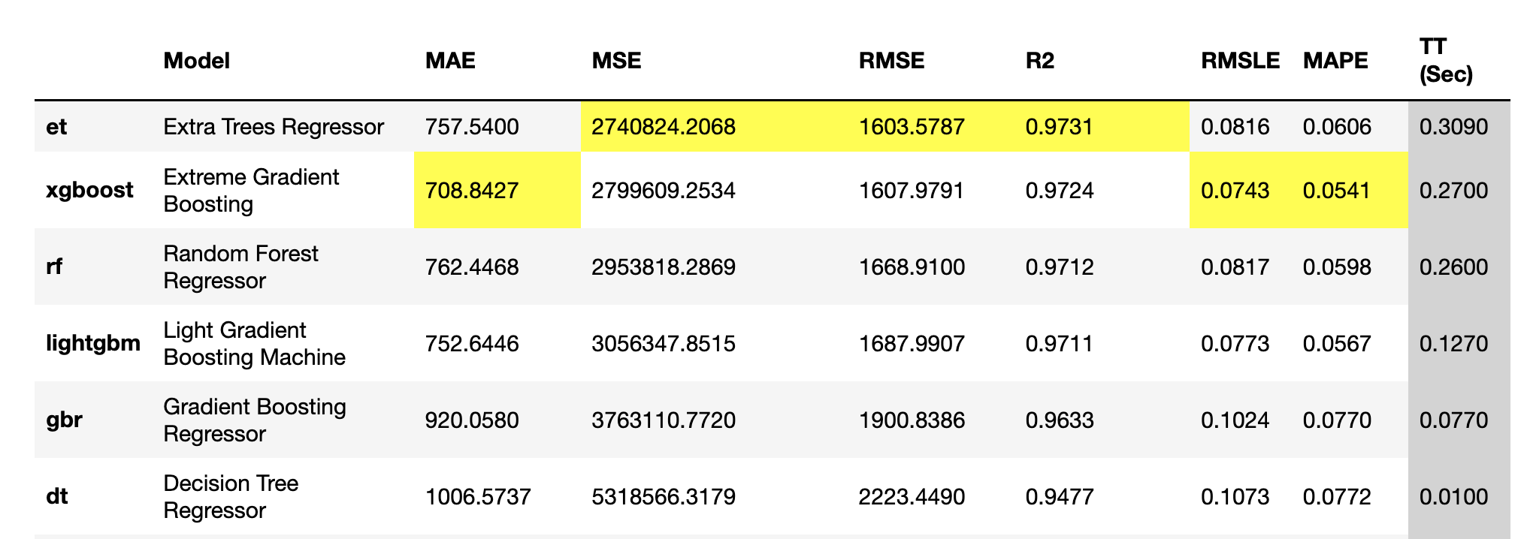

|  |
| --- |
| from pycaret.datasets import get_data  import pandas as pd  import warnings  warnings.filterwarnings("ignore", category=FutureWarning)  # Show all columns in same row.  pd.set_option('display.max_columns', None)  pd.set_option('display.width', 1000)  dataset = get_data('diamond')  # Get data and hold some back for testing.  data = dataset.sample(frac=0.9, random_state=786)  data_unseen = dataset.drop(data.index)  data.reset_index(drop=True, inplace=True)  data_unseen.reset_index(drop=True, inplace=True)  print('Data for Modeling: ' + str(data.shape))  print('Unseen Data For Predictions: ' + str(data_unseen.shape))  from pycaret.regression import *  exp_reg101 = setup(data = data, target = 'Price', session_id=123)  best = compare_models() |

## Tuning a Top Model

Once a top model has been identified, the best parameters and features can be identified.

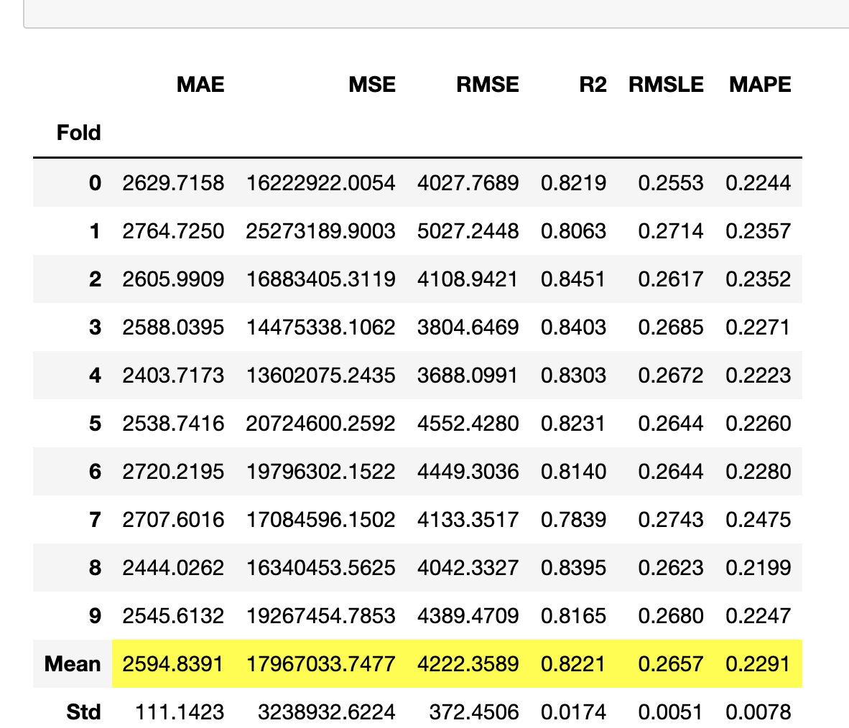

|  |
| --- |
| AdaBoostRegressor(base_estimator=None, learning_rate=0.05, loss='linear',  n_estimators=90, random_state=123) |

Example : Tuning a Regression Model

To generate the model evaluation metrics and optimized parameter listing run this code.

|  |
| --- |
| # Create model  ada = create_model('ada')  tuned_ada = tune_model(ada)  print(tuned_ada) |

Running the following instruction in a separate cell shows the residual error plot.

plot_model(tuned_ada)

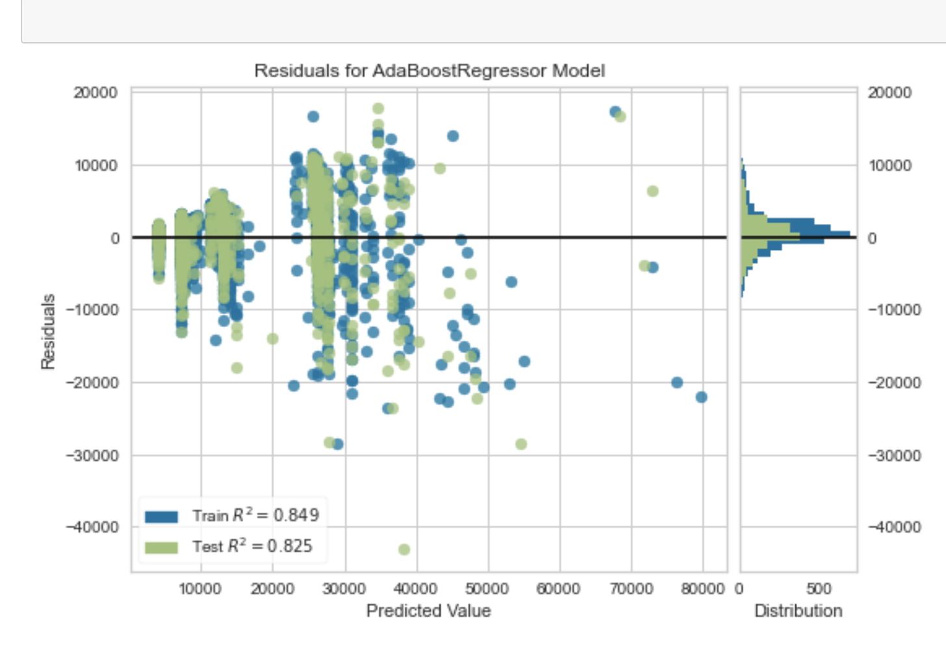

Features can be identified by running this code:

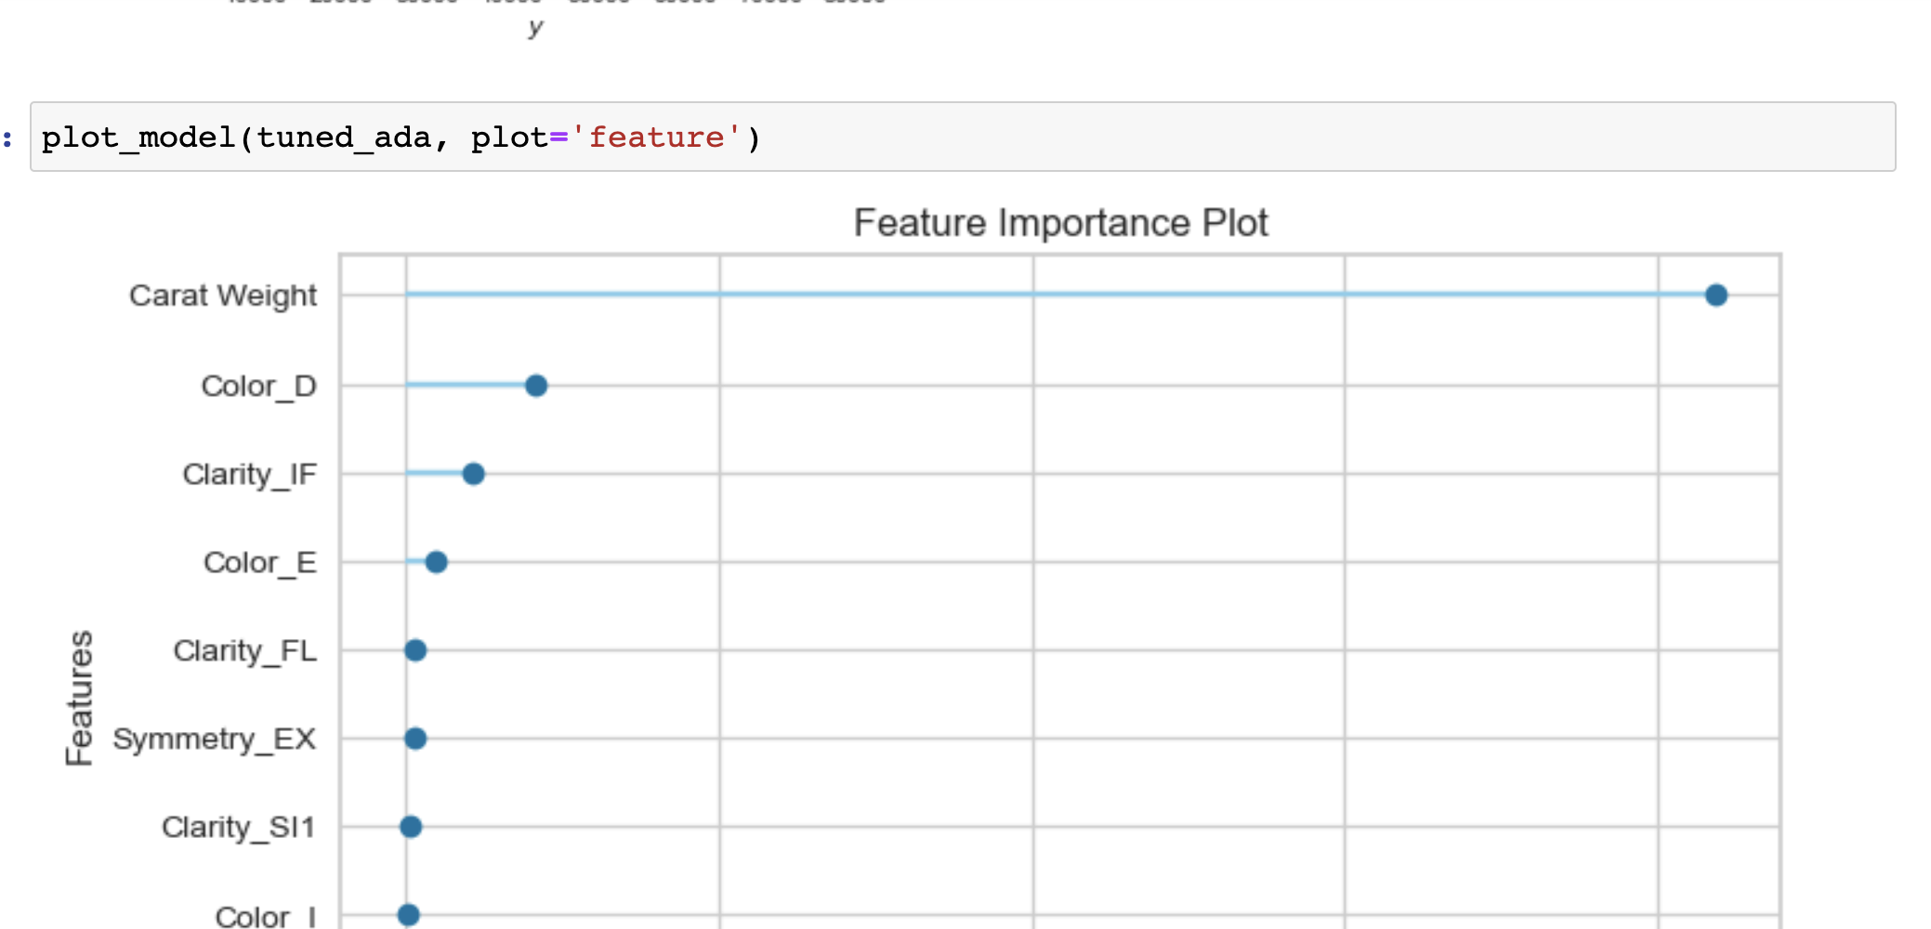

Exercise (5 MARKS)

Using the winequality.csv file, use linear regression in PyCaret to find the best model type. After identifying a suitable top candidate, show a screenshot of the optimized parameters for the model type here:

|  |
| --- |
|  |

Show a screenshot of the residual error plot here:

|  |
| --- |
|  |

Show a screenshot of the feature importance plot for the wine quality model here:

|  |
| --- |
|  |

## Next Steps

For more information on PyCaret see:

<https://github.com/pycaret/pycaret/tree/master/tutorials>

Table of Contents

Requirements 1

References 1

Convolutional Neural Networks (CNN’s) 1

Common Filters (Kernels) 3

Stride 3

Padding 4

Pool Size 5

Applying Multiple Filters 5

Increasing Filters in Each Consecutive Layer 5

Kernel Size 9

Filters 9

Strides 9

Early Stopping and Saving the Best Model 13

## Requirements

This was implemented using **tensorflow 2.4** and **keras 2.4.3**.

On Windows I had to run PyCharm as Administrator.

On my Mac I had to install open CV when the CV2 module was missing. The installation required admin status: **sudo pip install opencv-python**

## Introduction

The goal of this document is to provide a light introd uction to convolutional neural networks. Tuning them can be a challenge so the focus will be more on the general terminology instead.

## References

<https://www.analyticsvidhya.com/blog/2017/06/architecture-of-convolutional-neural-networks-simplified-demystified/>

<https://medium.com/@RaghavPrabhu/understanding-of-convolutional-neural-network-cnn-deep-learning-99760835f148#:~:text=Strides,with%20a%20stride%20of%202>.

## Convolutional Neural Networks (CNN’s)

Convolutional Neural Networks, or CNNs for short, are a type of network designed for image input. They are comprised of models with convolutional layers which extract and transform features into simpler pooled elements. The pooled features are then flattened into arrays which are fed through a neural network for classification.

Figure 1: Feature Pooling and Classification Activities of a Convolutional Neural Network

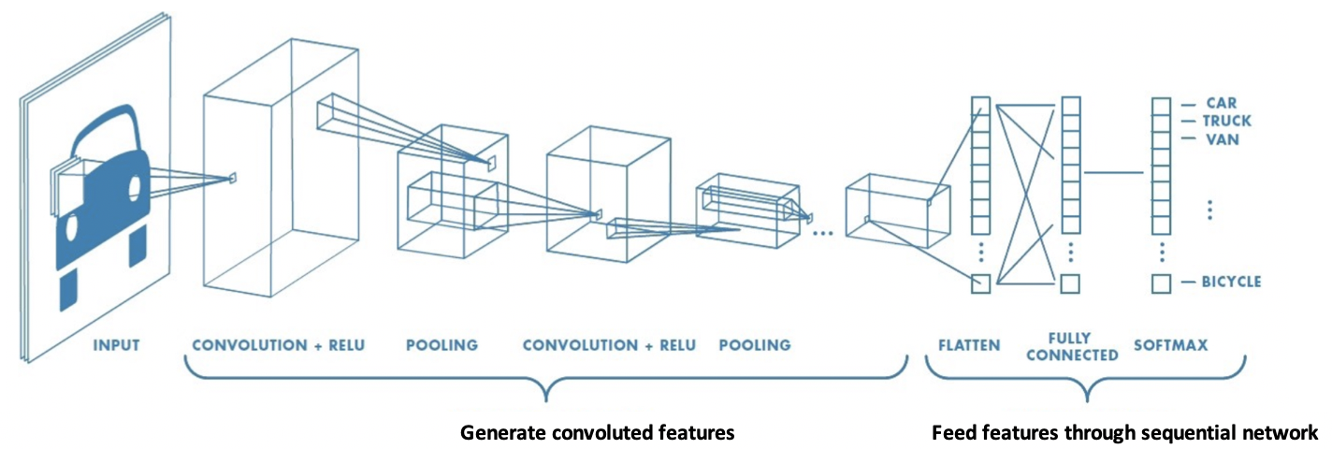

Figure 2 shows how nine pixels of an image can be convoluted into one element of a pooled layer. Notice how the pooled layer dimensions are much smaller than the original image.

Figure 2: Transforming Nine Elements into One Pooled Element

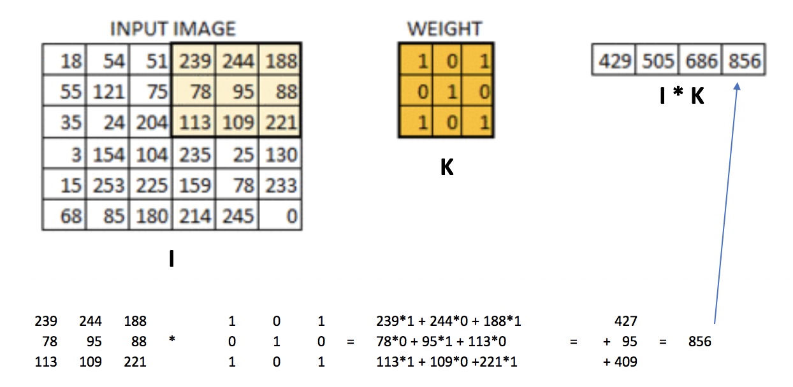

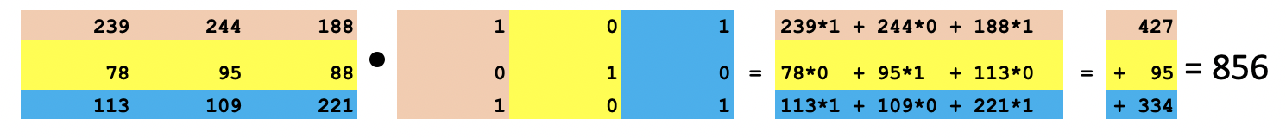

Convolving with a filter creates a feature map like the one in Figure 3.

Figure 3: Real Image vs. Convoluted Image

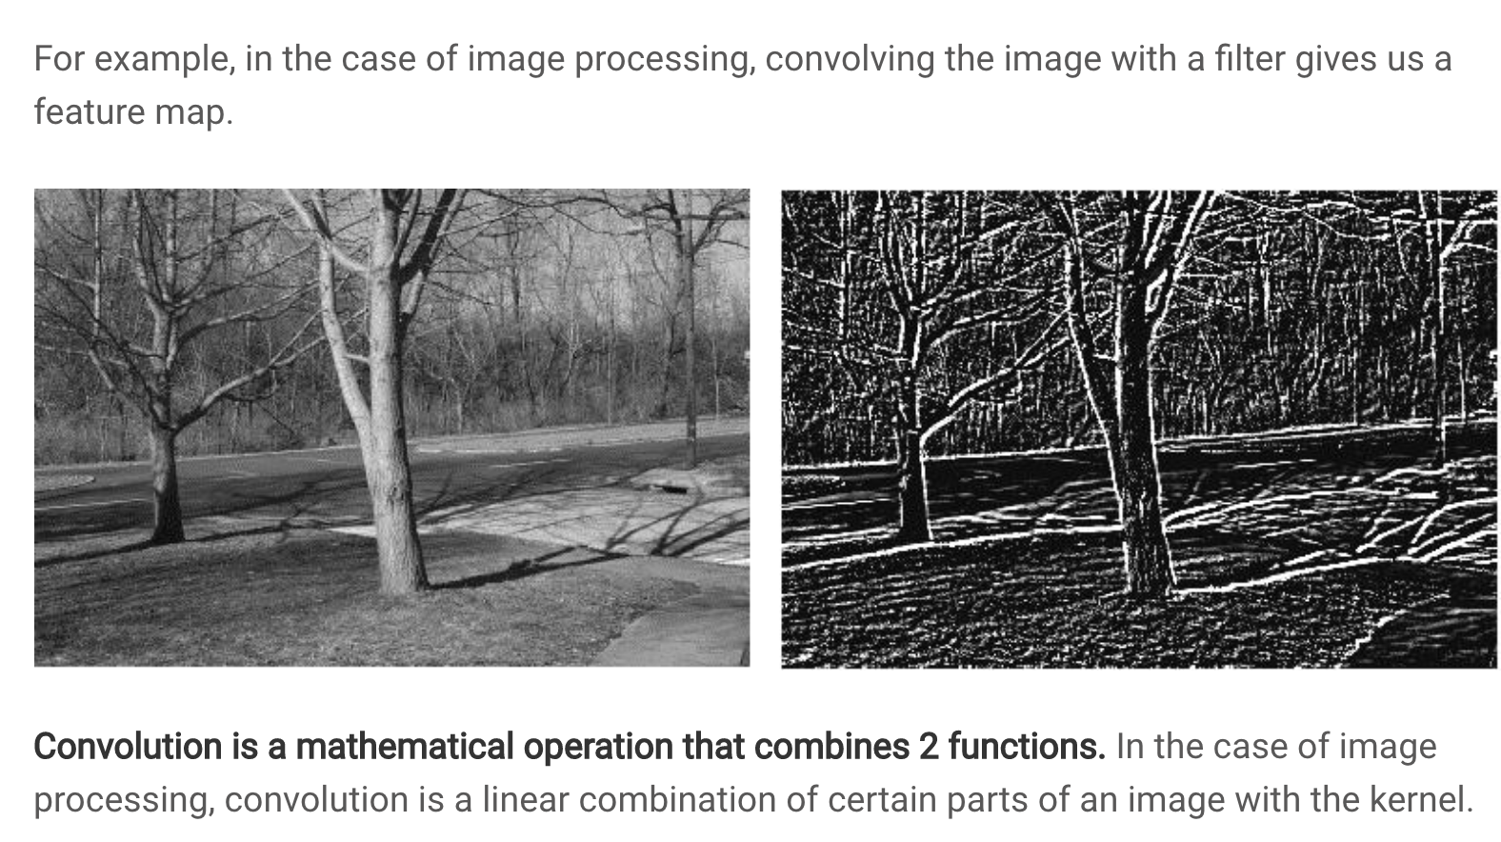

## Common Filters (Kernels)

Not all filters are the same. Figure 4 highlights several filter types.

Figure 4: Common Image Filters

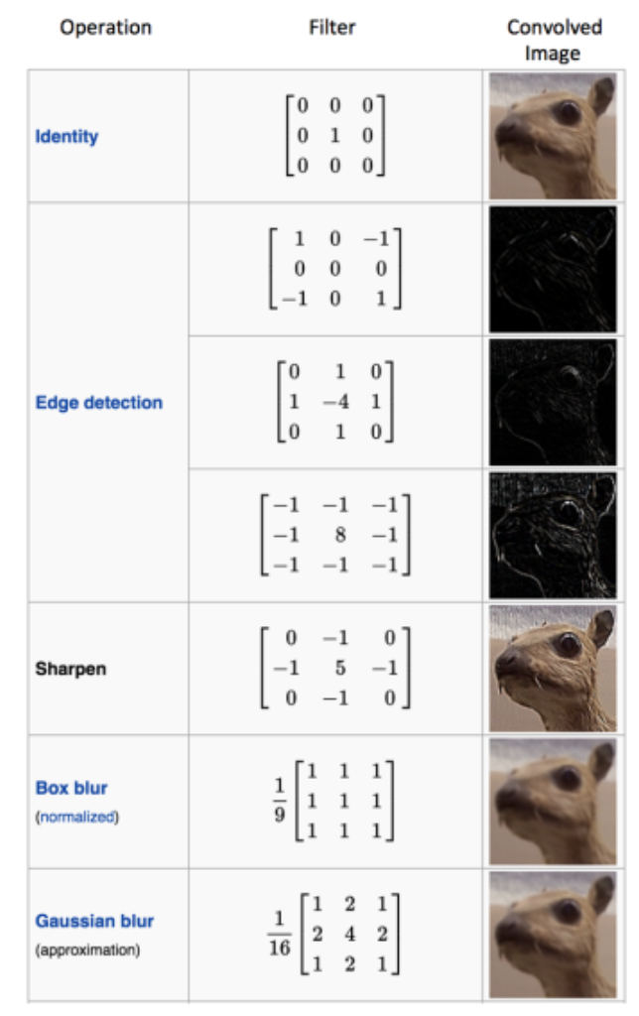

## Stride

Like we saw in Figure 2 the weight matrix was applied to sub sections of the image. In the example given, the sub sections were selected by shifting a window horizontally across the original image one pixel at a time and then down one pixel at a time. This **stride** of 1 pixel x 1 pixel led to a convoluted image that is 4x4 pixels. Lower strides leads to a higher amount of detail in the convoluted image.

A higher stride of 2x2 leads to a smaller convoluted image. Figure 5 illustrates a how a convoluted image is created with a filter by using a 2x2 stride. The first section of the image is selected and is filtered. Then the selection is shifted two pixels across. The new selection is multiplied by the filter. Then the selection is taken from the bottom left of the original image and is multiplied by the filter. Then the selection is taken from the bottom right of the image and this section is multiplied by the filter.

Figure 5: Creating a Convoluted Image with a 2x2 Stride

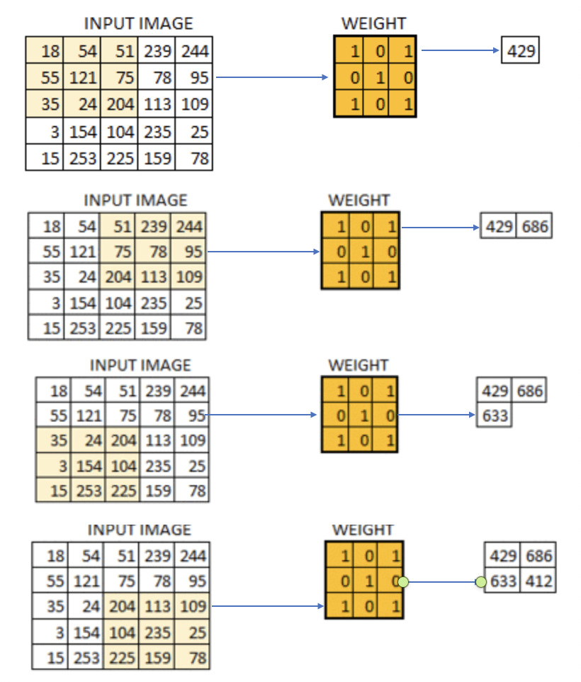

Exercise 1 (3 marks)

Show the calculation needed to multiply the section of the input image by the filter to generate 686. See Figure 5.

|  |
| --- |
| 51 + 244 + 78 + 204 + 109 = 686 |

## Padding

You may have noticed that striding across the image leads to a smaller convoluted image. However, we could pad the border with zeros to retain the original size of the image. Padding also allows us to obtain more information about the borders (see Figure 6).

Figure 6: Padding an Image

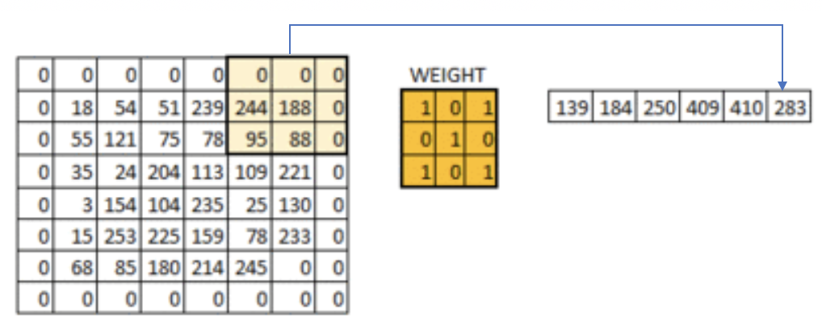

## Pool Size

A pool_size attribute is used in the network to downsample the image. The calculation used for downsampling is:

output_shape = (input_shape - pool_size + 1) / strides)

## Applying Multiple Filters

If we have a 32x32 image with a 3-byte color layer and we apply a stack of ten 5x5x3 filters **we** end up with a convoluted output of 28x28x3.

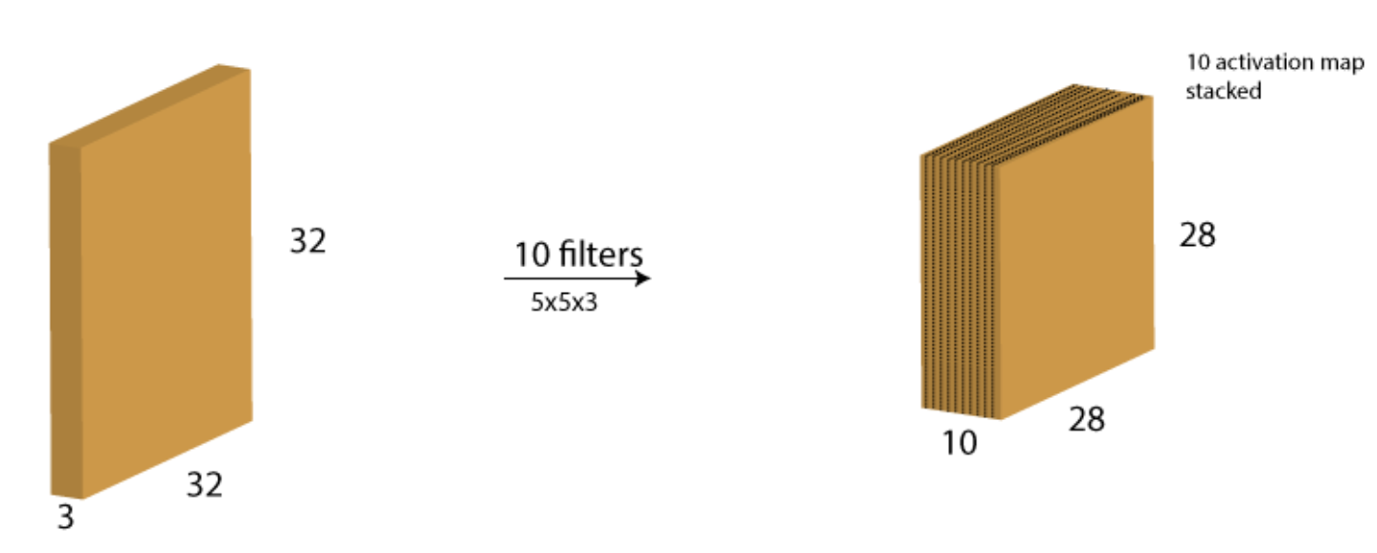

### Increasing Filters in Each Consecutive Layer

In every layer filters are there to capture patterns. For example in the first layer filters capture patterns like edges, corners, dots etc. In the subsequent layers we combine those patterns to make bigger patterns. Like combine edges to make squares, circle etc.

Now as we move forward in the layers the patterns gets more complex, hence larger combinations of patterns to capture. That's why we increase filter size in the subsequent layers to capture as many combinations as possible.

<https://datascience.stackexchange.com/questions/55545/in-cnn-why-do-we-increase-the-number-of-filters-in-deeper-convolution-layers-fo>

Example 1: Processing and Displaying Images

This first example demonstrates how to prepare the images for modelling.

Initially the images are loaded.

img = cv2.imread(filePath)

The images are then scaled to a size of 96x96 pixels.

img = cv2.resize(img, (IMAGE_SIZE, IMAGE_SIZE))

Next, the code eliminates the 3 byte color channel.

img = cv2.cvtColor(img, cv2.COLOR_RGB2GRAY)

To understand our image data better some print statements are used to display the data attributes and contents.

print("Image Label: " + str(labels[index]))

print("Image Shape: " + str(images[index].shape))

print("Image Data: ")

print(images[index])

|  |
| --- |
| Image Label: 0  Image Shape: (96, 96)  Image Data:  [[0.06666667 0.03137255 0.01568627 ... 0.14901961 0.16470588 0.38039216]  [0.02352941 0.05098039 0.03137255 ... 0.18039216 0.21568627 0.37254902]  [0.03921569 0.03137255 0.03529412 ... 0.18823529 0.2 0.32941176]  ...  [0.30196078 0.27843137 0.29019608 ... 0.34901961 0.36470588 0.36470588]  [0.33333333 0.32156863 0.31764706 ... 0.3372549 0.33333333 0.33333333]  [0.34901961 0.31764706 0.32941176 ... 0.33333333 0.33333333 0.35294118]] |

To verify that the images are process properly, two processed test images are displayed on the screen.

plt.imshow(images[index])

plt.show()

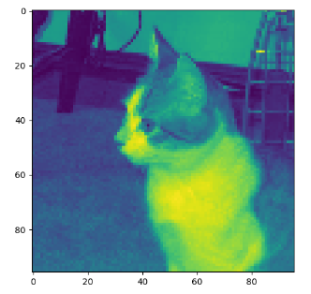 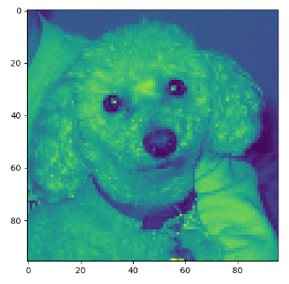

|  |
| --- |
| import matplotlib.pyplot as plt  import os  import numpy as np  import cv2  PATH = "/Users/pm/Desktop/DayDocs/data/small_cats_and_dogs/"  # Loads the image file.  def load_image(fileName, subFolder):  try:  filePath = PATH + subFolder + "/" + fileName  img = cv2.imread(filePath)  return img  except:  return np.NaN  # Extract the actual class from the image file name.  def extract_label(file_name):  return 1 if "dog" in file_name else 0  # Transforms image into scaled and squared image.  def preprocess_image(img):  IMAGE_SIZE = 96  try:  # Finds minimum of height and width.  min_side = min(img.shape[0], img.shape[1])  # Reduce image to square using minimum of width and height.  img = img[:min_side, :min_side]  # Reside to 96x96.  img = cv2.resize(img, (IMAGE_SIZE, IMAGE_SIZE))  print(img.shape)  # Eliminate three byte color channel.  img = cv2.cvtColor(img, cv2.COLOR_RGB2GRAY)  print(img.shape)  print("***")  # Scale numbers to range between 0 and 1.0  return img / 255.0  except:  return np.NaN  def getImages(dirName):  imageList = []  labelList = []  # List all items in the directory.  image_files = os.listdir(PATH + dirName + "/")  for i in range(0, len(image_files)):  image = load_image(image_files[i], dirName)  processedImage = preprocess_image(image)  # Build list of processed images and labels.  if processedImage is not np.NaN:  imageList.append(processedImage)  label = extract_label(image_files[i])  labelList.append(label)  return imageList, labelList  # Displays grayscale image and image data to ensure everything is working properly.  def verifyImage(images, labels, index):  print("Image Label: " + str(labels[index]))  print("Image Shape: " + str(images[index].shape))  print("Image Data: ")  print(images[index])  # Display the image.  plt.imshow(images[index])  plt.show()  print("*****")  # Add an extra dimension for the signle color channel.  # Changes (2000, 96, 96) to (2000, 96, 96, 1)  # Load transformed and scaled images.  X_train, y_train = getImages('train')  X_test, y_test = getImages('test')  # Verify first image in training set.  verifyImage(X_train, y_train, 0)  # Verify second image in training set.  verifyImage(X_train, y_train, 1) |

Example 2: Convert to 3D Array

Like other neural network examples, we need to ensure our inputs are in vertical array format to enable matrix multiplication. This code transforms our data into a vertical array. Here is the shape and data formatted after the transformation.

|  |  |
| --- | --- |
| **X shape: (2000, 96, 96, 1)** | **y shape: (2000,)** |
| array([[0.27058824, 0.28627451, 0.30588235, ..., 0.33333333, 0.39215686,  0.33333333],  [0.31372549, 0.30588235, 0.30588235, ..., 0.34509804, 0.38039216,  0.40784314],  [0.31372549, 0.3254902 , 0.30980392, ..., 0.36470588, 0.42745098,  0.39215686],  ...,  [0.25490196, 0.25490196, 0.24313725, ..., 0.01960784, 0.01960784,  0.01568627],  [0.28235294, 0.29803922, 0.30588235, ..., 0.01568627, 0.02352941,  0.01176471],  [0.30980392, 0.3254902 , 0.32156863, ..., 0.02352941, 0.02352941,  0.01176471]]),  array([[0.83529412, 0.85882353, 0.8627451 , ..., 0.41960784, 0.45098039,  0.43921569],  [0.79607843, 0.79215686, 0.81176471, ..., 0.41960784, 0.44705882,  0.43921569],  [0.76862745, 0.77647059, 0.78039216, ..., 0.40392157, 0.44313725,  0.4627451 ],  ...,  [0.31764706, 0.3372549 , 0.34509804, ..., 0.24705882, 0.23529412,  0.23137255],  [0.32941176, 0.3372549 , 0.36862745, ..., 0.21568627, 0.24705882,  0.22352941],  [0.34117647, 0.35294118, 0.34117647, ..., 0.22745098, 0.24705882,  0.24313725]]),  ...] | [1,  0,  0,  1,  1,  1,  1,  0,  0,  0,  0,  1,  0,  0,  1,  0,  1,  1,  1,  1,  1,  0,  0,  1,  0,  0 |

This is the code that performs the transformation to a matrix. Add this code to Example 1:

|  |
| --- |
| def convertToArray(x, y):  x = np.array(x)  x = np.expand_dims(x, -1)  y = np.array(y)  print(x.shape)  print(y.shape)  print("***")  return x, y  X_train, y_train = convertToArray(X_train, y_train) X_test, y_test = convertToArray(X_test, y_test) |

Example 3: Building and Evaluating the Model

To help understand how the model is built here are some terms.

## Kernel Size

The kernel is our sliding window which performs the convolution. Typical sizes include (1,1), (2,2),(3,3),(4,4),(5,5),(6,6),(7,7). It is rare to have more than a 7x7 kernal size.

## Filters

The number of filters determines the number of ways the kernel data is transformed. The number of filters corresponds to the number of outputs that are generated during the convolution.

## Strides

A stride is the horizontal and vertical step taken when shifting the convolutional window.

The model is decent - this is as good as I could make it.

|  |
| --- |
| Accuracy: 0.755  Confusion Matrix  Predicted 0 1  Actual  0 360 140  1 105 395 |

Here is the code that builds our model. Add this code to Example 2:

|  |
| --- |
| import tensorflow as tf  from tensorflow.keras import Sequential  from tensorflow.keras.layers import Dense  from tensorflow.keras.layers import Conv2D  from tensorflow.keras.layers import MaxPool2D  from tensorflow.keras.layers import Flatten  from tensorflow.keras.layers import Dropout  def create_model(X_train, y_train, X_test, y_test):  model = Sequential()  model.add(Conv2D(filters=32, kernel_size=(3, 3), activation='relu',  kernel_initializer='he_uniform',  input_shape=X_train.shape[1:]))  # Add a pooling layer to down sample height and widths by half.  # pool_size is filter size.  model.add(MaxPool2D(pool_size=(2, 2), strides=(2, 2)))  # It is common to repeat this pattern a few times by doubling the filter  # each time to offset the reduction in size from down sampling.  model.add(Conv2D(filters=64, kernel_size=(3, 3), activation='relu',  kernel_initializer='he_uniform',  input_shape=X_train.shape[1:]))  model.add(MaxPool2D(pool_size=(2, 2), strides=(2, 2)))  model.add(Conv2D(filters=128, kernel_size=(3, 3), activation='relu',  kernel_initializer='he_uniform',  input_shape=X_train.shape[1:]))  model.add(MaxPool2D(pool_size=(2, 2), strides=(2, 2)))  model.add(Conv2D(filters=256, kernel_size=(3, 3), activation='relu',  kernel_initializer='he_uniform',  input_shape=X_train.shape[1:]))  model.add(MaxPool2D(pool_size=(2, 2), strides=(2, 2)))  model.add(Conv2D(filters=512, kernel_size=(3, 3), activation='relu',  kernel_initializer='he_uniform',  input_shape=X_train.shape[1:]))  model.add(MaxPool2D(pool_size=(2, 2), strides=(2, 2)))  # feed data convolved features to a sequential network.  model.add(Flatten())  model.add(Dense(512, activation='relu', kernel_initializer='he_uniform'))  model.add(Dropout(0.5))  model.add(Dense(256, activation='relu', kernel_initializer='he_uniform'))  model.add(Dropout(0.5))  # Create output layer which has two classes.  model.add(Dense(units=2, activation='softmax'))  model.compile(optimizer=tf.optimizers.Adam(),  # We are using classification.  loss=tf.losses.SparseCategoricalCrossentropy(),  # Show accuracy.  metrics=['accuracy'])  history = model.fit(X_train, y_train, epochs=20, batch_size=100,  validation_data=(X_test, y_test))  model.save_weights("model.tf")  return model, history  model, history = create_model(X_train, y_train, X_test, y_test)  predictions = model.predict(X_test)  # Iterates through pairs of predictions and adds most probable option to list.  predictionList = []  for i in range(0, len(predictions)):  prediction = predictions[i]  if(prediction[0] > prediction[1]):  predictionList.append(0)  else:  predictionList.append(1)  predictionArray = np.array(predictionList)  print(predictionList)  import pandas as pd  from sklearn import metrics  # Show confusion matrix and accuracy scores.  confusion_matrix = pd.crosstab(y_test, predictionArray,  rownames=['Actual'],  colnames=['Predicted'])  print('\nAccuracy: ',metrics.accuracy_score(y_test, predictionArray))  print("\nConfusion Matrix")  print(confusion_matrix) |

Exercise (3 marks)

Perform this calculation for one dimension only. Given that the input width is 96, the pooling filter size is 2 and the strides value is 2, prove the convoluted image that is output is approximately half the size of the original.

output_shape = (input_shape - pool_size + 1) / strides)

Show your output here:

|  |
| --- |
| (96 – 2 + 1) / 2 = 47.5 |

Example 4: Showing the loss and accuracy

It is helpful to visualize the validation loss and accuracy. The loss function begins to rise at epoch 16. This suggests overfitting.

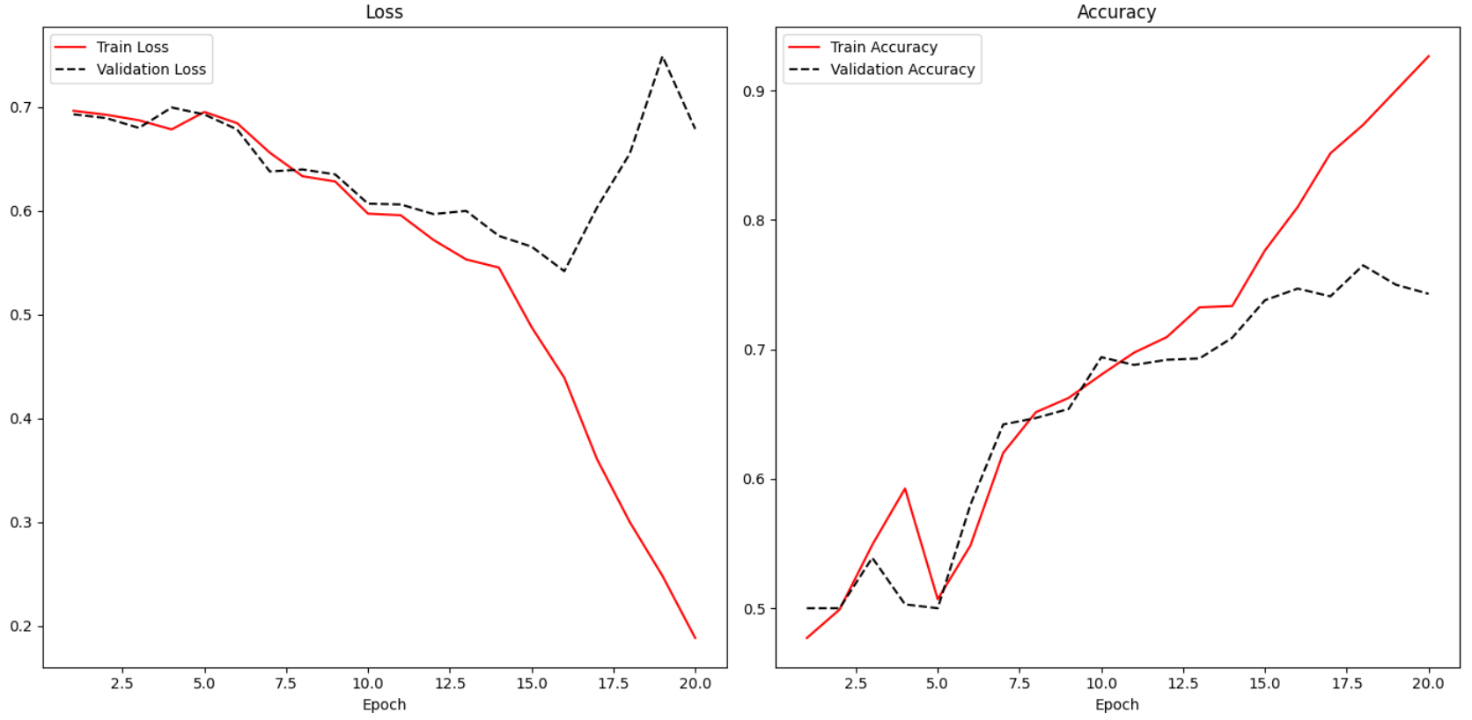

Adding the following code to Example 3 enables the reporting of loss and accuracy for classification algorithms.

|  |
| --- |
| def showLoss(history):  # Get training and test loss histories  training_loss = history.history['loss']  validation_loss = history.history['val_loss']  # Create count of the number of epochs  epoch_count = range(1, len(training_loss) + 1)  plt.subplot(1, 2, 1)  # Visualize loss history for training data.  plt.plot(epoch_count, training_loss, label='Train Loss', color='red')  # View loss on unseen data.  plt.plot(epoch_count, validation_loss, 'r--', label='Validation Loss',  color='black')  plt.xlabel('Epoch')  plt.legend(loc="best")  plt.title("Loss")  def showAccuracy(history):  # Get training and test loss histories  training_loss = history.history['accuracy']  validation_loss = history.history['val_accuracy']  # Create count of the number of epochs  epoch_count = range(1, len(training_loss) + 1)  plt.subplot(1, 2, 2)  # Visualize loss history for training data.  plt.plot(epoch_count, training_loss, label='Train Accuracy', color='red')  # View loss on unseen data.  plt.plot(epoch_count, validation_loss, 'r--',  label='Validation Accuracy', color='black')  plt.xlabel('Epoch')  plt.legend(loc="best")  plt.title('Accuracy')  plt.subplots(nrows=1, ncols=2, figsize=(14,7))  showLoss(history)  showAccuracy(history)  plt.show() |

## Early Stopping and Saving the Best Model

Early stopping is a technique and saving the best model that is used in machine learning algorithms to detect overfitting. Early stopping allows you to stop training the model when the validation loss increases a specific number of times. You can control the number of times that the loss may increase with the patience level.

Example 5: Enabling Early Stopping and Saving the Best Model

To enable early stopping and save the best model, start with Example 4. Then place this line of code above at the start of the program. Be sure to use the big_cats_and_dogs data set for this test for best results.

|  |
| --- |
| from tensorflow.keras.callbacks import EarlyStopping  from tensorflow.keras.callbacks import ModelCheckpoint |

Next, replace the line of code where the model is fit with this instruction.

|  |
| --- |
| # configure early stopping  es = EarlyStopping(monitor='val_loss', patience=10)  mc = ModelCheckpoint('best_model.h5', monitor='val_accuracy', mode='max', verbose=1,  save_best_only=True)  history = model.fit(X_train, y_train, epochs=20, batch_size=100,  validation_data=(X_test, y_test), callbacks=[es,mc]) |

Next, replace this line of code:

predictions = model.predict(X_test)

With code that loads the binary model before making a prediction:

|  |
| --- |
| # Must match from tensorflow.keras.callbacks import ModelCheckpoint  from tensorflow.keras.models import load_model  saved_model = load_model('best_model.h5')  predictions = saved_model.predict(X_test) |

Exercise 3 (10 marks)

Train your model to check for dogs, cats and octopi. **Be sure to use the small_cats_and_dogs_and_octopi data set for this test.**

To enable training with the new files, drop the extracted files from octopusTest into the test folder. Drop the extract files from octopusTrain into the train folder.

After, replace extract_label() with the following code:

|  |
| --- |
| def extract_label(file_name):  if "dog" in file_name:  return 1  elif "cat" in file_name:  return 0  else:  return 2 |

The output layer needs to be set to 3 since it is classifying for dogs, cats and octopi. Replace the output layer with this version:

|  |
| --- |
| model.add(Dense(units=3, activation='softmax')) |

Next, fix the code which sets up the confusion matrix. You will want to output 0, 1 or 2 depending on the maximum element in each row of the ***predictions*** list. This is the code that needs to be fixed:

|  |
| --- |
| predictionList = []  # Iterates through pairs of predictions and adds most probable option to list.  for i in range(0, len(predictions)):  prediction = predictions[i]  if(prediction[0] > prediction[1]):  predictionList.append(0)  else:  predictionList.append(1)  predictionArray = np.array(predictionList)  print(predictionList)  import pandas as pd  from sklearn import metrics  # Show confusion matrix and accuracy scores.  confusion_matrix = pd.crosstab(y_test, predictionArray,  rownames=['Actual'],  colnames=['Predicted'])  print('\nAccuracy: ',metrics.accuracy_score(y_test, predictionArray))  print("\nConfusion Matrix")  print(confusion_matrix) |

Show your fixed code here:

|  |
| --- |
| import tensorflow as tf from tensorflow import keras from keras.callbacks import EarlyStopping from keras.callbacks import ModelCheckpoint import matplotlib.pyplot as plt import os import numpy as np import cv2  PATH = "C:/datasets/small_cats_and_dogs_and_octopi/"   # Loads the image file. def load_image(fileName, subFolder):  try:  filePath = PATH + subFolder + "/" + fileName  img = cv2.imread(filePath)  return img  except:  return np.NaN   # Extract the actual class from the image file name. def extract_label(file_name):  if "dog" in file_name:  return 1  elif "cat" in file_name:  return 0  else:  return 2   # Transforms image into scaled and squared image. def preprocess_image(img):  IMAGE_SIZE = 96   try:  # Finds minimum of height and width.  min_side = min(img.shape[0], img.shape[1])   # Reduce image to square using minimum of width and height.  img = img[:min_side, :min_side]   # Reside to 96x96.  img = cv2.resize(img, (IMAGE_SIZE, IMAGE_SIZE))  print(img.shape)   # Eliminate three byte color channel.  img = cv2.cvtColor(img, cv2.COLOR_RGB2GRAY)  print(img.shape)  print("***")   # Scale numbers to range between 0 and 1.0  return img / 255.0  except:  return np.NaN   def getImages(dirName):  imageList = []  labelList = []   # List all items in the directory.  image_files = os.listdir(PATH + dirName + "/")   for i in range(0, len(image_files)):  image = load_image(image_files[i], dirName)  processedImage = preprocess_image(image)   # Build list of processed images and labels.  if processedImage is not np.NaN:  imageList.append(processedImage)   label = extract_label(image_files[i])  labelList.append(label)  return imageList, labelList   # Displays grayscale image and image data to ensure everything is working properly. def verifyImage(images, labels, index):  print("Image Label: " + str(labels[index]))  print("Image Shape: " + str(images[index].shape))  print("Image Data: ")  print(images[index])   # Display the image.  plt.imshow(images[index])  plt.show()  print("*****")   # Add an extra dimension for the single color channel. # Changes (2000, 96, 96) to (2000, 96, 96, 1)  # Load transformed and scaled images. X_train, y_train = getImages('train') X_test, y_test = getImages('test')  # Verify first image in training set. verifyImage(X_train, y_train, 0)  # Verify second image in training set. verifyImage(X_train, y_train, 1)    def convertToArray(x, y):  x = np.array(x)  x = np.expand_dims(x, -1)  y = np.array(y)  print(x.shape)  print(y.shape)  print("***")  return x, y   X_train, y_train = convertToArray(X_train, y_train) X_test, y_test = convertToArray(X_test, y_test)   import tensorflow as tf from tensorflow import keras from keras import Sequential from keras.layers import Dense from keras.layers import Conv2D from keras.layers import MaxPool2D from keras.layers import Flatten from keras.layers import Dropout   def create_model(X_train, y_train, X_test, y_test):  model = Sequential()   model.add(Conv2D(filters=32, kernel_size=(3, 3), activation='relu',  kernel_initializer='he_uniform',  input_shape=X_train.shape[1:]))  # Add a pooling layer to down sample height and widths by half.  # pool_size is filter size.  model.add(MaxPool2D(pool_size=(2, 2), strides=(2, 2)))   # It is common to repeat this pattern a few times by doubling the filter  # each time to offset the reduction in size from down sampling.  model.add(Conv2D(filters=64, kernel_size=(3, 3), activation='relu',  kernel_initializer='he_uniform',  input_shape=X_train.shape[1:]))  model.add(MaxPool2D(pool_size=(2, 2), strides=(2, 2)))   model.add(Conv2D(filters=128, kernel_size=(3, 3), activation='relu',  kernel_initializer='he_uniform',  input_shape=X_train.shape[1:]))  model.add(MaxPool2D(pool_size=(2, 2), strides=(2, 2)))   model.add(Conv2D(filters=256, kernel_size=(3, 3), activation='relu',  kernel_initializer='he_uniform',  input_shape=X_train.shape[1:]))  model.add(MaxPool2D(pool_size=(2, 2), strides=(2, 2)))   model.add(Conv2D(filters=512, kernel_size=(3, 3), activation='relu',  kernel_initializer='he_uniform',  input_shape=X_train.shape[1:]))  model.add(MaxPool2D(pool_size=(2, 2), strides=(2, 2)))   # feed data convolved features to a sequential network.  model.add(Flatten())   model.add(Dense(512, activation='relu', kernel_initializer='he_uniform'))  model.add(Dropout(0.5))  model.add(Dense(256, activation='relu', kernel_initializer='he_uniform'))  model.add(Dropout(0.5))   # Create output layer which has two classes.  model.add(Dense(units=3, activation='softmax'))   model.compile(optimizer=tf.optimizers.Adam(),  # We are using classification.  loss=tf.losses.SparseCategoricalCrossentropy(),  # Show accuracy.  metrics=['accuracy'])  # configure early stopping  es = EarlyStopping(monitor='val_loss', patience=10)  mc = ModelCheckpoint('best_model.h5', monitor='val_accuracy', mode='max', verbose=1,  save_best_only=True)   history = model.fit(X_train, y_train, epochs=20, batch_size=100,  validation_data=(X_test, y_test), callbacks=[es, mc])   model.save_weights("model.tf")  return model, history   model, history = create_model(X_train, y_train, X_test, y_test)  # Must match from tensorflow.keras.callbacks import ModelCheckpoint from keras.models import load_model  saved_model = load_model('best_model.h5') predictions = saved_model.predict(X_test)  # Iterates through pairs of predictions and adds most probable option to list. predictionList = []  # Iterates through pairs of predictions and adds most probable option to list. for i in range(0, len(predictions)):  prediction = predictions[i]  if (prediction[0] > prediction[1]):  predictionList.append(0)  else:  predictionList.append(1)  predictionArray = np.array(predictionList)  print(predictionList) import pandas as pd from sklearn import metrics  # Show confusion matrix and accuracy scores. confusion_matrix = pd.crosstab(y_test, predictionArray,  rownames=['Actual'],  colnames=['Predicted'])  print('\nAccuracy: ', metrics.accuracy_score(y_test, predictionArray)) print("\nConfusion Matrix") print(confusion_matrix)   def showLoss(history):  # Get training and test loss histories  training_loss = history.history['loss']  validation_loss = history.history['val_loss']   # Create count of the number of epochs  epoch_count = range(1, len(training_loss) + 1)  plt.subplot(1, 2, 1)  # Visualize loss history for training data.  plt.plot(epoch_count, training_loss, label='Train Loss', color='red')   # View loss on unseen data.  plt.plot(epoch_count, validation_loss, 'r--', label='Validation Loss',  color='black')   plt.xlabel('Epoch')  plt.legend(loc="best")  plt.title("Loss")   def showAccuracy(history):  # Get training and test loss histories  training_loss = history.history['accuracy']  validation_loss = history.history['val_accuracy']   # Create count of the number of epochs  epoch_count = range(1, len(training_loss) + 1)  plt.subplot(1, 2, 2)  # Visualize loss history for training data.  plt.plot(epoch_count, training_loss, label='Train Accuracy', color='red')   # View loss on unseen data.  plt.plot(epoch_count, validation_loss, 'r--',  label='Validation Accuracy', color='black')  plt.xlabel('Epoch')  plt.legend(loc="best")  plt.title('Accuracy')   plt.subplots(nrows=1, ncols=2, figsize=(14, 7)) showLoss(history) showAccuracy(history) plt.show() |

Show your new confusion matrix here:

|  |
| --- |
|  |

Table of Contents

Binary Classification Model 1

Loss and Accuracy Plot 4

Grid Search and Random Search 7

RuntimeError: mat1 and mat2 must have the same dtype 10

Multiclass Classification Model Plus Loss & Accuracy Plots 13

Early Stopping 16

## Introduction

This document focuses on PyTorch basics with Skorch. Skorch is a wrapper that enables an interface that is familiar to scikit learn users. Skorch will be helpful later for grid searching. The focus today will be on classification models.

## Binary Classification Model

Example : Binary Classification

This example demonstrates how to create a neural network in PyTorch for making a binary prediction. The model uses unexciting made-up data but the model is decent as a predictor.

**precision recall f1-score support**

**0 0.86 0.89 0.88 92**

**1 0.90 0.88 0.89 108**

I am using a library called **skorch** that will enable grid searching of parameters a little later in the document. The detail for how the PyTorch code works is in the comments. Exercises later will offer hands-on practice for a better understanding.

|  |
| --- |
| from sklearn.datasets import make_classification  from torch import optim  from skorch import NeuralNetClassifier  import torch.nn as nn  import numpy as np  from sklearn.model_selection import train_test_split  from sklearn.metrics import classification_report  # This class could be any name.  # nn.Module is needed to enable grid searching of parameters  # with skorch later.  class MyNeuralNet(nn.Module):  # Define network objects.  # Defaults are set for number of neurons and the  # dropout rate.  def __init__(self, num_neurons=10, dropout=0.1):  super(MyNeuralNet, self).__init__()  # 1st hidden layer.  # nn. Linear(n,m) is a module that creates single layer  # feed forward network with n inputs and m output.  self.dense0 = nn.Linear(20, num_neurons)  self.activationFunc = nn.ReLU()  # Drop samples to help prevent overfitting.  self.dropout = nn.Dropout(dropout)  # 2nd hidden layer.  self.dense1 = nn.Linear(num_neurons, num_neurons)  # Output layer.  self.output = nn.Linear(num_neurons, 2)  # Softmax activation function allows for multiclass predictions.  # In this case the prediction is binary.  self.softmax = nn.Softmax(dim=-1)  # Move data through the different network objects.  def forward(self, x):  # Pass data from 1st hidden layer to activation function  # before sending to next layer.  X = self.activationFunc(self.dense0(x))  X = self.dropout(X)  X = self.activationFunc(self.dense1(X))  X = self.softmax(self.output(X))  return X  def buildModel(x, y):  # Trains the Neural Network with fixed hyperparameters  # The Neural Net is initialized with fixed hyperparameters  myNetwork = MyNeuralNet(num_neurons=10, dropout=0.1)  nn = NeuralNetClassifier(myNetwork, max_epochs=10,  lr=0.01, batch_size=12,  optimizer=optim.RMSprop)  model = nn.fit(x, y)  return model  def evaluateModel(model, X_test, y_test):  print(model)  y_pred = model.predict(X_test)  report = classification_report(y_test, y_pred)  print(report)  # Prep the data.  X, y = make_classification(1000, 20, n_informative=10, random_state=0)  X = X.astype(np.float32)  y = y.astype(np.int64)  X_train, X_test, y_train, y_test =\  train_test_split(X, y, test_size=0.2)  # Build the model.  model = buildModel(X_train, y_train)  # Evaluate the model.  evaluateModel(model, X_test, y_test) |

Exercise (3 marks)

Modify the code so that 20 neurons and 21 epochs are used. Do not over think this. Also add a third hidden layer. Show your code changes here:

|  |
| --- |
| from sklearn.datasets import make_classification from torch import optim from skorch import NeuralNetClassifier import torch.nn as nn import numpy as np from sklearn.model_selection import train_test_split from sklearn.metrics import classification_report  # This class could be any name. # nn.Module is needed to enable grid searching of parameters # with skorch later. class MyNeuralNet(nn.Module):  # Define network objects.  # Defaults are set for number of neurons and the  # dropout rate.  def __init__(self, num_neurons=20, dropout=0.1):  super(MyNeuralNet, self).__init__()  # 1st hidden layer.  # nn. Linear(n,m) is a module that creates single layer  # feed forward network with n inputs and m output.  self.dense0 = nn.Linear(20, num_neurons)  self.activationFunc = nn.ReLU()   # Drop samples to help prevent overfitting.  self.dropout = nn.Dropout(dropout)   # 2nd hidden layer.  self.dense1 = nn.Linear(num_neurons, num_neurons)   # Output layer.  self.output = nn.Linear(num_neurons, 2)   # Softmax activation function allows for multiclass predictions.  # In this case the prediction is binary.  self.softmax = nn.Softmax(dim=-1)   # Move data through the different network objects.  def forward(self, x):  # Pass data from 1st hidden layer to activation function  # before sending to next layer.  X = self.activationFunc(self.dense0(x))  X = self.dropout(X)  X = self.activationFunc(self.dense1(X))  X = self.softmax(self.output(X))  return X  def buildModel(x, y):  # Trains the Neural Network with fixed hyperparameters  # The Neural Net is initialized with fixed hyperparameters  myNetwork = MyNeuralNet(num_neurons=10, dropout=0.1)  nn = NeuralNetClassifier(myNetwork, max_epochs=21,  lr=0.01, batch_size=12,  optimizer=optim.RMSprop)  model = nn.fit(x, y)  return model  def evaluateModel(model, X_test, y_test):  print(model)  y_pred = model.predict(X_test)  report = classification_report(y_test, y_pred)  print(report)  # Prep the data. X, y = make_classification(1000, 20, n_informative=10, random_state=0) X = X.astype(np.float32) y = y.astype(np.int64) X_train, X_test, y_train, y_test =\  train_test_split(X, y, test_size=0.2)  # Build the model. model = buildModel(X_train, y_train)  # Evaluate the model. evaluateModel(model, X_test, y_test) |

Show the classification report after running the code with these changes here:

|  |
| --- |
|  |

Exercise (3 marks)

Use the following code hint build a neural network with PyTorch to detect if the bill is fraudulent. Note that scaling and torch tensors are used to format the data. Use of torch tensors is the generally recommended approach for working with neural networks in PyTorch.

|  |
| --- |
| import torch  import pandas as pd  df = pd.read_csv('/users/pm/desktop/daydocs/data/bill_authentication.csv')  X = df.copy()  del X['Class']  y = df['Class']  X_train, X_test, y_train, y_test =\  train_test_split(X, y, test_size=0.2)  from sklearn.preprocessing import StandardScaler  scalerX = StandardScaler()  scaledXTrain = scalerX.fit_transform(X_train)  scaledXTest = scalerX.transform(X_test)  # Must convert the data to PyTorch tensors  X_train_tensor = torch.tensor(scaledXTrain, dtype=torch.float32)  X_test_tensor = torch.tensor(scaledXTest, dtype=torch.float32)  y_train_tensor = torch.tensor(list(y_train), dtype=torch.long) |

Show the print out of the classification report and of the final model configuration that appears after successfully building your model for bill_authentication. The print out of the configuration should show the number of features and the number of neurons in each layer. Remember to change the number of features to get this working. Hint: An extra tensor is needed to make this work as well.

|  |
| --- |
|  |

## Loss and Accuracy Plot

Training and validation loss information of each epoch are available through the ***history*** property of the **NeuralNetClassifier** object (see Figure 1).

Figure : Tracking Epoch History in the Debugger



For classification models, accuracy information can also be tracked each epoch by setting up a callback. Here a callback stores accuracy information in a property that is named ‘train_acc’ but it could have been named anything.

callbacks=[EpochScoring(scoring='accuracy',

name='train_acc', on_train=True)]

Example : Loss and Accuracy Plot

This example shows how to use PyTorch to visualize the accuracy and loss information from each epoch in a plot like in Figure 2.

Figure : Loss and Accuracy Plots

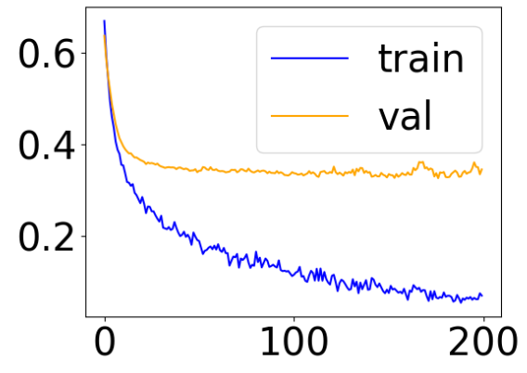 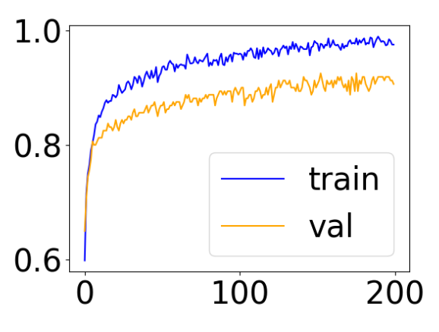

To implement the loss and accuracy plots start by replacing buildModel() in Example 1 with the following code. The callback for tracking accuracy during training is highlighted in yellow.

|  |
| --- |
| from skorch.callbacks import EpochScoring  def buildModel(X_train, y_train):  num_neurons = 25 # hidden layers  net = NeuralNetClassifier(MyNeuralNet( num_neurons), max_epochs=200,  lr=0.001, batch_size=100, optimizer=optim.RMSprop,  callbacks=[EpochScoring(scoring='accuracy',  name='train_acc', on_train=True)] )  # Pipeline execution  model = net.fit(X_train, y_train)  return model, net |

Next, replace the call to buildModel() with:

|  |
| --- |
| # Build the model.  model, net = buildModel(X_train, y_train) |

After, add this code to the end of the program to draw the graphs:

|  |
| --- |
| import matplotlib.pyplot as plt  plt.rcParams.update({'font.size': 30})  def drawLossPlot(net):  plt.plot(net.history[:, 'train_loss'], color='blue', label='train')  plt.plot(net.history[:, 'valid_loss'], color='orange', label='val')  plt.legend()  plt.show()  def drawAccuracyPlot(net):  plt.plot(net.history[:, 'train_acc'], color='blue', label='train')  plt.plot(net.history[:, 'valid_acc'], color='orange', label='val')  plt.legend()  plt.show()  drawLossPlot(net)  drawAccuracyPlot(net) |

Exercise (2 marks)

Rename 'train_acc' in Example 2 to *yourFirstName_acc*. Then run the program and obtain a screenshot of the debugger while halted and inspecting the NeuralNetClassifier’s history property after it has been populated. In the screenshot, be sure to show a few values of ***yourFirstName_train_acc*_*best***. It should look like the following.



Show your screenshot here:

|  |
| --- |
|  |

Exercise (2 marks)

Continuing from Exercise 3, also take a screenshot of the console output which shows the training accuracy for each epoch within a column that has your name on it. The screenshot should look like the following but with your name.



Show your screenshot here:

|  |
| --- |
|  |

## Grid Search and Random Search

Sklearns’s GridSearchCV class can be used to grid search PyTorch network parameters. As you may have guessed, to implement a random search on a subset of options RandomizedSearchCV can also be used to save time.

To enable the grid search I am using nn.Module to organize the network.

You will notice where the search parameters are defined that ***num_neurons*** and ***dropout*** are prefixed with ***nn_module***.

'nn__module__num_neurons': [5, 10],

'nn__module__dropout': [0.1, 0.5],

These nn__module__ parameters can then be passed into the constructor to enable their grid search. You can pass whatever variables you want to the constructor of the neural network as long as they are prefixed with nn__module__.

class MyNeuralNet(nn.Module):

# Define network objects.

# Defaults are set for number of neurons and the

# dropout rate.

def __init__(self, num_neurons=10, dropout=0.1):

super(MyNeuralNet, self).__init__()

You will also notice other parameters in the grid search. These are special case variables which do not need to be passed to the constructor of the network.

'nn__max_epochs': [10, 20],

'nn__lr': [0.1, 0.01],

'nn__optimizer': [optim.Adam, optim.SGD, optim.RMSprop]

A pipeline is used to assemble the scaling and network objects since GridSearchCV needs to work with a Pipeline object. Also note that the network class is not directly instantiated when referenced in the NeuralNetClassifier. However, the parameters for instatiation of the network are passed in the GridSearchCV function.

nn = NeuralNetClassifier(MyNeuralNet, verbose=0, train_split=False)

pipeline = Pipeline([('scale', StandardScaler()), ('nn', nn)])

params = {

'nn__max_epochs': [10, 20],

'nn__lr': [0.1, 0.01],

'nn__module__num_neurons': [5, 10],

'nn__module__dropout': [0.1, 0.5],

'nn__optimizer': [optim.Adam, optim.SGD, optim.RMSprop]}

# The grid search module is instantiated

gs = GridSearchCV(pipeline, params, refit=True, cv=3,

scoring='balanced_accuracy', verbose=1)

Example : Grid Search

This example shows the full code needed to grid search multiple parameters. These are the model parameters that were chosen for the best estimator:

|  |
| --- |
| Best parameters:  {'nn__lr': 0.01, 'nn__max_epochs': 20, 'nn__module__dropout': 0.1,  'nn__module__num_neurons': 10, 'nn__optimizer': <class  'torch.optim.rmsprop.RMSprop'>} |

Here is the full code solution:

|  |
| --- |
| from sklearn.datasets import make_classification  from torch import optim  from skorch import NeuralNetClassifier  import torch.nn as nn  import numpy as np  from sklearn.model_selection import train_test_split  from sklearn.metrics import classification_report  # This class could be any name.  # nn.Module is needed to enable grid searching of parameters  # with skorch later.  class MyNeuralNet(nn.Module):  # Define network objects.  # Defaults are set for number of neurons and the  # dropout rate.  def __init__(self, num_neurons=10, dropout=0.1):  super(MyNeuralNet, self).__init__()  # 1st hidden layer.  # nn. Linear(n,m) is a module that creates single layer  # feed forward network with n inputs and m output.  self.dense0 = nn.Linear(20, num_neurons)  print("Dense layer type:")  print(self.dense0.weight.dtype)  self.activationFunc = nn.ReLU()  # Drop samples to help prevent overfitting.  self.dropout = nn.Dropout(dropout)  # 2nd hidden layer.  self.dense1 = nn.Linear(num_neurons, num_neurons)  # Output layer.  self.output = nn.Linear(num_neurons, 2)  # Softmax activation function allows for multiclass predictions.  # In this case the prediction is binary.  self.softmax = nn.Softmax(dim=-1)  # Move data through the different network objects.  def forward(self, x):  print("X type: ")  print(x.dtype)  # Pass data from 1st hidden layer to activation function  # before sending to next layer.  X = self.activationFunc(self.dense0(x))  X = self.dropout(X)  X = self.activationFunc(self.dense1(X))  X = self.softmax(self.output(X))  return X  from sklearn.pipeline import Pipeline  from sklearn.preprocessing import StandardScaler  from sklearn.model_selection import GridSearchCV  def buildModel(x, y):  # Through a grid search, the optimal hyperparameters are found  # A pipeline is used in order to scale and train the neural net  # The grid search module from scikit-learn wraps the pipeline  # The Neural Net is instantiated, none hyperparameter is provided  nn = NeuralNetClassifier(MyNeuralNet, verbose=0, train_split=False)  # The pipeline is instantiated, it wraps scaling and training phase  pipeline = Pipeline([('scale', StandardScaler()), ('nn', nn)])  # The parameters for the grid search are defined  # Must use prefix "nn__" when setting hyperparamters for the training phase  # Must use prefix "nn__module__" when setting hyperparameters for the Neural Net  params = {  'nn__max_epochs': [10, 20],  'nn__lr': [0.1, 0.01],  'nn__module__num_neurons': [5, 10],  'nn__module__dropout': [0.1, 0.5],  'nn__optimizer': [optim.Adam, optim.SGD, optim.RMSprop]}  # The grid search module is instantiated  gs = GridSearchCV(pipeline, params, refit=True, cv=3,  scoring='balanced_accuracy', verbose=1)  return gs.fit(x, y)  def evaluateModel(model, X_test, y_test):  print(model)  y_pred = model.predict(X_test)  report = classification_report(y_test, y_pred)  print(report)  # Prep the data.  X, y = make_classification(1000, 20, n_informative=10, random_state=0)  X = X.astype(np.float32)  y = y.astype(np.int64)  X_train, X_test, y_train, y_test =\  train_test_split(X, y, test_size=0.2)  # Build the model.  model = buildModel(X_train, y_train)  print("Best parameters:")  print(model.best_params_)  # Evaluate the model.  evaluateModel(model.best_estimator_, X_test, y_test) |

## RuntimeError: mat1 and mat2 must have the same dtype

If you ever receive the error “RuntimeError: mat1 and mat2 must have the same dtype”, it probably means that there is a data type mismatch between X and what is expected by the dense layer.

Example : Handling the mat1 and mat2 must have the same dtype error

This example creates the mat1 and mat2 error and shows how to fix it. First, starting with Example 3, replace this block of code:

|  |
| --- |
| # Prep the data.  X, y = make_classification(1000, 20, n_informative=10, random_state=0)  X = X.astype(np.float32)  y = y.astype(np.int64)  X_train, X_test, y_train, y_test = train_test_split(X, y, test_size=0.2) |

With:

|  |
| --- |
| ######################### Data Prep Start  # Setup data.  import pandas as pd  import numpy as np  import torch  candidates = {'gmat': [780,750,690,710,680,730,690,720,  740,690,610,690,710,680,770,610,580,650,540,590,620,  600,550,550,570,670,660,580,650,660,640,620,660,660,  680,650,670,580,590,690],  'gpa': [4,3.9,3.3,3.7,3.9,3.7,2.3,3.3,  3.3,1.7,2.7,3.7,3.7,3.3,3.3,3,2.7,3.7,2.7,2.3,  3.3,2,2.3,2.7,3,3.3,3.7,2.3,3.7,3.3,3,2.7,4,  3.3,3.3,2.3,2.7,3.3,1.7,3.7],  'work_experience': [3,4,3,5,4,6,1,4,5,  1,3,5,6,4,3,1,4,6,2,3,2,1,4,1,2,6,4,2,6,5,1,2,4,6,  5,1,2,1,4,5],  'admitted': [1,1,1,1,1,1,0,1,1,0,0,1,  1,1,1,0,0,1,0,0,0,0,0,0,0,1,1,0,1,1,0,0,1,1,1,0,0,  0,0,1]}  df = pd.DataFrame(candidates,columns= ['gmat', 'gpa',  'work_experience','admitted'])  y = np.array(df['admitted'])  X = df.copy()  del X['admitted']  X = X  # Split the data into training and test sets  X_train, X_test, y_train, y_test = train_test_split(X, y, test_size=0.2)  # define standard scaler  from sklearn.preprocessing import StandardScaler  scaler = StandardScaler()  # transform data  X_train_scaled = scaler.fit_transform(X_train)  X_test_scaled = scaler.transform(X_test)  # Convert the data to PyTorch tensors  X_train = torch.tensor(X_train_scaled, dtype=torch.float32)  X_test = torch.tensor(X_test_scaled, dtype=torch.float32)  y_train = torch.tensor(y_train, dtype=torch.long) # whole number needed  y_test = torch.tensor(y_test, dtype=torch.long) # for classification.  ######################### End |

Also, adjust the number of features that are received by the first hidden layer.

|  |
| --- |
| self.dense0 = nn.Linear(3, num_neurons) |

Since scaling has already been performed manually, remove the scaling task from the pipeline:

|  |
| --- |
| pipeline = Pipeline([('nn', nn)]) |

When running the code after these changes that the “RuntimeError: mat1 and mat2 must have the same dtype” message appears. You will notice that the console output shows there is a difference in data types between X’s type and what is expected by the dense layer.

**Dense layer type:**

torch.float32

**X type:**

torch.float64

Adding this line of code to the start of the forward() function will fix the error by converting X to the format that is defined already for the dense layer.

x = x.to(torch.float32)

Exercise (2 marks)

Fix the network in Example 4 and adjust the output so the final network is displayed but with your name to get the mark.



Show a screenshot of your output after making the changes. The screenshot must show your name and the network configuration.

|  |
| --- |
|  |

Exercise (3 marks)

Grid search a PyTorch network with that predicts ‘Diagnosed’ using the fluDiagnosis.csv file. When finished show a screåenshot of the console. The display of the best parameters must have your name beside it to get the mark.



Show your screenshot here:

|  |
| --- |
|  |

Exercise (10 marks)

Now that you have grid searched and found decent parameters for the **fluDiagnosis.csv** dataset in Exercise 6, implement the network and parameters by building a network with code similar to code presented in Example 1. Draw the loss and accuracy plot for the network similar to Example 2. Show your entire program as text here:

|  |
| --- |
| from sklearn.datasets import make_classification from torch import optim from skorch import NeuralNetClassifier import torch.nn as nn import numpy as np import pandas as pd from sklearn.model_selection import train_test_split from sklearn.metrics import classification_report  df = pd.read_csv('C:/datasets/fluDiagnosis.csv') X = df.copy() del X['Diagnosed'] y = df['Diagnosed']  # This class could be any name. # nn.Module is needed to enable grid searching of parameters # with skorch later. class MyNeuralNet(nn.Module):  # Define network objects.  # Defaults are set for number of neurons and the  # dropout rate.  def __init__(self, num_neurons=10, dropout=0.1):  super(MyNeuralNet, self).__init__()  # 1st hidden layer.  # nn. Linear(n,m) is a module that creates single layer  # feed forward network with n inputs and m output.  self.dense0 = nn.Linear(20, num_neurons)  self.activationFunc = nn.ReLU()   # Drop samples to help prevent overfitting.  self.dropout = nn.Dropout(dropout)   # 2nd hidden layer.  self.dense1 = nn.Linear(num_neurons, num_neurons)   # Output layer.  self.output = nn.Linear(num_neurons, 2)   # Softmax activation function allows for multiclass predictions.  # In this case the prediction is binary.  self.softmax = nn.Softmax(dim=-1)   # Move data through the different network objects.  def forward(self, x):  # Pass data from 1st hidden layer to activation function  # before sending to next layer.  X = self.activationFunc(self.dense0(x))  X = self.dropout(X)  X = self.activationFunc(self.dense1(X))  X = self.softmax(self.output(X))  return X  from skorch.callbacks import EpochScoring def buildModel(X_train, y_train):  num_neurons = 25 # hidden layers  net = NeuralNetClassifier(MyNeuralNet( num_neurons), max_epochs=20,  lr=0.01, batch_size=100, optimizer=optim.RMSprop,  callbacks=[EpochScoring(scoring='accuracy',  name='train_acc', on_train=True)] )  # Pipeline execution  model = net.fit(X_train, y_train)  return model, net  def evaluateModel(model, X_test, y_test):  print(model)  y_pred = model.predict(X_test)  report = classification_report(y_test, y_pred)  print(report)  # Prep the data. X, y = make_classification(1000, 20, n_informative=10, random_state=0) X = X.astype(np.float32) y = y.astype(np.int64) X_train, X_test, y_train, y_test =\  train_test_split(X, y, test_size=0.2)  # Build the model. model, net = buildModel(X_train, y_train)  # Evaluate the model. evaluateModel(model, X_test, y_test)  import matplotlib.pyplot as plt plt.rcParams.update({'font.size': 30})  def drawLossPlot(net):  plt.plot(net.history[:, 'train_loss'], color='blue', label='train')  plt.plot(net.history[:, 'valid_loss'], color='orange', label='val')  plt.legend()  plt.show()  def drawAccuracyPlot(net):  plt.plot(net.history[:, 'train_acc'], color='blue', label='train')  plt.plot(net.history[:, 'valid_acc'], color='orange', label='val')  plt.legend()  plt.show()  drawLossPlot(net) drawAccuracyPlot(net) |

Show screenshots of your loss and accuracy plots here:

|  |
| --- |
|  |

Show a screenshot of your classification report here:

|  |
| --- |
|  |

## Multiclass Classification Model Plus Loss & Accuracy Plots

Example : Multiclass Prediction and Loss and Accuracy Plots

This example shows how to build a model which makes predictions for the type of Iris flower. The classification report below shows metrics for each of the three available Iris classes.

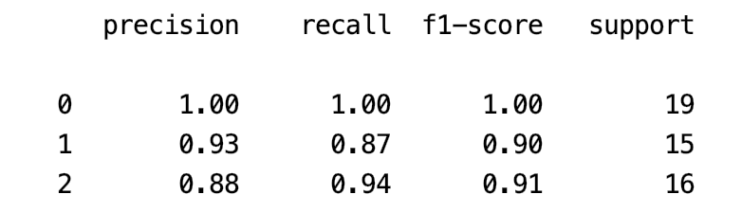 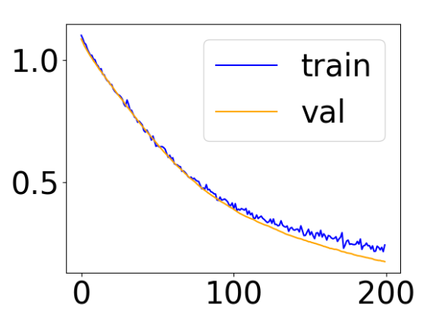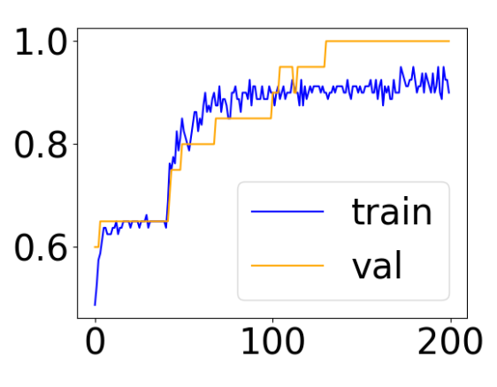

The loss and accuracy plots are a bit odd since the validation loss appears below the training loss and since the validation accuracy appears above the training accuracy. Usually the reverse is true. The use of a dropout parameter likely causes this situation.

Here is the complete code solution:

|  |
| --- |
| import sklearn  import torch.nn as nn  import torch  from sklearn.datasets import load_iris  from torch import optim  from skorch import NeuralNetClassifier  from sklearn.preprocessing import StandardScaler  from sklearn.metrics import classification_report  from skorch.callbacks import EpochScoring  # Get iris data.  iris = load_iris()  X = iris.data  Y = iris.target  # Split and scale the data.  from sklearn.model_selection import train_test_split  X_train, X_test, y_train, y_test = train_test_split(X, Y, test_size=0.33, random_state=42)  scaler = StandardScaler()  X_train_scaled = scaler.fit_transform(X_train)  X_test_scaled = scaler.transform(X_test)  # Convert the data to PyTorch tensors  X_train = torch.tensor(X_train_scaled, dtype=torch.float32)  X_test = torch.tensor(X_test_scaled, dtype=torch.float32)  class Net(nn.Module):  def __init__(self, num_features, num_neurons, output_dim):  super(Net, self).__init__()  # 1st hidden layer.  # nn. Linear(n,m) is a module that creates single layer of a  # feed forward network with n inputs and m output.  self.dense0 = nn.Linear(num_features, num_neurons)  self.activationFunc = nn.ReLU()  # Drop samples to help prevent overfitting.  DROPOUT = 0.1  self.dropout = nn.Dropout(DROPOUT)  # 2nd hidden layer.  self.dense1 = nn.Linear(num_neurons, output_dim)  # Output layer.  self.output = nn.Linear(output_dim, 3)  self.softmax = nn.Softmax(dim=-1)  def forward(self, x):  # Pass data from 1st hidden layer to activation function  # before sending to next layer.  X = self.activationFunc(self.dense0(x))  X = self.dropout(X)  X = self.activationFunc(self.dense1(X))  X = self.softmax(self.output(X))  return X  def evaluateModel(model, X_test, y_test):  print(model)  y_pred = model.predict(X_test)  report = classification_report(y_test, y_pred)  print(report)  def buildModel(X_train, y_train):  input_dim = 4 # how many Variables are in the dataset  num_neurons = 25 # hidden layers  output_dim = 3 # number of classes  net = NeuralNetClassifier(Net(  input_dim, num_neurons, output_dim), max_epochs=200,  lr=0.001, batch_size=100, optimizer=optim.RMSprop,  callbacks=[EpochScoring(scoring='accuracy', name='train_acc', on_train=True)],  )  model = net.fit(X_train, y_train)  return model, net  model, net = buildModel(X_train, y_train)  evaluateModel(model, X_test, y_test)  print("Done")  import matplotlib.pyplot as plt  plt.rcParams.update({'font.size': 30})  def drawLossPlot(net):  plt.plot(net.history[:, 'train_loss'], color='blue', label='train')  plt.plot(net.history[:, 'valid_loss'], color='orange', label='val')  plt.legend()  plt.show()  def drawAccuracyPlot(net):  plt.plot(net.history[:, 'train_acc'], color='blue', label='train')  plt.plot(net.history[:, 'valid_acc'], color='orange', label='val')  plt.legend()  plt.show()  drawLossPlot(net)  drawAccuracyPlot(net) |

Exercise (2 marks)

Explain how the output layers for Example 1 and Example 5 are different.

|  |
| --- |
| Example 1 uses a linear layer that has 2 output dimensions. Example 5 uses the output layer and the softmax activation function for 3 output classes. |

Exercise (2 marks)

The screenshot below shows how to use the debugger to examine the history object that stores information about the training session.



Expand the history object so the train_loss and val_loss is data is visible in the debugger. Show a screenshot of it here:

|  |
| --- |
|  |

## Early Stopping

Early stopping forces the network to stop training if no improvements are made within a specified number of epochs (patience).

Example : Adding Early Stopping

This example explains how to add early stopping to Example 5.

EarlyStopping must be imported from skorch.callbacks:

|  |
| --- |
| from skorch.callbacks import EarlyStopping |

Then EarlyStopping can be referenced in the callbacks list:

|  |
| --- |
| callbacks=[EpochScoring(scoring='accuracy', name='train_acc', on_train=True),  EarlyStopping(patience=100)] |

Exercise (4 marks)

Add early stopping to Example 5. Change the setting for max_epochs from 200 to 1000:

max_epochs=1000

Show the loss and accuracy plot screenshots here:

|  |
| --- |
|  |

At what epoch did the training exit?

|  |
| --- |
| ~950 or so |

Show the classification report from Example 5 here:

|  |
| --- |
|  |

Show the classification report when using early stopping here:

|  |
| --- |
|  |

Exercise (5 marks)

Starting with the following code, build a PyTorch neural network and do not perform a grid search. Include early stopping. You do not need to be concerned about building the best model.

|  |
| --- |
| import pandas as pd  # Show all columns.  pd.set_option('display.max_columns', None)  pd.set_option('display.width', 1000)  def getCustomerSegmentationData():  df = pd.read_csv('CustomerSegmentation.csv')  df = pd.get_dummies(df, columns=[  'Gender','Ever_Married',  'Graduated','Profession','Spending_Score', 'Var_1'])  df['Segmentation'] = df['Segmentation'].replace({'A': 0, 'B':1, 'C':2, 'D':3})  print(df['Segmentation'].value_counts())  X = df.copy()  del X['Segmentation']  y = df['Segmentation']  return X, y  X, y = getCustomerSegmentationData()  import sklearn  import torch.nn as nn  import torch  from sklearn.datasets import load_iris  from torch import optim  from skorch import NeuralNetClassifier  from sklearn.preprocessing import StandardScaler  from sklearn.metrics import classification_report  from skorch.callbacks import EpochScoring  # Split and scale the data.  from sklearn.model_selection import train_test_split  X_train, X_test, y_train, y_test = train_test_split(X, y, test_size=0.33, random_state=42)  scaler = StandardScaler()  X_train_scaled = scaler.fit_transform(X_train)  X_test_scaled = scaler.transform(X_test)  # Convert the data to PyTorch tensors  X_train = torch.tensor(X_train_scaled, dtype=torch.float32)  X_test = torch.tensor(X_test_scaled, dtype=torch.float32) |

Show the accuracy and loss plot here:

|  |
| --- |
|  |

Show the classification report here:

|  |
| --- |
|  |

Show the code as text for your full program here:

|  |
| --- |
| import pandas as pd from skorch.callbacks import EarlyStopping  # Show all columns. pd.set_option('display.max_columns', None) pd.set_option('display.width', 1000)  def getCustomerSegmentationData():  df = pd.read_csv('C:/datasets/CustomerSegmentation.csv')  df = pd.get_dummies(df, columns=[  'Gender','Ever_Married',  'Graduated','Profession','Spending_Score', 'Var_1'])  df['Segmentation'] = df['Segmentation'].replace({'A': 0, 'B':1, 'C':2, 'D':3})  print(df['Segmentation'].value_counts())  X = df.copy()  del X['Segmentation']  y = df['Segmentation']  return X, y  X, y = getCustomerSegmentationData()  import sklearn import torch.nn as nn import torch from sklearn.datasets import load_iris from torch import optim from skorch import NeuralNetClassifier from sklearn.preprocessing import StandardScaler from sklearn.metrics import classification_report from skorch.callbacks import EpochScoring  # Split and scale the data. from sklearn.model_selection import train_test_split X_train, X_test, y_train, y_test = train_test_split(X, y, test_size=0.33, random_state=42) scaler = StandardScaler() X_train_scaled = scaler.fit_transform(X_train) X_test_scaled = scaler.transform(X_test)  # Convert the data to PyTorch tensors X_train = torch.tensor(X_train_scaled, dtype=torch.float32) X_test = torch.tensor(X_test_scaled, dtype=torch.float32)  # # Must have y in tensor format with long data type. # y_train = torch.tensor(y_train, dtype=torch.long) # y_test = torch.tensor(y_test, dtype=torch.long)  class Net(nn.Module):  def __init__(self, num_features, num_neurons, output_dim):  super(Net, self).__init__()  # 1st hidden layer.  # nn. Linear(n,m) is a module that creates single layer of a  # feed forward network with n inputs and m output.  self.dense0 = nn.Linear(num_features, num_neurons)  self.activationFunc = nn.ReLU()   # Drop samples to help prevent overfitting.  DROPOUT = 0.1  self.dropout = nn.Dropout(DROPOUT)   # 2nd hidden layer.  self.dense1 = nn.Linear(num_neurons, output_dim)   # Output layer.  self.output = nn.Linear(output_dim, 4)  self.softmax = nn.Softmax(dim=-1)   def forward(self, x):  # Pass data from 1st hidden layer to activation function  # before sending to next layer.  X = self.activationFunc(self.dense0(x))  X = self.dropout(X)  X = self.activationFunc(self.dense1(X))  X = self.softmax(self.output(X))  return X  def evaluateModel(model, X_test, y_test):  print(model)  y_pred = model.predict(X_test)  report = classification_report(y_test, y_pred)  print(report)  def buildModel(X_train, y_train):  input_dim = 28 # how many Variables are in the dataset  num_neurons = 25 # hidden layers  output_dim = 4 # number of classes   net = NeuralNetClassifier(Net(  input_dim, num_neurons, output_dim), max_epochs=1000,  lr=0.001, batch_size=100, optimizer=optim.RMSprop,  callbacks=[EpochScoring(scoring='accuracy', name='train_acc', on_train=True), EarlyStopping(patience=100)])  model = net.fit(X_train, y_train)  return model, net  model, net = buildModel(X_train, y_train) evaluateModel(model, X_test, y_test) print("Done")  import matplotlib.pyplot as plt plt.rcParams.update({'font.size': 30}) def drawLossPlot(net):  plt.plot(net.history[:, 'train_loss'], color='blue', label='train')  plt.plot(net.history[:, 'valid_loss'], color='orange', label='val')  plt.legend()  plt.show()  def drawAccuracyPlot(net):  plt.plot(net.history[:, 'train_acc'], color='blue', label='train')  plt.plot(net.history[:, 'valid_acc'], color='orange', label='val')  plt.legend()  plt.show()  drawLossPlot(net) drawAccuracyPlot(net) |

Example : Grid Searching a Multi-Class Predictor

This code shows how to perform a RandomGridSearchCV for a PyTorch Neural Network with the CustomerSegmentation.csv data set.

The search suggests the following parameters:

|  |
| --- |
| {'nn__optimizer': <class 'torch.optim.adam.Adam'>, 'nn__module__num_neurons': 5, 'nn__max_epochs': 100, 'nn__lr': 0.007} |

There are the metrics from the best estimator found.

|  |
| --- |
| Actual  0 265 109 47 123  1 145 151 145 58  2 61 95 316 89  3 125 35 7 429  precision recall f1-score support  0 0.44 0.49 0.46 544  1 0.39 0.30 0.34 499  2 0.61 0.56 0.59 561  3 0.61 0.72 0.66 596  accuracy 0.53 2200  macro avg 0.51 0.52 0.51 2200  weighted avg 0.52 0.53 0.52 2200 |

Here is the code:

|  |
| --- |
| import pandas as pd  # Show all columns.  pd.set_option('display.max_columns', None)  pd.set_option('display.width', 1000)  def getCustomerSegmentationData():  df = pd.read_csv('CustomerSegmentation.csv')  df = pd.get_dummies(df, columns=[  'Gender','Ever_Married',  'Graduated','Profession','Spending_Score', 'Var_1'])  df['Segmentation'] = df['Segmentation'].replace({'A': 0, 'B':1, 'C':2, 'D':3})  print(df['Segmentation'].value_counts())  X = df.copy()  del X['Segmentation']  y = df['Segmentation']  return X, y  X, y = getCustomerSegmentationData()  import sklearn  import torch.nn as nn  import torch  from sklearn.datasets import load_iris  from torch import optim  from skorch import NeuralNetClassifier  from sklearn.preprocessing import StandardScaler  from sklearn.metrics import classification_report  from skorch.callbacks import EpochScoring  # Split and scale the data.  from sklearn.model_selection import train_test_split  X_train, X_test, y_train, y_test = train_test_split(X, y, test_size=0.33, random_state=42)  scaler = StandardScaler()  X_train_scaled = scaler.fit_transform(X_train)  X_test_scaled = scaler.transform(X_test)  # Convert the data to PyTorch tensors  X_train = torch.tensor(X_train_scaled, dtype=torch.float32)  X_test = torch.tensor(X_test_scaled, dtype=torch.float32)  class Net(nn.Module):  NUM_FEATURES = 28  OUTPUT_DIM = 4  def __init__(self, num_neurons):  super(Net, self).__init__()  # 1st hidden layer.  # nn. Linear(n,m) is a module that creates single layer of a  # feed forward network with n inputs and m output.  self.dense0 = nn.Linear(self.NUM_FEATURES, num_neurons)  self.activationFunc = nn.ReLU()  # Drop samples to help prevent overfitting.  DROPOUT = 0.1  self.dropout = nn.Dropout(DROPOUT)  # 2nd hidden layer.  self.dense1 = nn.Linear(num_neurons, self.OUTPUT_DIM)  # Output layer.  self.output = nn.Linear(self.OUTPUT_DIM, self.OUTPUT_DIM)  self.softmax = nn.Softmax(dim=-1)  def forward(self, x):  # Pass data from 1st hidden layer to activation function  # before sending to next layer.  X = self.activationFunc(self.dense0(x))  X = self.dropout(X)  X = self.activationFunc(self.dense1(X))  X = self.softmax(self.output(X))  return X  def evaluateModel(model, X_test, y_test):  print(model)  y_pred = model.predict(X_test)  report = classification_report(y_test, y_pred)  cm = pd.crosstab(y_test, y_pred,  rownames=['Actual'],  colnames=['Predicted'])  print("Confusion matrix")  print(cm)  print(report)  from sklearn.pipeline import Pipeline  from sklearn.model_selection import RandomizedSearchCV  def buildModel(X_train, y_train):  input_dim = 28 # how many Variables are in the dataset  num_neurons = 25 # hidden layers  output_dim = 4 # number of classes  # Note that 'Net' is referenced without a parameter list.  nn = NeuralNetClassifier(Net, max_epochs=200,  lr=0.001, batch_size=100, optimizer=optim.RMSprop,  callbacks=[EpochScoring(scoring='accuracy', name='train_acc', on_train=True)],  )  pipeline = Pipeline([ ('nn', nn)])  params = {  'nn__max_epochs': [50,100, 150], # No constructor parameter needed.  'nn__lr': [0.1, 0.007, 0.005, 0.001], # No constructor parameter needed.  # Anything prefixed with nn__module__ must  # go in the constructor parameter list.  # def __init__(self, num_neurons):  'nn__module__num_neurons': [5, 10, 30], # Constructor parameter 'num_neurons' needed,  # No constructor parameter needed.  'nn__optimizer': [optim.Adam, optim.SGD, optim.RMSprop]}  gs = RandomizedSearchCV(pipeline, params, refit=True, cv=3,  scoring='balanced_accuracy', verbose=1)  return gs.fit(X_train, y_train)  # Build the model.  model = buildModel(X_train, y_train)  print("Best parameters:")  print(model.best_params_)  # Evaluate the model.  evaluateModel(model.best_estimator_, X_test, y_test) |

Table of Contents

References – Better Deep Learning 1

ReLU – Vanishing Gradients 1

Leaky ReLU – Avoiding Dying ReLU 2

Overfitting-Early Stopping and Model Save 6

Exploding Gradients 10

Norm Scaling 11

Gradient Clipping 13

Importance of Scaling 14

Input and Output Scaling 15

Greedy Layer-wise Pretraining 16

## References – Better Deep Learning

ReLU and Vanishing Gradients – Chapter 7

Early Stopping – Chapter 18

“Better Deep Learning’ by Dr. Jason Brownlee <https://machinelearningmastery.com/better-deep-learning/>

## ReLU – Vanishing Gradients

**Note:** I will not get into the math but a nice explanation of vanishing gradients. However, this article offers a nice summary of how they work.

<https://medium.com/analytics-vidhya/how-batch-normalization-and-relu-solve-vanishing-gradients-3f1a8ace1c88>

Deep networks were not possible until recently with the emergence of the ReLU activation function. Back propagation with activation functions like **sigmoid** led to vanishing gradients. For the nodes with sigmoid activation functions, we know that the partial derivative of the sigmoid function reaches a maximum value of 0.25 (refer to Figure 1).

Figure : Sigmoid function and Derivative of Sigmoid Function

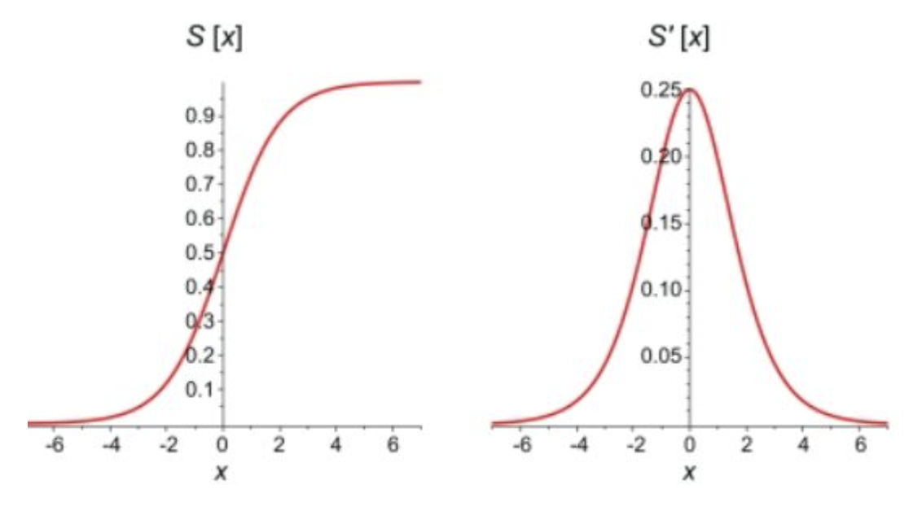

When there are more layers in the network, the product of derivatives decreases until at some point the partial derivative of the loss function approaches a value close to zero. When this happens, the partial derivative vanishes (0.25*0.25*0.25 leads to a small number). We call this the vanishing gradient problem. As a result, sigmoid and tanh activation functions (and others) often cause failures to update weights during back propagation so learning stops in deep networks.

The rectified linear unit (ReLU) helps to avoid the problem for vanishing gradients. The derivative of the activation function for positive values of X solves to 1 so gradients can back propagate (See Figure 2). Neurons with negative values of X will still die but enough neurons will survive to keep learning most of the time.

Figure : ReLU Function

|  |  |
| --- | --- |
|  | # ReLu function  def relu(X):  return np.maximum(0,X)  # Example with matrix input of:  # [[1,2,3],[4,5,6]]  relu(mmatrix)  # Output:  array([[1, 2, 3], [4, 5, 6]]) |

## Leaky ReLU – Avoiding Dying ReLU

Activation functions like the Leaky ReLU have been created to avoid the vanishing gradient altogether (see Figure 3). It turns out though that ReLU often performs just as well as the Leaky ReLU so a standard ReLU is more common.

Figure : Leaky ReLU

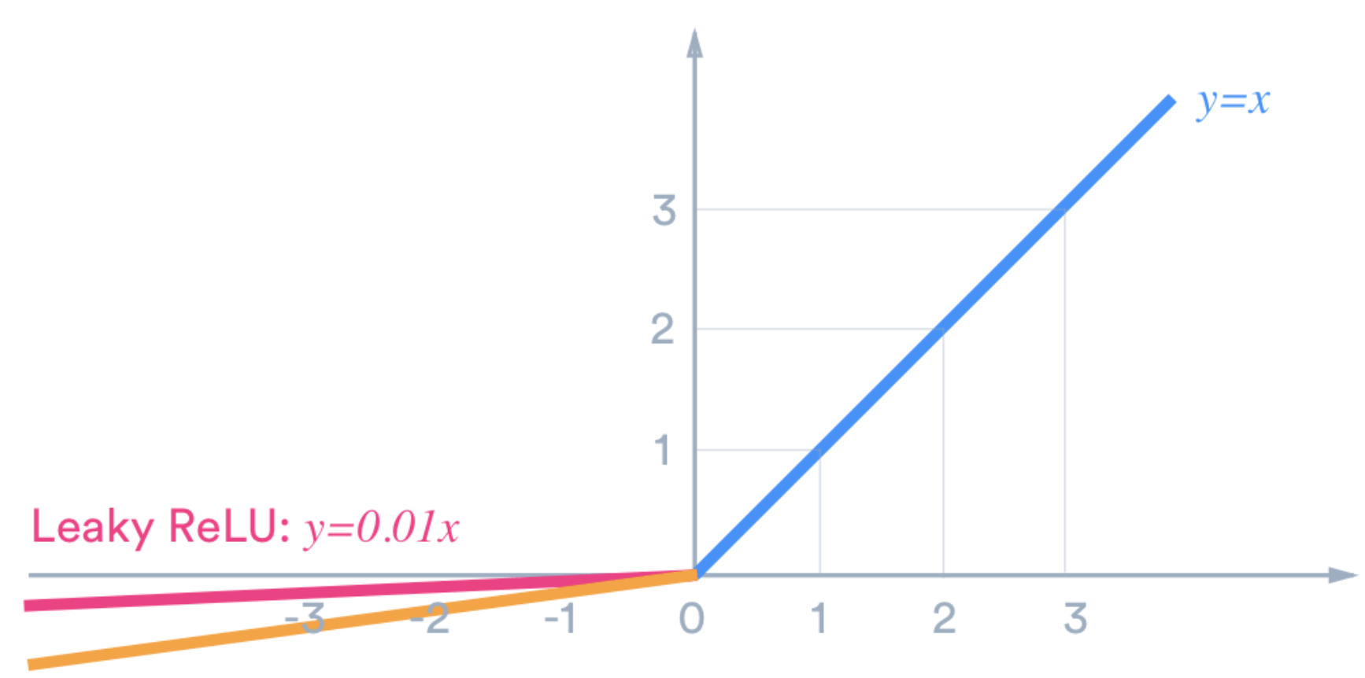

Example : Under-performing deep network with Tanh function (See chapter 7 of Better Deep Learning)

This example demonstrates a situation where vanishing gradients occurs. For this case, the loss and accuracy curves that are displayed in Figure 4 show that the network is unable to learn. To enable this failure a deep network has been built with the ‘sigmoid’ activation function.

Figure : Loss and Accuracy Curves for Vanishing Gradients

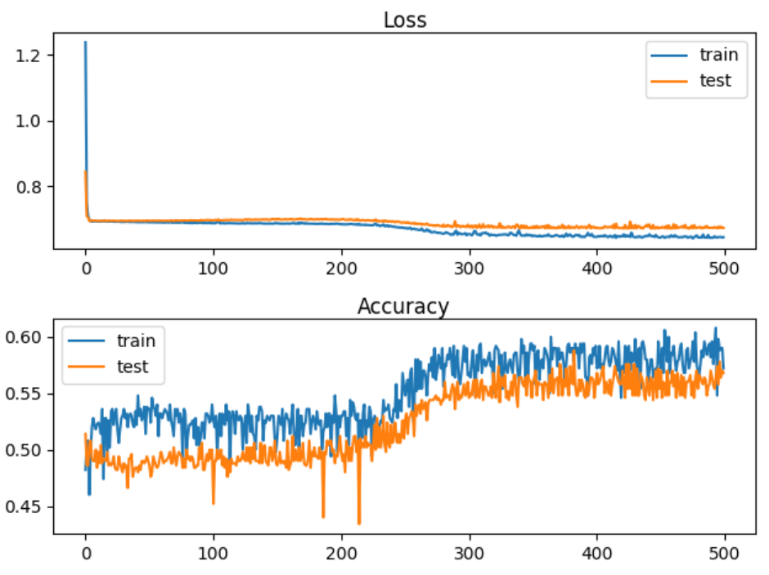

The quantitative output shows that the accuracy stagnates at around 57% for training and for testing.

Train Accuracy: 0.578, Test Accuracy: 0.568

Here is the code. Note that the ‘sigmoid’ activation function is used as the activation function.

|  |
| --- |
| # deeper mlp with tanh for the two circles classification problem  from sklearn.datasets import make_circles  from sklearn.preprocessing import MinMaxScaler  from keras.layers import Dense  from keras.models import Sequential  from keras.optimizers import SGD  from keras.initializers import RandomUniform  import matplotlib.pyplot as plt  # Generate 2d classification dataset.  X, y = make_circles(n_samples=1000, noise=0.1, random_state=1)  scaler = MinMaxScaler(feature_range=(-1, 1))  X = scaler.fit_transform(X)  # split into train and test  n_train = 500  trainX, testX = X[:n_train, :], X[n_train:, :]  trainy, testy = y[:n_train], y[n_train:]  # Define the model.  model = Sequential()  init = 'he_uniform'  model.add(Dense(5, input_dim=2, activation='sigmoid', kernel_initializer=init))  model.add(Dense(5, activation='sigmoid', kernel_initializer=init))  model.add(Dense(5, activation='sigmoid', kernel_initializer=init))  model.add(Dense(5, activation='sigmoid', kernel_initializer=init))  model.add(Dense(5, activation='sigmoid', kernel_initializer=init))  model.add(Dense(1, activation='sigmoid'))  # Compile model.  opt = SGD(lr=0.01, momentum=0.9)  model.compile(loss='binary_crossentropy', optimizer=opt, metrics=['accuracy'])  # fit model  history = model.fit(trainX, trainy, validation_data=(testX, testy), epochs=500, verbose=1)  # evaluate the model  _, train_acc = model.evaluate(trainX, trainy, verbose=0)  _, test_acc = model.evaluate(testX, testy, verbose=0)  print('Train Accuracy: %.3f, Test Accuracy: %.3f' % (train_acc, test_acc))  # Plot loss learning curves.  plt.subplot(211)  plt.title('Loss', pad=-40)  plt.plot(history.history['loss'], label='train')  plt.plot(history.history['val_loss'], label='test')  plt.legend()  # Plot accuracy learning curves.  plt.subplot(212)  plt.title('Accuracy', pad=-40)  plt.plot(history.history['accuracy'], label='train')  plt.plot(history.history['val_accuracy'], label='test')  plt.legend()  plt.show() plt.show() |

Example : Using RELU to Enable Deeper Networks (See Chapter 7 of Better Deep Learning)

This example shows how to solve the vanishing gradient problem that occurs in Example 1. A ReLU activation function much better. The train and test accuracy scores jump by approximately 25% after implementing the ReLU activation functions.

Train Accuracy: 0.832, Test Accuracy: 0.824

Figure : Accuracy and Loss Curves when using the ReLU activation function with ‘he_normal’.

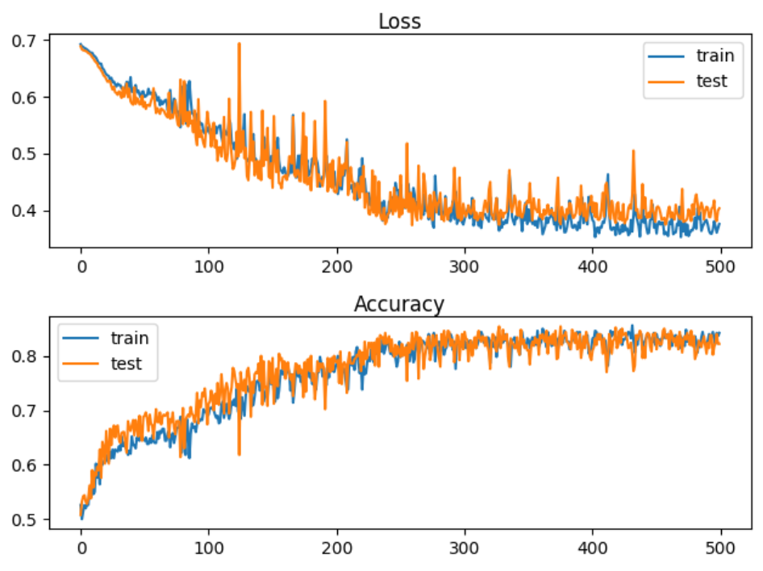

To build this model, replace the model definition code in Example 1 with this version. The difference with this new code is in activation and kernel_initializer function which enable the deep network:

|  |
| --- |
| # Define the model.  model = Sequential()  init = 'he_uniform'  model.add(Dense(5, input_dim=2, activation='relu', kernel_initializer=init))  model.add(Dense(5, activation='relu', kernel_initializer=init))  model.add(Dense(5, activation='relu', kernel_initializer=init))  model.add(Dense(5, activation='relu', kernel_initializer=init))  model.add(Dense(5, activation='relu', kernel_initializer=init))  model.add(Dense(1, activation='sigmoid')) # output layer |

Example : Leaky ReLU

To implement a leaky ReLU replace the model definition code inside Example 2 with the following:

|  |
| --- |
| import tensorflow as tf  leakyReLU = tf.keras.layers.LeakyReLU(alpha=0.3)  # Define the model.  model = Sequential()  model.add(Dense(5, input_dim=2, activation=leakyReLU, kernel_initializer='he_uniform'))  model.add(Dense(5, activation=leakyReLU, kernel_initializer='he_uniform'))  model.add(Dense(5, activation=leakyReLU, kernel_initializer='he_uniform'))  model.add(Dense(5, activation=leakyReLU, kernel_initializer='he_uniform'))  model.add(Dense(5, activation=leakyReLU, kernel_initializer='he_uniform'))  model.add(Dense(1, activation='sigmoid')) |

## Overfitting-Early Stopping and Model Save

Early stopping is a technique to help prevent over-fitting. Early stopping exits training when either losses increase or accuracy begins to diminish. A patience property can be included to set an additional number of epochs that must occur before the routine ends training.

An additional helpful technique involves saving the very best model during training. EarlyStopping and ModelCheckpoint work together to save you time and to provide you with the best model. Both features are set up with a callback.

Two important parameters of the EarlyStopping() function are:

**min_delta**: Minimum change in the monitored quantity to qualify as an improvement.

An absolute change of less than min_delta, will count as no improvement.

**patience**: Number of epochs with no improvement after which training will be

stopped.

# Simple early stopping.

es = EarlyStopping(monitor='val_loss', mode='min', verbose=1, min_delta=0.1, patience=200)

mc = ModelCheckpoint('best_model.h5', monitor='val_accuracy', mode='max', verbose=1,

save_best_only=True)

# Fit model.

history = model.fit(trainX, trainy, validation_data=(testX, testy), epochs=4000, verbose=0, callbacks=[es, mc])

The model can then be loaded later.

# Load the saved model.

saved_model = load_model('best_model.h5')

The following code snippet above allows you to save the model when the best validation accuracy. However, you can also trigger a model save based on minimum validation loss.

tf.keras.callbacks.ModelCheckpoint(

filepath, monitor='val_loss', verbose=0, save_best_only=False,

save_weights_only=False, mode='auto', save_freq='epoch', options=None, **kwargs

)

Example : Preventing overfitting with early-stopping and model save.

This example demonstrates a network that fails due to overfitting. Figure 6 shows a typical overfitting situation where a loss curve which starts out by gradually declining and then rising.

Figure : Failed Network due to Overfitting

Train accuracy: 1.000, Test accuracy: 0.914

Train loss: 0.000, Test loss: 0.497

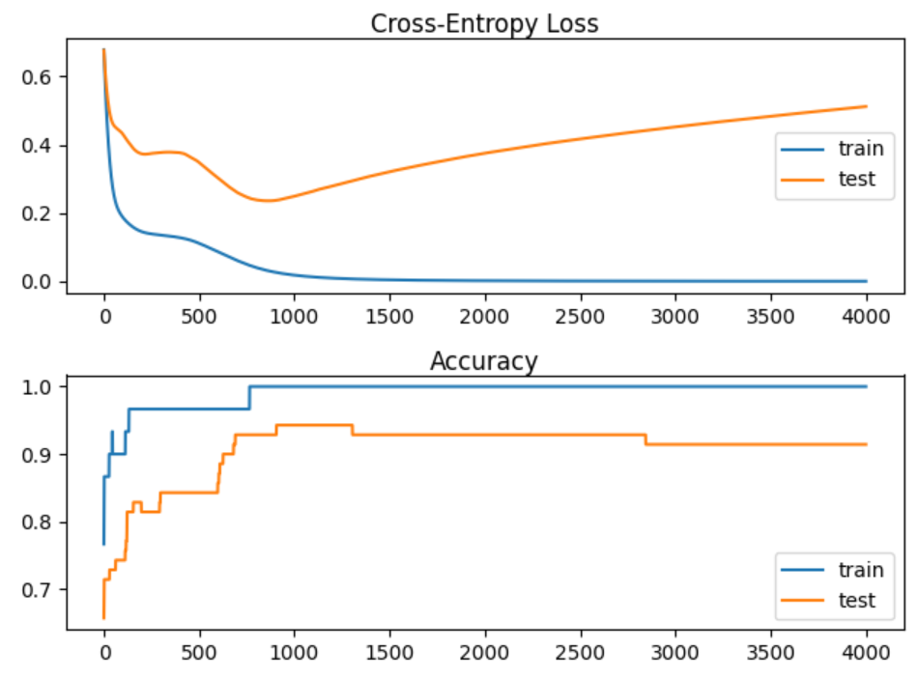

Here is the code to set up and evaluate the failed network:

|  |
| --- |
| # Creating an overfit situation with the moons data set.  from sklearn.datasets import make_moons  from keras.layers import Dense  from keras.models import Sequential  import matplotlib.pyplot as plt  # Generate 2d classification dataset.  X, y = make_moons(n_samples=100, noise=0.2, random_state=1)  # Split data into train and test.  n_train = 30  trainX, testX = X[:n_train, :], X[n_train:, :]  trainy, testy = y[:n_train], y[n_train:]  # Define the model.  model = Sequential()  model.add(Dense(500, input_dim=2, activation='relu'))  model.add(Dense(1, activation='sigmoid'))  model.compile(loss='binary_crossentropy', optimizer='adam', metrics=['accuracy'])  # Fit the model.  history = model.fit(trainX, trainy, validation_data=(testX, testy), epochs=4000, verbose=1)  # Evaluate the model.  train_loss, train_acc = model.evaluate(trainX, trainy, verbose=0)  test_loss, test_acc = model.evaluate(testX, testy, verbose=0)  print('Train accuracy: %.3f, Test accuracy: %.3f' % (train_acc, test_acc))  print('Train loss: %.3f, Test loss: %.3f' % (train_loss, test_loss))  # Plot loss learning curves.  plt.subplot(211)  plt.title('Cross-Entropy Loss', pad=-40)  plt.plot(history.history['loss'], label='train')  plt.plot(history.history['val_loss'], label='test')  plt.legend()  # Plot accuracy learning curves.  plt.subplot(212)  plt.title('Accuracy', pad=-40)  plt.plot(history.history['accuracy'], label='train')  plt.plot(history.history['val_accuracy'], label='test')  plt.legend()  plt.show() |

Example : Early Stopping

The code needed to save the best model and to implement early stopping w

To build this example, replace the green highlighted section in Example 4 with this version.

|  |
| --- |
| # Fit the model.  from keras.callbacks import EarlyStopping  from keras.callbacks import ModelCheckpoint  from keras.models import load_model  # simple early stopping  # patience: # of epochs observed where no improvement before exiting.  # mode: Could be max, min, or auto.  # min_delta: Amount of change needed to be considered an improvement.  es = EarlyStopping(monitor='val_loss', mode='min', verbose=1, min_delta=0.000001, patience=200)  mc = ModelCheckpoint('best_model.h5', monitor='val_loss', mode='min', verbose=1,  save_best_only=True)  # fit model  history = model.fit(trainX, trainy, validation_data=(testX, testy), epochs=4000, verbose=0,  callbacks=[es, mc])  # load the saved model  model = load_model('best_model.h5') |

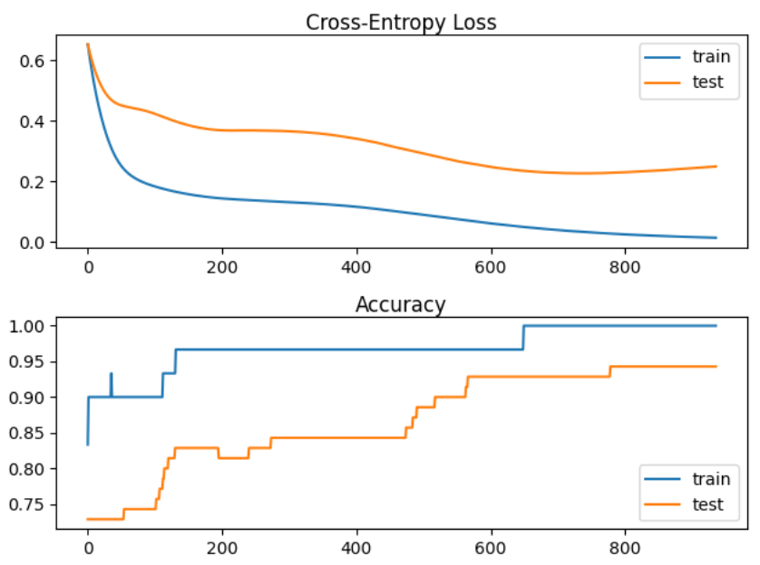

The improvement is evident in the graph where no overfitting occurs. However, only modest gains were achieved in accuracy.

Train accuracy: 1.000, Test accuracy: 0.929

Exercise (2 marks)

Study the output after running Example 5. How many epochs executed? How many epochs would have executed without the patience attribute? How many epochs would have executed without early stopping?

|  |
| --- |
| 1029 epochs executed  1029-200 = 829 would be executed without the patience attribute  4000 would be executed without stopping early. |

Exercise (2 marks)

Show a screenshot of the model that is saved in your project folder.

|  |
| --- |
|  |

Exercise (3 marks)

Change the implementation of early stopping so it maximizes val_accuracy.

es = EarlyStopping(monitor='val_loss', mode='min', verbose=1, min_delta=0.000001,

patience=200)

mc = ModelCheckpoint('best_model.h5', monitor='val_loss', mode='min', verbose=1,

save_best_only=True)

The parameters that need changing are shown above. Note, in this case it will not improve results but it is important to know where to configure these settings. This is the final output that appears when running the code from Example 5. Notice that it is reporting changes for val_loss.

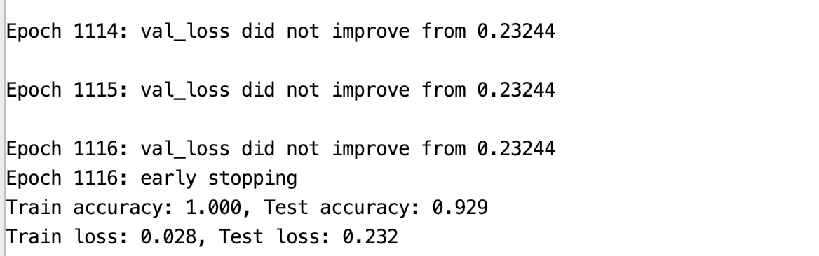

Show a screenshot of the final output when making the changes in this exercise. Also be sure to include a section which shows that val_accuracy did not improve.

|  |
| --- |
|  |

## Exploding Gradients

Exploding gradients can occur when overflowing gradients are back propagated. This situation is more common with LSTM’s where the context from several past gradients are included with the back propagation.

Exploding gradients can occur due to:

* Improperly scaled inputs to the network.
* Poorly chosen learning rates that allow for large weight updates.
* Loss functions which allow the calculation of large error values.

Gradient clipping can be used to fix this error. There are two ways to clip gradients:

* Norm scaling
* Norm clipping

Example : Bad Exploding Gradient (See Chapter 8 of Better Deep Learning)

This example causes exploding gradients because the inputs are not scaled. The sample data has 20 unscaled features. The y-value is unscaled as well (see Figure 7).

Figure : Unscaled y-values

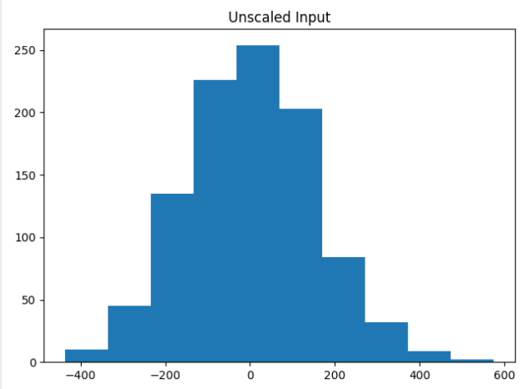

The unscaled data caused the model weights to explode during training. Very large errors were generated while the data was fed through the network. The network was unable to learn anything. As a result, the predictions are NaN values which leads to MSE values that are also not numbers.

Train MSE: nan, Test MSE: nan

Here is the code which sets up the data and network that causes the exploding gradients.

|  |
| --- |
| # mlp with unscaled data for the regression problem  from sklearn.datasets import make_regression  from keras.layers import Dense  from keras.models import Sequential  from keras.optimizers import SGD  import matplotlib.pyplot as plt  # Generate the regression dataset.  X, y = make_regression(n_samples=1000, n_features=20, noise=0.1, random_state=1)  plt.hist(y)  plt.title("Unscaled Input")  plt.show()  # Split into train and test.  n_train = 500  trainX, testX = X[:n_train, :], X[n_train:, :]  trainy, testy = y[:n_train], y[n_train:]  # Define the model.  model = Sequential()  model.add(Dense(25,input_dim=20, activation='relu',kernel_initializer='he_uniform'))  model.add(Dense(1, activation='linear'))  # Compile the model.  model.compile(loss='mean_squared_error', optimizer=SGD(lr=0.01, momentum=0.9))  # Fit the model.  history = model.fit(trainX, trainy, validation_data=(testX, testy), epochs=100, verbose=1)  # Evaluate the model.  train_mse = model.evaluate(trainX, trainy, verbose=0)  test_mse = model.evaluate(testX, testy, verbose=0)  print('Train MSE: %.3f, Test MSE: %.3f' % (train_mse, test_mse))  # Plot losses during training.  plt.title('Losses')  plt.plot(history.history['loss'], label='train')  plt.plot(history.history['val_loss'], label='test')  plt.legend()  plt.show() |

### Norm Scaling

One way to clip the gradients involves norm scaling. When weights are greater than a specific value, they are rescaled to a chosen value. Norm scaling is implemented with the *clipnorm* attribute. In this case clipnorm is set to 1 but other values could have been used.

opt = SGD(lr=0.01, momentum=0.9, clipnorm=1.0)

Example : Norm Scaling (See Chapter 8 Better Deep Learrning)

A way to fix the exploding gradient issue presented in Example 6Example 7 is to replace the compilation statement with one that includes a *clipnorm* attribute in the optimizer.

|  |
| --- |
| opt = SGD(lr=0.01, momentum=0.9, clipnorm=1.0)  model.compile(loss='mean_squared_error', optimizer=opt) |

When running the example now, training is possible. An MSE value of 16.874 is generated.

Train MSE: 1.158, Test MSE: 16.874

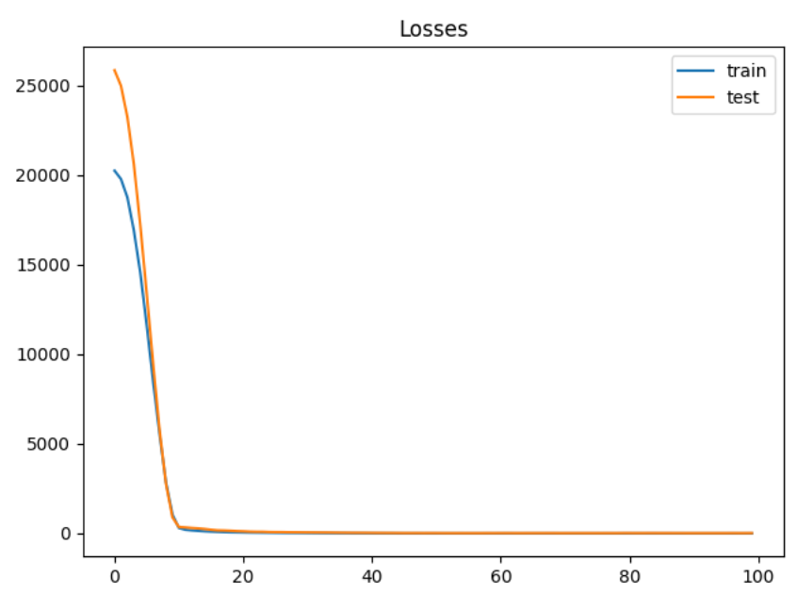

Exercise (2 marks)

Starting with the following code, determine if you can find a better clip norm:

|  |
| --- |
| # mlp with unscaled data for the regression problem  from sklearn.datasets import make_regression  from keras.layers import Dense  from keras.models import Sequential  from keras.optimizers import SGD  import matplotlib.pyplot as plt  # Generate the regression dataset.  X, y = make_regression(n_samples=1000, n_features=20, noise=0.1, random_state=1)  plt.hist(y)  plt.title("Unscaled Input")  plt.show()  # Split into train and test.  n_train = 500  trainX, testX = X[:n_train, :], X[n_train:, :]  trainy, testy = y[:n_train], y[n_train:]  clipResults = []  def buildModel(clipSize):  # Define the model.  model = Sequential()  model.add(Dense(25,input_dim=20, activation='relu',kernel_initializer='he_uniform'))  model.add(Dense(1, activation='linear'))  # Compile the model.  opt = SGD(lr=0.01, momentum=0.9, clipnorm=1.0)  model.compile(loss='mean_squared_error', optimizer=opt)  # Fit the model.  history = model.fit(trainX, trainy, validation_data=(testX, testy), epochs=100, verbose=1)  # Evaluate the model.  train_mse = model.evaluate(trainX, trainy, verbose=0)  test_mse = model.evaluate(testX, testy, verbose=0)  print('Train MSE: %.3f, Test MSE: %.3f' % (train_mse, test_mse))  clipResults.append({'train mse': train_mse, 'test mse':test_mse,  'clip size':clipSize})  # Plot losses during training.  plt.title('Losses')  plt.plot(history.history['loss'], label='train')  plt.plot(history.history['val_loss'], label='test')  plt.legend()  plt.show()  clipSizes = [0.9, 1, 1.1, 2]  for i in range(0, len(clipSizes)):  buildModel(clipSizes[i])  for clipResult in clipResults:  print(clipResult) |

Try to improve the clips scale. Show your optimal clip norm scale here and explain why you chose it.

|  |
| --- |
| Clip size of 1 has the lowest MSE |

### Gradient Clipping

Another solution involves clipping gradients if they become too large.

Example : Norm Clipping (See Chapter 8 Better Deep Learning)

To build this example, replace the compile statement in Example 6 with this code.

|  |
| --- |
| opt = SGD(lr=0.01, momentum=0.9, clipvalue=5.0)  model.compile(loss='mean_squared_error', optimizer=opt) |

Train MSE: 50.182, Test MSE: 71.380

Figure : Loss Functions with Gradient Clipping

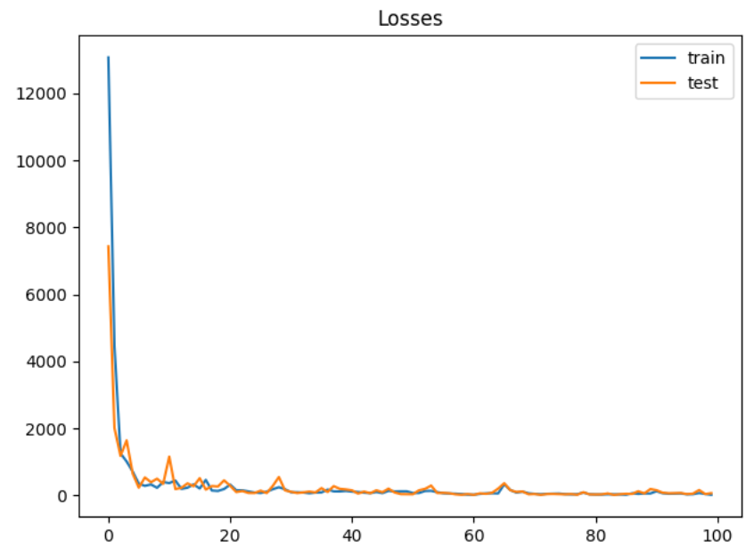

Exercise (2 marks)

Modify the code in Exercise 4 to so it implements a grid search on clip value. Show your revised program here:

|  |
| --- |
| # mlp with unscaled data for the regression problem from sklearn.datasets import make_regression from keras.layers import Dense from keras.models import Sequential from keras.optimizers import SGD import matplotlib.pyplot as plt  # Generate the regression dataset. X, y = make_regression(n_samples=1000, n_features=20, noise=0.1, random_state=1)  plt.hist(y) plt.title("Unscaled Input") plt.show()  # Split into train and test. n_train = 500 trainX, testX = X[:n_train, :], X[n_train:, :] trainy, testy = y[:n_train], y[n_train:]  clipResults = []   def buildModel(clipSize):  # Define the model.  model = Sequential()  model.add(Dense(25, input_dim=20, activation='relu', kernel_initializer='he_uniform'))  model.add(Dense(1, activation='linear'))   # # Compile the model.  # opt = SGD(lr=0.01, momentum=0.9, clipnorm=clipSize)  # model.compile(loss='mean_squared_error', optimizer=opt)   opt = SGD(lr=0.01, momentum=0.9, clipvalue=clipSize)  model.compile(loss='mean_squared_error', optimizer=opt)   # Fit the model.  history = model.fit(trainX, trainy, validation_data=(testX, testy), epochs=100, verbose=1)   # Evaluate the model.  train_mse = model.evaluate(trainX, trainy, verbose=0)  test_mse = model.evaluate(testX, testy, verbose=0)  print('Train MSE: %.3f, Test MSE: %.3f' % (train_mse, test_mse))  clipResults.append({'train mse': train_mse, 'test mse': test_mse,  'clip size': clipSize})  # Plot losses during training.  plt.title('Losses')  plt.plot(history.history['loss'], label='train')  plt.plot(history.history['val_loss'], label='test')  plt.legend()  plt.show()   clipSizes = [0.1, 0.5, 1, 5, 10] for i in range(0, len(clipSizes)):  buildModel(clipSizes[i])  for clipResult in clipResults:  print(clipResult) |

Show an optimized value here and show the MSE.

|  |
| --- |
| Clip size of 0.1 has the lowest MSE value |

## Importance of Scaling

Since neural networks rely heavily on properly sized weights for the model, scaling the data often matters.

Example : Unscaled Data

For comparison, this example generates mse values from regression without scaling.

|  |
| --- |
| Train loss: 10.055, Test loss: 13.413 |

Here is the code.

|  |
| --- |
| from sklearn.datasets import make_regression  from keras.layers import Dense  from keras.models import Sequential  from keras.optimizers import SGD  from matplotlib import pyplot  # Generate regression set.  X, y = make_regression(n_samples=1000, n_features=20,  noise=0.1, random_state=1)  # Split data into train and test.  n_train = 500  trainX, testX = X[:n_train, :], X[n_train:, :]  trainy, testy = y[:n_train], y[n_train:]  normSizeEvaluations = []  # Define the model.  model = Sequential()  model.add(Dense(25, input_dim=20, activation='relu',  kernel_initializer='he_uniform'))  model.add(Dense(1, activation='linear'))  # Compile the model.  model.compile(loss='mean_squared_error',  optimizer=SGD(lr=0.01, momentum=0.9, clipvalue=1.05))  # Fit the model.  history = model.fit(trainX, trainy,  validation_data=(testX, testy),  epochs=200, verbose=1)  # Evaluate the model.  train_mse = model.evaluate(trainX, trainy, verbose=0)  test_mse = model.evaluate(testX, testy, verbose=0)  print('Train loss: %.3f, Test loss: %.3f' % (train_mse, test_mse))  normSizeEvaluations.append({'train mse':train_mse,  'test mse':test_mse,  'size':1})  # Plot the loss during training.  pyplot.title('Mean Squared Error - norm size: ')  pyplot.plot(history.history['loss'], label='train')  pyplot.plot(history.history['val_loss'], label='test')  pyplot.legend()  pyplot.show() |

## Input and Output Scaling

As you may have guessed, gains can be achieved by scaling the X and Y values.

Example : Input and Output Scaling

For this case we can achieve better gains by scaling the y-value. The output is:

|  |
| --- |
| Train loss: 0.002, Test loss: 0.004 |

To implement this solution, replace the compile instruction in Example 9 with this version.

|  |
| --- |
| # Compile the model.  model.compile(loss='mean_squared_error',  optimizer=SGD(lr=0.01, momentum=0.9))  from sklearn.preprocessing import StandardScaler  # reshape 1d arrays to 2d arrays  trainy = trainy.reshape(len(trainy), 1)  testy = testy.reshape(len(trainy), 1)  # Scale y  scaler = StandardScaler()  scaler.fit(trainy)  trainy = scaler.transform(trainy)  testy = scaler.transform(testy)  # Scale x  xscaler = StandardScaler()  xscaler.fit(trainX)  trainX = xscaler.transform(trainX)  testX = xscaler.transform(testX) |

## Greedy Layer-wise Pretraining

Greedy layer-wise pretraining involves successively adding a new hidden layer to a model and refitting, allowing the newly added model to learn the inputs from the existing hidden layer, often while keeping the weights for the existing hidden layers. Sometimes, but not always, being able to build layers in isolation can lead to a better model.

The algorithm begins with a base model just like we have created before. However, when adding new layers, the output layer is stored and removed, existing layers are set so they cannot be modified, a new layer is added and then the output layer is added back.

|  |
| --- |
| # Add one new layer and re-train only the new layer.  def add_layer(model, trainX, trainy):  # Store the output layer.  output_layer = model.layers[-1]  # Remove the output layer.  model.pop()  # Mark all remaining layers as non-trainable.  for layer in model.layers:  layer.trainable = False  # Add a new hidden layer.  model.add(Dense(10, activation='relu', kernel_initializer='he_uniform'))  # Add the output layer back.  model.add(output_layer)  # fit model  model.fit(trainX, trainy, epochs=100, verbose=1)  return model |

Example : Data Setup (See Chapter 20 of Better Deep Learning)

This example sets up the data for greedy layer-wise pretraining classification problem by generating three separate clusters.

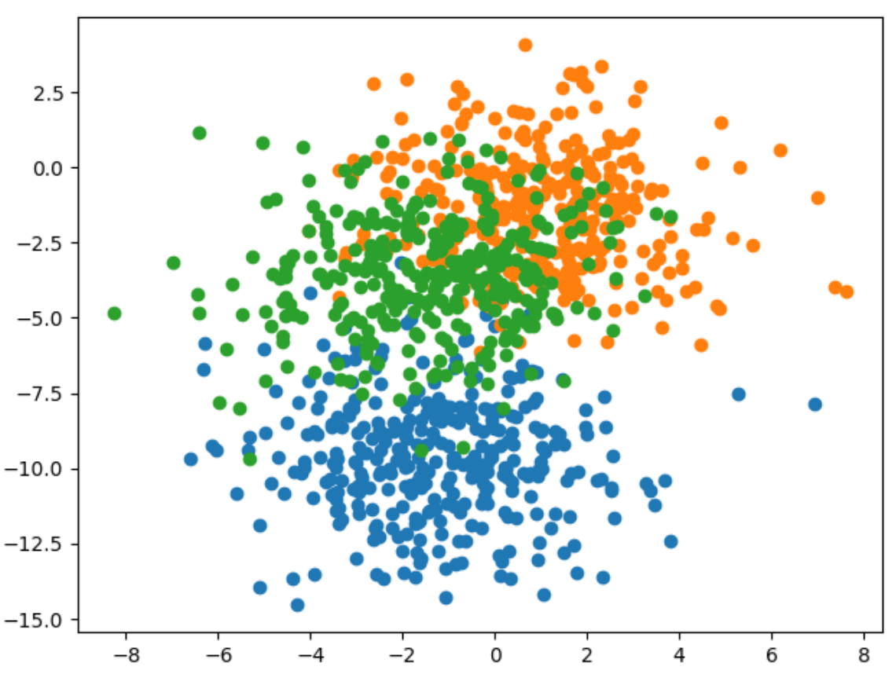

Here is the code that generates and displays the data for the example

|  |
| --- |
| # scatter plot of blobs dataset  from sklearn.datasets import make_blobs  from matplotlib import pyplot  from numpy import where  # generate 2d classification dataset  X, y = make_blobs(n_samples=1000, centers=3, n_features=2, cluster_std=2, random_state=2)  # scatter plot for each class value  for class_value in range(3):  # select indices of points with the class label  row_ix = where(y == class_value)  # scatter plot for points with a different color  pyplot.scatter(X[row_ix, 0], X[row_ix, 1])  # show plot  pyplot.show() |

Example : Greedy Layer-wise Pretraining (See Chapter 20 of Better Deep Learning)

Here is the entire code needed to implement greedy layer-wise pretraining.

|  |
| --- |
| from sklearn.datasets import make_blobs  from keras.layers import Dense  from keras.models import Sequential  from keras.optimizers import SGD  from keras.utils import to_categorical  import matplotlib.pyplot as plt  # Generate the data.  def prepare_data():  X, y = make_blobs(n_samples=1000, centers=3,  n_features=2, cluster_std=2, random_state=2)  y = to_categorical(y)  n_train = 500  trainX, testX = X[:n_train, :], X[n_train:, :]  trainy, testy = y[:n_train], y[n_train:]  return trainX, testX, trainy, testy  # Build the base model.  def get_base_model(trainX, trainy):  # Define the model.  model = Sequential()  model.add(Dense(10, input_dim=2, activation='relu',  kernel_initializer='he_uniform'))  model.add(Dense(3, activation='softmax'))  # Compile the model.  opt = SGD(lr=0.01, momentum=0.9)  model.compile(loss='categorical_crossentropy', optimizer=opt,  metrics=['accuracy'])  # Fit the model.  model.fit(trainX, trainy, epochs=100, verbose=0)  return model  stats = []  # Evaluate the model.  def evaluate_model(numLayers, model, trainX, testX, trainy, testy):  train_loss, train_acc = model.evaluate(trainX, trainy, verbose=1)  test_loss, test_acc = model.evaluate(testX, testy, verbose=1)  stats.append({ '# layers':numLayers, 'train_acc':train_acc, 'test_acc':test_acc,  'train_loss':train_loss, 'test_loss':test_loss })  # Add one new layer and re-train only the new layer.  def add_layer(model, trainX, trainy):  # Store the output layer.  output_layer = model.layers[-1]  # Remove the output layer.  model.pop()  # Mark all remaining layers as non-trainable.  for layer in model.layers:  layer.trainable = False  # Add a new hidden layer.  model.add(Dense(10, activation='relu', kernel_initializer='he_uniform'))  # Add the output layer back.  model.add(output_layer)  # fit model  model.fit(trainX, trainy, epochs=100, verbose=1)  return model  # Get the data and build the base model.  trainX, testX, trainy, testy = prepare_data()  model = get_base_model(trainX, trainy)  # Evaluate the base model  scores = dict()  evaluate_model(-1, model, trainX, testX, trainy, testy)  # add layers and evaluate the updated model  n_layers = 10  for i in range(n_layers):  model = add_layer(model, trainX, trainy)  evaluate_model(i, model, trainX, testX, trainy, testy)  import pandas as pd  columns = ['# layers', 'train_acc', 'test_acc', 'train_loss', 'test_loss']  df = pd.DataFrame(columns=columns)  for i in range(0, len(stats)):  df = df.append(stats[i], ignore_index=True)  print(df) |

The test accuracy appears to improve. The first row shows the full model with all layers when no greedy layer-wise pretraining is used. However, three rows with greedy layer-wise pretraining shows some slight improvement in accuracy.

|  |
| --- |
| # layers train_acc test_acc train_loss test_loss  0 -1.0 0.836 0.818 0.398433 0.413762  1 0.0 0.836 0.824 0.388216 0.407569  2 1.0 0.838 0.822 0.385031 0.411448  3 2.0 0.828 0.830 0.396971 0.411076  4 3.0 0.822 0.820 0.390866 0.409562  5 4.0 0.844 0.822 0.383811 0.418827  6 5.0 0.828 0.802 0.396735 0.437487  7 6.0 0.840 0.824 0.392394 0.433040  8 7.0 0.840 0.816 0.380537 0.412962  9 8.0 0.838 0.826 0.384223 0.426899  10 9.0 0.818 0.836 0.405867 0.413323 |

Exercise (4 marks)

This code uses greedy layer-wise pretraining to add layers to a model which performs diabetes diagnosis classification.

|  |
| --- |
| from sklearn.datasets import make_blobs  from keras.layers import Dense  from keras.models import Sequential  from keras.optimizers import SGD  from keras.utils import to_categorical  import matplotlib.pyplot as plt  # Generate the data.  import tensorflow as tf  from sklearn.model_selection import train_test_split  import pandas as pd  def prepare_data():  PATH = "/Users/pm/Desktop/DayDocs/data/"  # load the dataset  df = pd.read_csv(PATH + 'diabetes.csv', sep=',')  # split into input (X) and output (y) variables  X = df[['Pregnancies', 'Glucose', 'BloodPressure', 'SkinThickness', 'Insulin', 'BMI',  'DiabetesPedigreeFunction', 'Age']]  y = df[['Outcome']]  # Split into train and test data sets.  X_train, X_test, y_train, y_test = train_test_split(X, y, test_size=0.33)  return X_train, X_test, y_train, y_test  # Build the base model.  def get_base_model(trainX, trainy):  # define the keras model  model = Sequential()  model.add(Dense(230, input_dim=8, activation='relu',  kernel_initializer='he_normal'))  model.add(Dense(1, activation='sigmoid'))  opitimizer = tf.keras.optimizers.SGD(  learning_rate=0.0005, momentum=0.9, name="SGD",  )  # Compile the keras model.  model.compile(loss='binary_crossentropy', optimizer=opitimizer,  metrics=['accuracy'])  # Fit the keras model on the dataset.  model.fit(trainX, trainy, epochs=200, batch_size=10)  return model  stats = []  # Evaluate the model.  def evaluate_model(numLayers, model, trainX, testX, trainy, testy):  train_loss, train_acc = model.evaluate(trainX, trainy, verbose=1)  test_loss, test_acc = model.evaluate(testX, testy, verbose=1)  stats.append({ '# layers':numLayers, 'train_acc':train_acc, 'test_acc':test_acc,  'train_loss':train_loss, 'test_loss':test_loss })  # Add one new layer and re-train only the new layer.  def add_layer(model, trainX, trainy):  # Store the output layer.  output_layer = model.layers[-1]  # Remove the output layer.  model.pop()  # Mark all remaining layers as non-trainable.  for layer in model.layers:  layer.trainable = False  # Add a new hidden layer.  model.add(Dense(230, activation='relu', kernel_initializer='he_uniform'))  # Add the output layer back.  model.add(output_layer)  # fit model  model.fit(trainX, trainy, epochs=300, verbose=1)  return model  # Get the data and build the base model.  trainX, testX, trainy, testy = prepare_data()  model = get_base_model(trainX, trainy)  # Evaluate the base model  scores = dict()  evaluate_model(-1, model, trainX, testX, trainy, testy)  # add layers and evaluate the updated model  n_layers = 14  for i in range(n_layers):  model = add_layer(model, trainX, trainy)  evaluate_model(i, model, trainX, testX, trainy, testy)  columns = ['# layers', 'train_acc', 'test_acc', 'train_loss', 'test_loss']  df = pd.DataFrame(columns=columns)  for i in range(0, len(stats)):  df = df.append(stats[i], ignore_index=True)  print(df) |

Run the code and find the optimal number of layers. Show the output here and highlight the optimal number of layers based on test accuracy:

|  |
| --- |
|  |

Exercise (1 mark)

Which line of code in Exercise 6 saves the output layer for use later?

|  |
| --- |
| output_layer = model.layers[-1] |

Exercise (1 mark)

Which line of code in Exercise 6 adds the output layer that is stored in memory back onto the network.

|  |
| --- |
| model.add(output_layer) |

Exercise (1 mark)

Which line of code in Exercise 6 removes the output layer so a new layer can be added?

|  |
| --- |
| model.pop() |

Exercise (1 mark)

Which lines of code in Exercise 6 ensures that the previously added hidden layers cannot be adjusted?

|  |
| --- |
| layer.trainable = False |

Exercise (1 mark)

Explain in your own words how greedy layer-wise pretraining works.

|  |
| --- |
| Each layer learns features that are useful for the next layers to use to improve. Adding more layers lets the network get a more accurate reading of the input data. |

Table of Contents

GridSearchCV 1

RandomSearchCV 3

Visualizing Loss and Accuracy for a Classification Model 4

Viewing Losses for Linear Models 9

MLPClassifier and MLPRegressor from Scikit-learn 12

GridSearchCV with MLPClassifier 14

MLPRegressor 15

## GridSearchCV

Since many parameters are not linearly related it can help to grid search many at once. That way it is possible to have a better sense of which parameter settings perform well together.

Example : GridSearch

GridSearch offers an approach to search multiple determine the best parameters for adding a new layer. The process may take between 20 minutes to an hour. When finished the output will

show the best performing model with parameters at the top. The other models with their average score and standard deviation will appear after.

|  |
| --- |
| Best: -19.212292 using {'numNeurons': 25, 'initializer': 'glorot_uniform', 'activation': 'softplus'}  -26.609111 (8.702621) with: {'numNeurons': 15, 'initializer': 'zero', 'activation': 'linear'}  -47.283887 (14.076808) with: {'numNeurons': 15, 'initializer': 'glorot_uniform', 'activation': 'softsign'}  -23.229303 (4.183168) with: {'numNeurons': 15, 'initializer': 'lecun_uniform', 'activation': 'relu'}  -19.212292 (2.931735) with: {'numNeurons': 25, 'initializer': 'glorot_uniform', 'activation': 'softplus'}  -25.405355 (9.082541) with: {'numNeurons': 30, 'initializer': 'he_normal', 'activation': 'softplus'}  … |

Here is the code:

|  |
| --- |
| import pandas as pd  import tensorflow  from sklearn.model_selection import train_test_split  PATH = "/users/pm/desktop/daydocs/data/"  CSV_DATA = "housing.data"  df = pd.read_csv(PATH + CSV_DATA, header=None)  # Show all columns.  pd.set_option('display.max_columns', None)  # Increase number of columns that display on one line.  pd.set_option('display.width', 1000)  print(df.head())  print(df.tail())  print(df.describe())  dataset = df.values  # split into input (X) and output (Y) variables  X = dataset[:,0:13]  y = dataset[:,13]  ROW_DIM = 0  COL_DIM = 1  x_arrayReshaped = X.reshape(X.shape[ROW_DIM],  X.shape[COL_DIM])  # Convert DataFrame columns to vertical columns of target variables values.  y_arrayReshaped = y.reshape(y.shape[ROW_DIM],1)  X_train, X_temp, y_train, y_temp = train_test_split(x_arrayReshaped,  y_arrayReshaped, test_size=0.3, random_state=0)  X_val, X_test, y_val, y_test = train_test_split(X_temp,  y_temp, test_size=0.5, random_state=0)  n_features = X_train.shape[1]  from keras.models import Sequential  from keras.layers import Dense  from keras.wrappers.scikit_learn import KerasRegressor  from sklearn.model_selection import GridSearchCV  # Define the model.  def create_model(numNeurons=5, initializer='uniform', activation='softplus'):  # create model  model = Sequential()  model.add(Dense(25, kernel_initializer='uniform',  input_dim=n_features, activation='softplus'))  model.add(Dense(numNeurons, kernel_initializer=initializer,  activation=activation))  model.add(Dense(1, kernel_initializer='he_normal', activation='softplus'))  opt = tensorflow.keras.optimizers.Adam(learning_rate=0.005)  # Compile model  model.compile(loss='mse', optimizer=opt)  return model  ### Grid Building Section #######################  # Define the parameters to try out  params = { 'activation' : ['softmax', 'softplus', 'softsign', 'relu', 'tanh',  'sigmoid', 'hard_sigmoid', 'linear'],  'numNeurons':[10, 15, 20, 25, 30, 35],  'initializer': ['uniform', 'lecun_uniform', 'normal', 'zero',  'glorot_normal', 'glorot_uniform', 'he_normal', 'he_uniform']  }  model = KerasRegressor(build_fn=create_model, epochs=100,  batch_size=9, verbose=1)  grid = GridSearchCV(estimator=model, param_grid=params, n_jobs=-1, cv=3)  #################################################  grid_result = grid.fit(X_train, y_train)  # summarize results  print("Best: %f using %s" % (grid_result.best_score_, grid_result.best_params_))  means = grid_result.cv_results_['mean_test_score']  stds = grid_result.cv_results_['std_test_score']  params = grid_result.cv_results_['params']  for mean, stdev, param in zip(means, stds, params):  print("%f (%f) with: %r" % (mean, stdev, param)) |

## RandomSearchCV

To save time you can use RandomSearchCV which implements a random subset of combinations of the GridSearchCV algorithm. RandomSearchCV() is faster than GridSearchCV() but RandomSearchCV is less accurate. Still, during a first pass you might consider using RandomSearchCV() to discover suitable parameter combinations and ranges before running a more time consuming grid search.

Note: Neural networks are sensitive to scaling so ideally scaling should be performed or at least tried as an option. I have left scaling out to avoid complexity but really it probably should be performed.

Example : RandomSearchCV

This example converts Example 1 to use a much quicker search for suitable parameters.

Switching to using a RandomSearchCV() function instead of the GridSearchCV() function only involves swapping out two lines of code. To make the change, replace:

|  |
| --- |
| grid = GridSearchCV(estimator=model, param_grid=params, n_jobs=-1, cv=3) |

with:

|  |
| --- |
| from sklearn.model_selection import RandomizedSearchCV  grid = RandomizedSearchCV(model, param_distributions = params, cv = 3) |

Exercise (2 marks)

Explain two advantages of RandomizedSearchCV here:

|  |
| --- |
| Randomized search is faster than grid search since it randomly samples from a given range of parameters rather than going through every single combination of parameters.  Randomized search can cover and explore a larger range than grid search if you only offer it a set range. |

Exercise (6 marks)

Modify Example 2 to perform a random search on the following parameters:

|  |
| --- |
| params = { 'activation' : ['relu', 'sigmoid'],  'numNeurons': [50, 100, 200],  'numHiddenLayers':[1,2,3],  'initializer': ['normal']  } |

Hints:

* You will need to adjust the parameters of the create_model() function.
* The hidden layers will need to be added in a loop.

Show your revised code as text here:

|  |
| --- |
| import pandas as pd import tensorflow from sklearn.model_selection import train_test_split  PATH = "C:\\datasets\\" CSV_DATA = "housing.data" df = pd.read_csv(PATH + CSV_DATA, header=None)  # Show all columns. pd.set_option('display.max_columns', None)  # Increase number of columns that display on one line. pd.set_option('display.width', 1000)  print(df.head()) print(df.tail()) print(df.describe())  dataset = df.values  # split into input (X) and output (Y) variables X = dataset[:, 0:13] y = dataset[:, 13]  ROW_DIM = 0 COL_DIM = 1  x_arrayReshaped = X.reshape(X.shape[ROW_DIM],  X.shape[COL_DIM])  # Convert DataFrame columns to vertical columns of target variables values. y_arrayReshaped = y.reshape(y.shape[ROW_DIM], 1)  X_train, X_temp, y_train, y_temp = train_test_split(x_arrayReshaped,  y_arrayReshaped, test_size=0.3, random_state=0) X_val, X_test, y_val, y_test = train_test_split(X_temp,  y_temp, test_size=0.5, random_state=0)  n_features = X_train.shape[1]  from keras.models import Sequential from keras.layers import Dense from keras.wrappers.scikit_learn import KerasRegressor from sklearn.model_selection import GridSearchCV   def create_model(numNeurons=50, numHiddenLayers=1, initializer='normal', activation='relu'):  # create model  model = Sequential()  model.add(Dense(25, kernel_initializer='uniform',  input_dim=n_features, activation='softplus'))   for i in range(numHiddenLayers):  model.add(Dense(numNeurons, kernel_initializer=initializer,  activation=activation))   model.add(Dense(1, kernel_initializer='he_normal', activation='softplus'))  opt = tensorflow.keras.optimizers.Adam(learning_rate=0.005)  # Compile model  model.compile(loss='mse', optimizer=opt)  return model  ### Grid Building Section ####################### # Define the parameters to try out  params = { 'activation' : ['relu', 'sigmoid'],  'numNeurons': [50, 100, 200],  'numHiddenLayers':[1,2,3],  'initializer': ['normal']  }   model = KerasRegressor(build_fn=create_model, epochs=100,  batch_size=9, verbose=1) # grid = GridSearchCV(estimator=model, param_grid=params, n_jobs=-1, cv=3)  from sklearn.model_selection import RandomizedSearchCV grid = RandomizedSearchCV(model, param_distributions = params, cv = 3)  #################################################  grid_result = grid.fit(X_train, y_train)  # summarize results print("Best: %f using %s" % (grid_result.best_score_, grid_result.best_params_)) means = grid_result.cv_results_['mean_test_score'] stds = grid_result.cv_results_['std_test_score'] params = grid_result.cv_results_['params']  for mean, stdev, param in zip(means, stds, params):  print("%f (%f) with: %r" % (mean, stdev, param)) |

Show a screenshot which displays the output including the best model. Ensure that all four parameters are visible in the screenshot.

|  |
| --- |
|  |

Exercise (4 marks)

Calculate the root mean square error with your best model from the grid search in Example 2.

predictions = grid.best_estimator_.predict(X_test)

Show your revised code here:

|  |
| --- |
| from sklearn import metrics predictions = grid.best_estimator_.predict(X_test) print(predictions) mse = metrics.mean_squared_error(y_test, predictions) print("Neural network MSE: " + str(mse)) print("Neural network RMSE: " + str(np.sqrt(mse))) |

Show a screenshot of the output here:

|  |
| --- |
|  |

## Visualizing Loss and Accuracy for a Classification Model

Being able to visualize loss and accuracy during training and testing helps to understand the effectiveness of the hyperparameters. Figure 1 shows an ideal scenario for loss and accuracy for a classification model. Loss decline is smooth. The accuracy peaks at approximately 200 epochs. There is some fluctuation in accuracy. The information suggests that potentially 200 to 400 epochs are required for reaching peak performance during training with the current set of parameters. You will also notice that validation (test) sets have slightly higher losses and the tests sets are also slightly less accurate than the training sets.

Figure : Visualizing Loss and Accuracy Parameters for a Classification Model

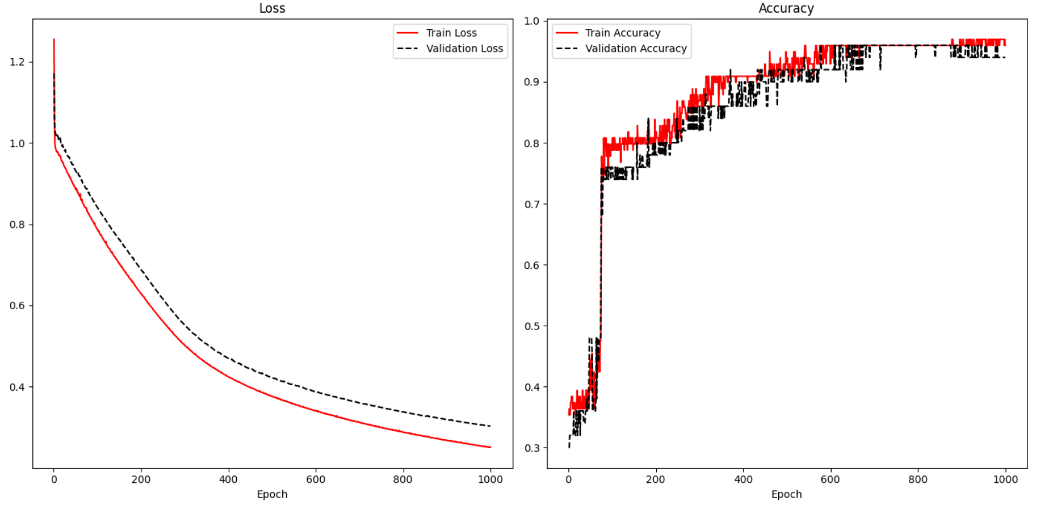

To enable display of train and validation results, validation_data arguments must be supplied in the model.fit() instruction. Note that the data has already been split into three data sets so that the model can be fit with training data and validated during training with validation data. The test data set is unseen data which is then used after the model has been trained for a final evaluation.

|  |
| --- |
| X_train, **X_temp**, y_train, **y_temp** = train_test_split(x_arrayReshaped,  y_arrayReshaped, test_size=0.3)  X_val, X_test, y_val, y_test = train_test_split(**X_temp**,  **y_temp**, test_size=0.5) |

A history variable is needed to store the loss and accuracy results.

|  |
| --- |
| history = model.fit(X_train, y_train, epochs=1000, batch_size=28, verbose=1,  validation_data=(X_val, y_val)) |

To track the accuracy of the result, metrics=['accuracy'] is included in the compile statement.

|  |
| --- |
| model.compile(optimizer='sgd', loss='sparse_categorical_crossentropy',  metrics=['accuracy']) |

Example : Visualizing Loss and Accuracy

Here is the code that is used to display the accuracy and losses in Figure 1 when fitting an iris data set prediction model. The locations where the history variable is set and referenced are highlighted to show how the losses and accuracy are tracked.

A detailed classification report shows how well the model performs with test data which the model did not see during training or validation.

|  |
| --- |
| precision recall f1-score support  0 1.00 1.00 1.00 9  1 1.00 0.89 0.94 9  2 0.88 1.00 0.93 7 |

Here is the code:

|  |
| --- |
| import pandas as pd  from sklearn.model_selection import train_test_split  from sklearn.preprocessing import LabelEncoder  from tensorflow.keras import Sequential  from tensorflow.keras.layers import Dense  PATH = "/Users/pm/Desktop/DayDocs/data/"  df = pd.read_csv(PATH + 'iris_old.csv')  df.columns = ['Sepal L', 'Sepal W', 'Petal L', 'Petal W', 'Iris Type']  print(df)  # Convert text to numeric category.  # 0 is setosa, 1 is versacolor and 2 is virginica  df['y'] = LabelEncoder().fit_transform(df['Iris Type'])  # Prepare the data.  dfX = df.iloc[:, 0:4] # Get X features only from columns 0 to 3  dfY = df.iloc[:, 5:6] # Get X features only from column 5  ROW_DIM = 0  COL_DIM = 1  # Create vertical array of features.  x_array = dfX.values  x_arrayReshaped = x_array.reshape(x_array.shape[ROW_DIM],  x_array.shape[COL_DIM])  y_array = dfY.values  y_arrayReshaped = y_array.reshape(y_array.shape[ROW_DIM],  y_array.shape[COL_DIM])  # Split into train, validation and test data sets.  X_train, X_temp, y_train, y_temp = train_test_split(  x_arrayReshaped, y_arrayReshaped, test_size=0.33)  X_val, X_test, y_val, y_test = train_test_split(  X_temp, y_temp, test_size=0.50)  n_features = X_train.shape[COL_DIM]  # Define the model.  model = Sequential()  # Hidden layer 1 (also receives the input layer)  model.add(Dense(2, activation='relu', input_shape=(n_features,)))  # Output layer  model.add(Dense(3, activation='softmax'))  # Compile the model.  model.compile(optimizer='sgd', loss='sparse_categorical_crossentropy', metrics=['accuracy'])  # Fit the model.  history = model.fit(X_train, y_train, epochs=1000, batch_size=28, verbose=1,  validation_data=(X_val, y_val))  # Evaluate the model with unseen data.  loss, acc = model.evaluate(X_test, y_test, verbose=0)  print('Test Accuracy: %.3f' % acc)  # make a prediction  row = [5.1, 3.5, 1.4, 0.2]  yhat = model.predict([row])  print('Predicted: s (class=d)' + str(yhat))  import matplotlib.pyplot as plt  def showLoss(history):  # Get training and test loss histories  training_loss = history.history['loss']  validation_loss = history.history['val_loss']  # Create count of the number of epochs  epoch_count = range(1, len(training_loss) + 1)  plt.subplot(1, 2, 1)  # Visualize loss history for training data.  plt.plot(epoch_count, training_loss, label='Train Loss', color='red')  # View loss on unseen data.  plt.plot(epoch_count, validation_loss, 'r--', label='Validation Loss',  color='black')  plt.xlabel('Epoch')  plt.legend(loc="best")  plt.title("Loss")  def showAccuracy(history):  # Get training and test loss histories  training_loss = history.history['accuracy']  validation_loss = history.history['val_accuracy']  # Create count of the number of epochs  epoch_count = range(1, len(training_loss) + 1)  plt.subplot(1, 2, 2)  # Visualize loss history for training data.  plt.plot(epoch_count, training_loss, label='Train Accuracy', color='red')  # View loss on unseen data.  plt.plot(epoch_count, validation_loss, 'r--',  label='Validation Accuracy', color='black')  plt.xlabel('Epoch')  plt.legend(loc="best")  plt.title('Accuracy')  plt.subplots(nrows=1, ncols=2, figsize=(14,7))  showLoss(history)  showAccuracy(history)  plt.show()  from sklearn.metrics import classification_report  # Provide detailed evaluation with unseen data.  y_probability = model.predict(X_test)  import numpy as np  # Convert probability arrays to whole numbers.  # eg. [0.0003, 0.01, 0.9807] becomes 2.  predictions = np.argmax(y_probability, axis=-1)  print(classification_report(y_test, predictions)) |

Exercise (6 marks)

Starting with the following code which loads a bill fraud data set, create a neural network to predict if the bill is fraudulent. Track losses and accuracy and show the results at the end.

|  |
| --- |
| import pandas as pd  from sklearn.model_selection import train_test_split  from sklearn.preprocessing import LabelEncoder  from tensorflow.keras import Sequential  from tensorflow.keras.layers import Dense  import numpy as np  PATH = "/Users/pm/Desktop/DayDocs/data/"  df = pd.read_csv(PATH + 'bill_authentication.csv')  # Convert text to numeric category.  # 0 is setosa, 1 is versacolor and 2 is virginica  y = df['Class']  X = df  del X['Class']  ROW_DIM = 0  COL_DIM = 1  # Create vertical array of features.  x_array = X.values  x_arrayReshaped = x_array.reshape(x_array.shape[ROW_DIM],  x_array.shape[COL_DIM])  y_array = np.array(y.values)  y_arrayReshaped = y_array.reshape(len(y_array),1) |

Show the loss curve at the end when the model is finished training.

|  |
| --- |
|  |

Even if the precision, recall and accuracy are perfect, what improvement does the plot above suggest is possible?

|  |
| --- |
| About 100 to 200 epochs are required before the loss approaches 0. |

## Viewing Losses for Linear Models

Since linear models use measures such as RMSE to judge the fit of a model, accuracy is not plotted for linear models like in Figure 1. However, the loss plot is still useful for linear models.

The loss plot on the left of Figure 2 shows a situation where overfitting occurs. The overfitting is observed when the test data suddenly demonstrates rising losses while the training losses continue to decline.

The graph at the right of Figure 2 suggests underfitting. For this case, it appears as if the minimum loss has not been reached. The model may be improved by increasing the number of epochs.

Figure : Overfitting and Underfitting

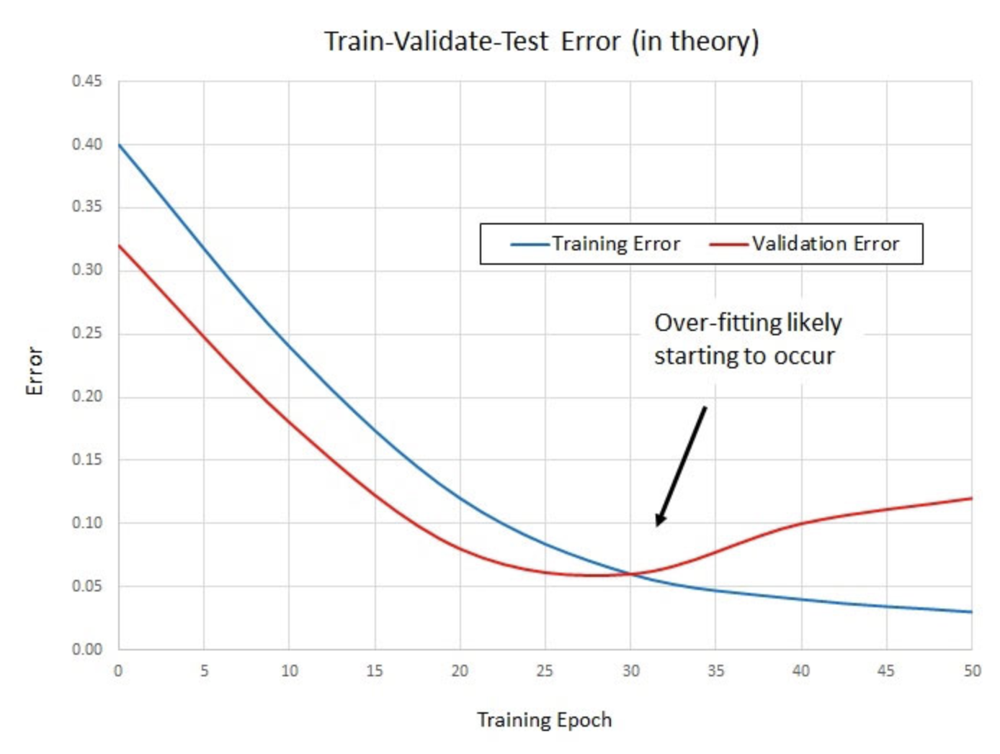 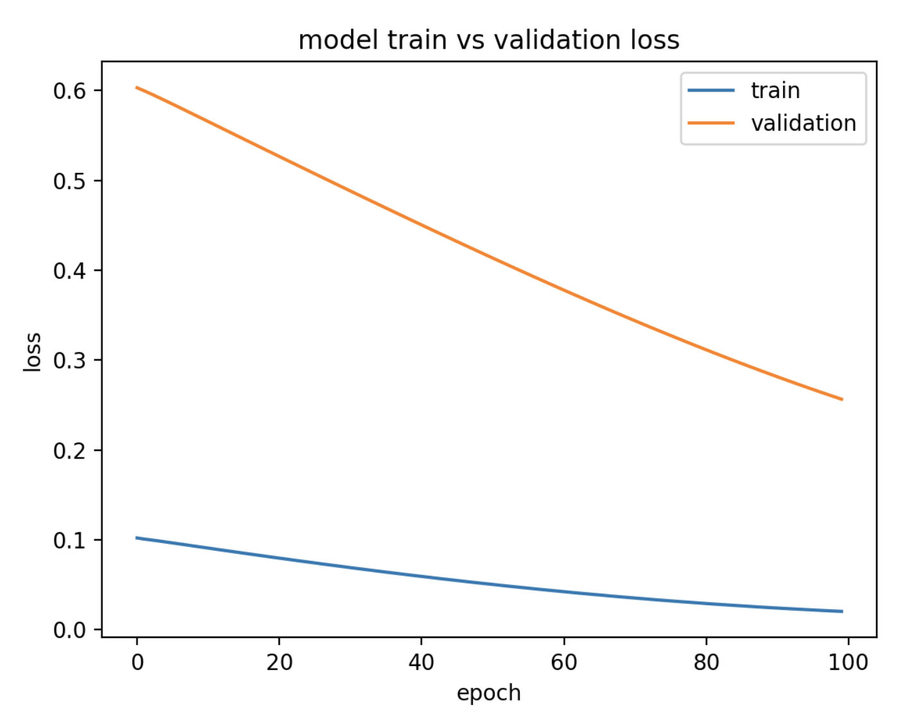

Example : Predicting Housing Price

Last day, the following code for predicting housing prices was discussed. This code implements a neural network that was previously optimized with a grid search.

|  |
| --- |
| import pandas as pd  import numpy as np  from sklearn import metrics  from sklearn.model_selection import train_test_split  PATH = "/Users/pm/Desktop/DayDocs/data/"  CSV_DATA = "housing.data"  df = pd.read_csv(PATH + CSV_DATA, header=None)  # Show all columns.  pd.set_option('display.max_columns', None)  # Increase number of columns that display on one line.  pd.set_option('display.width', 1000)  print(df.head())  print(df.tail())  print(df.describe())  dataset = df.values  # split into input (X) and output (Y) variables  X = dataset[:, 0:13]  y = dataset[:, 13]  ROW_DIM = 0  COL_DIM = 1  x_arrayReshaped = X.reshape(X.shape[ROW_DIM],  X.shape[COL_DIM])  # Convert DataFrame columns to vertical columns of target variables values.  y_arrayReshaped = y.reshape(y.shape[ROW_DIM], 1)  # Splitting data into 3 data sets.  # Train and val are used while model is being fit.  # Test is held back until the end for the final evaluation.  X_train, X_temp, y_train, y_temp = train_test_split(x_arrayReshaped,  y_arrayReshaped, test_size=0.3, random_state=0)  X_val, X_test, y_val, y_test = train_test_split(X_temp,  y_temp, test_size=0.3, random_state=0)  from keras.models import Sequential  from keras.layers import Dense  from keras.wrappers.scikit_learn import KerasRegressor  from sklearn.model_selection import cross_val_score  from sklearn.model_selection import KFold  # define base model  from keras.optimizers import Adam #for adam optimizer  def baseline_model():  model = Sequential()  model.add(Dense(25, input_dim=13, kernel_initializer='uniform',  activation='softplus'))  model.add(Dense(10, kernel_initializer='lecun_uniform', activation='softplus'))  model.add(Dense(1, kernel_initializer='uniform'))  # Use Adam optimizer with the given learning rate  opt = Adam(lr=0.005)  model.compile(loss='mean_squared_error')  return model  # evaluate model  estimator = KerasRegressor(build_fn=baseline_model, epochs=100,  batch_size=9, verbose=1)  kfold = KFold(n_splits=10)  results = cross_val_score(estimator, X_train, y_train, cv=kfold)  print("Baseline Mean (%.2f) MSE (%.2f) " % (results.mean(), results.std()))  print("Baseline RMSE: " + str(np.sqrt(results.std())))  # So then we build the model.  model = baseline_model()  history = model.fit(X_train, y_train, epochs=100,  batch_size=9, verbose=1,  validation_data=(X_val, y_val))  predictions = model.predict(X_test)  mse = metrics.mean_squared_error(y_test, predictions)  print("Neural network MSE: " + str(mse))  print("Neural network RMSE: " + str(np.sqrt(mse))) |

Exercise (1 mark)

Explain why it does not make sense to draw an accuracy plot for the code in Example 4.

|  |
| --- |
| This code uses a regression model, not a classification model. Regression models are for continuous values, not class values. |

Exercise (6 marks)

Plot the loss function plot that appears when the model in Example 4 is fit. Show your revised program here. Refer to Example 3 for code that plots the loss function. Show a screenshot of the loss plot here:

|  |
| --- |
| import pandas as pd import numpy as np from sklearn import metrics from sklearn.model_selection import train_test_split import matplotlib.pyplot as plt  PATH = "C:\\datasets\\" CSV_DATA = "housing.data"  df = pd.read_csv(PATH + CSV_DATA, header=None)  # Show all columns. pd.set_option('display.max_columns', None)  # Increase number of columns that display on one line. pd.set_option('display.width', 1000)  print(df.head()) print(df.tail()) print(df.describe())  dataset = df.values # split into input (X) and output (Y) variables X = dataset[:, 0:13] y = dataset[:, 13]  ROW_DIM = 0 COL_DIM = 1 x_arrayReshaped = X.reshape(X.shape[ROW_DIM],  X.shape[COL_DIM])  # Convert DataFrame columns to vertical columns of target variables values. y_arrayReshaped = y.reshape(y.shape[ROW_DIM], 1)  # Splitting data into 3 data sets. # Train and val are used while model is being fit. # Test is held back until the end for the final evaluation. X_train, X_temp, y_train, y_temp = train_test_split(x_arrayReshaped,  y_arrayReshaped, test_size=0.3, random_state=0) X_val, X_test, y_val, y_test = train_test_split(X_temp,  y_temp, test_size=0.3, random_state=0)  from keras.models import Sequential from keras.layers import Dense from keras.wrappers.scikit_learn import KerasRegressor from sklearn.model_selection import cross_val_score from sklearn.model_selection import KFold  # define base model from keras.optimizers import Adam #for adam optimizer def baseline_model():  model = Sequential()  model.add(Dense(25, input_dim=13, kernel_initializer='uniform',  activation='softplus'))  model.add(Dense(10, kernel_initializer='lecun_uniform', activation='softplus'))  model.add(Dense(1, kernel_initializer='uniform'))   # Use Adam optimizer with the given learning rate  opt = Adam(lr=0.005)  model.compile(loss='mean_squared_error')  return model  # evaluate model estimator = KerasRegressor(build_fn=baseline_model, epochs=100,  batch_size=9, verbose=1) kfold = KFold(n_splits=10) results = cross_val_score(estimator, X_train, y_train, cv=kfold) print("Baseline Mean (%.2f) MSE (%.2f) " % (results.mean(), results.std())) print("Baseline RMSE: " + str(np.sqrt(results.std())))  # So then we build the model. model = baseline_model() history = model.fit(X_train, y_train, epochs=100,  batch_size=9, verbose=1,  validation_data=(X_val, y_val)) predictions = model.predict(X_test)  mse = metrics.mean_squared_error(y_test, predictions) print("Neural network MSE: " + str(mse)) print("Neural network RMSE: " + str(np.sqrt(mse))) def showLoss(history):  # Get training and test loss histories  training_loss = history.history['loss']  validation_loss = history.history['val_loss']   # Create count of the number of epochs  epoch_count = range(1, len(training_loss) + 1)  plt.subplot(1, 2, 1)  # Visualize loss history for training data.  plt.plot(epoch_count, training_loss, label='Train Loss', color='red')   # View loss on unseen data.  plt.plot(epoch_count, validation_loss, 'r--', label='Validation Loss',  color='black')   plt.xlabel('Epoch')  plt.legend(loc="best")  plt.title("Loss")   def showAccuracy(history):  # Get training and test loss histories  training_loss = history.history['accuracy']  validation_loss = history.history['val_accuracy']   # Create count of the number of epochs  epoch_count = range(1, len(training_loss) + 1)  plt.subplot(1, 2, 2)  # Visualize loss history for training data.  plt.plot(epoch_count, training_loss, label='Train Accuracy', color='red')   # View loss on unseen data.  plt.plot(epoch_count, validation_loss, 'r--',  label='Validation Accuracy', color='black')  plt.xlabel('Epoch')  plt.legend(loc="best")  plt.title('Accuracy')   plt.subplots(nrows=1, ncols=2, figsize=(14, 7)) showLoss(history) # showAccuracy(history) plt.show() |

It is typical for the validation data to show higher losses than the training losses because the model learns with the training data. With this in mind, explain if you think the loss function shows a reasonably good fit, underfitting or overfitting.

|  |
| --- |
| It shows a reasonably good fit. The train loss follows the validation loss closely. |

## MLPClassifier and MLPRegressor from Scikit-learn

The MLPClassifier and MLPRegressor machine learning pipeline classes from scikit-learn offer

a simple and fast way to generate neural networks while hiding the details. MLP stands for multi-layer perceptron which essentially is a sequential neural network with back propagation.

Not only are the MLPClassifier and MLPRegressor useful classes from an educational perspective, they can be used for simple ANN (artificial neural network) implementations and they can also be used to explore suitable ANN parameters which could then be used with a different framework.

At a very basic level, the MLPClassifier (or MLPRegressor) can be instantiated without any parameters.

# Create and fit model.

model = MLPClassifier()

model.fit(trainX_scaled, y_train)

print(model)

# Evaluate model.

predicted_y = model.predict(testX_scaled)

The basic instantiations of these models are actually very competitive and often perform just as well as models that are developed with basic grid searching.

Example : MLPClassifier

In this example, the MLPClassifier is initialized without any parameters. The results show a reasonable learning rate and decent metrics (results will vary from run to run):

Figure : Loss Plot for MLPClassifier

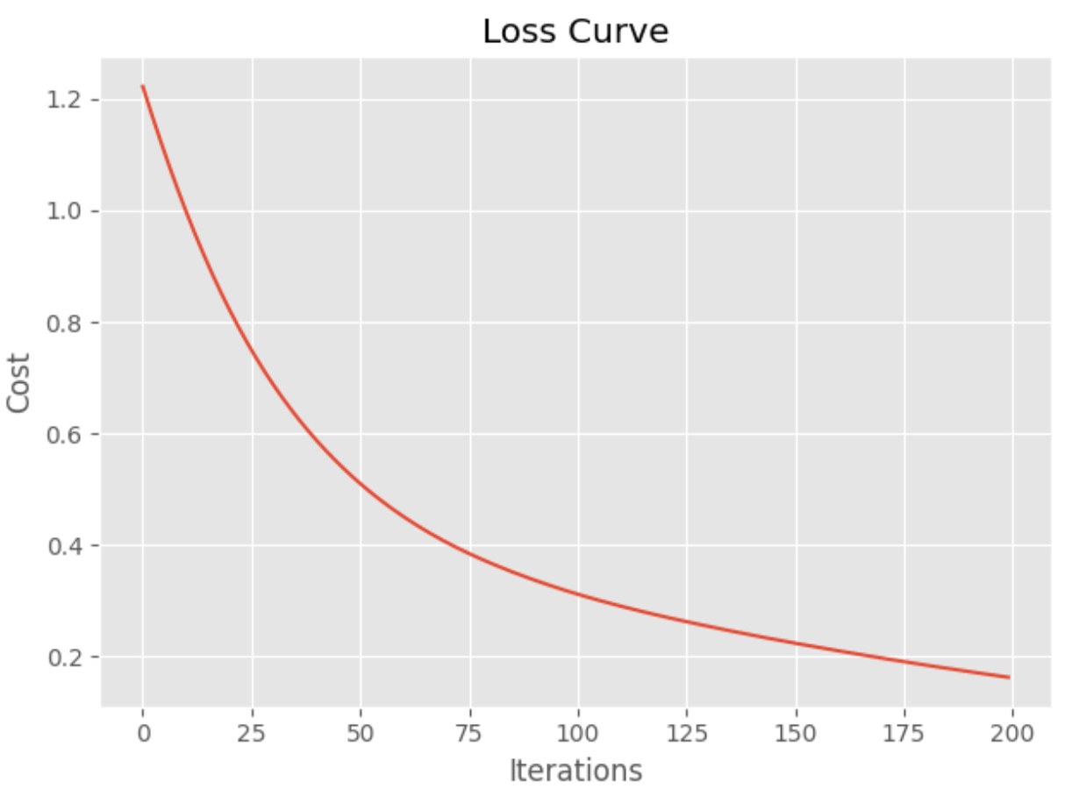

|  |
| --- |
| precision recall f1-score support  0 1.00 0.93 0.96 14  1 0.86 0.86 0.86 14  2 0.89 0.94 0.91 17 |

The default model often is very competitive with grid searched models. When the model is fitted, the parameters of the model can be displayed with the get_params() function.

|  |
| --- |
| print(model.get_params()) |

These are the parameters that were chosen for the default instantiation. You will notice some parameters such as warm_start, early_stopping, and momentum which we will talk about in a future lesson.

|  |
| --- |
| {'activation': 'relu', 'alpha': 0.0001, 'batch_size': 'auto', 'beta_1': 0.9, 'beta_2': 0.999, 'early_stopping': False, 'epsilon': 1e-08, 'hidden_layer_sizes': (100,), 'learning_rate': 'constant', 'learning_rate_init': 0.001, 'max_fun': 15000, 'max_iter': 200, 'momentum': 0.9, 'n_iter_no_change': 10, 'nesterovs_momentum': True, 'power_t': 0.5, 'random_state': None, 'shuffle': True, 'solver': 'adam', 'tol': 0.0001, 'validation_fraction': 0.1, 'verbose': False, 'warm_start': False} |

Here is the code for the example:

|  |
| --- |
| from sklearn import metrics  from sklearn.neural_network import MLPClassifier  from sklearn.model_selection import train_test_split, GridSearchCV  import matplotlib.pyplot as plt  from sklearn.preprocessing import StandardScaler  import pandas as pd  plt.style.use('ggplot')  # Create numeric target for iris type.  dataset = pd.read_csv('/Users/pm/Downloads/iris_v2.csv')  dataset.iris_type = pd.Categorical(dataset.iris_type)  # Prepare x and y.  dataset['flowertype'] = dataset.iris_type.cat.codes  del dataset['iris_type']  y = dataset['flowertype']  X = dataset  del X['flowertype']  # Split X and y.  X_train, X_test, y_train, y_test = train_test_split(X,  y, test_size=0.30)  # Scale X and Y.  scX=StandardScaler()  scalerX = scX.fit(X_train)  trainX_scaled = scalerX.transform(X_train)  testX_scaled = scalerX.transform(X_test)  # Create and fit model.  model = MLPClassifier()  model.fit(trainX_scaled, y_train)  print(model.get_params()) # Show model parameters.  # Evaluate model.  predicted_y = model.predict(testX_scaled)  print(metrics.classification_report(y_test, predicted_y))  print(metrics.confusion_matrix(y_test, predicted_y))  def showLosses(model):  plt.plot(model.loss_curve_)  plt.title("Loss Curve")  plt.xlabel('Iterations')  plt.ylabel('Cost')  plt.show()  showLosses(model) |

### GridSearchCV with MLPClassifier

Example : Grid searching the MLPClassifier

This example shows how to fine tune and ideally improve the MLPClassifier by grid searching different parameters. The custom classification report shows good results.

|  |
| --- |
| precision recall f1-score support  0 1.00 1.00 1.00 14  1 1.00 0.93 0.96 14  2 0.94 1.00 0.97 17 |

To build this example, add the following code to Example 5. Note, the **max_iter** parameter specifies the number of **epochs**. When grid searching you will see warnings when the algorithm does not reach an optimum. My understanding is that it is not possible to eliminate these warnings because the algorithm is grid searching with a fixed set of iteration options.

We are only grid searching a subset of parameters so often the model that is built with a default initialization in Example 5 will do better.

|  |
| --- |
| parameters={  'solver': ['adam', 'sgd'],  'learning_rate': ['constant', 'adaptive', 'invscaling'],  'hidden_layer_sizes': [(200,200), (300,200), (150,150)],  'activation': ["logistic", "relu", "tanh"]  }  model2 = GridSearchCV(estimator=model, param_grid=parameters,  scoring='accuracy', # average='macro'),  n_jobs=-1, cv=4, verbose=1,  return_train_score=False)  model2.fit(trainX_scaled, y_train)  print("Best parameters: ")  print(model2.best_params_)  y_pred = model2.predict(testX_scaled)  print("Report with grid: ")  print(metrics.classification_report(y_test, y_pred))  print(metrics.confusion_matrix(y_test, y_pred))  showLosses(model2.best_estimator_) |

Exercise (2 marks)

Run the code in Example 6. Show a screenshot which displays the parameters for the best model and be sure to include the hidden_layer_sizes in the screenshot.

|  |
| --- |
|  |

Explain what the hidden_layer_sizes parameter means (do not over think this).

|  |
| --- |
| The neural network has two hidden layers with 200, 300 or 150 nodes. |

### MLPRegressor

The MLPRegressor is the regressor version of the simplified MLP family from scikit-learn.

Example : MLP Regressor

This code fits a model for predicting house prices and evaluates a default MLPRegressor object without specifying any parameters. The results are quite good for the data set provided.

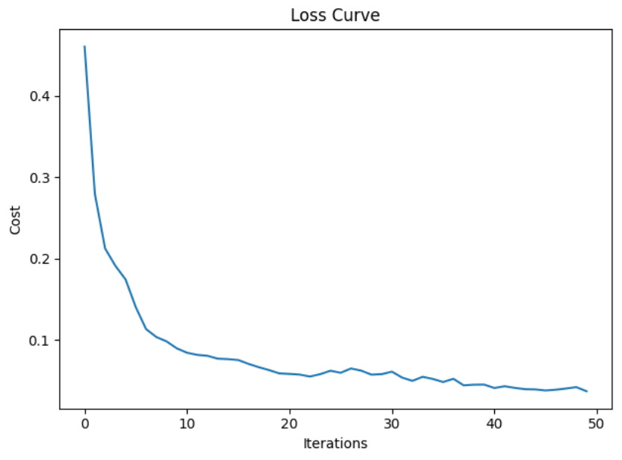

RMSE: 3.8574

|  |
| --- |
| import pandas as pd  import numpy as np  import matplotlib.pyplot as plt  from sklearn.model_selection import train_test_split  from sklearn.preprocessing import StandardScaler  from sklearn.neural_network import MLPRegressor  from sklearn import metrics  import warnings  warnings.filterwarnings(action='once')  PATH = "/users/pm/desktop/daydocs/data/"  CSV_DATA = "housing.data"  df = pd.read_csv(PATH + CSV_DATA, header=None)  # Show all columns.  pd.set_option('display.max_columns', None)  # Increase number of columns that display on one line.  pd.set_option('display.width', 1000)  print(df.head())  print(df.tail())  print(df.describe())  dataset = df.values  # split into input (X) and output (Y) variables  X = dataset[:,0:13]  y = dataset[:,13]  trainX, temp_X, trainY, temp_y = train_test_split(X, y, train_size = 0.7)  valX, testX, valY, testY = train_test_split(temp_X, temp_y, train_size = 0.5)  # Scale X and Y.  scX = StandardScaler()  scalerX = scX.fit(trainX)  trainX_scaled = scalerX.transform(trainX)  valX_scaled = scalerX.transform(valX)  testX_scaled = scalerX.transform(testX)  scY=StandardScaler()  trainY_scaled = scY.fit_transform(np.array(trainY).reshape(-1,1))  testY_scaled = scY.transform(np.array(testY).reshape(-1,1))  valY_scaled = scY.transform(np.array(valY).reshape(-1,1))  # Build basic multilayer perceptron.  model1 = MLPRegressor(  # 3 hidden layers with 150 neurons, 100, and 50.  hidden_layer_sizes = (150,100,50),  max_iter = 50, # epochs  activation = 'relu',  solver = 'adam', # optimizer  verbose=1)  model1.fit(trainX_scaled, trainY_scaled)  def showLosses(model):  plt.plot(model.loss_curve_)  plt.title("Loss Curve")  plt.xlabel('Iterations')  plt.ylabel('Cost')  plt.show()  def evaluateModel(model, testX_scaled, testY_scaled, scY):  showLosses(model)  scaledPredictions = model.predict(testX_scaled)  y_pred = scY.inverse_transform(  np.array(scaledPredictions).reshape(-1,1))  mse = metrics.mean_squared_error(testY_scaled, y_pred)  rmse = np.sqrt(mse)  print("RMSE: " + str(rmse))  evaluateModel(model1, valX_scaled, valY_scaled, scY)  # here is the new part.  param_grid = {  'hidden_layer_sizes': [(150,100,50), (120,80,40), (100,50,30)],  'max_iter': [50, 100],  'activation': ['tanh', 'relu'],  'solver': ['sgd', 'adam'],  'alpha': [0.0001, 0.05],  'learning_rate': ['constant','adaptive'],  } |

Example : Grid Searching the MLP Regressor

This example shows how to grid search the MLP Regressor parameters of the model from Example 7. It turns out that the base model tends to do a good job of fitting a neural network.

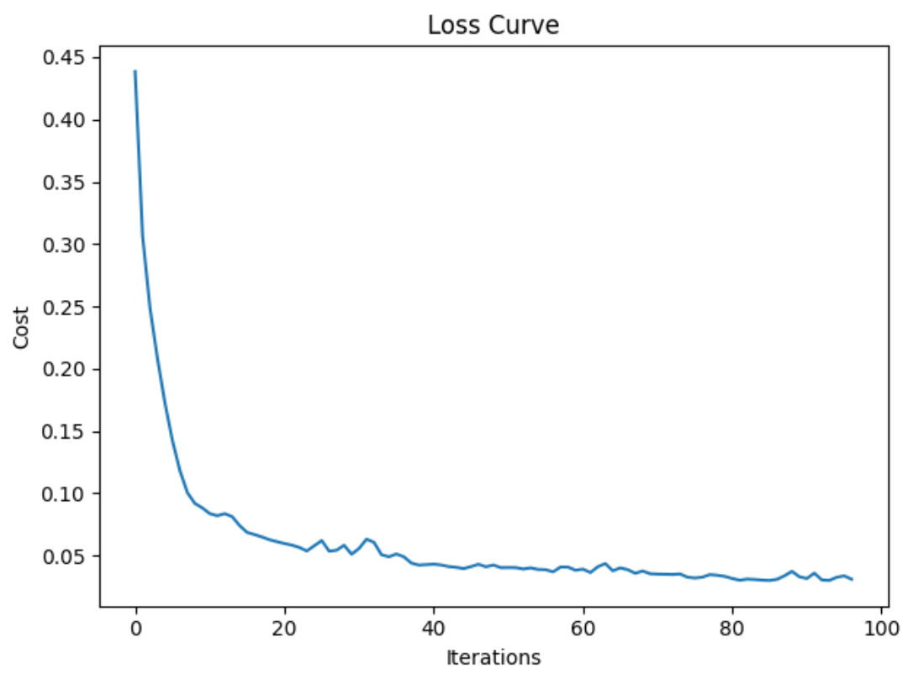

Sometimes, but not always, the grid search will find a better fit.

RMSE: 3.268

To build this example, add the following code to the end of Example 7.

|  |
| --- |
| # here is the new part.  param_grid = {  'hidden_layer_sizes': [(150,100,50), (120,80,40), (100,50,30)],  'max_iter': [50, 100],  'activation': ['tanh', 'relu'],  'solver': ['sgd', 'adam'],  'alpha': [0.0001, 0.05],  'learning_rate': ['constant','adaptive'],  }  from sklearn.model_selection import GridSearchCV  # n_jobs=-1 means use all processors.  # Run print(metrics.get_scorer_names()) for scoring choices.  model2 = MLPRegressor()  gridModel = GridSearchCV(model2, param_grid, n_jobs= -1, cv=10,  scoring='neg_mean_squared_error')  gridModel.fit(trainX_scaled, trainY_scaled)  print("Best parameters")  print(gridModel.best_params_)  evaluateModel(gridModel.best_estimator_, valX_scaled, valY_scaled, scY)  # Evaluate both models with test (unseen) data.  print("\n*** Base model with test data: ")  evaluateModel(model1, testX_scaled, testY_scaled, scY)  print(model1.get_params())  print("\n*** Grid searched model with test data: ")  evaluateModel(gridModel.best_estimator_, testX_scaled, testY_scaled, scY)  print(gridModel.get_params()) |

Exercise (2 marks)

Advanced parameter settings for learning rate provide algorithms for slowing down the learning rate as the model approaches an optimum. The scikit-learn model enables an adjusting learning rate with the ‘adaptive’ setting.

|  |
| --- |
| 'learning_rate': ['constant','adaptive'], |

Starting with Example 8, add an option to the grid search to include a range of starting learning rates. Then change the grid search so it uses a random search instead.

|  |
| --- |
| 'learning_rate_init': [0.0001, 0.001, 0.005, 0.01, 0.1, 0.2] |

Show your code here after making the changes:

|  |
| --- |
| import pandas as pd import numpy as np  import matplotlib.pyplot as plt from sklearn.model_selection import train_test_split from sklearn.preprocessing import StandardScaler from sklearn.neural_network import MLPRegressor from sklearn import metrics import warnings  warnings.filterwarnings(action='once')  PATH = "C:\\datasets\\" CSV_DATA = "housing.data" df = pd.read_csv(PATH + CSV_DATA, header=None)   # Show all columns. pd.set_option('display.max_columns', None)  # Increase number of columns that display on one line. pd.set_option('display.width', 1000)  print(df.head()) print(df.tail()) print(df.describe())  dataset = df.values  # split into input (X) and output (Y) variables X = dataset[:, 0:13] y = dataset[:, 13]  trainX, temp_X, trainY, temp_y = train_test_split(X, y, train_size=0.7) valX, testX, valY, testY = train_test_split(temp_X, temp_y, train_size=0.5)  # Scale X and Y. scX = StandardScaler() scalerX = scX.fit(trainX) trainX_scaled = scalerX.transform(trainX) valX_scaled = scalerX.transform(valX) testX_scaled = scalerX.transform(testX)  scY = StandardScaler() trainY_scaled = scY.fit_transform(np.array(trainY).reshape(-1, 1)) testY_scaled = scY.transform(np.array(testY).reshape(-1, 1)) valY_scaled = scY.transform(np.array(valY).reshape(-1, 1))  # Build basic multilayer perceptron. model1 = MLPRegressor(  # 3 hidden layers with 150 neurons, 100, and 50.  hidden_layer_sizes=(150, 100, 50),  max_iter=50, # epochs  activation='relu',  solver='adam', # optimizer  verbose=1) model1.fit(trainX_scaled, trainY_scaled)   def showLosses(model):  plt.plot(model.loss_curve_)  plt.title("Loss Curve")  plt.xlabel('Iterations')  plt.ylabel('Cost')  plt.show()   def evaluateModel(model, testX_scaled, testY_scaled, scY):  showLosses(model)  scaledPredictions = model.predict(testX_scaled)  y_pred = scY.inverse_transform(  np.array(scaledPredictions).reshape(-1, 1))  mse = metrics.mean_squared_error(testY_scaled, y_pred)  rmse = np.sqrt(mse)  print("RMSE: " + str(rmse))   evaluateModel(model1, valX_scaled, valY_scaled, scY)  # here is the new part. # param_grid = { # 'hidden_layer_sizes': [(150,100,50), (120,80,40), (100,50,30)], # 'max_iter': [50, 100], # 'activation': ['tanh', 'relu'], # 'solver': ['sgd', 'adam'], # 'alpha': [0.0001, 0.05], # 'learning_rate': ['constant','adaptive'], # }   # here is the new part. param_grid = {  'hidden_layer_sizes': [(150, 100, 50), (120, 80, 40), (100, 50, 30)],  'max_iter': [50, 100],  'activation': ['tanh', 'relu'],  'solver': ['sgd', 'adam'],  'alpha': [0.0001, 0.05],  'learning_rate': ['constant', 'adaptive'],  'learning_rate_init': [0.0001, 0.001, 0.005, 0.01, 0.1, 0.2] } from sklearn.model_selection import GridSearchCV from sklearn.model_selection import RandomizedSearchCV  # n_jobs=-1 means use all processors. # Run print(metrics.get_scorer_names()) for scoring choices. model2 = MLPRegressor() # gridModel = GridSearchCV(model2, param_grid, n_jobs=-1, cv=10,scoring='neg_mean_squared_error')  gridModel = RandomizedSearchCV(model2, param_distributions=param_grid, n_jobs=-1, scoring='neg_mean_squared_error')  gridModel.fit(trainX_scaled, trainY_scaled)  print("Best parameters") print(gridModel.best_params_) evaluateModel(gridModel.best_estimator_, valX_scaled, valY_scaled, scY)  # Evaluate both models with test (unseen) data. print("\n*** Base model with test data: ") evaluateModel(model1, testX_scaled, testY_scaled, scY) print(model1.get_params()) print("\n*** Grid searched model with test data: ") evaluateModel(gridModel.best_estimator_, testX_scaled, testY_scaled, scY) print(gridModel.get_params()) |

Run the random search after making the changes. Show a screenshot of the best model here.

|  |
| --- |
|  |

Table of Contents

Overcoming Memory Issues 1

Hyperparameter Terminology 2

Epoch 2

Batch Size 2

Loss Functions 2

For Classification 2

1. *Binary Crossentropy* **'binary_crossentropy'** 2

2. *Sparse Categorial Crossentropy* **'sparse_categorical_crossentropy'** 2

For Regression 3

Activation Functions 3

1. Sigmoid 'sigmoid' 3

2. Tanh 'tanh' 3

3. ReLU (Rectified Linear Unit) 'relu' 3

4. Leaky ReLU 4

5. Softmax 'softmax' 4

Optimizers 4

1. Adam 'adam' 4

2. SGD 'sgd' 4

Kernel Initializers 5

Gridsearching the Neural Network Hyperparameters 5

Least Squares Regression Baseline 5

Neural Network Baseline 7

Epoch and Batch Size 8

Optimizer 11

Learning Rate and Other Optimizer Parameters 12

Kernel Initializer 13

Number of Neurons 15

Adding Another Layer 16

Final Model 17

Additional Tuning Tips 17

Neural Network for Classification Tuning 18

Grid Searching the Learning Rate for a Classifier 23

## Overcoming Memory Issues

When working with networks or any data set in this course, if you experience memory issues, some strategies to cope are:

* Cut the data set into a half or a third of the size.
* Use Google Colab or AWS Sagemaker Studio Lab.

## Hyperparameter Terminology

Artificial neural networks have many parameters that need to be configured. This section describes some of the basic hyperparameter terms. The process of configuring hyperparameters is called **tuning**. This section will discuss some of the initial hyperparameters that we will work adjust when tuning.

### Epoch

An epoch is an iteration of all sample data through the network.

### Batch Size

The batch size is the number of samples that are processed before the model is updated. Batch size can range from 1 up to the number of samples. Figure 1 compares the advantages and disadvantages of small versus full sample batch sizes.

Figure : Comparing Small and Large Batch Sizes

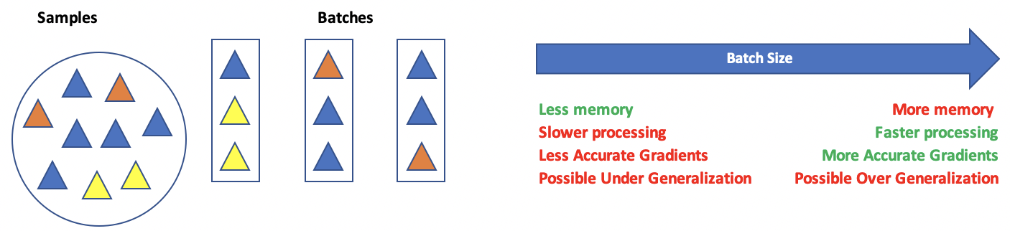

## Loss Functions

Loss functions help to measure the difference between actual and predicted results. There are many loss function algorithms. The selection relies on the type of output that is desired. For more information see <https://keras.io/api/losses/>

Here are some common loss function options:

### For Classification

### Binary Crossentropy **'binary_crossentropy'**

This option is used for a single output of 0 or 1.

### Sparse Categorial Crossentropy **'sparse_categorical_crossentropy'**

This option is used when categories are expressed as a series of non-binary integers such as:

0, 1, 2, 3

1. Categorical Crossentropy **'categorical_crossentropy'**

This option is less common but is helpful when output categories are one-hot encoded:

[1,0,0]

[0,1,0]

[0,0,1]

### For Regression

#### Mean squared error.

#### Mean absolute error.

<https://keras.io/api/losses/>

## Activation Functions

Activation functions are mathematical equations that determine the output of a neuron. Activation functions of the hidden layer are usually different than the activation function of an output layer. Here are some common activation functions:

### Sigmoid 'sigmoid'

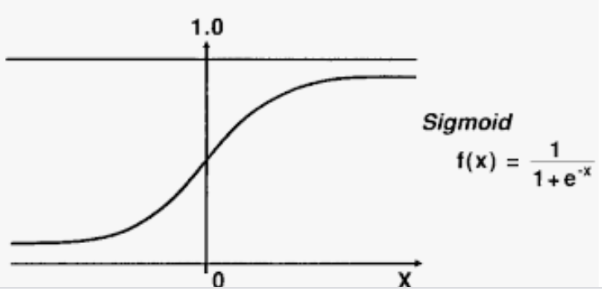

A sigmoid function transforms values to a value between 0 and 1. The sigmoid function can lead to a vanishing gradient problem in deeper networks because really large and really small values are not much different from each other. Computationally, the sigmoid is expensive.

### Tanh 'tanh'

With a tanh function, the outputs are centered about zero. Otherwise the advantages and disadvantages are similar to the sigmoid function.

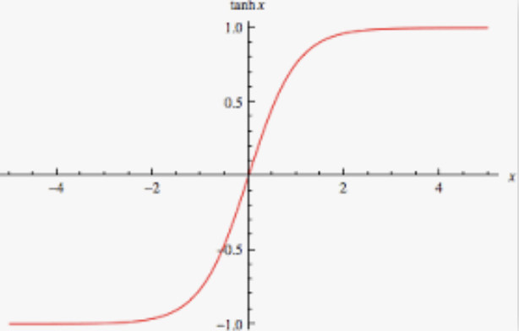

### ReLU (Rectified Linear Unit) 'relu'

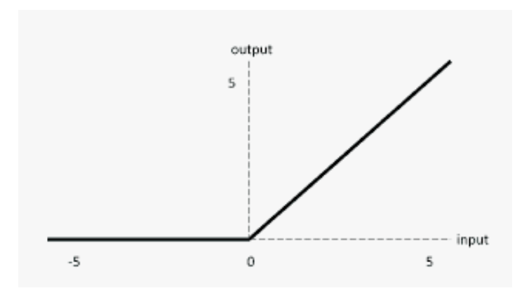

The ReLU is computationally efficient—it allows the network to converge very quickly. The ReLU is non-linear—but it looks like a linear function, ReLU has a derivative function and allows for backpropagation

**The Dying ReLU problem**—when inputs approach zero, or are negative, the gradient of the function becomes zero, the network cannot perform backpropagation and cannot learn when this happens.

### Leaky ReLU

|  |  |
| --- | --- |
|  | import tensorflow.keras as tf  lrelu = tf.keras.layers.LeakyReLU(  alpha=0.3  )  LeakyReLU allows a small gradient when neuron not active.  f(x) = alpha * x if x < 0   f(x) = x if x >= 0 |

The Leaky ReLU (LReLU or LReL) modifies the function to allow small negative values when the input is less than zero. This prevents dying the ReLU problem—this variation of ReLU has a small positive slope in the negative area, so it enables backpropagation, even for negative input values. Results are not consistent though since the leaky ReLU does not provide consistent predictions for negative input values.

### Softmax 'softmax'

Softmax is often used with **output neurons**. Softmax gives the probability of the input value being in a specific class. Softmax is good for classifying outputs in many categories and continuous values.

## Optimizers

Optimizers provide an algorithm to adjust **weights and bias** to reduce the losses in the network. Common optimizers are: Adadelta, Adagrad, Adam, Adamax, Ftrl, Nadam, RMSprop, and SGD. Often, optimizers can be implemented by name but often they can be further customized with additional parameters for items such as learning rates. For example, here are custom configurations for the adam and sgd optimizers:

### Adam 'adam'

tf.keras.optimizers.Adam(  
    learning_rate=0.001, beta_1=0.9, beta_2=0.999, epsilon=1e-07,

amsgrad=False, name='Adam', **kwargs  
)

### SGD 'sgd'

Updates with SGD can fluctuate with significant volatility. Momentum is a time-based weighting that helps to smooth the updates. Nesterov’s Accelerated Gradient Descent is an additional option that can sometimes eliminate volatility.

tf.keras.optimizers.SGD(  
    learning_rate=0.01, momentum=0.0, nesterov=False, name='SGD', **kwargs  
)

## Kernel Initializers

Kernel initializers set the algorithm which initializes weight values in each neuron. The aim of weight initialization is to prevent neuron gradients from exploding or vanishing. In other words, neurons cannot be revived if their gradients become too large or if the gradient is 0. The network may never reach an optimum if too many neuron gradients explode or vanish. Some initializer options include 'uniform', 'lecun_uniform', 'normal', 'zero', 'glorot_normal', 'glorot_uniform', 'he_normal', 'he_uniform'.

# Gridsearching the Neural Network Hyperparameters

KerasClassifier and KerasRegressor libraries appear to be deprecated for the grid search pipeline so I will perform manual grid searches instead.

## Least Squares Regression Baseline

When tuning your network hyperparameters, I recommend that you first build a basic logistic regression model or a simple least squares regression model. This model can help to identify significant predictor variables. The model can also help to determine a reasonable level of accuracy for your network.

Example : Building a Baseline Least Squares Regression Model

This example generates prediction for housing price which is located in last column on the right.

|  |
| --- |
| 0 1 2 3 4 5 6 7 8 9 10 11 12 13  0 0.00632 18.0 2.31 0 0.538 6.575 65.2 4.0900 1 296.0 15.3 396.90 4.98 24.0  1 0.02731 0.0 7.07 0 0.469 6.421 78.9 4.9671 2 242.0 17.8 396.90 9.14 21.6  2 0.02729 0.0 7.07 0 0.469 7.185 61.1 4.9671 2 242.0 17.8 392.83 4.03 34.7  3 0.03237 0.0 2.18 0 0.458 6.998 45.8 6.0622 3 222.0 18.7 394.63 2.94 33.4  4 0.06905 0.0 2.18 0 0.458 7.147 54.2 6.0622 3 222.0 18.7 396.90 5.33 36.2 |

In this initial OLS example, coefficients 3 and 7 are insignificant. The value of 0.765 indicates a strong correlation between the price and predictor variables. The root mean-square error, RMSE, value of 5.21 provides a decent understanding of the deviation about the mean which can be used as a comparison for other models. Here is the output when running the code for this example:

|  |
| --- |
| OLS Regression Results  OLS Regression Results  ==============================================================================  Dep. Variable: y R-squared: 0.765  Model: OLS Adj. R-squared: 0.756  Method: Least Squares F-statistic: 84.92  Date: Tue, 24 Jan 2023 Prob (F-statistic): 2.76e-98  Time: 17:26:56 Log-Likelihood: -1032.2  No. Observations: 354 AIC: 2092.  Df Residuals: 340 BIC: 2147.  Df Model: 13  Covariance Type: nonrobust  ==============================================================================  coef std err t P>|t| [0.025 0.975]  ------------------------------------------------------------------------------  const 37.9371 5.876 6.457 0.000 26.380 49.494  x1 -0.1213 0.038 -3.185 0.002 -0.196 -0.046  x2 0.0445 0.016 2.834 0.005 0.014 0.075  x3 0.0113 0.068 0.166 0.868 -0.123 0.146  x4 2.5112 1.011 2.483 0.014 0.522 4.501  x5 -16.2313 4.487 -3.618 0.000 -25.056 -7.406  x6 3.8591 0.491 7.867 0.000 2.894 4.824  x7 -0.0100 0.016 -0.634 0.527 -0.041 0.021  x8 -1.5003 0.234 -6.402 0.000 -1.961 -1.039  x9 0.2421 0.077 3.152 0.002 0.091 0.393  x10 -0.0111 0.004 -2.586 0.010 -0.019 -0.003  x11 -1.0178 0.150 -6.803 0.000 -1.312 -0.723  x12 0.0068 0.003 2.099 0.037 0.000 0.013  x13 -0.4867 0.060 -8.068 0.000 -0.605 -0.368  ==============================================================================  Omnibus: 133.612 Durbin-Watson: 2.019  Prob(Omnibus): 0.000 Jarque-Bera (JB): 634.086  Skew: 1.547 Prob(JB): 2.04e-138  Kurtosis: 8.781 Cond. No. 1.52e+04  ============================================================================== |

Here is the code for generating the least squares regression:

|  |
| --- |
| import pandas as pd  import numpy as np  from sklearn import metrics  from sklearn.model_selection import train_test_split  import statsmodels.api as sm  PATH = "/Users/pm/Desktop/DayDocs/data/"  CSV_DATA = "housing.data"  df = pd.read_csv(PATH + CSV_DATA, header=None)  # Show all columns on one line.  pd.set_option('display.max_columns', None)  pd.set_option('display.width', 1000)  print(df.head())  print(df.tail())  print(df.describe())  dataset = df.values  # Split data into input (X) and output (Y) variables.  X = dataset[:,0:13]  y = dataset[:,13]  # Adding an intercept *** This is required ***. Don't forget this step.  # The intercept centers the error residuals around zero  # which helps to avoid over-fitting.  X = sm.add_constant(X)  # Split the data.  X_train, X_temp, y_train, y_temp = train_test_split(X,  y, test_size=0.3, random_state=0)  X_test, X_val, y_test, y_val = train_test_split(X_temp,  y_temp, test_size=0.5, random_state=0)  # Make predictions and evaluate with the RMSE.  model = sm.OLS(y_train, X_train).fit()  predictions = model.predict(X_test)  print(model.summary())  print('Root Mean Squared Error:',  np.sqrt(metrics.mean_squared_error(y_test, predictions))) |

## Neural Network Baseline

The next step involves creating a simple baseline neural network. I recommend that you begin by building a 1-layer network. You may decide later to start with more layers. For now, at least understand the grid search technique before designing more complicated solutions.

Example : Neural Network Baseline Housing Data

Right now, our crude baseline neural network model does not perform as well as the linear regression model. With some tuning it is very possible that we can generate a better fitting model than OLS.

|  |  |
| --- | --- |
| **OLS RMSE from Example 1** | **RMSE from Neural Network** |
| 5.2133376653973365 | 4.936674345497767 |

Here is the code.

**Note:** Remember to reshape your X and Y data into vertical columns.

|  |
| --- |
| import pandas as pd  import numpy as np  from sklearn import metrics  from sklearn.model_selection import train_test_split  from keras.models import Sequential  from keras.layers import Dense  # Read the data.  PATH = "/Users/pm/Desktop/DayDocs/data/"  CSV_DATA = "housing.data"  df = pd.read_csv(PATH + CSV_DATA, header=None)  # Show all columns.  pd.set_option('display.max_columns', None)  pd.set_option('display.width', 1000)  print(df.head())  print(df.tail())  print(df.describe())  # Convert DataFrame columns to vertical columns so they can be used by the NN.  dataset = df.values  X = dataset[:, 0:13] # Columns 0 to 12  y = dataset[:, 13] # Columns 13  ROW_DIM = 0  COL_DIM = 1  x_arrayReshaped = X.reshape(X.shape[ROW_DIM], X.shape[COL_DIM])  y_arrayReshaped = y.reshape(y.shape[ROW_DIM],1)  # Split the data.  X_train, X_temp, y_train, y_temp = train_test_split(x_arrayReshaped,  y_arrayReshaped, test_size=0.3, random_state=0)  X_test, X_val, y_test, y_val = train_test_split(X_temp,  y_temp, test_size=0.5, random_state=0)  # Define the model.  def create_model():  model = Sequential()  model.add(Dense(13, input_dim=13, kernel_initializer='normal',  activation='relu'))  model.add(Dense(1, kernel_initializer='normal'))  model.compile(loss='mean_squared_error', optimizer='adam')  return model  model = create_model()  # Build the model.  model = create_model()  history = model.fit(X_train, y_train, epochs=100,  batch_size=5, verbose=1,  validation_data=(X_val, y_val))  # Evaluate the model.  predictions = model.predict(X_test)  mse = metrics.mean_squared_error(y_test, predictions)  print("Neural network MSE: " + str(mse))  print("Neural network RMSE: " + str(np.sqrt(mse))) |

## Epoch and Batch Size

Now we can start grid searching our hyperparameters ideally to minimize the RMSE the house price predictions more.

Example : Epoch and Batch Tuning

This example manually grid searches batch size and epochs.

My trial showed that a batch of 10 and 100 epochs were most optimal. However, results will vary. It would be much better to use cross fold validation to evaluate the model over multiple runs.

|  |
| --- |
| rmse epochs batch  1 5.088442 100 10  2 5.286852 200 10  5 5.627772 200 60  0 5.853373 50 10  8 6.675932 200 100  4 7.190926 100 60  7 7.759760 100 100  6 8.367856 50 100  3 8.792805 50 60 |

Here is the code:

|  |
| --- |
| import pandas as pd  import numpy as np  from sklearn.model_selection import train_test_split  from sklearn.metrics import mean_squared_error  from keras.models import Sequential  from keras.layers import Dense  PATH = "/Users/pm/Desktop/DayDocs/data/"  CSV_DATA = "housing.data"  df = pd.read_csv(PATH + CSV_DATA, header=None)  # Show all columns.  pd.set_option('display.max_columns', None)  pd.set_option('display.width', 1000)  print(df.head())  print(df.tail())  print(df.describe())  dataset = df.values  # split into input (X) and output (Y) variables  X = dataset[:,0:13]  y = dataset[:,13]  # Split the data.  X_train, X_temp, y_train, y_temp = train_test_split(X,  y, test_size=0.3, random_state=0)  X_test, X_val, y_test, y_val = train_test_split(X_temp,  y_temp, test_size=0.5, random_state=0)  def evaluateModel(model, X_test, y_test):  predictions = model.predict(X_test)  rmse = np.sqrt(mean_squared_error(y_test, predictions))  print("RMSE: " + str(rmse))  return rmse  def showResults(networkStats):  dfStats = pd.DataFrame.from_records(networkStats)  dfStats = dfStats.sort_values(by=['rmse'])  print(dfStats)  networkStats = []  ### Model parameters ############################  batch_sizes = [10, 60, 100]  epochList = [50, 100, 200]  #################################################  #################################################  # Build model  def create_model():  model = Sequential()  model.add(Dense(13, input_dim=13, kernel_initializer='normal',  activation='relu'))  model.add(Dense(1, kernel_initializer='normal'))  model.compile(loss='mean_squared_error', optimizer='adam')  return model  for batch_size in batch_sizes:  for epochs in epochList:  model = create_model()  history = model.fit(X_train, y_train, epochs=epochs,  batch_size=batch_size, verbose=1,  validation_data=(X_val, y_val))  rmse = evaluateModel(model, X_test, y_test)  networkStats.append({"rmse":rmse, "epochs":epochs, "batch":batch_size})  showResults(networkStats)  ################################################# |

## Optimizer

This section shows a strategy for grid searching the general optimizer. A more advanced version of each optimizer likely exists. It is usually possible to tweak the learning rate and other parameters that are specific to each optimizer which once an optimizer candidate is found.

Example : Searching for the most efficient Optimizer

Now that we have established a batch size of 10 and 100 epochs is a suitable estimate, we can look for an optimizer. The output suggests that the adam optimizer is best. The ‘adam’ optimizer will be used as a result for the model in all future examples.

|  |
| --- |
| rmse optimizer  1 5.036573 Adam  6 5.272861 Nadam  4 5.346332 RMSprop  5 7.874382 Adamax  2 9.605278 Adagrad  0 9.794729 SGD  3 18.393395 Adadelta |

To build this example, swap out the “Model parameters” and “Build model” sections of Example 3 with the following code:

|  |
| --- |
| ### Model parameters ############################  optimizers = ['SGD', 'RMSprop', 'Adagrad',  'Adadelta', 'Adam', 'Adamax', 'Nadam']  #################################################  #################################################  # Build model  def create_model(optimizer="SGD"):  model = Sequential()  model.add(Dense(13, input_dim=13, kernel_initializer='normal',  activation='relu'))  model.add(Dense(1, kernel_initializer='normal'))  model.compile(loss='mean_squared_error', optimizer=optimizer)  return model  for optimizer in optimizers:  BATCH_SIZE = 10  EPOCHS = 100  model = create_model(optimizer)  history = model.fit(X_train, y_train, epochs=EPOCHS,  batch_size=BATCH_SIZE, verbose=1,  validation_data=(X_val, y_val))  rmse = evaluateModel(model, X_test, y_test)  networkStats.append({"rmse":rmse, "optimizer":optimizer})  showResults(networkStats)  ################################################# |

Exercise (1 mark)

Choose the best answer.

1. An optimizer sets an algorithm to initialize weights for each neuron.
2. An optimizer sets an algorithm for scaling data in each neuron.
3. An optimizer sets an algorithm for activation.
4. An optimizer sets an algorithm for minimizing losses.

## Learning Rate and Other Optimizer Parameters

Most optimizers have more advanced customizable settings. Usually you can adjust the learning rate and other parameters. Documentation for several common optimizers can be found at <https://keras.io/api/optimizers/>

Example : Optimizing the Learning Rate

Since the ‘adam’ optimizer was identified as a strong performer in the previous example, we can fine tune it more by adjusting its learning rate. The ‘adam’ optimizer actually has many more parameters but we will focus on only the learning rate for this example:

|  |
| --- |
| tf.keras.optimizers.Adam(  learning_rate=0.001  ) |

The output when running the grid search for the best learning rate suggest a learning rate of 0.005 for our optimizer.

|  |
| --- |
| rmse learningRate  2 4.992756 0.005  1 5.041506 0.010  0 5.465462 0.001  3 5.551813 0.015  4 9.798956 0.200 |

To build this example replace the “Model parameters” and “Build model” sections of Example 4 with the following:

|  |
| --- |
| ### Model parameters ############################  learningRates= [0.001, 0.005, 0.01, 0.015, 0.2]  #################################################  #################################################  # Build model  import keras  from keras.optimizers import Adam #for adam optimizer  def create_model(learningRate = 0.001):  model = Sequential()  model.add(Dense(13, input_dim=13, kernel_initializer='normal',  activation='relu'))  model.add(Dense(1, kernel_initializer='normal'))    # Use Adam optimizer with the given learning rate  optimizer = Adam(lr=learningRate)  model.compile(loss='mean_squared_error', optimizer=optimizer)  return model  for learningRate in learningRates:  BATCH_SIZE = 10  EPOCHS = 100  model = create_model(learningRate)  history = model.fit(X_train, y_train, epochs=EPOCHS,  batch_size=BATCH_SIZE, verbose=1,  validation_data=(X_val, y_val))  rmse = evaluateModel(model, X_test, y_test)  networkStats.append({"rmse":rmse, "learningRate":learningRate})  showResults(networkStats) |

Exercise (1 mark)

How is the parameter of the create_model() function in Example 5 different than the parameter in the create_model() function of Example 4?

|  |
| --- |
| The parameter of create_model() in example 4 takes and optimizer as a name. The parameter of create_model() in example 5 takes a learning rate as a decimal. |

Exercise (3 marks)

Manually plug-in a batch size of 10 into the code within Example 2. Ensure that the model is tuned with 100 epochs. Inside create_model() initialize an adam optimizer with a learning rate of 0.005. Assign this optimizer object to the optimizer parameter in create_model(). Show the RMSE that results after making these changes:

|  |
| --- |
| Neural network RMSE: 5.897710092895795 |

What is the RMSE of the original configuration from Example 2?

|  |
| --- |
| Neural network RMSE: 5.519604807593965 |

Show the section of code that you modified here.

|  |
| --- |
| # Define the model. def create_model(learningRate=0.005):  model = Sequential()  model.add(Dense(13, input_dim=13, kernel_initializer='normal',  activation='relu'))  model.add(Dense(1, kernel_initializer='normal'))   # Use Adam optimizer with the given learning rate  optimizer = Adam(lr=learningRate)  model.compile(loss='mean_squared_error', optimizer=optimizer)  return model   model = create_model()  # Build the model. model = create_model() history = model.fit(X_train, y_train, epochs=100,  batch_size=10, verbose=1,  validation_data=(X_val, y_val)) |

## Kernel Initializer

Kernel initializers use a distribution to optimize the initial model weights. The different algorithms for initializing weight can sometimes help to prevent vanishing and exploding gradients which destroy a neuron’s ability to back-propagate data.

Example : Grid Searching the Kernel Initializer

This section shows that some initializers perform much better than others. ‘uniform’ offers the best score and it is noticeably smaller than the ‘zero’ initializer.

|  |
| --- |
| rmse initializer  2 5.141459 uniform  7 5.147688 he_uniform  5 5.500346 glorot_uniform  0 5.506580 normal  6 5.556400 he_normal  1 5.840333 lecun_uniform  4 6.555245 glorot_normal  3 11.799726 zero |

To build this example replace the “Model parameters” and “Build model” sections of the last example with this version.

|  |
| --- |
| ### Model parameters ############################  init_modes = ['uniform', 'lecun_uniform', 'normal', 'zero',  'glorot_normal',  'glorot_uniform', 'he_normal', 'he_uniform']  #################################################  #################################################  # Build model  import keras  from keras.optimizers import Adam #for adam optimizer  def create_model(inialtizer = 'normal'):  model = Sequential()  model.add(Dense(13, input_dim=13, kernel_initializer=inialtizer,  activation='relu'))  model.add(Dense(1, kernel_initializer=inialtizer))  # Use Adam optimizer with the given learning rate  LEARNING_RATE = 0.005  optimizer = Adam(lr=LEARNING_RATE)  model.compile(loss='mean_squared_error', optimizer=optimizer)  return model  for initializer in init_modes:  BATCH_SIZE = 10  EPOCHS = 100  model = create_model(initializer)  history = model.fit(X_train, y_train, epochs=EPOCHS,  batch_size=BATCH_SIZE, verbose=1,  validation_data=(X_val, y_val))  rmse = evaluateModel(model, X_test, y_test)  networkStats.append({"rmse":rmse, "initializer":initializer})  showResults(networkStats)  ################################################# |

Exercise (3 marks)

Manually plug-in a batch size of 10 into the code within Example 2. Ensure that the model is tuned with 100 epochs. Inside create_model() initialize an adam optimizer with a learning rate of 0.005. Assign this optimizer object to the optimizer parameter in create_model(). Set the kernel initializer to ‘uniform’. Show the RMSE that results after making these changes:

|  |
| --- |
| Neural network RMSE: 5.085298452892481 |

What is the RMSE of the original configuration from Example 2?

|  |
| --- |
| Neural network RMSE: 5.519604807593965 |

Show the section of code that you modified here.

|  |
| --- |
| # Define the model. def create_model(inialtizer='uniform'):  model = Sequential()  model.add(Dense(13, input_dim=13, kernel_initializer=inialtizer,  activation='relu'))  model.add(Dense(1, kernel_initializer=inialtizer))   # Use Adam optimizer with the given learning rate  LEARNING_RATE = 0.005  optimizer = Adam(lr=LEARNING_RATE)  model.compile(loss='mean_squared_error', optimizer=optimizer)  return model   model = create_model()  # Build the model. model = create_model() history = model.fit(X_train, y_train, epochs=100,  batch_size=10, verbose=1,  validation_data=(X_val, y_val)) |

## Number of Neurons

Now we can examine the optimal number of neurons for the initial hidden layer.

Example : Number of Neurons Tuning

The output suggests that 25 neurons is optimal.

|  |
| --- |
| rmse # neurons  2 4.928856 25  1 4.959842 50  3 5.103180 100  4 5.173724 150  0 6.875537 5 |

To build this example replace the “Model parameters” and “Build model” sections of the last example with this version.

|  |
| --- |
| ### Model parameters ############################  neuronList = [5, 25, 50, 100, 150]  #################################################  #################################################  # Build model  import keras  from keras.optimizers import Adam #for adam optimizer  def create_model(numNeurons):  model = Sequential()  model.add(Dense(numNeurons,  input_dim=13, kernel_initializer='uniform',  activation='relu'))  model.add(Dense(1, kernel_initializer='uniform'))  # Use Adam optimizer with the given learning rate  LEARNING_RATE = 0.005  optimizer = Adam(lr=LEARNING_RATE)  model.compile(loss='mean_squared_error', optimizer=optimizer)  return model  for numNeurons in neuronList:  BATCH_SIZE = 10  EPOCHS = 100  model = create_model(numNeurons)  history = model.fit(X_train, y_train, epochs=EPOCHS,  batch_size=BATCH_SIZE, verbose=1,  validation_data=(X_val, y_val))  rmse = evaluateModel(model, X_test, y_test)  networkStats.append({"rmse":rmse, "# neurons":numNeurons})  showResults(networkStats)  ################################################# |

## Adding Another Layer

By now, you may realize just how many possible hyperparameter combinations exist. We could tinker with the algorithm further by adding another layer. You actually have the ability to include as many hyperparameters as you want in a grid search but a significant constraint is time so be practical about how many options that you tune at once.

The outcome suggests that two additional layers could improve results.

|  |
| --- |
| rmse # additional layers  2 4.761330 2  0 4.762825 0  5 5.143485 5  4 5.292722 4  1 5.308366 1  3 5.422089 3 |

To build this example replace the “Model parameters” and “Build model” sections of the last example with this version.

|  |
| --- |
| ### Model parameters ############################  additionalLayers = [0, 1, 2, 3, 4, 5]  #################################################  #################################################  # Build model  import keras  from keras.optimizers import Adam #for adam optimizer  def create_model(numExtraLayers):  NUM_NEURONS = 25  model = Sequential()  model.add(Dense(NUM_NEURONS,  input_dim=13, kernel_initializer='uniform',  activation='relu'))  for i in range(0, numExtraLayers):  # You could further grid search initializer, num_neurons  # and activation function for each layer if desired.  model.add(Dense(NUM_NEURONS,kernel_initializer='uniform',  activation='relu'))  model.add(Dense(1, kernel_initializer='uniform'))  # Use Adam optimizer with the given learning rate  LEARNING_RATE = 0.005  optimizer = Adam(lr=LEARNING_RATE)  model.compile(loss='mean_squared_error', optimizer=optimizer)  return model  for numLayers in additionalLayers:  BATCH_SIZE = 10  EPOCHS = 100  model = create_model(numLayers)  history = model.fit(X_train, y_train, epochs=EPOCHS,  batch_size=BATCH_SIZE, verbose=1,  validation_data=(X_val, y_val))  rmse = evaluateModel(model, X_test, y_test)  networkStats.append({"rmse":rmse, "# additional layers":numLayers})  showResults(networkStats)  ################################################# |

## Final Model

Example : Building the Final Model

The final model appears to be the best yet. Results will vary though since the data is randomized. For best results always evaluate models over multiple runs such as with cross fold validation.

|  |  |
| --- | --- |
| Model | RMSE |
| OLS Model | 5.21 |
| Baseline Neural Network | 4.94 |
| Optimized Neural Network | 4.76 |

## Additional Tuning Tips

This section lists some helpful tips to consider when tuning hyperparameters of your neural network. Pay attention to set size.

* **k-fold Cross Validation**. The network is trained with random subsets of data at each epoch so results will vary. Evaluating your models with cross fold validation over multiple runs will help to provide more stable evaluations.
* **Fine Tune**. Do not just focus on the best result, review the whole grid of results and look for trends to support configuration fine-tuning decisions.
* **Use a Sample of Your Dataset**. Because networks are slow to train, try training them on a smaller sample of your training dataset, just to get an idea of general directions of parameters rather than optimal configurations.

## Neural Network for Classification Tuning

Example : Grid Searching Batch Size and Number of Epochs

This example shows a way to grid search batch size and number of epochs for classification.

The logistic regression model shows the following statistics:

|  |
| --- |
| * **Precision**: 0.94 **Recall**: 0.70. **F1**: 0.80 |

The network does quite a bit better. Since 200 epochs produces the same results at 300 epochs I will go with 200 epochs to save time. Of course, there is room for fine-tuning and more reliable evaluation over multiple runs.

|  |
| --- |
| precision recall f1 epochs batch  6 0.941176 0.695652 0.800000 100 100  7 0.944444 0.739130 0.829268 200 100  4 1.000000 0.826087 0.904762 200 60  0 0.952381 0.869565 0.909091 100 10  2 0.952381 0.869565 0.909091 300 10  8 1.000000 0.869565 0.930233 300 100  3 0.954545 0.913043 0.933333 100 10  1 1.000000 0.913043 0.954545 200 60  5 1.000000 0.913043 0.954545 300 60 |

Here is the code:

|  |
| --- |
| import pandas as pd  from sklearn.model_selection import train_test_split  from sklearn.linear_model import LogisticRegression  from sklearn.metrics import precision_score, recall_score, f1_score,\  accuracy_score, classification_report  PATH = "/Users/pm/Desktop/DayDocs/data/"  FILE = "Social_Network_Ads.csv"  data = pd.read_csv(PATH + FILE)  y = data["Purchased"]  X = data.copy()  del X['User ID']  del X['Purchased']  X['Gender'] = X['Gender'].map({'Male': 0, 'Female': 1})  # Show all columns.  pd.set_option('display.max_columns', None)  pd.set_option('display.width', 1000)  print(data.head())  X_train, X_temp, y_train, y_temp = train_test_split(  X, y, test_size=0.3, random_state=42  )  X_test, X_val, y_test, y_val = train_test_split(  X_temp, y_temp, test_size=0.5, random_state=42  )  # Stochastic gradient descent models are sensitive to differences  from sklearn.preprocessing import StandardScaler  scaler = StandardScaler()  scaler.fit(X_train)  X_trainScaled = scaler.transform(X_train)  X_testScaled = scaler.transform(X_test)  X_valScaled = scaler.transform(X_val)  def showResults(networkStats):  dfStats = pd.DataFrame.from_records(networkStats)  dfStats = dfStats.sort_values(by=['f1'])  print(dfStats)  def evaluate_model(predictions, y_test):  precision = precision_score(y_test, predictions)  recall = recall_score(y_test, predictions)  f1 = f1_score(y_test, predictions)  print("Precision: " + str(precision) + " " +\  "Recall: " + str(recall) + " " +\  "F1: " + str(f1))  return precision, recall, f1  clf = LogisticRegression(max_iter=1000)  clf.fit(X_trainScaled, y_train)  predictions = clf.predict(X_testScaled)  evaluate_model(predictions, y_test)  COLUMN_DIMENSION = 1  #######################################################################  # Part 2  from keras.models import Sequential  from keras.layers import Dense  # shape() obtains rows (dim=0) and columns (dim=1)  n_features = X_trainScaled.shape[COLUMN_DIMENSION]  def getPredictions(model, X_test):  probabilities = model.predict(X_test)  predictions = []  for i in range(len(probabilities)):  if (probabilities[i][0] > 0.5):  predictions.append(1)  else:  predictions.append(0)  return predictions  ### Model parameters ############################  batch_sizes = [10, 60, 100]  epochList = [100, 200, 300]  #################################################  #######################################################################  # Model building section.  def create_model():  model = Sequential()  model.add(Dense(12, input_dim=n_features, activation='relu'))  model.add(Dense(1, activation='sigmoid'))  model.compile(loss='binary_crossentropy', optimizer='adam',  metrics=['accuracy'])  return model  networkStats = []  for batch_size in batch_sizes:  for epochs in epochList:  model = create_model()  history = model.fit(X_trainScaled, y_train, epochs=epochs,  batch_size=batch_size, verbose=1,  validation_data=(X_valScaled, y_val))  predictions = getPredictions(model, X_testScaled)  precision, recall, f1 = evaluate_model(predictions, y_test)  networkStats.append({"precision":precision, "recall":recall,  "f1":f1, "epochs":epochs,  "batch":batch_size})  showResults(networkStats)  ####################################################################### |

Exercise (1 mark)

How many input dimensions are used for the input layer in Example 9?

|  |
| --- |
| 3 |

Exercise (1 mark)

The values for batch or epochs may be fined tuned. Suggest a better pairing for number of epochs and batch size for Example 9. Show the model parameters section after you adjust the range of options here:

|  |
| --- |
| batch_sizes = [75, 100, 125] epochList = [300, 375, 400] |

Show the final results and highlight the optimal combination that is revealed here:

|  |
| --- |
|  |

Example : Grid Searching the Classifier for an Optimizer

This code grid searches an optimizer for the classification model. Here are the rankings. RMSprop appears to be the winner.

|  |
| --- |
| precision recall f1 optimizer  3 0.294118 0.434783 0.350877 Adadelta  5 0.941176 0.695652 0.800000 Adamax  2 0.800000 0.869565 0.833333 Adagrad  0 0.947368 0.782609 0.857143 SGD  4 0.947368 0.782609 0.857143 Adam  6 0.954545 0.913043 0.933333 Nadam  1 1.000000 0.913043 0.954545 RMSprop |

This is the code:

|  |
| --- |
| import pandas as pd  from sklearn.model_selection import train_test_split  from sklearn.linear_model import LogisticRegression  from sklearn.metrics import precision_score, recall_score, f1_score,\  accuracy_score, classification_report  PATH = "/Users/pm/Desktop/DayDocs/data/"  FILE = "Social_Network_Ads.csv"  data = pd.read_csv(PATH + FILE)  y = data["Purchased"]  X = data.copy()  del X['User ID']  del X['Purchased']  X['Gender'] = X['Gender'].map({'Male': 0, 'Female': 1})  # Show all columns.  pd.set_option('display.max_columns', None)  pd.set_option('display.width', 1000)  print(data.head())  X_train, X_temp, y_train, y_temp = train_test_split(  X, y, test_size=0.3, random_state=42  )  X_test, X_val, y_test, y_val = train_test_split(  X_temp, y_temp, test_size=0.5, random_state=42  )  # Stochastic gradient descent models are sensitive to differences  from sklearn.preprocessing import StandardScaler  scaler = StandardScaler()  scaler.fit(X_train)  X_trainScaled = scaler.transform(X_train)  X_testScaled = scaler.transform(X_test)  X_valScaled = scaler.transform(X_val)  def showResults(networkStats):  dfStats = pd.DataFrame.from_records(networkStats)  dfStats = dfStats.sort_values(by=['f1'])  print(dfStats)  def evaluate_model(predictions, y_test):  precision = precision_score(y_test, predictions)  recall = recall_score(y_test, predictions)  f1 = f1_score(y_test, predictions)  print("Precision: " + str(precision) + " " +\  "Recall: " + str(recall) + " " +\  "F1: " + str(f1))  return precision, recall, f1  clf = LogisticRegression(max_iter=1000)  clf.fit(X_trainScaled, y_train)  predictions = clf.predict(X_testScaled)  evaluate_model(predictions, y_test)  COLUMN_DIMENSION = 1  #######################################################################  # Part 2  from keras.models import Sequential  from keras.layers import Dense  # shape() obtains rows (dim=0) and columns (dim=1)  n_features = X_trainScaled.shape[COLUMN_DIMENSION]  def getPredictions(model, X_test):  probabilities = model.predict(X_test)  predictions = []  for i in range(len(probabilities)):  if (probabilities[i][0] > 0.5):  predictions.append(1)  else:  predictions.append(0)  return predictions  ### Model parameters ############################  optimizers = ['SGD', 'RMSprop', 'Adagrad',  'Adadelta', 'Adam', 'Adamax', 'Nadam']  #################################################  #######################################################################  # Model building section.  def create_model(optimizer):  model = Sequential()  model.add(Dense(12, input_dim=n_features, activation='relu'))  model.add(Dense(1, activation='sigmoid'))  model.compile(loss='binary_crossentropy', optimizer=optimizer,  metrics=['accuracy'])  return model  networkStats = []  EPOCHS = 200  NUM_BATCHES = 60  for optimizer in optimizers:  model = create_model(optimizer)  history = model.fit(X_trainScaled, y_train, epochs=EPOCHS,  batch_size=NUM_BATCHES, verbose=1,  validation_data=(X_valScaled, y_val))  predictions = getPredictions(model, X_testScaled)  precision, recall, f1 = evaluate_model(predictions, y_test)  networkStats.append({"precision":precision, "recall":recall,  "f1":f1, "optimizer":optimizer})  showResults(networkStats)  ####################################################################### |

## Grid Searching the Learning Rate for a Classifier

I am not an expert on RMSprop optimizers. However, when searching the Keras documentation at <https://keras.io/api/optimizers/>

I can see many parameter options. I will only focus on the learning rate for now.

|  |
| --- |
| tf.keras.optimizers.RMSprop(  learning_rate=0.001,  rho=0.9,  momentum=0.0,  epsilon=1e-07,  centered=False,  weight_decay=None,  clipnorm=None,  clipvalue=None,  global_clipnorm=None,  use_ema=False,  ema_momentum=0.99,  ema_overwrite_frequency=100,  jit_compile=True,  name="RMSprop",  **kwargs  ) |

Example : Grid Searching the Learning Rate

To build this example replace the “Model parameters” and “Build model” sections of the last example with this version.

|  |
| --- |
| ### Model parameters ############################  learningRates = [0.0001, 0.001, 0.005, 0.01]  #################################################  #######################################################################  # Model building section.  from keras.optimizers import RMSprop #for adam optimizer  def create_model(learningRate):  model = Sequential()  model.add(Dense(12, input_dim=n_features, activation='relu'))  model.add(Dense(1, activation='sigmoid'))  optimizer = RMSprop(learning_rate=learningRate)  model.compile(loss='binary_crossentropy', optimizer=optimizer,  metrics=['accuracy'])  return model  networkStats = []  EPOCHS = 200  NUM_BATCHES = 60  for learningRate in learningRates:  model = create_model(learningRate)  history = model.fit(X_trainScaled, y_train, epochs=EPOCHS,  batch_size=NUM_BATCHES, verbose=1,  validation_data=(X_valScaled, y_val))  predictions = getPredictions(model, X_testScaled)  precision, recall, f1 = evaluate_model(predictions, y_test)  networkStats.append({"precision":precision, "recall":recall,  "f1":f1, "learningRate":learningRate})  showResults(networkStats)  ####################################################################### |

The output shows that a learning rate of 0.001 achieves optimal results. Efforts to fine tune results might include [0.0005, 0.0008, 0.0012, 0.0014, 0.002] and so on in case further improvements can be made.

|  |
| --- |
| precision recall f1 learningRate  0 0.916667 0.478261 0.628571 0.0001  1 0.954545 0.913043 0.933333 0.0010  2 0.954545 0.913043 0.933333 0.0050  3 0.954545 0.913043 0.933333 0.0100 |

Exercise (3 marks)

Starting with the code from Example 11, set the optimal learning rate and modify the code to enable grid searching for the optimal number of neurons in the hidden layer.

Show the changes that you make to the model parameters and model building sections here:

|  |
| --- |
| # -------------------Model parameters---------------------------  neuronList = [5, 10, 25, 50, 75, 100, 125, 150]  # --------------------------------------------------------------  # ------------ Build model ------------------------------------- # Build model import keras from keras.optimizers import RMSprop   def create_model(numNeurons):  model = Sequential()  model.add(Dense(numNeurons,  input_dim=3, kernel_initializer='uniform',  activation='relu'))  model.add(Dense(1, kernel_initializer='uniform'))   # Use Adam optimizer with the given learning rate  LEARNING_RATE = 0.0100  # optimizer = Adam(lr=LEARNING_RATE)  optimizer = RMSprop(learning_rate=LEARNING_RATE)  # model.compile(loss='mean_squared_error', optimizer=optimizer)  model.compile(loss='binary_crossentropy', optimizer=optimizer,  metrics=['accuracy'])  return model   networkStats = [] EPOCHS = 200 NUM_BATCHES = 60  for numNeurons in neuronList:  # BATCH_SIZE = 10  # EPOCHS = 100  model = create_model(numNeurons)  history = model.fit(X_trainScaled, y_train, epochs=EPOCHS,  batch_size=NUM_BATCHES, verbose=1,  validation_data=(X_valScaled, y_val))  predictions = getPredictions(model, X_testScaled)   # Unfortunate need to format data.  y_test.to_list()  predictions = list(predictions)  # precision, recall, f1 = evaluate_model(model, X_test, y_test)  precision, recall, f1 = evaluate_model(predictions, y_test)  networkStats.append({"precision": precision, "recall": recall,  "f1": f1, "# neurons": numNeurons})  print(networkStats) print() showResults(networkStats) # -------------------------------------------------------------- |

Show a screenshot of the results that are obtained when grid searching the number of neurons in the hidden layer.

|  |
| --- |
|  |

How many neurons did you choose and explain why?

|  |
| --- |
| 10 neurons results in the highest f1 score. |

What are the metrics of your logistic regression model?

|  |
| --- |
| Precision, recall, f1 score |

What are the metrics of your final neural network model?

|  |
| --- |
| Precision, recall, F1, accuracy |

Table of Contents

Bagging 1

Bagged Classifier 1

Bagged Regressors 4

Grid Searching 5

Boosting 8

Adaptive Boosting 8

Gradient Boosting 12

Xtreme Gradient Boosting 12

Ensembles 14

Stacked Models 15

Stacking Regression 15

Stacking Classification 18

## Bagging

Bagging involves averaging the predictions from the weak learners to generate a more stable result with less variance. ‘Bagging’ is a term that is derived from the terms “bootstrapping” and “aggregating”. Bootstrapping involves sampling with replacement. Weak learners of the same type are built with the bootstrapped data.

A random forest is a great example of a bagging algorithm since it combines many weak decision trees with random data. Other types of learners can be bagged as well.

### Bagged Classifier

We have looked at bagging with random forests. We can perform bagging with other model types as well.

Example : Bagging

Next in this example, several stand-alone and bagged classifiers are compared. These classifiers include:

* KNeighborsClassifier()
* SVC()
* RidgeClassifier()

Bagging often offers a slight improvement in accuracy with generally less variance in most cases. Overall the KNeighborsClassifier appears to gain the most from bagging. (see Table 1). However, when bagging or not, RidgeClassifier scores already are superior to KNeighborsClassifier.

Table : Comparing Stand-Alone and Bagged Classifiers

|  |
| --- |
| *** KNeighborsClassifier ***  precision recall f1-score support  0 0.55 0.72 0.62 53  1 0.35 0.23 0.28 53  2 0.64 0.67 0.66 58    *** Bagged: KNeighborsClassifier ***  precision recall f1-score support  0 0.64 0.79 0.71 53  1 0.58 0.26 0.36 53  2 0.66 0.84 0.74 58  *** SVC ***  precision recall f1-score support  0 0.57 0.81 0.67 53  1 0.54 0.13 0.21 53  2 0.63 0.81 0.71 58  *** Bagged: SVC ***  precision recall f1-score support  0 0.60 0.83 0.70 53  1 0.53 0.17 0.26 53  2 0.62 0.79 0.70 58  *** RidgeClassifier ***  precision recall f1-score support  0 0.62 0.83 0.71 53  1 0.50 0.25 0.33 53  2 0.75 0.86 0.80 58  *** Bagged: RidgeClassifier ***  precision recall f1-score support  0 0.58 0.83 0.68 53  1 0.47 0.13 0.21 53  2 0.70 0.88 0.78 58 |

Here is the code for this sample:

|  |
| --- |
| import pandas as pd  # Get the housing data  df = pd.read_csv('housing_classification.csv')  # Show all columns.  pd.set_option('display.max_columns', None)  pd.set_option('display.width', 1000)  print(df.head(5))  # Split into two sets  y = df['price']  X = df.drop('price', 1)  from sklearn.ensemble import BaggingClassifier  from sklearn.neighbors import KNeighborsClassifier  from sklearn.linear_model import RidgeClassifier  from sklearn.svm import SVC  from sklearn.metrics import classification_report  # Create classifiers  knn = KNeighborsClassifier()  svc = SVC()  rg = RidgeClassifier()  # Build array of classifiers.  classifierArray = [knn, svc, rg]  def showStats(classifier, scores):  print(classifier + ": ", end="")  strMean = str(round(scores.mean(),2))  strStd = str(round(scores.std(),2))  print("Mean: " + strMean + " ", end="")  print("Std: " + strStd)  from sklearn.model_selection import train_test_split  X_train, X_test, y_train, y_test = train_test_split(X, y, test_size=0.30)  def evaluateModel(model, X_test, y_test, title):  print("\n*** " + title + " ***")  predictions = model.predict(X_test)  report = classification_report(y_test, predictions)  print(report)  # Search for the best classifier.  for clf in classifierArray:  modelType = clf.__class__.__name__  # Create and evaluate stand-alone model.  clfModel = clf.fit(X_train, y_train)  evaluateModel(clfModel, X_test, y_test, modelType)  # max_features means the maximum number of features to draw from X.  # max_samples sets the percentage of available data used for fitting.  bagging_clf = BaggingClassifier(clf, max_samples=0.4, max_features=6,  n_estimators=100)  baggedModel = bagging_clf.fit(X_train, y_train)  evaluateModel(baggedModel, X_test, y_test, "Bagged: " + modelType) |

Exercise (2 marks)

Compared to when max_features is 11, what happens if you set max_features to 3. Do the results for KNeighborsClassifier improve? Please explain.

|  |
| --- |
| Max_features set to 11. The bagged results of KNeighbours don’t improve much    Max_features set to 3. The bagged results of KNeighbours improve a lot. |

Exercise (3 marks)

Modify Example 1 by importing the LogisticRegression class.

|  |
| --- |
| from sklearn.linear_model import LogisticRegression |

Define the logistic regression classifier as shown here:

|  |
| --- |
| lr = LogisticRegression(fit_intercept=True, solver='liblinear') |

Modify the classifier array to also include your logistic regressor in the grid search. Show the output here:

|  |
| --- |
|  |

How does the logistic regressor compare to the best performing classifier?

|  |
| --- |
| The logistic regressor preforms better than the KNeighboursClassifier |

### Bagged Regressors

In addition to classification problems, you can use bagging to create an ensemble of regressors.

Example : Bagging with Linear Regression

This example uses a bagged regressor for linear regression to predict the total petrol consumption. The results show that the learning ensemble does more poorly but we will try to fix this in the next example

****** Ensemble

Root Mean Squared Error: 65.7520989586188

****** Linear Regression

Root Mean Squared Error: 70.4921615920565

For now, here is how to implement a basic ensemble for linear regression:

|  |
| --- |
| import pandas as pd  from sklearn.ensemble import BaggingRegressor  from sklearn.linear_model import LinearRegression  from sklearn.model_selection import train_test_split  import numpy as np  from sklearn.metrics import mean_squared_error  # Show all columns.  pd.set_option('display.max_columns', None)  pd.set_option('display.width', 1000)  # Load and prepare data.  FOLDER = '/users/pm/desktop/daydocs/data/'  FILE = 'petrol_consumption.csv'  dataset = pd.read_csv(FOLDER + FILE)  print(dataset)  X = dataset.copy()  del X['Petrol_Consumption']  y = dataset[['Petrol_Consumption']]  # Create random split.  X_train, X_test, y_train, y_test = train_test_split(X, y, test_size=0.2)  def evaluateModel(model, X_test, y_test, title):  print("\n****** " + title)  predictions = model.predict(X_test)  print('Root Mean Squared Error:',  np.sqrt(mean_squared_error(y_test, predictions)))  # Build linear regression ensemble.  ensembleModel = BaggingRegressor(base_estimator=LinearRegression(),max_features=4,  max_samples =0.5,  n_estimators=10).fit(X_train, y_train)  evaluateModel(ensembleModel, X_test, y_test, "Ensemble")  # Build stand alone linear regression model.  model = LinearRegression()  model.fit(X_train, y_train)  evaluateModel(model, X_test, y_test, "Linear Regression") |

## Grid Searching

With countless parameter combinations for ensembles and potential models it helps to be able to grid search different combinations to find the optimal combination.

Example : Grid Searching Bagging Regressor Parameters

This example actually shows that it is possible to reduce the variance with an ensemble. The optimal parameter combination is found through a grid search.

Since the data split and sampling is random, the results will vary each run. However, it appears that an ensemble with a maximum of 4 features and 800 estimators can out-perform linear regression.

|  |
| --- |
| estimators features rmse type  6 800 4 30.910344 Ensemble  4 800 3 47.448549 Ensemble  10 900 4 52.893641 Ensemble  2 750 4 53.472123 Ensemble  8 900 3 70.127002 Ensemble  14 1000 4 73.186699 Ensemble  12 1000 3 110.820228 Ensemble  0 750 3 122.607095 Ensemble  7 None None 33.178561 Linear Regression  5 None None 45.119426 Linear Regression  3 None None 51.786050 Linear Regression  11 None None 52.931385 Linear Regression  9 None None 60.539137 Linear Regression  15 None None 72.666123 Linear Regression  13 None None 97.148495 Linear Regression  1 None None 116.922646 Linear Regression |

The code that performs the grid search is similar to the code in Example 2. This code however loops through different combinations of numbers of estimators and maximum features.

|  |
| --- |
| import pandas as pd  from sklearn.ensemble import BaggingRegressor  from sklearn.linear_model import LinearRegression  from sklearn.model_selection import train_test_split  import numpy as np  from sklearn.metrics import mean_squared_error  # Show all columns.  pd.set_option('display.max_columns', None)  pd.set_option('display.width', 1000)  # Load and prepare data.  FOLDER = '/users/pm/desktop/daydocs/data/'  FILE = 'petrol_consumption.csv'  dataset = pd.read_csv(FOLDER + FILE)  print(dataset)  X = dataset.copy()  del X['Petrol_Consumption']  y = dataset[['Petrol_Consumption']]  feature_combo_list = []  def evaluateModel(model, X_test, y_test, title, num_estimators, max_features):  print("\n****** " + title)  predictions = model.predict(X_test)  rmse = np.sqrt(mean_squared_error(y_test, predictions))  # Store statistics and add to list.  stats = {"type":title, "rmse":rmse,  "estimators":num_estimators, "features":max_features}  feature_combo_list.append(stats)  num_estimator_list = [750, 800, 900, 1000]  max_features_list = [3, 4]  for num_estimators in num_estimator_list:  for max_features in max_features_list:  # Create random split.  X_train, X_test, y_train, y_test = train_test_split(X, y, test_size=0.2)  import numpy as np  # Build linear regression ensemble.  ensembleModel = BaggingRegressor(estimator=LinearRegression(),  max_features=max_features,  # Can be percent (float) or actual  # total of samples (int).  max_samples =0.5,  n_estimators=num_estimators).fit(X_train, y_train.values.ravel())  evaluateModel(ensembleModel, X_test, y_test, "Ensemble",  num_estimators, max_features)  # Build stand alone linear regression model.  model = LinearRegression()  model.fit(X_train, y_train)  evaluateModel(model, X_test, y_test, "Linear Regression", None, None)  # Build data frame with dictionary objects.  dfStats = pd.DataFrame()  print(dfStats)  for combo in feature_combo_list:  dfStats = pd.concat([dfStats,  pd.DataFrame.from_records([combo])],  ignore_index=True)  # Sort and show all combinations.  # Show all rows  pd.set_option('display.max_rows', None)  dfStats = dfStats.sort_values(by=['type', 'rmse'])  print(dfStats) |

Exercise (6 marks)

Modify the code in Example 3 so you can include the maximum samples in the grid search in addition to searching on the optimal number of features. Also, expand the range of maximum features to [0.2, 0.4, 0.6]. Show your revised program here:

|  |
| --- |
| import pandas as pd from sklearn.ensemble import BaggingRegressor from sklearn.linear_model import LinearRegression from sklearn.model_selection import train_test_split import numpy as np from sklearn.metrics import mean_squared_error  # Show all columns. pd.set_option('display.max_columns', None) pd.set_option('display.width', 1000)  # Load and prepare data. PATH = "C:\\datasets\\" FILE = 'petrol_consumption.csv' dataset = pd.read_csv(PATH + FILE) print(dataset) X = dataset.copy() del X['Petrol_Consumption'] y = dataset[['Petrol_Consumption']]  feature_combo_list = []   def evaluateModel(model, X_test, y_test, title, num_estimators, max_features):  print("\n****** " + title)  predictions = model.predict(X_test)  rmse = np.sqrt(mean_squared_error(y_test, predictions))   # Store statistics and add to list.  stats = {"type":title, "rmse":rmse,  "estimators":num_estimators, "features":max_features}  feature_combo_list.append(stats)   num_estimator_list = [750, 800, 900, 1000] max_features_list = [0.2, 0.4, 0.6]  for num_estimators in num_estimator_list:  for max_features in max_features_list:  # Create random split.  X_train, X_test, y_train, y_test = train_test_split(X, y, test_size=0.2)   import numpy as np   # Build linear regression ensemble.  ensembleModel = BaggingRegressor(base_estimator=LinearRegression(),  max_features=max_features,  # Can be percent (float) or actual  # total of samples (int).  max_samples=0.5,  n_estimators=num_estimators).fit(X_train, y_train.values.ravel())   evaluateModel(ensembleModel, X_test, y_test, "Ensemble",  num_estimators, max_features)   # Build stand alone linear regression model.  model = LinearRegression()  model.fit(X_train, y_train)  evaluateModel(model, X_test, y_test, "Linear Regression", None, None)  # Build data frame with dictionary objects. dfStats = pd.DataFrame() print(dfStats) for combo in feature_combo_list:  dfStats = pd.concat([dfStats,  pd.DataFrame.from_records([combo])],  ignore_index=True)  # Sort and show all combinations. # Show all rows pd.set_option('display.max_rows', None) dfStats = dfStats.sort_values(by=['type', 'rmse']) print(dfStats) |

Show your modified output here:

|  |
| --- |
|  |

## Boosting

Boosting is an ensemble technique which can often improve model performance. With boosting, models are added to an ensemble sequentially instead of all at once.

This article offers a good summary of boosting algorithms.

<https://aws.amazon.com/what-is/boosting/>

Adaptive Boosting

With adaptive boosting, when a new model is created, samples that are incorrectly predicted are weighted higher in the sample pool. Subsequent models that are built have a better chance to learn from past mistakes. Adaptive boosting is suitable for classification. Josh Stormer provides an excellent overview of how boosting (with AdaBoost) is implemented at:

<https://www.youtube.com/watch?v=LsK-xG1cLYA&t=1020s>

|  |  |
| --- | --- |
| With AdaBoost, the trees usually only include a root node and two leaves. These short trees are called stumps. Stumps on their own though are not great for classifications. |  |

|  |  |
| --- | --- |
| A stump generally uses one variable to make decisions. |  |

|  |  |
| --- | --- |
| With AdaBoost some stumps are weighted more in the classification. |  |

|  |  |
| --- | --- |
| Errors that are made by the first stump influence how the second stump is made and so on…. |  |

|  |  |
| --- | --- |
|  | For the heart disease prediction example, when the first stump is created, all samples are given the same weight.  Sample Weight = = |

|  |  |
| --- | --- |
| Patient weight turns out to be the best variable to perform the first prediction for heart disease. Only the prediction at the very right is incorrect. It is no coincidence that Gini index is also the lowest compared to all over predictor variables. This stump becomes the first stump in our forest. |  |

|  |  |
| --- | --- |
| The patient who is incorrectly classified by the stump actually has heart disease but the stump shown above says they do not. The total error for the stump is therefore . The total error always ranges between 0 for a good stump and 1 for a bad stump. |  |

The amount of say that a stump has in the prediction is:

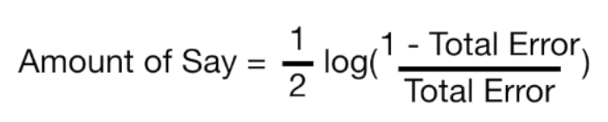

When total error is small, the amount of say for the sample is large. When the total error is large the amount of say is small. When the total error is 1/8 the amount of say is 0.97.



Exercise (4 marks)

The patient weight is definitely the correct classifier for the first stump. However, if we had chosen chest pain to be the classifier in the first stump 3 classifications would have been incorrect.

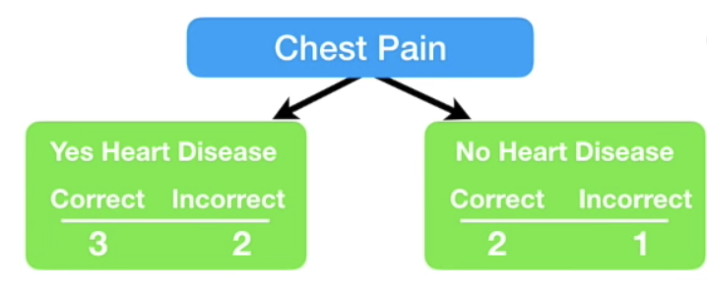

Calculate the amount of say that this stump would have had. Show your calculations here:

|  |
| --- |
| Total error =  Amount of say = = = |

|  |  |
| --- | --- |
| Continuing on with our example, since the first stump incorrectly classified the heart disease status for the person on the right, we need to adjust the sample weight. |  |
|  |  |

The **incorrectly classified** sample weight becomes:

New sample weight = sample weight = = 0.33

The **correctly classified** sample weights on the other hand must be decreased.

New sample weight = sample weight = = 0.05

|  |  |
| --- | --- |
| These are the weights after at the very right. |  |

Next, we need to normalize the weights so they sum up to 1.

= = 0.0736

= = 0.4853

|  |  |
| --- | --- |
| Next, we throw out the old weights and use the new weights to build our new sample set. To generate the new sample, we take random picks between 0 and 1. If the pick falls between 0 and 0.07 we choose sample 1. If we pick 0.1 we choose sample 2. If we pick between 0.22 and 0.71 we choose sample 4 and so on. |  |

|  |  |
| --- | --- |
| Note that we are likely to choose sample 4 several times as outlined at the right but this is okay since selection is with replacement. |  |

We continue these steps to build more stumps. To make a prediction we sum the ‘amounts of say’ for each stump. The largest sum represents the prediction.

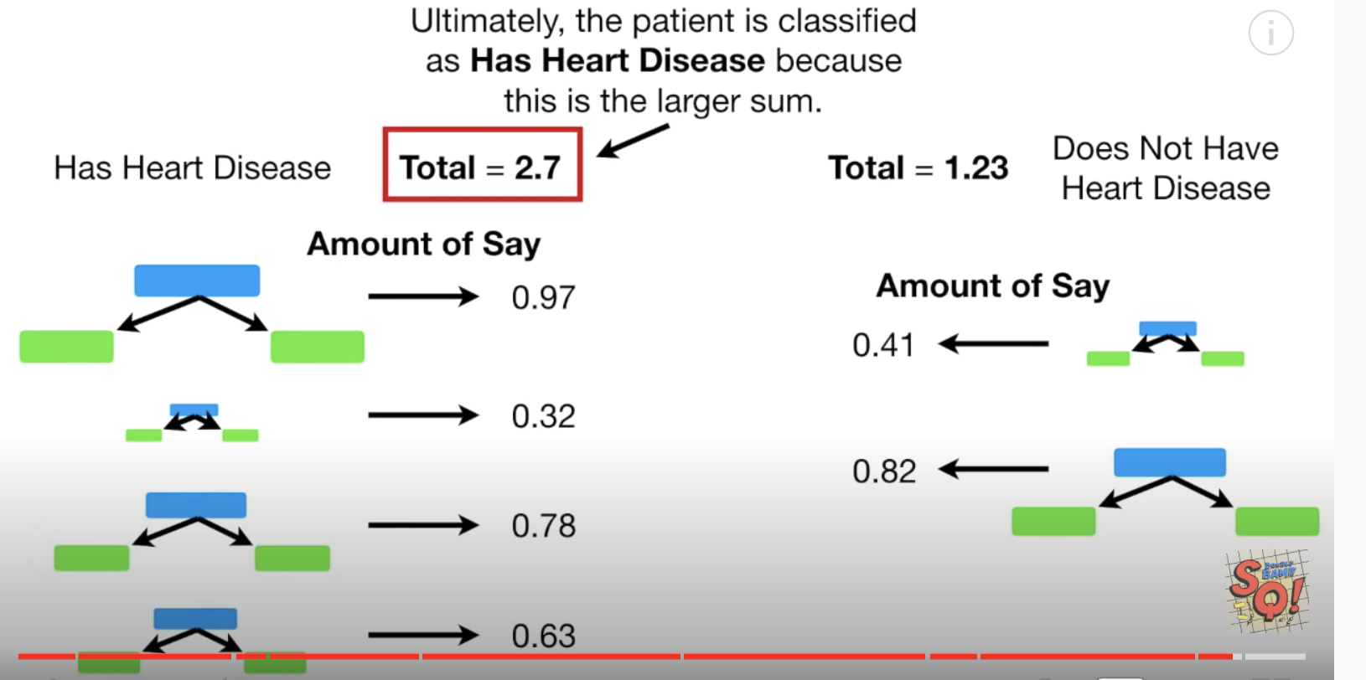

### Gradient Boosting

Gradient Boosting (GB) is similar to AdaBoost in that it, too, is a sequential training technique. The difference between AdaBoost and GB is that GB does not give incorrectly classified items more weight. Instead, GB software optimizes the loss function by generating base learners sequentially so that the present base learner is always more effective than the previous one. This method attempts to generate accurate results initially instead of correcting errors throughout the process, like AdaBoost. For this reason, GB software can lead to more accurate results. Gradient Boosting can help with both classification and regression-based problems.

### Xtreme Gradient Boosting

Extreme Gradient Boosting (XGBoost) improves gradient boosting for computational speed and scale in several ways. XGBoost uses multiple cores on the CPU so that learning can occur in parallel during training. It is a boosting algorithm that can handle extensive datasets, making it attractive for big data applications. The key features of XGBoost are parallelization, distributed computing, cache optimization, and out-of-core processing.

Example : Boosting

This example compares the performance of several boosting classifiers.

ada_boost = AdaBoostClassifier()

grad_boost = GradientBoostingClassifier()

xgb_boost = XGBClassifier()

|  |
| --- |
| AdaBoostClassifier  precision recall f1-score support  0 0.68 0.69 0.69 52  1 0.54 0.61 0.57 54  2 0.88 0.76 0.81 58  GradientBoostingClassifier  precision recall f1-score support  0 0.73 0.69 0.71 52  1 0.52 0.59 0.55 54  2 0.79 0.72 0.76 58  XGBClassifier  precision recall f1-score support  0 0.65 0.65 0.65 52  1 0.49 0.56 0.52 54  2 0.84 0.74 0.79 58 |

Here is the code:

|  |
| --- |
| import pandas as pd  from sklearn.metrics import classification_report  # Get the housing data  df = pd.read_csv('housing_classification.csv')  # Show all columns.  pd.set_option('display.max_columns', None)  pd.set_option('display.width', 1000)  print(df.head(5))  # Split into two sets  y = df['price']  X = df.drop('price', 1)  from sklearn.model_selection import train_test_split  X_train, X_test, y_train, y_test = train_test_split(X, y, test_size=0.30)  from sklearn.model_selection import cross_val_score  from mlxtend.classifier import EnsembleVoteClassifier  from xgboost import XGBClassifier, plot_importance  from sklearn.ensemble import AdaBoostClassifier, GradientBoostingClassifier  ada_boost = AdaBoostClassifier()  grad_boost = GradientBoostingClassifier()  xgb_boost = XGBClassifier()  classifiers = [ada_boost, grad_boost, xgb_boost]  for clf in classifiers:  print(clf.__class__.__name__)  clf.fit(X_train, y_train)  predictions = clf.predict(X_test)  report = classification_report(y_test, predictions)  print(report) |

Exercise (2 marks)

Add a reference for LogisticRegression to Example 4 and include it in the classifier array.

|  |
| --- |
| from sklearn.linear_model import LogisticRegression  lr = LogisticRegression(fit_intercept=True, solver='liblinear') |

Show the output for Logistic Regression here:

|  |
| --- |
|  |

How do the results for LogisticRegression compare with the other classifier algorithms?

|  |
| --- |
| LogisticRegression does better than GradientBoostingClassifier and XGBClassifier and is around the same as AdaBoosClassifer. |

Exercise (4 marks)

Using code from Example 4, compare the different boosting algorithm performances for the Iris data set. You could use the following code to load and prepare the Iris data.

|  |
| --- |
| # Get the housing data  df = pd.read_csv('/Users/pm/Downloads/iris_v2.csv')  dict_map = {'Iris-setosa':0,'Iris-versicolor':1, 'Iris-virginica':2}  df['target'] = df['iris_type'].map(dict_map)  y = df['target']  X = df.copy()  del X['target']  del X['iris_type'] |

Show your working program here:

|  |
| --- |
| import pandas as pd from sklearn.metrics import classification_report import warnings warnings.simplefilter(action='ignore', category=FutureWarning)  # Get the housing data df = pd.read_csv('C:\\datasets\\iris_v2.csv')  dict_map = {'Iris-setosa': 0, 'Iris-versicolor': 1, 'Iris-virginica': 2} df['target'] = df['iris_type'].map(dict_map)  y = df['target'] X = df.copy() del X['target'] del X['iris_type']  from sklearn.model_selection import train_test_split X_train, X_test, y_train, y_test = train_test_split(X, y, test_size=0.30)  from sklearn.model_selection import cross_val_score from mlxtend.classifier import EnsembleVoteClassifier from xgboost import XGBClassifier, plot_importance from sklearn.ensemble import AdaBoostClassifier, GradientBoostingClassifier  ada_boost = AdaBoostClassifier() grad_boost = GradientBoostingClassifier() xgb_boost = XGBClassifier() classifiers = [ada_boost, grad_boost, xgb_boost]  for clf in classifiers:  print(clf.__class__.__name__)  clf.fit(X_train, y_train)  predictions = clf.predict(X_test)  report = classification_report(y_test, predictions)  print(report) |

Show the output from your code:

|  |
| --- |
|  |

Explain which algorithm performed best and why you made that selection.

|  |
| --- |
| XGBClassifier performed the best from its precision, recall, and f-1 score being the highest. |

## Ensembles

Ensembles allow you to average the predictions from multiple models to provide a more stable and accurate model.

eclf = EnsembleVoteClassifier(clfs=[ada_boost, grad_boost,

xgb_boost], voting='hard')

* ‘hard’ voting chooses the majority of votes
* ‘soft’ voting averages the percentages of votes for each class.

Ensemble models do not usually end up being the best model but they do weight results from the best models more heavily. As a result ensemble models tend to be very competitive.

Example : Ensembles

Starting with Example 4, replace the definition for the *classifiers* list with the following code which groups the classifiers.

|  |
| --- |
| eclf = EnsembleVoteClassifier(clfs=[ada_boost, grad_boost,  xgb_boost], voting='hard')  classifiers = [ada_boost, grad_boost, xgb_boost, eclf] |

The output:

|  |
| --- |
| AdaBoostClassifier  precision recall f1-score support  0 0.60 0.63 0.61 54  1 0.39 0.47 0.43 51  2 0.80 0.63 0.70 59    GradientBoostingClassifier  precision recall f1-score support  0 0.59 0.65 0.62 54  1 0.45 0.49 0.47 51  2 0.82 0.68 0.74 59  XGBClassifier  precision recall f1-score support  0 0.60 0.61 0.61 54  1 0.46 0.53 0.49 51  2 0.84 0.71 0.77 59  EnsembleVoteClassifier  precision recall f1-score support  0 0.61 0.67 0.64 54  1 0.45 0.49 0.47 51  2 0.82 0.68 0.74 59 |

Exercise (2 marks)

Describe how the ensemble model in Example 5 performs compared to the individual base models for each of the classes that are being predicted.

|  |
| --- |
| The ensemble model performs better than the individual base models for each of the classes being predicted. |

## Stacked Models

A stacked model builds a model with the output from multiple models. Stacking can be applied to a combine the outputs from a wide variety of predictive models. Often, stacking helps to improve accuracy.

### Stacking Regression

Example : Stacking Regression

This example shows how to implement stacking with outputs from the following combination of regressors:

* ElasticNet
* DecisionTreeRegressor
* SVR
* AdaBoostRegressor
* BaggingRegressor
* RandomForestRegressor
* ExtraTreesRegressor

The output when running this program shows that our super learner is competitive when compared to most models.

|  |
| --- |
| **\*\* Evaluate Base Models \*\***  **RMSE:123799.119 ElasticNet**  **RMSE:352456.005 SVR**  **RMSE:188327.974 DecisionTreeRegressor**  **RMSE:155919.974 AdaBoostRegressor**  **RMSE:136916.041 RandomForestRegressor**  **RMSE:131182.792 ExtraTreesRegressor**  **\*\* Evaluate Stacked Model \*\***  **RMSE:104680.594 LinearRegression** |

Here is the code:

|  |
| --- |
| from sklearn.linear_model import LinearRegression  from sklearn.linear_model import ElasticNet  from sklearn.tree import DecisionTreeRegressor  from sklearn.svm import SVR  from sklearn.ensemble import AdaBoostRegressor  from sklearn.ensemble import RandomForestRegressor  from sklearn.ensemble import ExtraTreesRegressor  from sklearn.metrics import mean_squared_error  from sklearn.model_selection import train_test_split  import numpy as np  import pandas as pd  # Show all columns.  pd.set_option('display.max_columns', None)  pd.set_option('display.width', 1000)  # Prep data.  PATH = "/users/pm/desktop/daydocs/data/"  CSV_DATA = "USA_Housing.csv"  dataset = pd.read_csv(PATH + CSV_DATA)  print(dataset.head())  X = dataset[['Avg. Area Income','Avg. Area House Age', 'Avg. Area Number of Rooms',\  'Avg. Area Number of Bedrooms', "Area Population"]].values  y = dataset['Price']  def getUnfitModels():  models = list()  models.append(ElasticNet())  models.append(SVR(gamma='scale'))  models.append(DecisionTreeRegressor())  models.append(AdaBoostRegressor())  models.append(RandomForestRegressor(n_estimators=200))  models.append(ExtraTreesRegressor(n_estimators=200))  return models  def evaluateModel(y_test, predictions, model):  mse = mean_squared_error(y_test, predictions)  rmse = round(np.sqrt(mse),3)  print(" RMSE:" + str(rmse) + " " + model.__class__.__name__)  def fitBaseModels(X_train, y_train, X_test, models):  dfPredictions = pd.DataFrame()  # Fit base model and store its predictions in dataframe.  for i in range(0, len(models)):  models[i].fit(X_train, y_train)  predictions = models[i].predict(X_test)  colName = str(i)  # Add base model predictions to column of data frame.  dfPredictions[colName] = predictions  return dfPredictions, models  def fitStackedModel(X, y):  model = LinearRegression()  model.fit(X, y)  return model  # Split data into train, test and validation sets.  X_train, X_temp, y_train, y_temp = train_test_split(X, y, test_size=0.70)  X_test, X_val, y_test, y_val = train_test_split(X_temp, y_temp, test_size=0.50)  # Get base models.  unfitModels = getUnfitModels()  # Fit base and stacked models.  dfPredictions, models = fitBaseModels(X_train, y_train, X_val, unfitModels)  stackedModel = fitStackedModel(dfPredictions, y_val)  # Evaluate base models with validation data.  print("\n** Evaluate Base Models **")  dfValidationPredictions = pd.DataFrame()  for i in range(0, len(models)):  predictions = models[i].predict(X_test)  colName = str(i)  dfValidationPredictions[colName] = predictions  evaluateModel(y_test, predictions, models[i])  # Evaluate stacked model with validation data.  stackedPredictions = stackedModel.predict(dfValidationPredictions)  print("\n** Evaluate Stacked Model **")  evaluateModel(y_test, stackedPredictions, stackedModel) |

Exercise (3 marks)

Show a screenshot of the data frame that is used for input that is used to fit the stacked model in this exercise. Please make it reader-friendly by whatever means you feel is appropriate.

|  |
| --- |
|  |

Explain what the columns of the data frame referenced above within this exercise represent.

|  |
| --- |
| Each column of the dataframe represents a regressor used to produce the final super learner model. They are:  ElasticNet  DecisionTreeRegressor  SVR  AdaBoostRegressor  RandomForestRegressor  ExtraTreesRegressor |

Exercise (3 marks)

Replace the code that retrieves the data in Example 6 with the following code which imports and prepares the wine quality data set. Make any other adjustments as required.

|  |
| --- |
| PATH = "/Users/pm/Desktop/DayDocs/data/"  CSV_DATA = "winequality.csv"  dataset = pd.read_csv(PATH + CSV_DATA)  X = dataset[['fixed acidity', 'volatile acidity', 'citric acid', 'residual sugar',  'chlorides', 'free sulfur dioxide', 'total sulfur dioxide', 'density',  'pH', 'sulphates','alcohol']].values  y = dataset['quality'] |

Run the code after making the changes. Show the output here:

|  |
| --- |
|  |

What model appears to perform the best and explain why you made that choice.

|  |
| --- |
| The stacked model has the lowest RMSE, performing the best. |

### Stacking Classification

Example : Stacking for Classification

This example shows how to implement stacking for classification.

|  |
| --- |
| ** Evaluate Base Models **  *** LogisticRegression  precision recall f1-score support  0 0.64 1.00 0.78 89  1 0.00 0.00 0.00 51  *** DecisionTreeClassifier  precision recall f1-score support  0 0.84 0.88 0.86 89  1 0.77 0.71 0.73 51  *** AdaBoostClassifier  precision recall f1-score support  0 0.80 0.89 0.84 89  1 0.76 0.61 0.67 51  *** RandomForestClassifier  precision recall f1-score support  0 0.84 0.88 0.86 89  1 0.77 0.71 0.73 51  ** Evaluate Stacked Model **  *** LogisticRegression  precision recall f1-score support  0 0.83 0.88 0.85 89  1 0.76 0.69 0.72 51 |

Here is the code:

|  |
| --- |
| from sklearn.linear_model import LogisticRegression  from sklearn.tree import DecisionTreeClassifier  from sklearn.ensemble import AdaBoostClassifier  from sklearn.ensemble import RandomForestClassifier  from sklearn.metrics import classification_report  from sklearn.model_selection import train_test_split  import numpy as np  import pandas as pd  # Show all columns.  pd.set_option('display.max_columns', None)  pd.set_option('display.width', 1000)  # Prepare the data.  PATH = "/Users/pm/Desktop/DayDocs/data/"  CSV_DATA = "Social_Network_Ads.csv"  df = pd.read_csv(PATH + CSV_DATA)  df = pd.get_dummies(df,columns=['Gender'])  del df['User ID']  X = df.copy()  del X['Purchased']  y = df['Purchased']  def getUnfitModels():  models = list()  models.append(LogisticRegression())  models.append(DecisionTreeClassifier())  models.append(AdaBoostClassifier())  models.append(RandomForestClassifier(n_estimators=10))  return models  def evaluateModel(y_test, predictions, model):  print("\n*** " + model.__class__.__name__)  report = classification_report(y_test, predictions)  print(report)  def fitBaseModels(X_train, y_train, X_test, models):  dfPredictions = pd.DataFrame()  # Fit base model and store its predictions in dataframe.  for i in range(0, len(models)):  models[i].fit(X_train, y_train)  predictions = models[i].predict(X_test)  colName = str(i)  dfPredictions[colName] = predictions  return dfPredictions, models  def fitStackedModel(X, y):  model = LogisticRegression()  model.fit(X, y)  return model  # Split data into train, test and validation sets.  X_train, X_temp, y_train, y_temp = train_test_split(X, y, test_size=0.70)  X_test, X_val, y_test, y_val = train_test_split(X_temp, y_temp, test_size=0.50)  # Get base models.  unfitModels = getUnfitModels()  # Fit base and stacked models.  dfPredictions, models = fitBaseModels(X_train, y_train, X_val, unfitModels)  stackedModel = fitStackedModel(dfPredictions, y_val)  # Evaluate base models with validation data.  print("\n** Evaluate Base Models **")  dfValidationPredictions = pd.DataFrame()  for i in range(0, len(models)):  predictions = models[i].predict(X_test)  colName = str(i)  dfValidationPredictions[colName] = predictions  evaluateModel(y_test, predictions, models[i])  # Evaluate stacked model with validation data.  stackedPredictions = stackedModel.predict(dfValidationPredictions)  print("\n** Evaluate Stacked Model **")  evaluateModel(y_test, stackedPredictions, stackedModel) |

Exercise (3 marks)

Show a screenshot of the data frame that is used for input that is used to fit the stacked model in this exercise. Please make it reader-friendly by whatever means you feel is appropriate.

|  |
| --- |
|  |

Explain what the columns of the data frame referenced above within this exercise represent.

|  |
| --- |
| Each column of the dataframe represents a regressor used to produce the final super learner model. They are:  LogisticRegression  DecisionTreeRegressor  AdaBoostRegressor  RandomForestRegressor |

Exercise (3 marks)

Replace the code that retrieves the data in Example 6 with the following code which imports and prepares the iris data set. Make any other adjustments as required.

|  |
| --- |
| # Get the housing data  df = pd.read_csv('/Users/pm/Downloads/iris_v2.csv')  dict_map = {'Iris-setosa':0,'Iris-versicolor':1, 'Iris-virginica':2}  df['target'] = df['iris_type'].map(dict_map)  y = df['target']  X = df.copy()  del X['target']  del X['iris_type'] |

Run the code after making the changes. Show the output here:

|  |
| --- |
|  |

What model appears to perform the best and explain why you made that choice.

|  |
| --- |
| Logistic regression base model performs the best as it has the highest precision, recall, and f1-score. |

Table of Contents

Decision Trees 1

Advantages 1

Disadvantages 1

Decision Trees for Classification 1

Calculating Gini Impurity 3

Determining the Property for the Left Branch 4

Calculating the Gini Impurity before the Node is Separated 6

Calculating the Gini Impurity Index for Chest Pain 6

Visualizing the Decision Tree 9

About the Gini Index / Gini Split 10

Performing Linear Regression with a DecisionTreeRegressor 12

## Decision Trees

A decision tree is a supervised training algorithm for performing regression and classification.

The decision tree algorithm follows a decision path of an upside-down tree from the root to a leaf node.

### Advantages

Decision trees can be used to classify non-linearly separable data. They are very fast and easy to understand compared to KNN and other classification algorithms. They can also be useful for imputing data.

### Disadvantages

Decision trees can lead to over fitting. Decision trees also lose information when working with continuous variables.

## Decision Trees for Classification

This initial discussion covers how to manually create a decision tree with the guidance of the Gini impurity index. The discussion is based heavily on Josh Stormer’s video at:

<https://www.youtube.com/watch?v=7VeUPuFGJHk>

Example 1: Manually Building a Decision Tree

In this example we are building a best classifier to determine if a person has heart disease. We will not actually use a data set but we have a high-level look at how to build the tree. Figure 1 shows a snapshot of the data set.

Figure 1: Snapshot of the Heart Disease Dataset



First, we will examine how to build a leaf node to classify heart disease with the ‘Chest Pain’ attribute (see Figure 2).

Figure 2: Calculating Heart Disease Classification with Chest Pain



Exercise 1 (3 marks)

Given the data provided in Figure 2, add in the counts for categorizing heart disease based on Good Blood circulation. The numbers in the bottom row should add up to 3 if done correctly.

|  |  |  |  |
| --- | --- | --- | --- |
| Good Blood Circulation | | | |
| True | | False | |
| 1 | 1 | 0 | 1 |

While we do not have all of the data in the data set, if we did, the total sums of positive and negative heart disease diagnosis would appear in the leaves under the chest pain node in Figure 3.

Figure 3: Heart Disease Classifications with Chest Pain



Similarly, we can calculate the heart disease classifications for blood circulation and blocked artery nodes like in Figure 4.

Figure 4: Heart Disease totals with Blood Circulation and Blocked Arteries

 

Based on the data provided for this problem, we can use chest pain, blood circulation and blocked arteries as classifying properties for heart disease. We now need to determine which property should be placed at the top of our tree. There are lots of ways to determine which property to select. We will use Gini impurity index to make this decision.

### Calculating Gini Impurity

The lowest Gini impurity index helps to locate the best attribute to place at the top node. The Gini index is calculated as 1 – (P+ P+ … + P). The data in Figure 5 sets up the calculation for the Chest Pain node.

Figure 5: Calculating Gini Impurity for Chest Pain



The Gini impurity for the leaf node on the left of Figure 5 is:

= 1 - - = 0.395

The Gini impurity for the leaf node on the right branch of Figure 5 is:

= 1 - - = 0.336

Next, we must add the weighted Gini impurity indexes for each branch. This calculation becomes:

Gini Impurity Index Chest Pain

= 0.395 + 0.336 = 0.395 + 0.336 = 0.36404

Figure 6: Gini Impurity Indexes for Chest Pain, Good Blood Circulation, Blocked Arteries



**Good Blood Circulation has the lowest Gini impurity**. It does the best job of separating candidates with or without heart disease. So, for this reason we will include good blood circulation at the top (root) of the decision tree.

Exercise 2 (8 marks)

Calculate the Gini impurity for good blood circulation. If done correctly the answer should be 0.360. Show your calculations here (you can take a screenshot if you prefer):

|  |
| --- |
|  |

### Determining the Property for the Left Branch

Since Good Blood Circulation has the lowest Gini Impurity index, it is placed at the root of the tree in Figure 7.

Figure 7: Viewing the Root and Two Branches



Since circulation is at the top of the tree, we need to figure out whether to use chest pain or blocked arteries to separate the leaf nodes in Figure 7. We will focus first on the left leaf node in Figure 7 to examine how to split it further. There are 164 rows of data to consider in the left branch. Figure 8 shows the Gini Impurity scores that would exist if we split the left node of Figure 7 either using chest pain or blocked arteries.

For the chest pain in Figure 8, the Gini impurity of the left node is calculated as

= 1 - - = 0.2068

For the chest pain in Figure 8, the Gini impurity of the right node is calculated as

= 1 - - = 0.49555

The weighted Gini impurity for chest pain in Figure 8 is:

0.2068 + 0.49555 = 0.2068 + 0.49555

= 0.1399683 + 0.1601473 = 0.30012

Figure 8: Examining the Gini Impurity Indexes for the left node of Figure 7.



Since blocked arteries has the lowest Gini impurity index we will place it at the first left branch of the tree to separate patients (see Figure 9).

Figure 9: Good Blood Circulation as Root and Blocked Arteries in the Left Branch



If we were to continue building the tree on the left we would only be able to consider if Chest Pain should be added as a branch under Blocked Artery to perform further classification of Heart Disease. See Figure 10.

Figure 10: Adding Chest Pain to the bottom left node of the tree



### Calculating the Gini Impurity before the Node is Separated

= 0.4998

### Calculating the Gini Impurity Index for Chest Pain

The Gini Impurity index for the left branch of Chest Pain in Figure 10 is:

= 0.255

The Gini Impurity index for the right branch of Chest Pain in Figure 10 is:

= 0.3662

The Gini Impurity index for Chest Pain is:

0.255 + 0.3662 = 0.3208

Since Chest Pain offers a lower Gini Impurity index we will add it to the left leaf of the tree as shown in Figure 11.

Figure 11: Building Out Nodes of the Tree



When calculating the Gini impurity index for the right side of the Blocked Artery node in Figure 11 we get 0.2. If we were to split on Chest Pain the Gini Impurity index would be 0.29 as shown in Figure 12. Since not splitting on Chest Pain offers a lower Gini Impurity index we will make the circled classification of heart disease in Figure 11 a leaf node.

Figure 12: Calculating the Gini Impurity index at the bottom right of Blocked Arteries



Figure 13 shows the completed tree.

Figure 13: Completed Tree



Example 2: Decision Tree for Classification

This example shows how to use decision trees to validate the authenticity of bank notes based on skewness of the wavelet transformed image, variance of the image, entropy of the image, and kurtosis of the image. Here is a sample of the data set:

|  |
| --- |
| Variance Skewness Kurtosis Entropy Class  0 3.62160 8.66610 -2.8073 -0.44699 0  1 4.54590 8.16740 -2.4586 -1.46210 0  ... ... ... ... ...  1367 0.40614 1.34920 -1.4501 -0.55949 1 |

By observing the scores in this case we can see the decision tree makes relatively accurate predictions.

|  |
| --- |
| Model Evaluation  [[146 11]  [ 14 104]]  Accuracy: 0.9090909090909091  Precision: 0.9043478260869565  Recall: 0.8813559322033898 |

Here is the code used the build **DecisionTreeClassifier** model to predict whether the bill is fraudulent or not. For this case we are setting the **max_depth** property to 2 so we can limit the depth of the tree.

|  |
| --- |
| import pandas as pd  import numpy as np  import matplotlib.pyplot as plt  PATH = "/Users/pm/Desktop/DayDocs/PythonForDataAnalytics/workingData/"  CSV = "bill_authentication.csv"  dataset = pd.read_csv(PATH + CSV)  X = dataset.drop('Class', axis=1)  y = dataset['Class']  print(dataset)  from sklearn.model_selection import train_test_split  X_train, X_test, y_train, y_test = train_test_split(X, y, test_size=0.20,  random_state=0)  from sklearn.tree import DecisionTreeClassifier  classifier = DecisionTreeClassifier(max_depth=2)  classifier.fit(X_train, y_train)  y_pred = classifier.predict(X_test)  from sklearn.metrics import classification_report, confusion_matrix  def showAccuracyScores(y_test, y_pred):  print("\nModel Evaluation")  cm = confusion_matrix(y_test, y_pred)  print(cm)  print("")  tn = cm[0][0]  fp = cm[0][1]  tp = cm[1][1]  fn = cm[1][0]  accuracy = (tp + tn)/(tn + fp + tp + fn)  precision = tp/(tp + fp)  recall = tp/(tp + fn)  print("Accuracy: " + str(accuracy))  print("Precision: " + str(precision))  print("Recall: " + str(recall))  showAccuracyScores(y_test, y_pred) |

### Visualizing the Decision Tree

Example 3: Visualizing the Decision Tree Model

This example adds a visualization to observe the tree that is generated by the code in Example 2. Figure 14 shows the tree model. The nodes at the bottom are the leaves. The blue leaves represent cases where fraud occurred.

When a sample is perfectly classified the Gini index is 0. When looking at the tree you will notice the Gini index is higher at the root node and it is lower at the leaf nodes.

Figure 14: Decision Tree for Predicting Fraud



To build this example, add this code to the code in Example 2.

|  |
| --- |
| from sklearn.tree import plot_tree  fig, ax = plt.subplots(figsize=(20, 10))  plot_tree(classifier.fit(X_train, y_train), max_depth=4, fontsize=4)  a = plot_tree(classifier,  feature_names=['Variance', 'Skewness', 'Kurtosis', 'Entropy'],  class_names='Class',  filled=True,  rounded=True,  fontsize=14)  plt.show() |

Example 4: Manually Implementing the Model

When you examine the leaf nodes in Figure 14, keep in mind the blue nodes represent fraud and the orange nodes indicate that the bank note is valid.

Figure 15: Leaf Nodes for Counterfeit Bank Note Classification



* The total number of fraudulent notes are 441 + 34 = 475.
* The total number of valid notes are 83 + 539 = 622

The information from the decision tree can be used to build the model. One way to verify the model is built correctly is to ensure the prediction counts from the training data match the summed prediction counts in the leaf nodes.

The following code reconstructs the tree manually and calculates the fraudulent and non-fraudulent counts with the training data. The output verifies the original predictions that are indicated in the decision tree output:

Zeros: 622

Ones: 475

|  |
| --- |
| import pandas as pd  PATH = "/Users/pm/Desktop/DayDocs/PythonForDataAnalytics/workingData/"  CSV = "bill_authentication.csv"  dataset = pd.read_csv(PATH + CSV)  X = dataset.drop('Class', axis=1)  y = dataset['Class']  from sklearn.model_selection import train_test_split  X_train, X_test, y_train, y_test = train_test_split(X, y,  test_size=0.20, random_state=0)  def manuallyClassify(X,y):  predictions=[]  ones = 0  zeros = 0  for i in range(0,len(X)):  if(X.iloc[i]['Variance'] <= 0.274): # Blue  if(X.iloc[i]['Skewness'] <= 7.565):  ones +=1 #Blue  else:  zeros +=1  else:  if(X.iloc[i]['Kurtosis'] <= -4.394):  ones += 1 # Blue  else:  zeros += 1  print("Zeros: " + str(zeros))  print("Ones: " + str(ones))  manuallyClassify(X_train,y_train)  print(len(X_train)) |

Exercise 3 (1 mark)

Is the Gini index in the leaf nodes higher or lower than the gini index in the nodes that are closer to the root?

1. Higher b) Lower

Exercise (10 marks)

Starting with the following code, build a decision tree to predict if breast cancer is malignant with a depth of 2. Output the decision tree plot and show the accuracy, precision and recall scores.

|  |
| --- |
| import sklearn.datasets as datasets  from sklearn.tree import DecisionTreeClassifier  from sklearn.tree import plot_tree  import matplotlib.pyplot as plt  # check for the sklearn version, it has to be 0.21  import sklearn  print(sklearn.__version__)  breast_cancer = datasets.load_breast_cancer()  from sklearn.model_selection import train_test_split  X_train, X_test, y_train, y_test = train_test_split(  breast_cancer.data, breast_cancer.target, test_size=0.20,  random_state=0) |

Show your code here:

|  |
| --- |
| import sklearn.datasets as datasets from sklearn.tree import DecisionTreeClassifier from sklearn.tree import plot_tree import matplotlib.pyplot as plt  # check for the sklearn version, it has to be 0.21 import sklearn print(sklearn.__version__) breast_cancer = datasets.load_breast_cancer()  import pandas as pd dfX = pd.DataFrame(breast_cancer.data, columns = breast_cancer.feature_names) dfy = breast_cancer.target print(dfX.head()) print(dfy)  from sklearn.model_selection import train_test_split X_train, X_test, y_train, y_test = train_test_split(  breast_cancer.data, breast_cancer.target, test_size=0.20,  random_state=0)  print(breast_cancer)  from sklearn.tree import DecisionTreeClassifier classifier = DecisionTreeClassifier(max_depth=2) classifier.fit(X_train, y_train)  y_pred = classifier.predict(X_test)  from sklearn.metrics import classification_report, confusion_matrix  def showAccuracyScores(y_test, y_pred):  print("\nModel Evaluation")  cm = confusion_matrix(y_test, y_pred)  print(cm)  print("")  tn = cm[0][0]  fp = cm[0][1]  tp = cm[1][1]  fn = cm[1][0]  accuracy = (tp + tn)/(tn + fp + tp + fn)  precision = tp/(tp + fp)  recall = tp/(tp + fn)  print("Accuracy: " + str(accuracy))  print("Precision: " + str(precision))  print("Recall: " + str(recall))  showAccuracyScores(y_test, y_pred)  from sklearn.tree import plot_tree fig, ax = plt.subplots(figsize=(20, 10))  plot_tree(classifier.fit(X_train, y_train), max_depth=2, fontsize=4) a = plot_tree(classifier,  feature_names=['mean radius', 'mean texture', 'worst symmetry', 'worst fractal dimension'],  class_names='Class',  filled=True,  rounded=True,  fontsize=14) plt.show() |

Show the accuracy, decision and recall scores here:

|  |
| --- |
|  |

Show the decision tree plot here:

|  |
| --- |
|  |

## Performing Linear Regression with a DecisionTreeRegressor

It is possible to perform regression with a DecisionTreeRegressor. This may not seem so interesting now but it will offer a useful approach that can compete with other algorithms. Next week we will examine how to implement decision trees in random forests.

Example 6: Decision Tree for Regression (Predicting Gas Consumption)

This example demonstrates how to use decision trees to predict gasoline consumption. This is a sample of the data set:

|  |
| --- |
| Petrol_tax Average_income Paved_Highways Population_Driver_licence(%) Petrol_Consumption  0 9.00 3571 1976 0.525 541  1 9.00 4092 1250 0.572 524 |

The output shows that the predictions have a relatively decent accuracy.

|  |
| --- |
| Actual versus predicted values  Actual Predicted  29 534 541.0  4 410 414.0  26 577 574.0  …  Mean Absolute Error: 50.8  Mean Squared Error: 5065.0  Root Mean Squared Error: 71.16881339463234 |

Here is the code:

|  |
| --- |
| import pandas as pd  import numpy as np  import matplotlib.pyplot as plt  PATH = "/Users/pm/Desktop/DayDocs/PythonForDataAnalytics/workingData/"  CSV = "petrol_consumption.csv"  df = pd.read_csv(PATH + CSV)  # Show all columns.  pd.set_option('display.max_columns', None)  # Increase number of columns that display on one line.  pd.set_option('display.width', 1000)  X = df.drop('Petrol_Consumption', axis=1)  y = df['Petrol_Consumption']  print(df)  from sklearn.model_selection import train_test_split  X_train, X_test, y_train, y_test = train_test_split(X, y, test_size=0.2, random_state=0)  from sklearn.tree import DecisionTreeRegressor  regressor = DecisionTreeRegressor()  regressor.fit(X_train, y_train)  y_pred = regressor.predict(X_test)  df=pd.DataFrame({'Actual':y_test, 'Predicted':y_pred})  print("\nActual versus predicted values")  print(df)  from sklearn import metrics  print('Mean Absolute Error:', metrics.mean_absolute_error(y_test, y_pred))  print('Mean Squared Error:', metrics.mean_squared_error(y_test, y_pred))  print('Root Mean Squared Error:',  np.sqrt(metrics.mean_squared_error(y_test, y_pred))) |

Table of Contents

PyCaret 1

Specifying the number of Folders 4

Plotting Feature Importance and Model Evaluation 5

Classification with Pycaret and Initial Conclusion 10

Searching Regression Models with PyCaret 11

Tuning a Top Model 12

Next Steps 14

## PyCaret

PyCaret automates the process to find an optimized data model. With parameter adjustments, PyCaret can grid search model configurations and features.

**Note:** PyCaret by default displays outputs more nicely in Jupyter Notebook compared to PyCharm. As a result, for this demonstration a Notebook is recommended.

Example : Beginner Classification

This example is the first in a series which shows how to use PyCaret to find an optimized algorithm to predict when a person will default on a loan default.

<https://github.com/pycaret/pycaret/blob/master/tutorials/Binary%20Classification%20Tutorial%20Level%20Beginner%20-%20%20CLF101.ipynb>

First install PyCaret with the command. I recommend using Amazon SageMaker Studio Lab since the install is a big one. It will take some time to install. In the Notebook be sure to use “!”.

|  |
| --- |
| !pip install pycaret |

This code loads the loan data. Notice that .T is being used to trop the dataframe so unsightly word wrap is not present.

|  |
| --- |
| from pycaret.datasets import get_data  import pandas as pd  import warnings  warnings.filterwarnings("ignore", category=FutureWarning)  # Show all columns in same row.  pd.set_option('display.max_columns', None)  pd.set_option('display.width', 1000)  dataset = get_data('credit')  display(dataset.head(4).T)  display(dataset.describe().T) |

Table 1 shows a summary of the loan default data that is used to create the classification model.

Table : View of First 5 Rows of the Loan Default Data Set



Example : Building a Model with PyCaret

This example continues from Example 1 to search for the best model. When running hardly any code at all you will notice that PyCaret identifies the RidgeClassifier as the best model.



**Note:** PyCaret will generate a lot of unnecessary output. If you use PyCaret, please do not blindly copy this output into your report since a lot of it does not really add any value to the report. Use proper care to ensure the data that you present is relevant to understanding the problem that is being solved.

The setup() function initializes the environment in pycaret and creates the transformation pipeline to prepare the data for modeling and deployment. setup() must be called before executing any other function in pycaret. It takes two mandatory parameters: a pandas dataframe and the name of the target column. All other parameters are optional and are used to customize the pre-processing pipeline (we will see them in later tutorials).

Unfortunately, the setup() function will not work with DataFrames so the code in this example uses a work around when splitting the data.

Note also that when running the setup() function you will be prompted to press enter but you could also type **quit** before pressing enter if you wish to stop the algorithm.



|  |
| --- |
| # Cannot use DataFrames with PyCaret's setup() function.  train = dataset.sample(frac=0.95, random_state=786)  test = dataset.drop(train.index)  train.reset_index(inplace=True, drop=True)  test.reset_index(inplace=True, drop=True)  print('Data for Modeling: ' + str(train.shape))  print('Unseen Data For Predictions: ' + str(test.shape))  # show data types.  from pycaret.classification import *  exp_clf101 = setup(data = train, target = 'default', session_id=123)  print(exp_clf101)  print("*** Showing best model")  best_model = compare_models()  print(best_model)  # Need this step for PyCharm  print("*** Showing best model")  regression_results = pull()  print(regression_results) |

Exercise (1 mark)

What are the two mandatory parameters of the PyCaret setup function?

|  |
| --- |
| Pandas dataframe and the target variable |

Exercise (2 marks)

For example compare_models(sort = 'Recall') will sort the grid by Recall instead of Accuracy. Show a screenshot of the output after sorting the results by recall.

|  |
| --- |
|  |

## Specifying the number of Folders

To save on processing time, when comparing multiple models, you can specify the total number of folds.

|  |
| --- |
| compare_models(fold = 5) |

If creating a single model you can also specify the number of folds for it.

|  |
| --- |
| ridge = create_model('ridge')  tuned_ridge = tune_model(ridge, fold=3) |

Example Creating and tuning a single model.

When a model is created using the create_model() function it uses the default hyperparameters to train the model. In order to tune hyperparameters, the tune_model() function is used. This function automatically tunes the hyperparameters of a model using Random Grid Search.

This example shows how to create and tune a single model. You can see the parameters of a suggested best model in the output.

|  |
| --- |
| RidgeClassifier(alpha=1, class_weight=None, copy_X=True, fit_intercept=False,  max_iter=None, normalize=True, random_state=123, solver='auto',  tol=0.001) |

Here is the full sample for tuning the RidgeClassifier model with PyCaret.

|  |
| --- |
| from sklearn.linear_model import RidgeClassifier  from pycaret.datasets import get_data  import pandas as pd  import warnings  warnings.filterwarnings("ignore", category=FutureWarning)  # Show all columns in same row.  pd.set_option('display.max_columns', None)  pd.set_option('display.width', 1000)  dataset = get_data('credit')  print(dataset.T) # Transpose for a reader-friendly display  # Redo this for test_train_split  data        = dataset.sample(frac=0.95, random_state=786)  data_unseen = dataset.drop(data.index)  data.reset_index(inplace=True, drop=True)  data_unseen.reset_index(inplace=True, drop=True)  print('Data for Modeling: ' + str(data.shape))  print('Unseen Data For Predictions: ' + str(data_unseen.shape))  ridge = RidgeClassifier(alpha=1.0, class_weight=None, copy_X=True, fit_intercept=True, max_iter=None, random_state=123, solver='auto',                  tol=0.001)  tuned_ridge = tune_model(ridge) |

## Plotting Feature Importance and Model Evaluation

PyCaret offers methods to help detect the best model features and to evaluate the model.

Example : Plotting Feature Importance and Model Evaluation



Here is the full program to draw the plot. To build this, add the following code in after the code from .

|  |
| --- |
| from pycaret.datasets import get_data  import pandas as pd  import warnings  warnings.filterwarnings("ignore", category=FutureWarning)  # Show all columns in same row.  pd.set_option('display.max_columns', None)  pd.set_option('display.width', 1000)  dataset = get_data('credit')  print(dataset) # Transpose for a reader-friendly display  # Redo this for test_train_split  data = dataset.sample(frac=0.95, random_state=786)  data_unseen = dataset.drop(data.index)  data.reset_index(inplace=True, drop=True)  data_unseen.reset_index(inplace=True, drop=True)  print('Data for Modeling: ' + str(data.shape))  print('Unseen Data For Predictions: ' + str(data_unseen.shape))  from pycaret.classification import *  exp_clf101 = setup(data = data, target = 'default', session_id=123)  print(exp_clf101)  ridge = create_model('ridge')  tuned_ridge = tune_model(ridge, fold=3)  #evaluate_model(tuned_ridge)  plot_model(tuned_ridge, plot='feature') |

To draw a confusion matrix add the following code to separate cell.

|  |
| --- |
| plot_model(tuned_ridge, plot = 'confusion_matrix') |



To display a precision-recall curve add the following code to a separate cell.

|  |
| --- |
| plot_model(tuned_ridge, plot = 'pr') |



To detect the best set of hyperparameters for the ridge classifier, run the following instruction after running the code for Example 4.

|  |
| --- |
| evaluate_model(tuned_ridge) |

Selecting **Hyperparameters** option displays parameter values that are suggested to be used with the model.



This **Feature Importance** option gives a wider range of variable choices compared to the feature importance plot that was displayed earlier.



The **Feature Selection** option suggests that 25 features should be selected. Through experimentation I found that I could use about the top six or seven features and still get decent results.

Note: When clicking Feature Selection it will take quite a long time for the code to run. Be prepared to wait.



Example : Building the Recommended Model

After following the recommended model approach from PyCaret, I then built a model using the recommended hyper parameters and model type. Instead of using all 25 of the top features I used 11 of the top features.

The output shows:

|  |
| --- |
| precision recall f1-score support  0 0.85 0.96 0.90 948  1 0.71 0.35 0.46 252  accuracy 0.83 1200  macro avg 0.78 0.65 0.68 1200  weighted avg 0.82 0.83 0.81 1200  [[912 36]  [165 87]] |

This model recommendation from PyCaret can be implemented in PyCharm.

|  |
| --- |
| from sklearn.linear_model import RidgeClassifier  from sklearn.model_selection import train_test_split  from pycaret.datasets import get_data  import pandas as pd  import warnings  warnings.filterwarnings("ignore", category=FutureWarning)  from sklearn.metrics import classification_report, confusion_matrix  # Show all columns in same row.  pd.set_option('display.max_columns', None)  pd.set_option('display.width', 1000)  df = get_data('credit')  print(df)  from   sklearn.model_selection import train_test_split  # Re-assign X with significant columns only after chi-square test.  X = pd.get_dummies(df, columns=['PAY_1', 'PAY_2', 'PAY_3','PAY_4','PAY_5',                                  'PAY_6', 'MARRIAGE', 'EDUCATION'])  # show all rows.  pd.set_option('display.max_rows', None)  X = X[["PAY_1_0",  "PAY_4_6",  "PAY_3_5",  "PAY_4_4",  "PAY_1_-2",  "PAY_1_2",  "PAY_1_3",  "PAY_1_5",  "PAY_4_5",  "PAY_1_-1",  "MARRIAGE_0",  ]]  y = df['default']  # Split data.  X_train,X_test,y_train,y_test = train_test_split(X, y, test_size=0.05)  # Build logistic regression model and make predictions.  clfModel = RidgeClassifier(alpha=3.37, class_weight=None,                  copy_X=True, fit_intercept=False, max_iter=None, solver='auto', tol=0.001)  clfModel.fit(X_train,y_train)  y_pred=clfModel.predict(X_test)  print(classification_report(y_test, y_pred))  print(confusion_matrix(y_test, y_pred)) |

## Classification with Pycaret and Initial Conclusion

I think PyCaret is an excellent tool that helps to automate finding optimized models and top features. However, I also found that PyCaret is not perfect. It is still important to implement proper model validation and to experiment with other model types. Contrary to what PyCaret recommended; I could build a Logistic Regression model with the features that were recommended by PyCaret. The logistic regression model was competitive with the Ridge classifier model that was recommended by PyCaret.

Example : Building a Logistic Regression Model with the PyCaret Recommended Features

The Ridge model recommended by PyCaret does very well. However, this example shows that the logistic regression model is more competitive as a model than initially reported. Furthermore, results will vary over multiple runs so a proper validation process is required.

|  |  |
| --- | --- |
| Ridge Classifier | Logistic Regression |
| precision recall f1-score support  0 0.85 0.96 0.90 948  1 0.71 0.35 0.46 252  accuracy 0.83 1200  macro avg 0.78 0.65 0.68 1200  weighted avg 0.82 0.83 0.81 1200  [[912 36]  [165 87]] | precision recall f1-score support  0 0.83 0.96 0.89 933  1 0.68 0.31 0.43 267  accuracy 0.81 1200  macro avg 0.75 0.64 0.66 1200  weighted avg 0.80 0.81 0.79 1200  [[893 40]  [183 84]] |

To build this example, starting with , replace this line of code:

|  |
| --- |
| clfModel = RidgeClassifier(alpha=3.37, class_weight=None,  copy_X=True, fit_intercept=False, max_iter=None,  solver='auto', tol=0.001) |

with the following lines of code:

|  |
| --- |
| from sklearn.linear_model import LogisticRegression  # Build logistic regression model and make predictions.  clfModel = LogisticRegression(solver='liblinear') |

Exercise (2 marks)

Use PyCaret to search for the best model for the iris_v2.csv data set to predict flower type. Show a screenshot of the models and their metrics. Identify the top model (there is no perfect choice here but please use reasonable judgement) and ensure that it is in the screenshot.

|  |
| --- |
|  |

Exercise (3 marks)

Using PyCaret, identify the optimized hyper parameters for your selected model. Show a screenshot here.

|  |
| --- |
|  |

Exercise (3 marks)

Using PyCaret, identify the top features for your selected model. Show a screenshot here.

|  |
| --- |
|  |

## Searching Regression Models with PyCaret

Example : Searching for Regression Models

Running this code in Jupyter shows how PyCaret could be used to search for regression models.



|  |
| --- |
| from pycaret.datasets import get_data  import pandas as pd  import warnings  warnings.filterwarnings("ignore", category=FutureWarning)  # Show all columns in same row.  pd.set_option('display.max_columns', None)  pd.set_option('display.width', 1000)  dataset = get_data('diamond')  # Get data and hold some back for testing.  data = dataset.sample(frac=0.9, random_state=786)  data_unseen = dataset.drop(data.index)  data.reset_index(drop=True, inplace=True)  data_unseen.reset_index(drop=True, inplace=True)  print('Data for Modeling: ' + str(data.shape))  print('Unseen Data For Predictions: ' + str(data_unseen.shape))  from pycaret.regression import *  exp_reg101 = setup(data = data, target = 'Price', session_id=123)  best = compare_models() |

## Tuning a Top Model

Once a top model has been identified, the best parameters and features can be identified.



|  |
| --- |
| AdaBoostRegressor(base_estimator=None, learning_rate=0.05, loss='linear',  n_estimators=90, random_state=123) |

Example : Tuning a Regression Model

To generate the model evaluation metrics and optimized parameter listing run this code.

|  |
| --- |
| # Create model  ada = create_model('ada')  tuned_ada = tune_model(ada)  print(tuned_ada) |

Running the following instruction in a separate cell shows the residual error plot.

plot_model(tuned_ada)



Features can be identified by running this code:



Exercise (5 MARKS)

Using the winequality.csv file, use linear regression in PyCaret to find the best model type. After identifying a suitable top candidate, show a screenshot of the optimized parameters for the model type here:

|  |
| --- |
|  |

Show a screenshot of the residual error plot here:

|  |
| --- |
|  |

Show a screenshot of the feature importance plot for the wine quality model here:

|  |
| --- |
|  |

## Next Steps

For more information on PyCaret see:

<https://github.com/pycaret/pycaret/tree/master/tutorials>

Table of Contents

Requirements 1

References 1

Convolutional Neural Networks (CNN’s) 1

Common Filters (Kernels) 3

Stride 3

Padding 4

Pool Size 5

Applying Multiple Filters 5

Increasing Filters in Each Consecutive Layer 5

Kernel Size 9

Filters 9

Strides 9

Early Stopping and Saving the Best Model 13

## Requirements

This was implemented using **tensorflow 2.4** and **keras 2.4.3**.

On Windows I had to run PyCharm as Administrator.

On my Mac I had to install open CV when the CV2 module was missing. The installation required admin status: **sudo pip install opencv-python**

## Introduction

The goal of this document is to provide a light introd uction to convolutional neural networks. Tuning them can be a challenge so the focus will be more on the general terminology instead.

## References

<https://www.analyticsvidhya.com/blog/2017/06/architecture-of-convolutional-neural-networks-simplified-demystified/>

<https://medium.com/@RaghavPrabhu/understanding-of-convolutional-neural-network-cnn-deep-learning-99760835f148#:~:text=Strides,with%20a%20stride%20of%202>.

## Convolutional Neural Networks (CNN’s)

Convolutional Neural Networks, or CNNs for short, are a type of network designed for image input. They are comprised of models with convolutional layers which extract and transform features into simpler pooled elements. The pooled features are then flattened into arrays which are fed through a neural network for classification.

Figure 1: Feature Pooling and Classification Activities of a Convolutional Neural Network



Figure 2 shows how nine pixels of an image can be convoluted into one element of a pooled layer. Notice how the pooled layer dimensions are much smaller than the original image.

Figure 2: Transforming Nine Elements into One Pooled Element





Convolving with a filter creates a feature map like the one in Figure 3.

Figure 3: Real Image vs. Convoluted Image



## Common Filters (Kernels)

Not all filters are the same. Figure 4 highlights several filter types.

Figure 4: Common Image Filters



## Stride

Like we saw in Figure 2 the weight matrix was applied to sub sections of the image. In the example given, the sub sections were selected by shifting a window horizontally across the original image one pixel at a time and then down one pixel at a time. This **stride** of 1 pixel x 1 pixel led to a convoluted image that is 4x4 pixels. Lower strides leads to a higher amount of detail in the convoluted image.

A higher stride of 2x2 leads to a smaller convoluted image. Figure 5 illustrates a how a convoluted image is created with a filter by using a 2x2 stride. The first section of the image is selected and is filtered. Then the selection is shifted two pixels across. The new selection is multiplied by the filter. Then the selection is taken from the bottom left of the original image and is multiplied by the filter. Then the selection is taken from the bottom right of the image and this section is multiplied by the filter.

Figure 5: Creating a Convoluted Image with a 2x2 Stride



Exercise 1 (3 marks)

Show the calculation needed to multiply the section of the input image by the filter to generate 686. See Figure 5.

|  |
| --- |
| 51 + 244 + 78 + 204 + 109 = 686 |

## Padding

You may have noticed that striding across the image leads to a smaller convoluted image. However, we could pad the border with zeros to retain the original size of the image. Padding also allows us to obtain more information about the borders (see Figure 6).

Figure 6: Padding an Image



## Pool Size

A pool_size attribute is used in the network to downsample the image. The calculation used for downsampling is:

output_shape = (input_shape - pool_size + 1) / strides)

## Applying Multiple Filters

If we have a 32x32 image with a 3-byte color layer and we apply a stack of ten 5x5x3 filters **we** end up with a convoluted output of 28x28x3.



### Increasing Filters in Each Consecutive Layer

In every layer filters are there to capture patterns. For example in the first layer filters capture patterns like edges, corners, dots etc. In the subsequent layers we combine those patterns to make bigger patterns. Like combine edges to make squares, circle etc.

Now as we move forward in the layers the patterns gets more complex, hence larger combinations of patterns to capture. That's why we increase filter size in the subsequent layers to capture as many combinations as possible.

<https://datascience.stackexchange.com/questions/55545/in-cnn-why-do-we-increase-the-number-of-filters-in-deeper-convolution-layers-fo>

Example 1: Processing and Displaying Images

This first example demonstrates how to prepare the images for modelling.

Initially the images are loaded.

img = cv2.imread(filePath)

The images are then scaled to a size of 96x96 pixels.

img = cv2.resize(img, (IMAGE_SIZE, IMAGE_SIZE))

Next, the code eliminates the 3 byte color channel.

img = cv2.cvtColor(img, cv2.COLOR_RGB2GRAY)

To understand our image data better some print statements are used to display the data attributes and contents.

print("Image Label: " + str(labels[index]))

print("Image Shape: " + str(images[index].shape))

print("Image Data: ")

print(images[index])

|  |
| --- |
| Image Label: 0  Image Shape: (96, 96)  Image Data:  [[0.06666667 0.03137255 0.01568627 ... 0.14901961 0.16470588 0.38039216]  [0.02352941 0.05098039 0.03137255 ... 0.18039216 0.21568627 0.37254902]  [0.03921569 0.03137255 0.03529412 ... 0.18823529 0.2 0.32941176]  ...  [0.30196078 0.27843137 0.29019608 ... 0.34901961 0.36470588 0.36470588]  [0.33333333 0.32156863 0.31764706 ... 0.3372549 0.33333333 0.33333333]  [0.34901961 0.31764706 0.32941176 ... 0.33333333 0.33333333 0.35294118]] |

To verify that the images are process properly, two processed test images are displayed on the screen.

plt.imshow(images[index])

plt.show()

 

|  |
| --- |
| import matplotlib.pyplot as plt  import os  import numpy as np  import cv2  PATH = "/Users/pm/Desktop/DayDocs/data/small_cats_and_dogs/"  # Loads the image file.  def load_image(fileName, subFolder):  try:  filePath = PATH + subFolder + "/" + fileName  img = cv2.imread(filePath)  return img  except:  return np.NaN  # Extract the actual class from the image file name.  def extract_label(file_name):  return 1 if "dog" in file_name else 0  # Transforms image into scaled and squared image.  def preprocess_image(img):  IMAGE_SIZE = 96  try:  # Finds minimum of height and width.  min_side = min(img.shape[0], img.shape[1])  # Reduce image to square using minimum of width and height.  img = img[:min_side, :min_side]  # Reside to 96x96.  img = cv2.resize(img, (IMAGE_SIZE, IMAGE_SIZE))  print(img.shape)  # Eliminate three byte color channel.  img = cv2.cvtColor(img, cv2.COLOR_RGB2GRAY)  print(img.shape)  print("***")  # Scale numbers to range between 0 and 1.0  return img / 255.0  except:  return np.NaN  def getImages(dirName):  imageList = []  labelList = []  # List all items in the directory.  image_files = os.listdir(PATH + dirName + "/")  for i in range(0, len(image_files)):  image = load_image(image_files[i], dirName)  processedImage = preprocess_image(image)  # Build list of processed images and labels.  if processedImage is not np.NaN:  imageList.append(processedImage)  label = extract_label(image_files[i])  labelList.append(label)  return imageList, labelList  # Displays grayscale image and image data to ensure everything is working properly.  def verifyImage(images, labels, index):  print("Image Label: " + str(labels[index]))  print("Image Shape: " + str(images[index].shape))  print("Image Data: ")  print(images[index])  # Display the image.  plt.imshow(images[index])  plt.show()  print("*****")  # Add an extra dimension for the signle color channel.  # Changes (2000, 96, 96) to (2000, 96, 96, 1)  # Load transformed and scaled images.  X_train, y_train = getImages('train')  X_test, y_test = getImages('test')  # Verify first image in training set.  verifyImage(X_train, y_train, 0)  # Verify second image in training set.  verifyImage(X_train, y_train, 1) |

Example 2: Convert to 3D Array

Like other neural network examples, we need to ensure our inputs are in vertical array format to enable matrix multiplication. This code transforms our data into a vertical array. Here is the shape and data formatted after the transformation.

|  |  |
| --- | --- |
| **X shape: (2000, 96, 96, 1)** | **y shape: (2000,)** |
| array([[0.27058824, 0.28627451, 0.30588235, ..., 0.33333333, 0.39215686,  0.33333333],  [0.31372549, 0.30588235, 0.30588235, ..., 0.34509804, 0.38039216,  0.40784314],  [0.31372549, 0.3254902 , 0.30980392, ..., 0.36470588, 0.42745098,  0.39215686],  ...,  [0.25490196, 0.25490196, 0.24313725, ..., 0.01960784, 0.01960784,  0.01568627],  [0.28235294, 0.29803922, 0.30588235, ..., 0.01568627, 0.02352941,  0.01176471],  [0.30980392, 0.3254902 , 0.32156863, ..., 0.02352941, 0.02352941,  0.01176471]]),  array([[0.83529412, 0.85882353, 0.8627451 , ..., 0.41960784, 0.45098039,  0.43921569],  [0.79607843, 0.79215686, 0.81176471, ..., 0.41960784, 0.44705882,  0.43921569],  [0.76862745, 0.77647059, 0.78039216, ..., 0.40392157, 0.44313725,  0.4627451 ],  ...,  [0.31764706, 0.3372549 , 0.34509804, ..., 0.24705882, 0.23529412,  0.23137255],  [0.32941176, 0.3372549 , 0.36862745, ..., 0.21568627, 0.24705882,  0.22352941],  [0.34117647, 0.35294118, 0.34117647, ..., 0.22745098, 0.24705882,  0.24313725]]),  ...] | [1,  0,  0,  1,  1,  1,  1,  0,  0,  0,  0,  1,  0,  0,  1,  0,  1,  1,  1,  1,  1,  0,  0,  1,  0,  0 |

This is the code that performs the transformation to a matrix. Add this code to Example 1:

|  |
| --- |
| def convertToArray(x, y):  x = np.array(x)  x = np.expand_dims(x, -1)  y = np.array(y)  print(x.shape)  print(y.shape)  print("***")  return x, y  X_train, y_train = convertToArray(X_train, y_train) X_test, y_test = convertToArray(X_test, y_test) |

Example 3: Building and Evaluating the Model

To help understand how the model is built here are some terms.

## Kernel Size

The kernel is our sliding window which performs the convolution. Typical sizes include (1,1), (2,2),(3,3),(4,4),(5,5),(6,6),(7,7). It is rare to have more than a 7x7 kernal size.

## Filters

The number of filters determines the number of ways the kernel data is transformed. The number of filters corresponds to the number of outputs that are generated during the convolution.

## Strides

A stride is the horizontal and vertical step taken when shifting the convolutional window.

The model is decent - this is as good as I could make it.

|  |
| --- |
| Accuracy: 0.755  Confusion Matrix  Predicted 0 1  Actual  0 360 140  1 105 395 |

Here is the code that builds our model. Add this code to Example 2:

|  |
| --- |
| import tensorflow as tf  from tensorflow.keras import Sequential  from tensorflow.keras.layers import Dense  from tensorflow.keras.layers import Conv2D  from tensorflow.keras.layers import MaxPool2D  from tensorflow.keras.layers import Flatten  from tensorflow.keras.layers import Dropout  def create_model(X_train, y_train, X_test, y_test):  model = Sequential()  model.add(Conv2D(filters=32, kernel_size=(3, 3), activation='relu',  kernel_initializer='he_uniform',  input_shape=X_train.shape[1:]))  # Add a pooling layer to down sample height and widths by half.  # pool_size is filter size.  model.add(MaxPool2D(pool_size=(2, 2), strides=(2, 2)))  # It is common to repeat this pattern a few times by doubling the filter  # each time to offset the reduction in size from down sampling.  model.add(Conv2D(filters=64, kernel_size=(3, 3), activation='relu',  kernel_initializer='he_uniform',  input_shape=X_train.shape[1:]))  model.add(MaxPool2D(pool_size=(2, 2), strides=(2, 2)))  model.add(Conv2D(filters=128, kernel_size=(3, 3), activation='relu',  kernel_initializer='he_uniform',  input_shape=X_train.shape[1:]))  model.add(MaxPool2D(pool_size=(2, 2), strides=(2, 2)))  model.add(Conv2D(filters=256, kernel_size=(3, 3), activation='relu',  kernel_initializer='he_uniform',  input_shape=X_train.shape[1:]))  model.add(MaxPool2D(pool_size=(2, 2), strides=(2, 2)))  model.add(Conv2D(filters=512, kernel_size=(3, 3), activation='relu',  kernel_initializer='he_uniform',  input_shape=X_train.shape[1:]))  model.add(MaxPool2D(pool_size=(2, 2), strides=(2, 2)))  # feed data convolved features to a sequential network.  model.add(Flatten())  model.add(Dense(512, activation='relu', kernel_initializer='he_uniform'))  model.add(Dropout(0.5))  model.add(Dense(256, activation='relu', kernel_initializer='he_uniform'))  model.add(Dropout(0.5))  # Create output layer which has two classes.  model.add(Dense(units=2, activation='softmax'))  model.compile(optimizer=tf.optimizers.Adam(),  # We are using classification.  loss=tf.losses.SparseCategoricalCrossentropy(),  # Show accuracy.  metrics=['accuracy'])  history = model.fit(X_train, y_train, epochs=20, batch_size=100,  validation_data=(X_test, y_test))  model.save_weights("model.tf")  return model, history  model, history = create_model(X_train, y_train, X_test, y_test)  predictions = model.predict(X_test)  # Iterates through pairs of predictions and adds most probable option to list.  predictionList = []  for i in range(0, len(predictions)):  prediction = predictions[i]  if(prediction[0] > prediction[1]):  predictionList.append(0)  else:  predictionList.append(1)  predictionArray = np.array(predictionList)  print(predictionList)  import pandas as pd  from sklearn import metrics  # Show confusion matrix and accuracy scores.  confusion_matrix = pd.crosstab(y_test, predictionArray,  rownames=['Actual'],  colnames=['Predicted'])  print('\nAccuracy: ',metrics.accuracy_score(y_test, predictionArray))  print("\nConfusion Matrix")  print(confusion_matrix) |

Exercise (3 marks)

Perform this calculation for one dimension only. Given that the input width is 96, the pooling filter size is 2 and the strides value is 2, prove the convoluted image that is output is approximately half the size of the original.

output_shape = (input_shape - pool_size + 1) / strides)

Show your output here:

|  |
| --- |
| (96 – 2 + 1) / 2 = 47.5 |

Example 4: Showing the loss and accuracy

It is helpful to visualize the validation loss and accuracy. The loss function begins to rise at epoch 16. This suggests overfitting.



Adding the following code to Example 3 enables the reporting of loss and accuracy for classification algorithms.

|  |
| --- |
| def showLoss(history):  # Get training and test loss histories  training_loss = history.history['loss']  validation_loss = history.history['val_loss']  # Create count of the number of epochs  epoch_count = range(1, len(training_loss) + 1)  plt.subplot(1, 2, 1)  # Visualize loss history for training data.  plt.plot(epoch_count, training_loss, label='Train Loss', color='red')  # View loss on unseen data.  plt.plot(epoch_count, validation_loss, 'r--', label='Validation Loss',  color='black')  plt.xlabel('Epoch')  plt.legend(loc="best")  plt.title("Loss")  def showAccuracy(history):  # Get training and test loss histories  training_loss = history.history['accuracy']  validation_loss = history.history['val_accuracy']  # Create count of the number of epochs  epoch_count = range(1, len(training_loss) + 1)  plt.subplot(1, 2, 2)  # Visualize loss history for training data.  plt.plot(epoch_count, training_loss, label='Train Accuracy', color='red')  # View loss on unseen data.  plt.plot(epoch_count, validation_loss, 'r--',  label='Validation Accuracy', color='black')  plt.xlabel('Epoch')  plt.legend(loc="best")  plt.title('Accuracy')  plt.subplots(nrows=1, ncols=2, figsize=(14,7))  showLoss(history)  showAccuracy(history)  plt.show() |

## Early Stopping and Saving the Best Model

Early stopping is a technique and saving the best model that is used in machine learning algorithms to detect overfitting. Early stopping allows you to stop training the model when the validation loss increases a specific number of times. You can control the number of times that the loss may increase with the patience level.

Example 5: Enabling Early Stopping and Saving the Best Model

To enable early stopping and save the best model, start with Example 4. Then place this line of code above at the start of the program. Be sure to use the big_cats_and_dogs data set for this test for best results.

|  |
| --- |
| from tensorflow.keras.callbacks import EarlyStopping  from tensorflow.keras.callbacks import ModelCheckpoint |

Next, replace the line of code where the model is fit with this instruction.

|  |
| --- |
| # configure early stopping  es = EarlyStopping(monitor='val_loss', patience=10)  mc = ModelCheckpoint('best_model.h5', monitor='val_accuracy', mode='max', verbose=1,  save_best_only=True)  history = model.fit(X_train, y_train, epochs=20, batch_size=100,  validation_data=(X_test, y_test), callbacks=[es,mc]) |

Next, replace this line of code:

predictions = model.predict(X_test)

With code that loads the binary model before making a prediction:

|  |
| --- |
| # Must match from tensorflow.keras.callbacks import ModelCheckpoint  from tensorflow.keras.models import load_model  saved_model = load_model('best_model.h5')  predictions = saved_model.predict(X_test) |

Exercise 3 (10 marks)

Train your model to check for dogs, cats and octopi. **Be sure to use the small_cats_and_dogs_and_octopi data set for this test.**

To enable training with the new files, drop the extracted files from octopusTest into the test folder. Drop the extract files from octopusTrain into the train folder.

After, replace extract_label() with the following code:

|  |
| --- |
| def extract_label(file_name):  if "dog" in file_name:  return 1  elif "cat" in file_name:  return 0  else:  return 2 |

The output layer needs to be set to 3 since it is classifying for dogs, cats and octopi. Replace the output layer with this version:

|  |
| --- |
| model.add(Dense(units=3, activation='softmax')) |

Next, fix the code which sets up the confusion matrix. You will want to output 0, 1 or 2 depending on the maximum element in each row of the ***predictions*** list. This is the code that needs to be fixed:

|  |
| --- |
| predictionList = []  # Iterates through pairs of predictions and adds most probable option to list.  for i in range(0, len(predictions)):  prediction = predictions[i]  if(prediction[0] > prediction[1]):  predictionList.append(0)  else:  predictionList.append(1)  predictionArray = np.array(predictionList)  print(predictionList)  import pandas as pd  from sklearn import metrics  # Show confusion matrix and accuracy scores.  confusion_matrix = pd.crosstab(y_test, predictionArray,  rownames=['Actual'],  colnames=['Predicted'])  print('\nAccuracy: ',metrics.accuracy_score(y_test, predictionArray))  print("\nConfusion Matrix")  print(confusion_matrix) |

Show your fixed code here:

|  |
| --- |
| import tensorflow as tf from tensorflow import keras from keras.callbacks import EarlyStopping from keras.callbacks import ModelCheckpoint import matplotlib.pyplot as plt import os import numpy as np import cv2  PATH = "C:/datasets/small_cats_and_dogs_and_octopi/"   # Loads the image file. def load_image(fileName, subFolder):  try:  filePath = PATH + subFolder + "/" + fileName  img = cv2.imread(filePath)  return img  except:  return np.NaN   # Extract the actual class from the image file name. def extract_label(file_name):  if "dog" in file_name:  return 1  elif "cat" in file_name:  return 0  else:  return 2   # Transforms image into scaled and squared image. def preprocess_image(img):  IMAGE_SIZE = 96   try:  # Finds minimum of height and width.  min_side = min(img.shape[0], img.shape[1])   # Reduce image to square using minimum of width and height.  img = img[:min_side, :min_side]   # Reside to 96x96.  img = cv2.resize(img, (IMAGE_SIZE, IMAGE_SIZE))  print(img.shape)   # Eliminate three byte color channel.  img = cv2.cvtColor(img, cv2.COLOR_RGB2GRAY)  print(img.shape)  print("***")   # Scale numbers to range between 0 and 1.0  return img / 255.0  except:  return np.NaN   def getImages(dirName):  imageList = []  labelList = []   # List all items in the directory.  image_files = os.listdir(PATH + dirName + "/")   for i in range(0, len(image_files)):  image = load_image(image_files[i], dirName)  processedImage = preprocess_image(image)   # Build list of processed images and labels.  if processedImage is not np.NaN:  imageList.append(processedImage)   label = extract_label(image_files[i])  labelList.append(label)  return imageList, labelList   # Displays grayscale image and image data to ensure everything is working properly. def verifyImage(images, labels, index):  print("Image Label: " + str(labels[index]))  print("Image Shape: " + str(images[index].shape))  print("Image Data: ")  print(images[index])   # Display the image.  plt.imshow(images[index])  plt.show()  print("*****")   # Add an extra dimension for the single color channel. # Changes (2000, 96, 96) to (2000, 96, 96, 1)  # Load transformed and scaled images. X_train, y_train = getImages('train') X_test, y_test = getImages('test')  # Verify first image in training set. verifyImage(X_train, y_train, 0)  # Verify second image in training set. verifyImage(X_train, y_train, 1)    def convertToArray(x, y):  x = np.array(x)  x = np.expand_dims(x, -1)  y = np.array(y)  print(x.shape)  print(y.shape)  print("***")  return x, y   X_train, y_train = convertToArray(X_train, y_train) X_test, y_test = convertToArray(X_test, y_test)   import tensorflow as tf from tensorflow import keras from keras import Sequential from keras.layers import Dense from keras.layers import Conv2D from keras.layers import MaxPool2D from keras.layers import Flatten from keras.layers import Dropout   def create_model(X_train, y_train, X_test, y_test):  model = Sequential()   model.add(Conv2D(filters=32, kernel_size=(3, 3), activation='relu',  kernel_initializer='he_uniform',  input_shape=X_train.shape[1:]))  # Add a pooling layer to down sample height and widths by half.  # pool_size is filter size.  model.add(MaxPool2D(pool_size=(2, 2), strides=(2, 2)))   # It is common to repeat this pattern a few times by doubling the filter  # each time to offset the reduction in size from down sampling.  model.add(Conv2D(filters=64, kernel_size=(3, 3), activation='relu',  kernel_initializer='he_uniform',  input_shape=X_train.shape[1:]))  model.add(MaxPool2D(pool_size=(2, 2), strides=(2, 2)))   model.add(Conv2D(filters=128, kernel_size=(3, 3), activation='relu',  kernel_initializer='he_uniform',  input_shape=X_train.shape[1:]))  model.add(MaxPool2D(pool_size=(2, 2), strides=(2, 2)))   model.add(Conv2D(filters=256, kernel_size=(3, 3), activation='relu',  kernel_initializer='he_uniform',  input_shape=X_train.shape[1:]))  model.add(MaxPool2D(pool_size=(2, 2), strides=(2, 2)))   model.add(Conv2D(filters=512, kernel_size=(3, 3), activation='relu',  kernel_initializer='he_uniform',  input_shape=X_train.shape[1:]))  model.add(MaxPool2D(pool_size=(2, 2), strides=(2, 2)))   # feed data convolved features to a sequential network.  model.add(Flatten())   model.add(Dense(512, activation='relu', kernel_initializer='he_uniform'))  model.add(Dropout(0.5))  model.add(Dense(256, activation='relu', kernel_initializer='he_uniform'))  model.add(Dropout(0.5))   # Create output layer which has two classes.  model.add(Dense(units=3, activation='softmax'))   model.compile(optimizer=tf.optimizers.Adam(),  # We are using classification.  loss=tf.losses.SparseCategoricalCrossentropy(),  # Show accuracy.  metrics=['accuracy'])  # configure early stopping  es = EarlyStopping(monitor='val_loss', patience=10)  mc = ModelCheckpoint('best_model.h5', monitor='val_accuracy', mode='max', verbose=1,  save_best_only=True)   history = model.fit(X_train, y_train, epochs=20, batch_size=100,  validation_data=(X_test, y_test), callbacks=[es, mc])   model.save_weights("model.tf")  return model, history   model, history = create_model(X_train, y_train, X_test, y_test)  # Must match from tensorflow.keras.callbacks import ModelCheckpoint from keras.models import load_model  saved_model = load_model('best_model.h5') predictions = saved_model.predict(X_test)  # Iterates through pairs of predictions and adds most probable option to list. predictionList = []  # Iterates through pairs of predictions and adds most probable option to list. for i in range(0, len(predictions)):  prediction = predictions[i]  if (prediction[0] > prediction[1]):  predictionList.append(0)  else:  predictionList.append(1)  predictionArray = np.array(predictionList)  print(predictionList) import pandas as pd from sklearn import metrics  # Show confusion matrix and accuracy scores. confusion_matrix = pd.crosstab(y_test, predictionArray,  rownames=['Actual'],  colnames=['Predicted'])  print('\nAccuracy: ', metrics.accuracy_score(y_test, predictionArray)) print("\nConfusion Matrix") print(confusion_matrix)   def showLoss(history):  # Get training and test loss histories  training_loss = history.history['loss']  validation_loss = history.history['val_loss']   # Create count of the number of epochs  epoch_count = range(1, len(training_loss) + 1)  plt.subplot(1, 2, 1)  # Visualize loss history for training data.  plt.plot(epoch_count, training_loss, label='Train Loss', color='red')   # View loss on unseen data.  plt.plot(epoch_count, validation_loss, 'r--', label='Validation Loss',  color='black')   plt.xlabel('Epoch')  plt.legend(loc="best")  plt.title("Loss")   def showAccuracy(history):  # Get training and test loss histories  training_loss = history.history['accuracy']  validation_loss = history.history['val_accuracy']   # Create count of the number of epochs  epoch_count = range(1, len(training_loss) + 1)  plt.subplot(1, 2, 2)  # Visualize loss history for training data.  plt.plot(epoch_count, training_loss, label='Train Accuracy', color='red')   # View loss on unseen data.  plt.plot(epoch_count, validation_loss, 'r--',  label='Validation Accuracy', color='black')  plt.xlabel('Epoch')  plt.legend(loc="best")  plt.title('Accuracy')   plt.subplots(nrows=1, ncols=2, figsize=(14, 7)) showLoss(history) showAccuracy(history) plt.show() |

Show your new confusion matrix here:

|  |
| --- |
|  |

Table of Contents

Binary Classification Model 1

Loss and Accuracy Plot 4

Grid Search and Random Search 7

RuntimeError: mat1 and mat2 must have the same dtype 10

Multiclass Classification Model Plus Loss & Accuracy Plots 13

Early Stopping 16

## Introduction

This document focuses on PyTorch basics with Skorch. Skorch is a wrapper that enables an interface that is familiar to scikit learn users. Skorch will be helpful later for grid searching. The focus today will be on classification models.

## Binary Classification Model

Example : Binary Classification

This example demonstrates how to create a neural network in PyTorch for making a binary prediction. The model uses unexciting made-up data but the model is decent as a predictor.

**precision recall f1-score support**

**0 0.86 0.89 0.88 92**

**1 0.90 0.88 0.89 108**

I am using a library called **skorch** that will enable grid searching of parameters a little later in the document. The detail for how the PyTorch code works is in the comments. Exercises later will offer hands-on practice for a better understanding.

|  |
| --- |
| from sklearn.datasets import make_classification  from torch import optim  from skorch import NeuralNetClassifier  import torch.nn as nn  import numpy as np  from sklearn.model_selection import train_test_split  from sklearn.metrics import classification_report  # This class could be any name.  # nn.Module is needed to enable grid searching of parameters  # with skorch later.  class MyNeuralNet(nn.Module):  # Define network objects.  # Defaults are set for number of neurons and the  # dropout rate.  def __init__(self, num_neurons=10, dropout=0.1):  super(MyNeuralNet, self).__init__()  # 1st hidden layer.  # nn. Linear(n,m) is a module that creates single layer  # feed forward network with n inputs and m output.  self.dense0 = nn.Linear(20, num_neurons)  self.activationFunc = nn.ReLU()  # Drop samples to help prevent overfitting.  self.dropout = nn.Dropout(dropout)  # 2nd hidden layer.  self.dense1 = nn.Linear(num_neurons, num_neurons)  # Output layer.  self.output = nn.Linear(num_neurons, 2)  # Softmax activation function allows for multiclass predictions.  # In this case the prediction is binary.  self.softmax = nn.Softmax(dim=-1)  # Move data through the different network objects.  def forward(self, x):  # Pass data from 1st hidden layer to activation function  # before sending to next layer.  X = self.activationFunc(self.dense0(x))  X = self.dropout(X)  X = self.activationFunc(self.dense1(X))  X = self.softmax(self.output(X))  return X  def buildModel(x, y):  # Trains the Neural Network with fixed hyperparameters  # The Neural Net is initialized with fixed hyperparameters  myNetwork = MyNeuralNet(num_neurons=10, dropout=0.1)  nn = NeuralNetClassifier(myNetwork, max_epochs=10,  lr=0.01, batch_size=12,  optimizer=optim.RMSprop)  model = nn.fit(x, y)  return model  def evaluateModel(model, X_test, y_test):  print(model)  y_pred = model.predict(X_test)  report = classification_report(y_test, y_pred)  print(report)  # Prep the data.  X, y = make_classification(1000, 20, n_informative=10, random_state=0)  X = X.astype(np.float32)  y = y.astype(np.int64)  X_train, X_test, y_train, y_test =\  train_test_split(X, y, test_size=0.2)  # Build the model.  model = buildModel(X_train, y_train)  # Evaluate the model.  evaluateModel(model, X_test, y_test) |

Exercise (3 marks)

Modify the code so that 20 neurons and 21 epochs are used. Do not over think this. Also add a third hidden layer. Show your code changes here:

|  |
| --- |
| from sklearn.datasets import make_classification from torch import optim from skorch import NeuralNetClassifier import torch.nn as nn import numpy as np from sklearn.model_selection import train_test_split from sklearn.metrics import classification_report  # This class could be any name. # nn.Module is needed to enable grid searching of parameters # with skorch later. class MyNeuralNet(nn.Module):  # Define network objects.  # Defaults are set for number of neurons and the  # dropout rate.  def __init__(self, num_neurons=20, dropout=0.1):  super(MyNeuralNet, self).__init__()  # 1st hidden layer.  # nn. Linear(n,m) is a module that creates single layer  # feed forward network with n inputs and m output.  self.dense0 = nn.Linear(20, num_neurons)  self.activationFunc = nn.ReLU()   # Drop samples to help prevent overfitting.  self.dropout = nn.Dropout(dropout)   # 2nd hidden layer.  self.dense1 = nn.Linear(num_neurons, num_neurons)   # Output layer.  self.output = nn.Linear(num_neurons, 2)   # Softmax activation function allows for multiclass predictions.  # In this case the prediction is binary.  self.softmax = nn.Softmax(dim=-1)   # Move data through the different network objects.  def forward(self, x):  # Pass data from 1st hidden layer to activation function  # before sending to next layer.  X = self.activationFunc(self.dense0(x))  X = self.dropout(X)  X = self.activationFunc(self.dense1(X))  X = self.softmax(self.output(X))  return X  def buildModel(x, y):  # Trains the Neural Network with fixed hyperparameters  # The Neural Net is initialized with fixed hyperparameters  myNetwork = MyNeuralNet(num_neurons=10, dropout=0.1)  nn = NeuralNetClassifier(myNetwork, max_epochs=21,  lr=0.01, batch_size=12,  optimizer=optim.RMSprop)  model = nn.fit(x, y)  return model  def evaluateModel(model, X_test, y_test):  print(model)  y_pred = model.predict(X_test)  report = classification_report(y_test, y_pred)  print(report)  # Prep the data. X, y = make_classification(1000, 20, n_informative=10, random_state=0) X = X.astype(np.float32) y = y.astype(np.int64) X_train, X_test, y_train, y_test =\  train_test_split(X, y, test_size=0.2)  # Build the model. model = buildModel(X_train, y_train)  # Evaluate the model. evaluateModel(model, X_test, y_test) |

Show the classification report after running the code with these changes here:

|  |
| --- |
|  |

Exercise (3 marks)

Use the following code hint build a neural network with PyTorch to detect if the bill is fraudulent. Note that scaling and torch tensors are used to format the data. Use of torch tensors is the generally recommended approach for working with neural networks in PyTorch.

|  |
| --- |
| import torch  import pandas as pd  df = pd.read_csv('/users/pm/desktop/daydocs/data/bill_authentication.csv')  X = df.copy()  del X['Class']  y = df['Class']  X_train, X_test, y_train, y_test =\  train_test_split(X, y, test_size=0.2)  from sklearn.preprocessing import StandardScaler  scalerX = StandardScaler()  scaledXTrain = scalerX.fit_transform(X_train)  scaledXTest = scalerX.transform(X_test)  # Must convert the data to PyTorch tensors  X_train_tensor = torch.tensor(scaledXTrain, dtype=torch.float32)  X_test_tensor = torch.tensor(scaledXTest, dtype=torch.float32)  y_train_tensor = torch.tensor(list(y_train), dtype=torch.long) |

Show the print out of the classification report and of the final model configuration that appears after successfully building your model for bill_authentication. The print out of the configuration should show the number of features and the number of neurons in each layer. Remember to change the number of features to get this working. Hint: An extra tensor is needed to make this work as well.

|  |
| --- |
|  |

## Loss and Accuracy Plot

Training and validation loss information of each epoch are available through the ***history*** property of the **NeuralNetClassifier** object (see Figure 1).

Figure : Tracking Epoch History in the Debugger



For classification models, accuracy information can also be tracked each epoch by setting up a callback. Here a callback stores accuracy information in a property that is named ‘train_acc’ but it could have been named anything.

callbacks=[EpochScoring(scoring='accuracy',

name='train_acc', on_train=True)]

Example : Loss and Accuracy Plot

This example shows how to use PyTorch to visualize the accuracy and loss information from each epoch in a plot like in Figure 2.

Figure : Loss and Accuracy Plots

 

To implement the loss and accuracy plots start by replacing buildModel() in Example 1 with the following code. The callback for tracking accuracy during training is highlighted in yellow.

|  |
| --- |
| from skorch.callbacks import EpochScoring  def buildModel(X_train, y_train):  num_neurons = 25 # hidden layers  net = NeuralNetClassifier(MyNeuralNet( num_neurons), max_epochs=200,  lr=0.001, batch_size=100, optimizer=optim.RMSprop,  callbacks=[EpochScoring(scoring='accuracy',  name='train_acc', on_train=True)] )  # Pipeline execution  model = net.fit(X_train, y_train)  return model, net |

Next, replace the call to buildModel() with:

|  |
| --- |
| # Build the model.  model, net = buildModel(X_train, y_train) |

After, add this code to the end of the program to draw the graphs:

|  |
| --- |
| import matplotlib.pyplot as plt  plt.rcParams.update({'font.size': 30})  def drawLossPlot(net):  plt.plot(net.history[:, 'train_loss'], color='blue', label='train')  plt.plot(net.history[:, 'valid_loss'], color='orange', label='val')  plt.legend()  plt.show()  def drawAccuracyPlot(net):  plt.plot(net.history[:, 'train_acc'], color='blue', label='train')  plt.plot(net.history[:, 'valid_acc'], color='orange', label='val')  plt.legend()  plt.show()  drawLossPlot(net)  drawAccuracyPlot(net) |

Exercise (2 marks)

Rename 'train_acc' in Example 2 to *yourFirstName_acc*. Then run the program and obtain a screenshot of the debugger while halted and inspecting the NeuralNetClassifier’s history property after it has been populated. In the screenshot, be sure to show a few values of ***yourFirstName_train_acc*_*best***. It should look like the following.



Show your screenshot here:

|  |
| --- |
|  |

Exercise (2 marks)

Continuing from Exercise 3, also take a screenshot of the console output which shows the training accuracy for each epoch within a column that has your name on it. The screenshot should look like the following but with your name.



Show your screenshot here:

|  |
| --- |
|  |

## Grid Search and Random Search

Sklearns’s GridSearchCV class can be used to grid search PyTorch network parameters. As you may have guessed, to implement a random search on a subset of options RandomizedSearchCV can also be used to save time.

To enable the grid search I am using nn.Module to organize the network.

You will notice where the search parameters are defined that ***num_neurons*** and ***dropout*** are prefixed with ***nn_module***.

'nn__module__num_neurons': [5, 10],

'nn__module__dropout': [0.1, 0.5],

These nn__module__ parameters can then be passed into the constructor to enable their grid search. You can pass whatever variables you want to the constructor of the neural network as long as they are prefixed with nn__module__.

class MyNeuralNet(nn.Module):

# Define network objects.

# Defaults are set for number of neurons and the

# dropout rate.

def __init__(self, num_neurons=10, dropout=0.1):

super(MyNeuralNet, self).__init__()

You will also notice other parameters in the grid search. These are special case variables which do not need to be passed to the constructor of the network.

'nn__max_epochs': [10, 20],

'nn__lr': [0.1, 0.01],

'nn__optimizer': [optim.Adam, optim.SGD, optim.RMSprop]

A pipeline is used to assemble the scaling and network objects since GridSearchCV needs to work with a Pipeline object. Also note that the network class is not directly instantiated when referenced in the NeuralNetClassifier. However, the parameters for instatiation of the network are passed in the GridSearchCV function.

nn = NeuralNetClassifier(MyNeuralNet, verbose=0, train_split=False)

pipeline = Pipeline([('scale', StandardScaler()), ('nn', nn)])

params = {

'nn__max_epochs': [10, 20],

'nn__lr': [0.1, 0.01],

'nn__module__num_neurons': [5, 10],

'nn__module__dropout': [0.1, 0.5],

'nn__optimizer': [optim.Adam, optim.SGD, optim.RMSprop]}

# The grid search module is instantiated

gs = GridSearchCV(pipeline, params, refit=True, cv=3,

scoring='balanced_accuracy', verbose=1)

Example : Grid Search

This example shows the full code needed to grid search multiple parameters. These are the model parameters that were chosen for the best estimator:

|  |
| --- |
| Best parameters:  {'nn__lr': 0.01, 'nn__max_epochs': 20, 'nn__module__dropout': 0.1,  'nn__module__num_neurons': 10, 'nn__optimizer': <class  'torch.optim.rmsprop.RMSprop'>} |

Here is the full code solution:

|  |
| --- |
| from sklearn.datasets import make_classification  from torch import optim  from skorch import NeuralNetClassifier  import torch.nn as nn  import numpy as np  from sklearn.model_selection import train_test_split  from sklearn.metrics import classification_report  # This class could be any name.  # nn.Module is needed to enable grid searching of parameters  # with skorch later.  class MyNeuralNet(nn.Module):  # Define network objects.  # Defaults are set for number of neurons and the  # dropout rate.  def __init__(self, num_neurons=10, dropout=0.1):  super(MyNeuralNet, self).__init__()  # 1st hidden layer.  # nn. Linear(n,m) is a module that creates single layer  # feed forward network with n inputs and m output.  self.dense0 = nn.Linear(20, num_neurons)  print("Dense layer type:")  print(self.dense0.weight.dtype)  self.activationFunc = nn.ReLU()  # Drop samples to help prevent overfitting.  self.dropout = nn.Dropout(dropout)  # 2nd hidden layer.  self.dense1 = nn.Linear(num_neurons, num_neurons)  # Output layer.  self.output = nn.Linear(num_neurons, 2)  # Softmax activation function allows for multiclass predictions.  # In this case the prediction is binary.  self.softmax = nn.Softmax(dim=-1)  # Move data through the different network objects.  def forward(self, x):  print("X type: ")  print(x.dtype)  # Pass data from 1st hidden layer to activation function  # before sending to next layer.  X = self.activationFunc(self.dense0(x))  X = self.dropout(X)  X = self.activationFunc(self.dense1(X))  X = self.softmax(self.output(X))  return X  from sklearn.pipeline import Pipeline  from sklearn.preprocessing import StandardScaler  from sklearn.model_selection import GridSearchCV  def buildModel(x, y):  # Through a grid search, the optimal hyperparameters are found  # A pipeline is used in order to scale and train the neural net  # The grid search module from scikit-learn wraps the pipeline  # The Neural Net is instantiated, none hyperparameter is provided  nn = NeuralNetClassifier(MyNeuralNet, verbose=0, train_split=False)  # The pipeline is instantiated, it wraps scaling and training phase  pipeline = Pipeline([('scale', StandardScaler()), ('nn', nn)])  # The parameters for the grid search are defined  # Must use prefix "nn__" when setting hyperparamters for the training phase  # Must use prefix "nn__module__" when setting hyperparameters for the Neural Net  params = {  'nn__max_epochs': [10, 20],  'nn__lr': [0.1, 0.01],  'nn__module__num_neurons': [5, 10],  'nn__module__dropout': [0.1, 0.5],  'nn__optimizer': [optim.Adam, optim.SGD, optim.RMSprop]}  # The grid search module is instantiated  gs = GridSearchCV(pipeline, params, refit=True, cv=3,  scoring='balanced_accuracy', verbose=1)  return gs.fit(x, y)  def evaluateModel(model, X_test, y_test):  print(model)  y_pred = model.predict(X_test)  report = classification_report(y_test, y_pred)  print(report)  # Prep the data.  X, y = make_classification(1000, 20, n_informative=10, random_state=0)  X = X.astype(np.float32)  y = y.astype(np.int64)  X_train, X_test, y_train, y_test =\  train_test_split(X, y, test_size=0.2)  # Build the model.  model = buildModel(X_train, y_train)  print("Best parameters:")  print(model.best_params_)  # Evaluate the model.  evaluateModel(model.best_estimator_, X_test, y_test) |

## RuntimeError: mat1 and mat2 must have the same dtype

If you ever receive the error “RuntimeError: mat1 and mat2 must have the same dtype”, it probably means that there is a data type mismatch between X and what is expected by the dense layer.

Example : Handling the mat1 and mat2 must have the same dtype error

This example creates the mat1 and mat2 error and shows how to fix it. First, starting with Example 3, replace this block of code:

|  |
| --- |
| # Prep the data.  X, y = make_classification(1000, 20, n_informative=10, random_state=0)  X = X.astype(np.float32)  y = y.astype(np.int64)  X_train, X_test, y_train, y_test = train_test_split(X, y, test_size=0.2) |

With:

|  |
| --- |
| ######################### Data Prep Start  # Setup data.  import pandas as pd  import numpy as np  import torch  candidates = {'gmat': [780,750,690,710,680,730,690,720,  740,690,610,690,710,680,770,610,580,650,540,590,620,  600,550,550,570,670,660,580,650,660,640,620,660,660,  680,650,670,580,590,690],  'gpa': [4,3.9,3.3,3.7,3.9,3.7,2.3,3.3,  3.3,1.7,2.7,3.7,3.7,3.3,3.3,3,2.7,3.7,2.7,2.3,  3.3,2,2.3,2.7,3,3.3,3.7,2.3,3.7,3.3,3,2.7,4,  3.3,3.3,2.3,2.7,3.3,1.7,3.7],  'work_experience': [3,4,3,5,4,6,1,4,5,  1,3,5,6,4,3,1,4,6,2,3,2,1,4,1,2,6,4,2,6,5,1,2,4,6,  5,1,2,1,4,5],  'admitted': [1,1,1,1,1,1,0,1,1,0,0,1,  1,1,1,0,0,1,0,0,0,0,0,0,0,1,1,0,1,1,0,0,1,1,1,0,0,  0,0,1]}  df = pd.DataFrame(candidates,columns= ['gmat', 'gpa',  'work_experience','admitted'])  y = np.array(df['admitted'])  X = df.copy()  del X['admitted']  X = X  # Split the data into training and test sets  X_train, X_test, y_train, y_test = train_test_split(X, y, test_size=0.2)  # define standard scaler  from sklearn.preprocessing import StandardScaler  scaler = StandardScaler()  # transform data  X_train_scaled = scaler.fit_transform(X_train)  X_test_scaled = scaler.transform(X_test)  # Convert the data to PyTorch tensors  X_train = torch.tensor(X_train_scaled, dtype=torch.float32)  X_test = torch.tensor(X_test_scaled, dtype=torch.float32)  y_train = torch.tensor(y_train, dtype=torch.long) # whole number needed  y_test = torch.tensor(y_test, dtype=torch.long) # for classification.  ######################### End |

Also, adjust the number of features that are received by the first hidden layer.

|  |
| --- |
| self.dense0 = nn.Linear(3, num_neurons) |

Since scaling has already been performed manually, remove the scaling task from the pipeline:

|  |
| --- |
| pipeline = Pipeline([('nn', nn)]) |

When running the code after these changes that the “RuntimeError: mat1 and mat2 must have the same dtype” message appears. You will notice that the console output shows there is a difference in data types between X’s type and what is expected by the dense layer.

**Dense layer type:**

torch.float32

**X type:**

torch.float64

Adding this line of code to the start of the forward() function will fix the error by converting X to the format that is defined already for the dense layer.

x = x.to(torch.float32)

Exercise (2 marks)

Fix the network in Example 4 and adjust the output so the final network is displayed but with your name to get the mark.



Show a screenshot of your output after making the changes. The screenshot must show your name and the network configuration.

|  |
| --- |
|  |

Exercise (3 marks)

Grid search a PyTorch network with that predicts ‘Diagnosed’ using the fluDiagnosis.csv file. When finished show a screåenshot of the console. The display of the best parameters must have your name beside it to get the mark.



Show your screenshot here:

|  |
| --- |
|  |

Exercise (10 marks)

Now that you have grid searched and found decent parameters for the **fluDiagnosis.csv** dataset in Exercise 6, implement the network and parameters by building a network with code similar to code presented in Example 1. Draw the loss and accuracy plot for the network similar to Example 2. Show your entire program as text here:

|  |
| --- |
| from sklearn.datasets import make_classification from torch import optim from skorch import NeuralNetClassifier import torch.nn as nn import numpy as np import pandas as pd from sklearn.model_selection import train_test_split from sklearn.metrics import classification_report  df = pd.read_csv('C:/datasets/fluDiagnosis.csv') X = df.copy() del X['Diagnosed'] y = df['Diagnosed']  # This class could be any name. # nn.Module is needed to enable grid searching of parameters # with skorch later. class MyNeuralNet(nn.Module):  # Define network objects.  # Defaults are set for number of neurons and the  # dropout rate.  def __init__(self, num_neurons=10, dropout=0.1):  super(MyNeuralNet, self).__init__()  # 1st hidden layer.  # nn. Linear(n,m) is a module that creates single layer  # feed forward network with n inputs and m output.  self.dense0 = nn.Linear(20, num_neurons)  self.activationFunc = nn.ReLU()   # Drop samples to help prevent overfitting.  self.dropout = nn.Dropout(dropout)   # 2nd hidden layer.  self.dense1 = nn.Linear(num_neurons, num_neurons)   # Output layer.  self.output = nn.Linear(num_neurons, 2)   # Softmax activation function allows for multiclass predictions.  # In this case the prediction is binary.  self.softmax = nn.Softmax(dim=-1)   # Move data through the different network objects.  def forward(self, x):  # Pass data from 1st hidden layer to activation function  # before sending to next layer.  X = self.activationFunc(self.dense0(x))  X = self.dropout(X)  X = self.activationFunc(self.dense1(X))  X = self.softmax(self.output(X))  return X  from skorch.callbacks import EpochScoring def buildModel(X_train, y_train):  num_neurons = 25 # hidden layers  net = NeuralNetClassifier(MyNeuralNet( num_neurons), max_epochs=20,  lr=0.01, batch_size=100, optimizer=optim.RMSprop,  callbacks=[EpochScoring(scoring='accuracy',  name='train_acc', on_train=True)] )  # Pipeline execution  model = net.fit(X_train, y_train)  return model, net  def evaluateModel(model, X_test, y_test):  print(model)  y_pred = model.predict(X_test)  report = classification_report(y_test, y_pred)  print(report)  # Prep the data. X, y = make_classification(1000, 20, n_informative=10, random_state=0) X = X.astype(np.float32) y = y.astype(np.int64) X_train, X_test, y_train, y_test =\  train_test_split(X, y, test_size=0.2)  # Build the model. model, net = buildModel(X_train, y_train)  # Evaluate the model. evaluateModel(model, X_test, y_test)  import matplotlib.pyplot as plt plt.rcParams.update({'font.size': 30})  def drawLossPlot(net):  plt.plot(net.history[:, 'train_loss'], color='blue', label='train')  plt.plot(net.history[:, 'valid_loss'], color='orange', label='val')  plt.legend()  plt.show()  def drawAccuracyPlot(net):  plt.plot(net.history[:, 'train_acc'], color='blue', label='train')  plt.plot(net.history[:, 'valid_acc'], color='orange', label='val')  plt.legend()  plt.show()  drawLossPlot(net) drawAccuracyPlot(net) |

Show screenshots of your loss and accuracy plots here:

|  |
| --- |
|  |

Show a screenshot of your classification report here:

|  |
| --- |
|  |

## Multiclass Classification Model Plus Loss & Accuracy Plots

Example : Multiclass Prediction and Loss and Accuracy Plots

This example shows how to build a model which makes predictions for the type of Iris flower. The classification report below shows metrics for each of the three available Iris classes.

 

The loss and accuracy plots are a bit odd since the validation loss appears below the training loss and since the validation accuracy appears above the training accuracy. Usually the reverse is true. The use of a dropout parameter likely causes this situation.

Here is the complete code solution:

|  |
| --- |
| import sklearn  import torch.nn as nn  import torch  from sklearn.datasets import load_iris  from torch import optim  from skorch import NeuralNetClassifier  from sklearn.preprocessing import StandardScaler  from sklearn.metrics import classification_report  from skorch.callbacks import EpochScoring  # Get iris data.  iris = load_iris()  X = iris.data  Y = iris.target  # Split and scale the data.  from sklearn.model_selection import train_test_split  X_train, X_test, y_train, y_test = train_test_split(X, Y, test_size=0.33, random_state=42)  scaler = StandardScaler()  X_train_scaled = scaler.fit_transform(X_train)  X_test_scaled = scaler.transform(X_test)  # Convert the data to PyTorch tensors  X_train = torch.tensor(X_train_scaled, dtype=torch.float32)  X_test = torch.tensor(X_test_scaled, dtype=torch.float32)  class Net(nn.Module):  def __init__(self, num_features, num_neurons, output_dim):  super(Net, self).__init__()  # 1st hidden layer.  # nn. Linear(n,m) is a module that creates single layer of a  # feed forward network with n inputs and m output.  self.dense0 = nn.Linear(num_features, num_neurons)  self.activationFunc = nn.ReLU()  # Drop samples to help prevent overfitting.  DROPOUT = 0.1  self.dropout = nn.Dropout(DROPOUT)  # 2nd hidden layer.  self.dense1 = nn.Linear(num_neurons, output_dim)  # Output layer.  self.output = nn.Linear(output_dim, 3)  self.softmax = nn.Softmax(dim=-1)  def forward(self, x):  # Pass data from 1st hidden layer to activation function  # before sending to next layer.  X = self.activationFunc(self.dense0(x))  X = self.dropout(X)  X = self.activationFunc(self.dense1(X))  X = self.softmax(self.output(X))  return X  def evaluateModel(model, X_test, y_test):  print(model)  y_pred = model.predict(X_test)  report = classification_report(y_test, y_pred)  print(report)  def buildModel(X_train, y_train):  input_dim = 4 # how many Variables are in the dataset  num_neurons = 25 # hidden layers  output_dim = 3 # number of classes  net = NeuralNetClassifier(Net(  input_dim, num_neurons, output_dim), max_epochs=200,  lr=0.001, batch_size=100, optimizer=optim.RMSprop,  callbacks=[EpochScoring(scoring='accuracy', name='train_acc', on_train=True)],  )  model = net.fit(X_train, y_train)  return model, net  model, net = buildModel(X_train, y_train)  evaluateModel(model, X_test, y_test)  print("Done")  import matplotlib.pyplot as plt  plt.rcParams.update({'font.size': 30})  def drawLossPlot(net):  plt.plot(net.history[:, 'train_loss'], color='blue', label='train')  plt.plot(net.history[:, 'valid_loss'], color='orange', label='val')  plt.legend()  plt.show()  def drawAccuracyPlot(net):  plt.plot(net.history[:, 'train_acc'], color='blue', label='train')  plt.plot(net.history[:, 'valid_acc'], color='orange', label='val')  plt.legend()  plt.show()  drawLossPlot(net)  drawAccuracyPlot(net) |

Exercise (2 marks)

Explain how the output layers for Example 1 and Example 5 are different.

|  |
| --- |
| Example 1 uses a linear layer that has 2 output dimensions. Example 5 uses the output layer and the softmax activation function for 3 output classes. |

Exercise (2 marks)

The screenshot below shows how to use the debugger to examine the history object that stores information about the training session.



Expand the history object so the train_loss and val_loss is data is visible in the debugger. Show a screenshot of it here:

|  |
| --- |
|  |

## Early Stopping

Early stopping forces the network to stop training if no improvements are made within a specified number of epochs (patience).

Example : Adding Early Stopping

This example explains how to add early stopping to Example 5.

EarlyStopping must be imported from skorch.callbacks:

|  |
| --- |
| from skorch.callbacks import EarlyStopping |

Then EarlyStopping can be referenced in the callbacks list:

|  |
| --- |
| callbacks=[EpochScoring(scoring='accuracy', name='train_acc', on_train=True),  EarlyStopping(patience=100)] |

Exercise (4 marks)

Add early stopping to Example 5. Change the setting for max_epochs from 200 to 1000:

max_epochs=1000

Show the loss and accuracy plot screenshots here:

|  |
| --- |
|  |

At what epoch did the training exit?

|  |
| --- |
| ~950 or so |

Show the classification report from Example 5 here:

|  |
| --- |
|  |

Show the classification report when using early stopping here:

|  |
| --- |
|  |

Exercise (5 marks)

Starting with the following code, build a PyTorch neural network and do not perform a grid search. Include early stopping. You do not need to be concerned about building the best model.

|  |
| --- |
| import pandas as pd  # Show all columns.  pd.set_option('display.max_columns', None)  pd.set_option('display.width', 1000)  def getCustomerSegmentationData():  df = pd.read_csv('CustomerSegmentation.csv')  df = pd.get_dummies(df, columns=[  'Gender','Ever_Married',  'Graduated','Profession','Spending_Score', 'Var_1'])  df['Segmentation'] = df['Segmentation'].replace({'A': 0, 'B':1, 'C':2, 'D':3})  print(df['Segmentation'].value_counts())  X = df.copy()  del X['Segmentation']  y = df['Segmentation']  return X, y  X, y = getCustomerSegmentationData()  import sklearn  import torch.nn as nn  import torch  from sklearn.datasets import load_iris  from torch import optim  from skorch import NeuralNetClassifier  from sklearn.preprocessing import StandardScaler  from sklearn.metrics import classification_report  from skorch.callbacks import EpochScoring  # Split and scale the data.  from sklearn.model_selection import train_test_split  X_train, X_test, y_train, y_test = train_test_split(X, y, test_size=0.33, random_state=42)  scaler = StandardScaler()  X_train_scaled = scaler.fit_transform(X_train)  X_test_scaled = scaler.transform(X_test)  # Convert the data to PyTorch tensors  X_train = torch.tensor(X_train_scaled, dtype=torch.float32)  X_test = torch.tensor(X_test_scaled, dtype=torch.float32) |

Show the accuracy and loss plot here:

|  |
| --- |
|  |

Show the classification report here:

|  |
| --- |
|  |

Show the code as text for your full program here:

|  |
| --- |
| import pandas as pd from skorch.callbacks import EarlyStopping  # Show all columns. pd.set_option('display.max_columns', None) pd.set_option('display.width', 1000)  def getCustomerSegmentationData():  df = pd.read_csv('C:/datasets/CustomerSegmentation.csv')  df = pd.get_dummies(df, columns=[  'Gender','Ever_Married',  'Graduated','Profession','Spending_Score', 'Var_1'])  df['Segmentation'] = df['Segmentation'].replace({'A': 0, 'B':1, 'C':2, 'D':3})  print(df['Segmentation'].value_counts())  X = df.copy()  del X['Segmentation']  y = df['Segmentation']  return X, y  X, y = getCustomerSegmentationData()  import sklearn import torch.nn as nn import torch from sklearn.datasets import load_iris from torch import optim from skorch import NeuralNetClassifier from sklearn.preprocessing import StandardScaler from sklearn.metrics import classification_report from skorch.callbacks import EpochScoring  # Split and scale the data. from sklearn.model_selection import train_test_split X_train, X_test, y_train, y_test = train_test_split(X, y, test_size=0.33, random_state=42) scaler = StandardScaler() X_train_scaled = scaler.fit_transform(X_train) X_test_scaled = scaler.transform(X_test)  # Convert the data to PyTorch tensors X_train = torch.tensor(X_train_scaled, dtype=torch.float32) X_test = torch.tensor(X_test_scaled, dtype=torch.float32)  # # Must have y in tensor format with long data type. # y_train = torch.tensor(y_train, dtype=torch.long) # y_test = torch.tensor(y_test, dtype=torch.long)  class Net(nn.Module):  def __init__(self, num_features, num_neurons, output_dim):  super(Net, self).__init__()  # 1st hidden layer.  # nn. Linear(n,m) is a module that creates single layer of a  # feed forward network with n inputs and m output.  self.dense0 = nn.Linear(num_features, num_neurons)  self.activationFunc = nn.ReLU()   # Drop samples to help prevent overfitting.  DROPOUT = 0.1  self.dropout = nn.Dropout(DROPOUT)   # 2nd hidden layer.  self.dense1 = nn.Linear(num_neurons, output_dim)   # Output layer.  self.output = nn.Linear(output_dim, 4)  self.softmax = nn.Softmax(dim=-1)   def forward(self, x):  # Pass data from 1st hidden layer to activation function  # before sending to next layer.  X = self.activationFunc(self.dense0(x))  X = self.dropout(X)  X = self.activationFunc(self.dense1(X))  X = self.softmax(self.output(X))  return X  def evaluateModel(model, X_test, y_test):  print(model)  y_pred = model.predict(X_test)  report = classification_report(y_test, y_pred)  print(report)  def buildModel(X_train, y_train):  input_dim = 28 # how many Variables are in the dataset  num_neurons = 25 # hidden layers  output_dim = 4 # number of classes   net = NeuralNetClassifier(Net(  input_dim, num_neurons, output_dim), max_epochs=1000,  lr=0.001, batch_size=100, optimizer=optim.RMSprop,  callbacks=[EpochScoring(scoring='accuracy', name='train_acc', on_train=True), EarlyStopping(patience=100)])  model = net.fit(X_train, y_train)  return model, net  model, net = buildModel(X_train, y_train) evaluateModel(model, X_test, y_test) print("Done")  import matplotlib.pyplot as plt plt.rcParams.update({'font.size': 30}) def drawLossPlot(net):  plt.plot(net.history[:, 'train_loss'], color='blue', label='train')  plt.plot(net.history[:, 'valid_loss'], color='orange', label='val')  plt.legend()  plt.show()  def drawAccuracyPlot(net):  plt.plot(net.history[:, 'train_acc'], color='blue', label='train')  plt.plot(net.history[:, 'valid_acc'], color='orange', label='val')  plt.legend()  plt.show()  drawLossPlot(net) drawAccuracyPlot(net) |

Example : Grid Searching a Multi-Class Predictor

This code shows how to perform a RandomGridSearchCV for a PyTorch Neural Network with the CustomerSegmentation.csv data set.

The search suggests the following parameters:

|  |
| --- |
| {'nn__optimizer': <class 'torch.optim.adam.Adam'>, 'nn__module__num_neurons': 5, 'nn__max_epochs': 100, 'nn__lr': 0.007} |

There are the metrics from the best estimator found.

|  |
| --- |
| Actual  0 265 109 47 123  1 145 151 145 58  2 61 95 316 89  3 125 35 7 429  precision recall f1-score support  0 0.44 0.49 0.46 544  1 0.39 0.30 0.34 499  2 0.61 0.56 0.59 561  3 0.61 0.72 0.66 596  accuracy 0.53 2200  macro avg 0.51 0.52 0.51 2200  weighted avg 0.52 0.53 0.52 2200 |

Here is the code:

|  |
| --- |
| import pandas as pd  # Show all columns.  pd.set_option('display.max_columns', None)  pd.set_option('display.width', 1000)  def getCustomerSegmentationData():  df = pd.read_csv('CustomerSegmentation.csv')  df = pd.get_dummies(df, columns=[  'Gender','Ever_Married',  'Graduated','Profession','Spending_Score', 'Var_1'])  df['Segmentation'] = df['Segmentation'].replace({'A': 0, 'B':1, 'C':2, 'D':3})  print(df['Segmentation'].value_counts())  X = df.copy()  del X['Segmentation']  y = df['Segmentation']  return X, y  X, y = getCustomerSegmentationData()  import sklearn  import torch.nn as nn  import torch  from sklearn.datasets import load_iris  from torch import optim  from skorch import NeuralNetClassifier  from sklearn.preprocessing import StandardScaler  from sklearn.metrics import classification_report  from skorch.callbacks import EpochScoring  # Split and scale the data.  from sklearn.model_selection import train_test_split  X_train, X_test, y_train, y_test = train_test_split(X, y, test_size=0.33, random_state=42)  scaler = StandardScaler()  X_train_scaled = scaler.fit_transform(X_train)  X_test_scaled = scaler.transform(X_test)  # Convert the data to PyTorch tensors  X_train = torch.tensor(X_train_scaled, dtype=torch.float32)  X_test = torch.tensor(X_test_scaled, dtype=torch.float32)  class Net(nn.Module):  NUM_FEATURES = 28  OUTPUT_DIM = 4  def __init__(self, num_neurons):  super(Net, self).__init__()  # 1st hidden layer.  # nn. Linear(n,m) is a module that creates single layer of a  # feed forward network with n inputs and m output.  self.dense0 = nn.Linear(self.NUM_FEATURES, num_neurons)  self.activationFunc = nn.ReLU()  # Drop samples to help prevent overfitting.  DROPOUT = 0.1  self.dropout = nn.Dropout(DROPOUT)  # 2nd hidden layer.  self.dense1 = nn.Linear(num_neurons, self.OUTPUT_DIM)  # Output layer.  self.output = nn.Linear(self.OUTPUT_DIM, self.OUTPUT_DIM)  self.softmax = nn.Softmax(dim=-1)  def forward(self, x):  # Pass data from 1st hidden layer to activation function  # before sending to next layer.  X = self.activationFunc(self.dense0(x))  X = self.dropout(X)  X = self.activationFunc(self.dense1(X))  X = self.softmax(self.output(X))  return X  def evaluateModel(model, X_test, y_test):  print(model)  y_pred = model.predict(X_test)  report = classification_report(y_test, y_pred)  cm = pd.crosstab(y_test, y_pred,  rownames=['Actual'],  colnames=['Predicted'])  print("Confusion matrix")  print(cm)  print(report)  from sklearn.pipeline import Pipeline  from sklearn.model_selection import RandomizedSearchCV  def buildModel(X_train, y_train):  input_dim = 28 # how many Variables are in the dataset  num_neurons = 25 # hidden layers  output_dim = 4 # number of classes  # Note that 'Net' is referenced without a parameter list.  nn = NeuralNetClassifier(Net, max_epochs=200,  lr=0.001, batch_size=100, optimizer=optim.RMSprop,  callbacks=[EpochScoring(scoring='accuracy', name='train_acc', on_train=True)],  )  pipeline = Pipeline([ ('nn', nn)])  params = {  'nn__max_epochs': [50,100, 150], # No constructor parameter needed.  'nn__lr': [0.1, 0.007, 0.005, 0.001], # No constructor parameter needed.  # Anything prefixed with nn__module__ must  # go in the constructor parameter list.  # def __init__(self, num_neurons):  'nn__module__num_neurons': [5, 10, 30], # Constructor parameter 'num_neurons' needed,  # No constructor parameter needed.  'nn__optimizer': [optim.Adam, optim.SGD, optim.RMSprop]}  gs = RandomizedSearchCV(pipeline, params, refit=True, cv=3,  scoring='balanced_accuracy', verbose=1)  return gs.fit(X_train, y_train)  # Build the model.  model = buildModel(X_train, y_train)  print("Best parameters:")  print(model.best_params_)  # Evaluate the model.  evaluateModel(model.best_estimator_, X_test, y_test) |

Table of Contents

References – Better Deep Learning 1

ReLU – Vanishing Gradients 1

Leaky ReLU – Avoiding Dying ReLU 2

Overfitting-Early Stopping and Model Save 6

Exploding Gradients 10

Norm Scaling 11

Gradient Clipping 13

Importance of Scaling 14

Input and Output Scaling 15

Greedy Layer-wise Pretraining 16

## References – Better Deep Learning

ReLU and Vanishing Gradients – Chapter 7

Early Stopping – Chapter 18

“Better Deep Learning’ by Dr. Jason Brownlee <https://machinelearningmastery.com/better-deep-learning/>

## ReLU – Vanishing Gradients

**Note:** I will not get into the math but a nice explanation of vanishing gradients. However, this article offers a nice summary of how they work.

<https://medium.com/analytics-vidhya/how-batch-normalization-and-relu-solve-vanishing-gradients-3f1a8ace1c88>

Deep networks were not possible until recently with the emergence of the ReLU activation function. Back propagation with activation functions like **sigmoid** led to vanishing gradients. For the nodes with sigmoid activation functions, we know that the partial derivative of the sigmoid function reaches a maximum value of 0.25 (refer to Figure 1).

Figure : Sigmoid function and Derivative of Sigmoid Function



When there are more layers in the network, the product of derivatives decreases until at some point the partial derivative of the loss function approaches a value close to zero. When this happens, the partial derivative vanishes (0.25*0.25*0.25 leads to a small number). We call this the vanishing gradient problem. As a result, sigmoid and tanh activation functions (and others) often cause failures to update weights during back propagation so learning stops in deep networks.

The rectified linear unit (ReLU) helps to avoid the problem for vanishing gradients. The derivative of the activation function for positive values of X solves to 1 so gradients can back propagate (See Figure 2). Neurons with negative values of X will still die but enough neurons will survive to keep learning most of the time.

Figure : ReLU Function

|  |  |
| --- | --- |
|  | # ReLu function  def relu(X):  return np.maximum(0,X)  # Example with matrix input of:  # [[1,2,3],[4,5,6]]  relu(mmatrix)  # Output:  array([[1, 2, 3], [4, 5, 6]]) |

## Leaky ReLU – Avoiding Dying ReLU

Activation functions like the Leaky ReLU have been created to avoid the vanishing gradient altogether (see Figure 3). It turns out though that ReLU often performs just as well as the Leaky ReLU so a standard ReLU is more common.

Figure : Leaky ReLU



Example : Under-performing deep network with Tanh function (See chapter 7 of Better Deep Learning)

This example demonstrates a situation where vanishing gradients occurs. For this case, the loss and accuracy curves that are displayed in Figure 4 show that the network is unable to learn. To enable this failure a deep network has been built with the ‘sigmoid’ activation function.

Figure : Loss and Accuracy Curves for Vanishing Gradients



The quantitative output shows that the accuracy stagnates at around 57% for training and for testing.

Train Accuracy: 0.578, Test Accuracy: 0.568

Here is the code. Note that the ‘sigmoid’ activation function is used as the activation function.

|  |
| --- |
| # deeper mlp with tanh for the two circles classification problem  from sklearn.datasets import make_circles  from sklearn.preprocessing import MinMaxScaler  from keras.layers import Dense  from keras.models import Sequential  from keras.optimizers import SGD  from keras.initializers import RandomUniform  import matplotlib.pyplot as plt  # Generate 2d classification dataset.  X, y = make_circles(n_samples=1000, noise=0.1, random_state=1)  scaler = MinMaxScaler(feature_range=(-1, 1))  X = scaler.fit_transform(X)  # split into train and test  n_train = 500  trainX, testX = X[:n_train, :], X[n_train:, :]  trainy, testy = y[:n_train], y[n_train:]  # Define the model.  model = Sequential()  init = 'he_uniform'  model.add(Dense(5, input_dim=2, activation='sigmoid', kernel_initializer=init))  model.add(Dense(5, activation='sigmoid', kernel_initializer=init))  model.add(Dense(5, activation='sigmoid', kernel_initializer=init))  model.add(Dense(5, activation='sigmoid', kernel_initializer=init))  model.add(Dense(5, activation='sigmoid', kernel_initializer=init))  model.add(Dense(1, activation='sigmoid'))  # Compile model.  opt = SGD(lr=0.01, momentum=0.9)  model.compile(loss='binary_crossentropy', optimizer=opt, metrics=['accuracy'])  # fit model  history = model.fit(trainX, trainy, validation_data=(testX, testy), epochs=500, verbose=1)  # evaluate the model  _, train_acc = model.evaluate(trainX, trainy, verbose=0)  _, test_acc = model.evaluate(testX, testy, verbose=0)  print('Train Accuracy: %.3f, Test Accuracy: %.3f' % (train_acc, test_acc))  # Plot loss learning curves.  plt.subplot(211)  plt.title('Loss', pad=-40)  plt.plot(history.history['loss'], label='train')  plt.plot(history.history['val_loss'], label='test')  plt.legend()  # Plot accuracy learning curves.  plt.subplot(212)  plt.title('Accuracy', pad=-40)  plt.plot(history.history['accuracy'], label='train')  plt.plot(history.history['val_accuracy'], label='test')  plt.legend()  plt.show() plt.show() |

Example : Using RELU to Enable Deeper Networks (See Chapter 7 of Better Deep Learning)

This example shows how to solve the vanishing gradient problem that occurs in Example 1. A ReLU activation function much better. The train and test accuracy scores jump by approximately 25% after implementing the ReLU activation functions.

Train Accuracy: 0.832, Test Accuracy: 0.824

Figure : Accuracy and Loss Curves when using the ReLU activation function with ‘he_normal’.



To build this model, replace the model definition code in Example 1 with this version. The difference with this new code is in activation and kernel_initializer function which enable the deep network:

|  |
| --- |
| # Define the model.  model = Sequential()  init = 'he_uniform'  model.add(Dense(5, input_dim=2, activation='relu', kernel_initializer=init))  model.add(Dense(5, activation='relu', kernel_initializer=init))  model.add(Dense(5, activation='relu', kernel_initializer=init))  model.add(Dense(5, activation='relu', kernel_initializer=init))  model.add(Dense(5, activation='relu', kernel_initializer=init))  model.add(Dense(1, activation='sigmoid')) # output layer |

Example : Leaky ReLU

To implement a leaky ReLU replace the model definition code inside Example 2 with the following:

|  |
| --- |
| import tensorflow as tf  leakyReLU = tf.keras.layers.LeakyReLU(alpha=0.3)  # Define the model.  model = Sequential()  model.add(Dense(5, input_dim=2, activation=leakyReLU, kernel_initializer='he_uniform'))  model.add(Dense(5, activation=leakyReLU, kernel_initializer='he_uniform'))  model.add(Dense(5, activation=leakyReLU, kernel_initializer='he_uniform'))  model.add(Dense(5, activation=leakyReLU, kernel_initializer='he_uniform'))  model.add(Dense(5, activation=leakyReLU, kernel_initializer='he_uniform'))  model.add(Dense(1, activation='sigmoid')) |

## Overfitting-Early Stopping and Model Save

Early stopping is a technique to help prevent over-fitting. Early stopping exits training when either losses increase or accuracy begins to diminish. A patience property can be included to set an additional number of epochs that must occur before the routine ends training.

An additional helpful technique involves saving the very best model during training. EarlyStopping and ModelCheckpoint work together to save you time and to provide you with the best model. Both features are set up with a callback.

Two important parameters of the EarlyStopping() function are:

**min_delta**: Minimum change in the monitored quantity to qualify as an improvement.

An absolute change of less than min_delta, will count as no improvement.

**patience**: Number of epochs with no improvement after which training will be

stopped.

# Simple early stopping.

es = EarlyStopping(monitor='val_loss', mode='min', verbose=1, min_delta=0.1, patience=200)

mc = ModelCheckpoint('best_model.h5', monitor='val_accuracy', mode='max', verbose=1,

save_best_only=True)

# Fit model.

history = model.fit(trainX, trainy, validation_data=(testX, testy), epochs=4000, verbose=0, callbacks=[es, mc])

The model can then be loaded later.

# Load the saved model.

saved_model = load_model('best_model.h5')

The following code snippet above allows you to save the model when the best validation accuracy. However, you can also trigger a model save based on minimum validation loss.

tf.keras.callbacks.ModelCheckpoint(

filepath, monitor='val_loss', verbose=0, save_best_only=False,

save_weights_only=False, mode='auto', save_freq='epoch', options=None, **kwargs

)

Example : Preventing overfitting with early-stopping and model save.

This example demonstrates a network that fails due to overfitting. Figure 6 shows a typical overfitting situation where a loss curve which starts out by gradually declining and then rising.

Figure : Failed Network due to Overfitting

Train accuracy: 1.000, Test accuracy: 0.914

Train loss: 0.000, Test loss: 0.497



Here is the code to set up and evaluate the failed network:

|  |
| --- |
| # Creating an overfit situation with the moons data set.  from sklearn.datasets import make_moons  from keras.layers import Dense  from keras.models import Sequential  import matplotlib.pyplot as plt  # Generate 2d classification dataset.  X, y = make_moons(n_samples=100, noise=0.2, random_state=1)  # Split data into train and test.  n_train = 30  trainX, testX = X[:n_train, :], X[n_train:, :]  trainy, testy = y[:n_train], y[n_train:]  # Define the model.  model = Sequential()  model.add(Dense(500, input_dim=2, activation='relu'))  model.add(Dense(1, activation='sigmoid'))  model.compile(loss='binary_crossentropy', optimizer='adam', metrics=['accuracy'])  # Fit the model.  history = model.fit(trainX, trainy, validation_data=(testX, testy), epochs=4000, verbose=1)  # Evaluate the model.  train_loss, train_acc = model.evaluate(trainX, trainy, verbose=0)  test_loss, test_acc = model.evaluate(testX, testy, verbose=0)  print('Train accuracy: %.3f, Test accuracy: %.3f' % (train_acc, test_acc))  print('Train loss: %.3f, Test loss: %.3f' % (train_loss, test_loss))  # Plot loss learning curves.  plt.subplot(211)  plt.title('Cross-Entropy Loss', pad=-40)  plt.plot(history.history['loss'], label='train')  plt.plot(history.history['val_loss'], label='test')  plt.legend()  # Plot accuracy learning curves.  plt.subplot(212)  plt.title('Accuracy', pad=-40)  plt.plot(history.history['accuracy'], label='train')  plt.plot(history.history['val_accuracy'], label='test')  plt.legend()  plt.show() |

Example : Early Stopping

The code needed to save the best model and to implement early stopping w

To build this example, replace the green highlighted section in Example 4 with this version.

|  |
| --- |
| # Fit the model.  from keras.callbacks import EarlyStopping  from keras.callbacks import ModelCheckpoint  from keras.models import load_model  # simple early stopping  # patience: # of epochs observed where no improvement before exiting.  # mode: Could be max, min, or auto.  # min_delta: Amount of change needed to be considered an improvement.  es = EarlyStopping(monitor='val_loss', mode='min', verbose=1, min_delta=0.000001, patience=200)  mc = ModelCheckpoint('best_model.h5', monitor='val_loss', mode='min', verbose=1,  save_best_only=True)  # fit model  history = model.fit(trainX, trainy, validation_data=(testX, testy), epochs=4000, verbose=0,  callbacks=[es, mc])  # load the saved model  model = load_model('best_model.h5') |



The improvement is evident in the graph where no overfitting occurs. However, only modest gains were achieved in accuracy.

Train accuracy: 1.000, Test accuracy: 0.929

Exercise (2 marks)

Study the output after running Example 5. How many epochs executed? How many epochs would have executed without the patience attribute? How many epochs would have executed without early stopping?

|  |
| --- |
| 1029 epochs executed  1029-200 = 829 would be executed without the patience attribute  4000 would be executed without stopping early. |

Exercise (2 marks)

Show a screenshot of the model that is saved in your project folder.

|  |
| --- |
|  |

Exercise (3 marks)

Change the implementation of early stopping so it maximizes val_accuracy.

es = EarlyStopping(monitor='val_loss', mode='min', verbose=1, min_delta=0.000001,

patience=200)

mc = ModelCheckpoint('best_model.h5', monitor='val_loss', mode='min', verbose=1,

save_best_only=True)

The parameters that need changing are shown above. Note, in this case it will not improve results but it is important to know where to configure these settings. This is the final output that appears when running the code from Example 5. Notice that it is reporting changes for val_loss.



Show a screenshot of the final output when making the changes in this exercise. Also be sure to include a section which shows that val_accuracy did not improve.

|  |
| --- |
|  |

## Exploding Gradients

Exploding gradients can occur when overflowing gradients are back propagated. This situation is more common with LSTM’s where the context from several past gradients are included with the back propagation.

Exploding gradients can occur due to:

* Improperly scaled inputs to the network.
* Poorly chosen learning rates that allow for large weight updates.
* Loss functions which allow the calculation of large error values.

Gradient clipping can be used to fix this error. There are two ways to clip gradients:

* Norm scaling
* Norm clipping

Example : Bad Exploding Gradient (See Chapter 8 of Better Deep Learning)

This example causes exploding gradients because the inputs are not scaled. The sample data has 20 unscaled features. The y-value is unscaled as well (see Figure 7).

Figure : Unscaled y-values



The unscaled data caused the model weights to explode during training. Very large errors were generated while the data was fed through the network. The network was unable to learn anything. As a result, the predictions are NaN values which leads to MSE values that are also not numbers.

Train MSE: nan, Test MSE: nan

Here is the code which sets up the data and network that causes the exploding gradients.

|  |
| --- |
| # mlp with unscaled data for the regression problem  from sklearn.datasets import make_regression  from keras.layers import Dense  from keras.models import Sequential  from keras.optimizers import SGD  import matplotlib.pyplot as plt  # Generate the regression dataset.  X, y = make_regression(n_samples=1000, n_features=20, noise=0.1, random_state=1)  plt.hist(y)  plt.title("Unscaled Input")  plt.show()  # Split into train and test.  n_train = 500  trainX, testX = X[:n_train, :], X[n_train:, :]  trainy, testy = y[:n_train], y[n_train:]  # Define the model.  model = Sequential()  model.add(Dense(25,input_dim=20, activation='relu',kernel_initializer='he_uniform'))  model.add(Dense(1, activation='linear'))  # Compile the model.  model.compile(loss='mean_squared_error', optimizer=SGD(lr=0.01, momentum=0.9))  # Fit the model.  history = model.fit(trainX, trainy, validation_data=(testX, testy), epochs=100, verbose=1)  # Evaluate the model.  train_mse = model.evaluate(trainX, trainy, verbose=0)  test_mse = model.evaluate(testX, testy, verbose=0)  print('Train MSE: %.3f, Test MSE: %.3f' % (train_mse, test_mse))  # Plot losses during training.  plt.title('Losses')  plt.plot(history.history['loss'], label='train')  plt.plot(history.history['val_loss'], label='test')  plt.legend()  plt.show() |

### Norm Scaling

One way to clip the gradients involves norm scaling. When weights are greater than a specific value, they are rescaled to a chosen value. Norm scaling is implemented with the *clipnorm* attribute. In this case clipnorm is set to 1 but other values could have been used.

opt = SGD(lr=0.01, momentum=0.9, clipnorm=1.0)

Example : Norm Scaling (See Chapter 8 Better Deep Learrning)

A way to fix the exploding gradient issue presented in Example 6Example 7 is to replace the compilation statement with one that includes a *clipnorm* attribute in the optimizer.

|  |
| --- |
| opt = SGD(lr=0.01, momentum=0.9, clipnorm=1.0)  model.compile(loss='mean_squared_error', optimizer=opt) |

When running the example now, training is possible. An MSE value of 16.874 is generated.

Train MSE: 1.158, Test MSE: 16.874



Exercise (2 marks)

Starting with the following code, determine if you can find a better clip norm:

|  |
| --- |
| # mlp with unscaled data for the regression problem  from sklearn.datasets import make_regression  from keras.layers import Dense  from keras.models import Sequential  from keras.optimizers import SGD  import matplotlib.pyplot as plt  # Generate the regression dataset.  X, y = make_regression(n_samples=1000, n_features=20, noise=0.1, random_state=1)  plt.hist(y)  plt.title("Unscaled Input")  plt.show()  # Split into train and test.  n_train = 500  trainX, testX = X[:n_train, :], X[n_train:, :]  trainy, testy = y[:n_train], y[n_train:]  clipResults = []  def buildModel(clipSize):  # Define the model.  model = Sequential()  model.add(Dense(25,input_dim=20, activation='relu',kernel_initializer='he_uniform'))  model.add(Dense(1, activation='linear'))  # Compile the model.  opt = SGD(lr=0.01, momentum=0.9, clipnorm=1.0)  model.compile(loss='mean_squared_error', optimizer=opt)  # Fit the model.  history = model.fit(trainX, trainy, validation_data=(testX, testy), epochs=100, verbose=1)  # Evaluate the model.  train_mse = model.evaluate(trainX, trainy, verbose=0)  test_mse = model.evaluate(testX, testy, verbose=0)  print('Train MSE: %.3f, Test MSE: %.3f' % (train_mse, test_mse))  clipResults.append({'train mse': train_mse, 'test mse':test_mse,  'clip size':clipSize})  # Plot losses during training.  plt.title('Losses')  plt.plot(history.history['loss'], label='train')  plt.plot(history.history['val_loss'], label='test')  plt.legend()  plt.show()  clipSizes = [0.9, 1, 1.1, 2]  for i in range(0, len(clipSizes)):  buildModel(clipSizes[i])  for clipResult in clipResults:  print(clipResult) |

Try to improve the clips scale. Show your optimal clip norm scale here and explain why you chose it.

|  |
| --- |
| Clip size of 1 has the lowest MSE |

### Gradient Clipping

Another solution involves clipping gradients if they become too large.

Example : Norm Clipping (See Chapter 8 Better Deep Learning)

To build this example, replace the compile statement in Example 6 with this code.

|  |
| --- |
| opt = SGD(lr=0.01, momentum=0.9, clipvalue=5.0)  model.compile(loss='mean_squared_error', optimizer=opt) |

Train MSE: 50.182, Test MSE: 71.380

Figure : Loss Functions with Gradient Clipping



Exercise (2 marks)

Modify the code in Exercise 4 to so it implements a grid search on clip value. Show your revised program here:

|  |
| --- |
| # mlp with unscaled data for the regression problem from sklearn.datasets import make_regression from keras.layers import Dense from keras.models import Sequential from keras.optimizers import SGD import matplotlib.pyplot as plt  # Generate the regression dataset. X, y = make_regression(n_samples=1000, n_features=20, noise=0.1, random_state=1)  plt.hist(y) plt.title("Unscaled Input") plt.show()  # Split into train and test. n_train = 500 trainX, testX = X[:n_train, :], X[n_train:, :] trainy, testy = y[:n_train], y[n_train:]  clipResults = []   def buildModel(clipSize):  # Define the model.  model = Sequential()  model.add(Dense(25, input_dim=20, activation='relu', kernel_initializer='he_uniform'))  model.add(Dense(1, activation='linear'))   # # Compile the model.  # opt = SGD(lr=0.01, momentum=0.9, clipnorm=clipSize)  # model.compile(loss='mean_squared_error', optimizer=opt)   opt = SGD(lr=0.01, momentum=0.9, clipvalue=clipSize)  model.compile(loss='mean_squared_error', optimizer=opt)   # Fit the model.  history = model.fit(trainX, trainy, validation_data=(testX, testy), epochs=100, verbose=1)   # Evaluate the model.  train_mse = model.evaluate(trainX, trainy, verbose=0)  test_mse = model.evaluate(testX, testy, verbose=0)  print('Train MSE: %.3f, Test MSE: %.3f' % (train_mse, test_mse))  clipResults.append({'train mse': train_mse, 'test mse': test_mse,  'clip size': clipSize})  # Plot losses during training.  plt.title('Losses')  plt.plot(history.history['loss'], label='train')  plt.plot(history.history['val_loss'], label='test')  plt.legend()  plt.show()   clipSizes = [0.1, 0.5, 1, 5, 10] for i in range(0, len(clipSizes)):  buildModel(clipSizes[i])  for clipResult in clipResults:  print(clipResult) |

Show an optimized value here and show the MSE.

|  |
| --- |
| Clip size of 0.1 has the lowest MSE value |

## Importance of Scaling

Since neural networks rely heavily on properly sized weights for the model, scaling the data often matters.

Example : Unscaled Data

For comparison, this example generates mse values from regression without scaling.

|  |
| --- |
| Train loss: 10.055, Test loss: 13.413 |

Here is the code.

|  |
| --- |
| from sklearn.datasets import make_regression  from keras.layers import Dense  from keras.models import Sequential  from keras.optimizers import SGD  from matplotlib import pyplot  # Generate regression set.  X, y = make_regression(n_samples=1000, n_features=20,  noise=0.1, random_state=1)  # Split data into train and test.  n_train = 500  trainX, testX = X[:n_train, :], X[n_train:, :]  trainy, testy = y[:n_train], y[n_train:]  normSizeEvaluations = []  # Define the model.  model = Sequential()  model.add(Dense(25, input_dim=20, activation='relu',  kernel_initializer='he_uniform'))  model.add(Dense(1, activation='linear'))  # Compile the model.  model.compile(loss='mean_squared_error',  optimizer=SGD(lr=0.01, momentum=0.9, clipvalue=1.05))  # Fit the model.  history = model.fit(trainX, trainy,  validation_data=(testX, testy),  epochs=200, verbose=1)  # Evaluate the model.  train_mse = model.evaluate(trainX, trainy, verbose=0)  test_mse = model.evaluate(testX, testy, verbose=0)  print('Train loss: %.3f, Test loss: %.3f' % (train_mse, test_mse))  normSizeEvaluations.append({'train mse':train_mse,  'test mse':test_mse,  'size':1})  # Plot the loss during training.  pyplot.title('Mean Squared Error - norm size: ')  pyplot.plot(history.history['loss'], label='train')  pyplot.plot(history.history['val_loss'], label='test')  pyplot.legend()  pyplot.show() |

## Input and Output Scaling

As you may have guessed, gains can be achieved by scaling the X and Y values.

Example : Input and Output Scaling

For this case we can achieve better gains by scaling the y-value. The output is:

|  |
| --- |
| Train loss: 0.002, Test loss: 0.004 |

To implement this solution, replace the compile instruction in Example 9 with this version.

|  |
| --- |
| # Compile the model.  model.compile(loss='mean_squared_error',  optimizer=SGD(lr=0.01, momentum=0.9))  from sklearn.preprocessing import StandardScaler  # reshape 1d arrays to 2d arrays  trainy = trainy.reshape(len(trainy), 1)  testy = testy.reshape(len(trainy), 1)  # Scale y  scaler = StandardScaler()  scaler.fit(trainy)  trainy = scaler.transform(trainy)  testy = scaler.transform(testy)  # Scale x  xscaler = StandardScaler()  xscaler.fit(trainX)  trainX = xscaler.transform(trainX)  testX = xscaler.transform(testX) |

## Greedy Layer-wise Pretraining

Greedy layer-wise pretraining involves successively adding a new hidden layer to a model and refitting, allowing the newly added model to learn the inputs from the existing hidden layer, often while keeping the weights for the existing hidden layers. Sometimes, but not always, being able to build layers in isolation can lead to a better model.

The algorithm begins with a base model just like we have created before. However, when adding new layers, the output layer is stored and removed, existing layers are set so they cannot be modified, a new layer is added and then the output layer is added back.

|  |
| --- |
| # Add one new layer and re-train only the new layer.  def add_layer(model, trainX, trainy):  # Store the output layer.  output_layer = model.layers[-1]  # Remove the output layer.  model.pop()  # Mark all remaining layers as non-trainable.  for layer in model.layers:  layer.trainable = False  # Add a new hidden layer.  model.add(Dense(10, activation='relu', kernel_initializer='he_uniform'))  # Add the output layer back.  model.add(output_layer)  # fit model  model.fit(trainX, trainy, epochs=100, verbose=1)  return model |

Example : Data Setup (See Chapter 20 of Better Deep Learning)

This example sets up the data for greedy layer-wise pretraining classification problem by generating three separate clusters.



Here is the code that generates and displays the data for the example

|  |
| --- |
| # scatter plot of blobs dataset  from sklearn.datasets import make_blobs  from matplotlib import pyplot  from numpy import where  # generate 2d classification dataset  X, y = make_blobs(n_samples=1000, centers=3, n_features=2, cluster_std=2, random_state=2)  # scatter plot for each class value  for class_value in range(3):  # select indices of points with the class label  row_ix = where(y == class_value)  # scatter plot for points with a different color  pyplot.scatter(X[row_ix, 0], X[row_ix, 1])  # show plot  pyplot.show() |

Example : Greedy Layer-wise Pretraining (See Chapter 20 of Better Deep Learning)

Here is the entire code needed to implement greedy layer-wise pretraining.

|  |
| --- |
| from sklearn.datasets import make_blobs  from keras.layers import Dense  from keras.models import Sequential  from keras.optimizers import SGD  from keras.utils import to_categorical  import matplotlib.pyplot as plt  # Generate the data.  def prepare_data():  X, y = make_blobs(n_samples=1000, centers=3,  n_features=2, cluster_std=2, random_state=2)  y = to_categorical(y)  n_train = 500  trainX, testX = X[:n_train, :], X[n_train:, :]  trainy, testy = y[:n_train], y[n_train:]  return trainX, testX, trainy, testy  # Build the base model.  def get_base_model(trainX, trainy):  # Define the model.  model = Sequential()  model.add(Dense(10, input_dim=2, activation='relu',  kernel_initializer='he_uniform'))  model.add(Dense(3, activation='softmax'))  # Compile the model.  opt = SGD(lr=0.01, momentum=0.9)  model.compile(loss='categorical_crossentropy', optimizer=opt,  metrics=['accuracy'])  # Fit the model.  model.fit(trainX, trainy, epochs=100, verbose=0)  return model  stats = []  # Evaluate the model.  def evaluate_model(numLayers, model, trainX, testX, trainy, testy):  train_loss, train_acc = model.evaluate(trainX, trainy, verbose=1)  test_loss, test_acc = model.evaluate(testX, testy, verbose=1)  stats.append({ '# layers':numLayers, 'train_acc':train_acc, 'test_acc':test_acc,  'train_loss':train_loss, 'test_loss':test_loss })  # Add one new layer and re-train only the new layer.  def add_layer(model, trainX, trainy):  # Store the output layer.  output_layer = model.layers[-1]  # Remove the output layer.  model.pop()  # Mark all remaining layers as non-trainable.  for layer in model.layers:  layer.trainable = False  # Add a new hidden layer.  model.add(Dense(10, activation='relu', kernel_initializer='he_uniform'))  # Add the output layer back.  model.add(output_layer)  # fit model  model.fit(trainX, trainy, epochs=100, verbose=1)  return model  # Get the data and build the base model.  trainX, testX, trainy, testy = prepare_data()  model = get_base_model(trainX, trainy)  # Evaluate the base model  scores = dict()  evaluate_model(-1, model, trainX, testX, trainy, testy)  # add layers and evaluate the updated model  n_layers = 10  for i in range(n_layers):  model = add_layer(model, trainX, trainy)  evaluate_model(i, model, trainX, testX, trainy, testy)  import pandas as pd  columns = ['# layers', 'train_acc', 'test_acc', 'train_loss', 'test_loss']  df = pd.DataFrame(columns=columns)  for i in range(0, len(stats)):  df = df.append(stats[i], ignore_index=True)  print(df) |

The test accuracy appears to improve. The first row shows the full model with all layers when no greedy layer-wise pretraining is used. However, three rows with greedy layer-wise pretraining shows some slight improvement in accuracy.

|  |
| --- |
| # layers train_acc test_acc train_loss test_loss  0 -1.0 0.836 0.818 0.398433 0.413762  1 0.0 0.836 0.824 0.388216 0.407569  2 1.0 0.838 0.822 0.385031 0.411448  3 2.0 0.828 0.830 0.396971 0.411076  4 3.0 0.822 0.820 0.390866 0.409562  5 4.0 0.844 0.822 0.383811 0.418827  6 5.0 0.828 0.802 0.396735 0.437487  7 6.0 0.840 0.824 0.392394 0.433040  8 7.0 0.840 0.816 0.380537 0.412962  9 8.0 0.838 0.826 0.384223 0.426899  10 9.0 0.818 0.836 0.405867 0.413323 |

Exercise (4 marks)

This code uses greedy layer-wise pretraining to add layers to a model which performs diabetes diagnosis classification.

|  |
| --- |
| from sklearn.datasets import make_blobs  from keras.layers import Dense  from keras.models import Sequential  from keras.optimizers import SGD  from keras.utils import to_categorical  import matplotlib.pyplot as plt  # Generate the data.  import tensorflow as tf  from sklearn.model_selection import train_test_split  import pandas as pd  def prepare_data():  PATH = "/Users/pm/Desktop/DayDocs/data/"  # load the dataset  df = pd.read_csv(PATH + 'diabetes.csv', sep=',')  # split into input (X) and output (y) variables  X = df[['Pregnancies', 'Glucose', 'BloodPressure', 'SkinThickness', 'Insulin', 'BMI',  'DiabetesPedigreeFunction', 'Age']]  y = df[['Outcome']]  # Split into train and test data sets.  X_train, X_test, y_train, y_test = train_test_split(X, y, test_size=0.33)  return X_train, X_test, y_train, y_test  # Build the base model.  def get_base_model(trainX, trainy):  # define the keras model  model = Sequential()  model.add(Dense(230, input_dim=8, activation='relu',  kernel_initializer='he_normal'))  model.add(Dense(1, activation='sigmoid'))  opitimizer = tf.keras.optimizers.SGD(  learning_rate=0.0005, momentum=0.9, name="SGD",  )  # Compile the keras model.  model.compile(loss='binary_crossentropy', optimizer=opitimizer,  metrics=['accuracy'])  # Fit the keras model on the dataset.  model.fit(trainX, trainy, epochs=200, batch_size=10)  return model  stats = []  # Evaluate the model.  def evaluate_model(numLayers, model, trainX, testX, trainy, testy):  train_loss, train_acc = model.evaluate(trainX, trainy, verbose=1)  test_loss, test_acc = model.evaluate(testX, testy, verbose=1)  stats.append({ '# layers':numLayers, 'train_acc':train_acc, 'test_acc':test_acc,  'train_loss':train_loss, 'test_loss':test_loss })  # Add one new layer and re-train only the new layer.  def add_layer(model, trainX, trainy):  # Store the output layer.  output_layer = model.layers[-1]  # Remove the output layer.  model.pop()  # Mark all remaining layers as non-trainable.  for layer in model.layers:  layer.trainable = False  # Add a new hidden layer.  model.add(Dense(230, activation='relu', kernel_initializer='he_uniform'))  # Add the output layer back.  model.add(output_layer)  # fit model  model.fit(trainX, trainy, epochs=300, verbose=1)  return model  # Get the data and build the base model.  trainX, testX, trainy, testy = prepare_data()  model = get_base_model(trainX, trainy)  # Evaluate the base model  scores = dict()  evaluate_model(-1, model, trainX, testX, trainy, testy)  # add layers and evaluate the updated model  n_layers = 14  for i in range(n_layers):  model = add_layer(model, trainX, trainy)  evaluate_model(i, model, trainX, testX, trainy, testy)  columns = ['# layers', 'train_acc', 'test_acc', 'train_loss', 'test_loss']  df = pd.DataFrame(columns=columns)  for i in range(0, len(stats)):  df = df.append(stats[i], ignore_index=True)  print(df) |

Run the code and find the optimal number of layers. Show the output here and highlight the optimal number of layers based on test accuracy:

|  |
| --- |
|  |

Exercise (1 mark)

Which line of code in Exercise 6 saves the output layer for use later?

|  |
| --- |
| output_layer = model.layers[-1] |

Exercise (1 mark)

Which line of code in Exercise 6 adds the output layer that is stored in memory back onto the network.

|  |
| --- |
| model.add(output_layer) |

Exercise (1 mark)

Which line of code in Exercise 6 removes the output layer so a new layer can be added?

|  |
| --- |
| model.pop() |

Exercise (1 mark)

Which lines of code in Exercise 6 ensures that the previously added hidden layers cannot be adjusted?

|  |
| --- |
| layer.trainable = False |

Exercise (1 mark)

Explain in your own words how greedy layer-wise pretraining works.

|  |
| --- |
| Each layer learns features that are useful for the next layers to use to improve. Adding more layers lets the network get a more accurate reading of the input data. |

Table of Contents

GridSearchCV 1

RandomSearchCV 3

Visualizing Loss and Accuracy for a Classification Model 4

Viewing Losses for Linear Models 9

MLPClassifier and MLPRegressor from Scikit-learn 12

GridSearchCV with MLPClassifier 14

MLPRegressor 15

## GridSearchCV

Since many parameters are not linearly related it can help to grid search many at once. That way it is possible to have a better sense of which parameter settings perform well together.

Example : GridSearch

GridSearch offers an approach to search multiple determine the best parameters for adding a new layer. The process may take between 20 minutes to an hour. When finished the output will

show the best performing model with parameters at the top. The other models with their average score and standard deviation will appear after.

|  |
| --- |
| Best: -19.212292 using {'numNeurons': 25, 'initializer': 'glorot_uniform', 'activation': 'softplus'}  -26.609111 (8.702621) with: {'numNeurons': 15, 'initializer': 'zero', 'activation': 'linear'}  -47.283887 (14.076808) with: {'numNeurons': 15, 'initializer': 'glorot_uniform', 'activation': 'softsign'}  -23.229303 (4.183168) with: {'numNeurons': 15, 'initializer': 'lecun_uniform', 'activation': 'relu'}  -19.212292 (2.931735) with: {'numNeurons': 25, 'initializer': 'glorot_uniform', 'activation': 'softplus'}  -25.405355 (9.082541) with: {'numNeurons': 30, 'initializer': 'he_normal', 'activation': 'softplus'}  … |

Here is the code:

|  |
| --- |
| import pandas as pd  import tensorflow  from sklearn.model_selection import train_test_split  PATH = "/users/pm/desktop/daydocs/data/"  CSV_DATA = "housing.data"  df = pd.read_csv(PATH + CSV_DATA, header=None)  # Show all columns.  pd.set_option('display.max_columns', None)  # Increase number of columns that display on one line.  pd.set_option('display.width', 1000)  print(df.head())  print(df.tail())  print(df.describe())  dataset = df.values  # split into input (X) and output (Y) variables  X = dataset[:,0:13]  y = dataset[:,13]  ROW_DIM = 0  COL_DIM = 1  x_arrayReshaped = X.reshape(X.shape[ROW_DIM],  X.shape[COL_DIM])  # Convert DataFrame columns to vertical columns of target variables values.  y_arrayReshaped = y.reshape(y.shape[ROW_DIM],1)  X_train, X_temp, y_train, y_temp = train_test_split(x_arrayReshaped,  y_arrayReshaped, test_size=0.3, random_state=0)  X_val, X_test, y_val, y_test = train_test_split(X_temp,  y_temp, test_size=0.5, random_state=0)  n_features = X_train.shape[1]  from keras.models import Sequential  from keras.layers import Dense  from keras.wrappers.scikit_learn import KerasRegressor  from sklearn.model_selection import GridSearchCV  # Define the model.  def create_model(numNeurons=5, initializer='uniform', activation='softplus'):  # create model  model = Sequential()  model.add(Dense(25, kernel_initializer='uniform',  input_dim=n_features, activation='softplus'))  model.add(Dense(numNeurons, kernel_initializer=initializer,  activation=activation))  model.add(Dense(1, kernel_initializer='he_normal', activation='softplus'))  opt = tensorflow.keras.optimizers.Adam(learning_rate=0.005)  # Compile model  model.compile(loss='mse', optimizer=opt)  return model  ### Grid Building Section #######################  # Define the parameters to try out  params = { 'activation' : ['softmax', 'softplus', 'softsign', 'relu', 'tanh',  'sigmoid', 'hard_sigmoid', 'linear'],  'numNeurons':[10, 15, 20, 25, 30, 35],  'initializer': ['uniform', 'lecun_uniform', 'normal', 'zero',  'glorot_normal', 'glorot_uniform', 'he_normal', 'he_uniform']  }  model = KerasRegressor(build_fn=create_model, epochs=100,  batch_size=9, verbose=1)  grid = GridSearchCV(estimator=model, param_grid=params, n_jobs=-1, cv=3)  #################################################  grid_result = grid.fit(X_train, y_train)  # summarize results  print("Best: %f using %s" % (grid_result.best_score_, grid_result.best_params_))  means = grid_result.cv_results_['mean_test_score']  stds = grid_result.cv_results_['std_test_score']  params = grid_result.cv_results_['params']  for mean, stdev, param in zip(means, stds, params):  print("%f (%f) with: %r" % (mean, stdev, param)) |

## RandomSearchCV

To save time you can use RandomSearchCV which implements a random subset of combinations of the GridSearchCV algorithm. RandomSearchCV() is faster than GridSearchCV() but RandomSearchCV is less accurate. Still, during a first pass you might consider using RandomSearchCV() to discover suitable parameter combinations and ranges before running a more time consuming grid search.

Note: Neural networks are sensitive to scaling so ideally scaling should be performed or at least tried as an option. I have left scaling out to avoid complexity but really it probably should be performed.

Example : RandomSearchCV

This example converts Example 1 to use a much quicker search for suitable parameters.

Switching to using a RandomSearchCV() function instead of the GridSearchCV() function only involves swapping out two lines of code. To make the change, replace:

|  |
| --- |
| grid = GridSearchCV(estimator=model, param_grid=params, n_jobs=-1, cv=3) |

with:

|  |
| --- |
| from sklearn.model_selection import RandomizedSearchCV  grid = RandomizedSearchCV(model, param_distributions = params, cv = 3) |

Exercise (2 marks)

Explain two advantages of RandomizedSearchCV here:

|  |
| --- |
| Randomized search is faster than grid search since it randomly samples from a given range of parameters rather than going through every single combination of parameters.  Randomized search can cover and explore a larger range than grid search if you only offer it a set range. |

Exercise (6 marks)

Modify Example 2 to perform a random search on the following parameters:

|  |
| --- |
| params = { 'activation' : ['relu', 'sigmoid'],  'numNeurons': [50, 100, 200],  'numHiddenLayers':[1,2,3],  'initializer': ['normal']  } |

Hints:

* You will need to adjust the parameters of the create_model() function.
* The hidden layers will need to be added in a loop.

Show your revised code as text here:

|  |
| --- |
| import pandas as pd import tensorflow from sklearn.model_selection import train_test_split  PATH = "C:\\datasets\\" CSV_DATA = "housing.data" df = pd.read_csv(PATH + CSV_DATA, header=None)  # Show all columns. pd.set_option('display.max_columns', None)  # Increase number of columns that display on one line. pd.set_option('display.width', 1000)  print(df.head()) print(df.tail()) print(df.describe())  dataset = df.values  # split into input (X) and output (Y) variables X = dataset[:, 0:13] y = dataset[:, 13]  ROW_DIM = 0 COL_DIM = 1  x_arrayReshaped = X.reshape(X.shape[ROW_DIM],  X.shape[COL_DIM])  # Convert DataFrame columns to vertical columns of target variables values. y_arrayReshaped = y.reshape(y.shape[ROW_DIM], 1)  X_train, X_temp, y_train, y_temp = train_test_split(x_arrayReshaped,  y_arrayReshaped, test_size=0.3, random_state=0) X_val, X_test, y_val, y_test = train_test_split(X_temp,  y_temp, test_size=0.5, random_state=0)  n_features = X_train.shape[1]  from keras.models import Sequential from keras.layers import Dense from keras.wrappers.scikit_learn import KerasRegressor from sklearn.model_selection import GridSearchCV   def create_model(numNeurons=50, numHiddenLayers=1, initializer='normal', activation='relu'):  # create model  model = Sequential()  model.add(Dense(25, kernel_initializer='uniform',  input_dim=n_features, activation='softplus'))   for i in range(numHiddenLayers):  model.add(Dense(numNeurons, kernel_initializer=initializer,  activation=activation))   model.add(Dense(1, kernel_initializer='he_normal', activation='softplus'))  opt = tensorflow.keras.optimizers.Adam(learning_rate=0.005)  # Compile model  model.compile(loss='mse', optimizer=opt)  return model  ### Grid Building Section ####################### # Define the parameters to try out  params = { 'activation' : ['relu', 'sigmoid'],  'numNeurons': [50, 100, 200],  'numHiddenLayers':[1,2,3],  'initializer': ['normal']  }   model = KerasRegressor(build_fn=create_model, epochs=100,  batch_size=9, verbose=1) # grid = GridSearchCV(estimator=model, param_grid=params, n_jobs=-1, cv=3)  from sklearn.model_selection import RandomizedSearchCV grid = RandomizedSearchCV(model, param_distributions = params, cv = 3)  #################################################  grid_result = grid.fit(X_train, y_train)  # summarize results print("Best: %f using %s" % (grid_result.best_score_, grid_result.best_params_)) means = grid_result.cv_results_['mean_test_score'] stds = grid_result.cv_results_['std_test_score'] params = grid_result.cv_results_['params']  for mean, stdev, param in zip(means, stds, params):  print("%f (%f) with: %r" % (mean, stdev, param)) |

Show a screenshot which displays the output including the best model. Ensure that all four parameters are visible in the screenshot.

|  |
| --- |
|  |

Exercise (4 marks)

Calculate the root mean square error with your best model from the grid search in Example 2.

predictions = grid.best_estimator_.predict(X_test)

Show your revised code here:

|  |
| --- |
| from sklearn import metrics predictions = grid.best_estimator_.predict(X_test) print(predictions) mse = metrics.mean_squared_error(y_test, predictions) print("Neural network MSE: " + str(mse)) print("Neural network RMSE: " + str(np.sqrt(mse))) |

Show a screenshot of the output here:

|  |
| --- |
|  |

## Visualizing Loss and Accuracy for a Classification Model

Being able to visualize loss and accuracy during training and testing helps to understand the effectiveness of the hyperparameters. Figure 1 shows an ideal scenario for loss and accuracy for a classification model. Loss decline is smooth. The accuracy peaks at approximately 200 epochs. There is some fluctuation in accuracy. The information suggests that potentially 200 to 400 epochs are required for reaching peak performance during training with the current set of parameters. You will also notice that validation (test) sets have slightly higher losses and the tests sets are also slightly less accurate than the training sets.

Figure : Visualizing Loss and Accuracy Parameters for a Classification Model



To enable display of train and validation results, validation_data arguments must be supplied in the model.fit() instruction. Note that the data has already been split into three data sets so that the model can be fit with training data and validated during training with validation data. The test data set is unseen data which is then used after the model has been trained for a final evaluation.

|  |
| --- |
| X_train, **X_temp**, y_train, **y_temp** = train_test_split(x_arrayReshaped,  y_arrayReshaped, test_size=0.3)  X_val, X_test, y_val, y_test = train_test_split(**X_temp**,  **y_temp**, test_size=0.5) |

A history variable is needed to store the loss and accuracy results.

|  |
| --- |
| history = model.fit(X_train, y_train, epochs=1000, batch_size=28, verbose=1,  validation_data=(X_val, y_val)) |

To track the accuracy of the result, metrics=['accuracy'] is included in the compile statement.

|  |
| --- |
| model.compile(optimizer='sgd', loss='sparse_categorical_crossentropy',  metrics=['accuracy']) |

Example : Visualizing Loss and Accuracy

Here is the code that is used to display the accuracy and losses in Figure 1 when fitting an iris data set prediction model. The locations where the history variable is set and referenced are highlighted to show how the losses and accuracy are tracked.

A detailed classification report shows how well the model performs with test data which the model did not see during training or validation.

|  |
| --- |
| precision recall f1-score support  0 1.00 1.00 1.00 9  1 1.00 0.89 0.94 9  2 0.88 1.00 0.93 7 |

Here is the code:

|  |
| --- |
| import pandas as pd  from sklearn.model_selection import train_test_split  from sklearn.preprocessing import LabelEncoder  from tensorflow.keras import Sequential  from tensorflow.keras.layers import Dense  PATH = "/Users/pm/Desktop/DayDocs/data/"  df = pd.read_csv(PATH + 'iris_old.csv')  df.columns = ['Sepal L', 'Sepal W', 'Petal L', 'Petal W', 'Iris Type']  print(df)  # Convert text to numeric category.  # 0 is setosa, 1 is versacolor and 2 is virginica  df['y'] = LabelEncoder().fit_transform(df['Iris Type'])  # Prepare the data.  dfX = df.iloc[:, 0:4] # Get X features only from columns 0 to 3  dfY = df.iloc[:, 5:6] # Get X features only from column 5  ROW_DIM = 0  COL_DIM = 1  # Create vertical array of features.  x_array = dfX.values  x_arrayReshaped = x_array.reshape(x_array.shape[ROW_DIM],  x_array.shape[COL_DIM])  y_array = dfY.values  y_arrayReshaped = y_array.reshape(y_array.shape[ROW_DIM],  y_array.shape[COL_DIM])  # Split into train, validation and test data sets.  X_train, X_temp, y_train, y_temp = train_test_split(  x_arrayReshaped, y_arrayReshaped, test_size=0.33)  X_val, X_test, y_val, y_test = train_test_split(  X_temp, y_temp, test_size=0.50)  n_features = X_train.shape[COL_DIM]  # Define the model.  model = Sequential()  # Hidden layer 1 (also receives the input layer)  model.add(Dense(2, activation='relu', input_shape=(n_features,)))  # Output layer  model.add(Dense(3, activation='softmax'))  # Compile the model.  model.compile(optimizer='sgd', loss='sparse_categorical_crossentropy', metrics=['accuracy'])  # Fit the model.  history = model.fit(X_train, y_train, epochs=1000, batch_size=28, verbose=1,  validation_data=(X_val, y_val))  # Evaluate the model with unseen data.  loss, acc = model.evaluate(X_test, y_test, verbose=0)  print('Test Accuracy: %.3f' % acc)  # make a prediction  row = [5.1, 3.5, 1.4, 0.2]  yhat = model.predict([row])  print('Predicted: s (class=d)' + str(yhat))  import matplotlib.pyplot as plt  def showLoss(history):  # Get training and test loss histories  training_loss = history.history['loss']  validation_loss = history.history['val_loss']  # Create count of the number of epochs  epoch_count = range(1, len(training_loss) + 1)  plt.subplot(1, 2, 1)  # Visualize loss history for training data.  plt.plot(epoch_count, training_loss, label='Train Loss', color='red')  # View loss on unseen data.  plt.plot(epoch_count, validation_loss, 'r--', label='Validation Loss',  color='black')  plt.xlabel('Epoch')  plt.legend(loc="best")  plt.title("Loss")  def showAccuracy(history):  # Get training and test loss histories  training_loss = history.history['accuracy']  validation_loss = history.history['val_accuracy']  # Create count of the number of epochs  epoch_count = range(1, len(training_loss) + 1)  plt.subplot(1, 2, 2)  # Visualize loss history for training data.  plt.plot(epoch_count, training_loss, label='Train Accuracy', color='red')  # View loss on unseen data.  plt.plot(epoch_count, validation_loss, 'r--',  label='Validation Accuracy', color='black')  plt.xlabel('Epoch')  plt.legend(loc="best")  plt.title('Accuracy')  plt.subplots(nrows=1, ncols=2, figsize=(14,7))  showLoss(history)  showAccuracy(history)  plt.show()  from sklearn.metrics import classification_report  # Provide detailed evaluation with unseen data.  y_probability = model.predict(X_test)  import numpy as np  # Convert probability arrays to whole numbers.  # eg. [0.0003, 0.01, 0.9807] becomes 2.  predictions = np.argmax(y_probability, axis=-1)  print(classification_report(y_test, predictions)) |

Exercise (6 marks)

Starting with the following code which loads a bill fraud data set, create a neural network to predict if the bill is fraudulent. Track losses and accuracy and show the results at the end.

|  |
| --- |
| import pandas as pd  from sklearn.model_selection import train_test_split  from sklearn.preprocessing import LabelEncoder  from tensorflow.keras import Sequential  from tensorflow.keras.layers import Dense  import numpy as np  PATH = "/Users/pm/Desktop/DayDocs/data/"  df = pd.read_csv(PATH + 'bill_authentication.csv')  # Convert text to numeric category.  # 0 is setosa, 1 is versacolor and 2 is virginica  y = df['Class']  X = df  del X['Class']  ROW_DIM = 0  COL_DIM = 1  # Create vertical array of features.  x_array = X.values  x_arrayReshaped = x_array.reshape(x_array.shape[ROW_DIM],  x_array.shape[COL_DIM])  y_array = np.array(y.values)  y_arrayReshaped = y_array.reshape(len(y_array),1) |

Show the loss curve at the end when the model is finished training.

|  |
| --- |
|  |

Even if the precision, recall and accuracy are perfect, what improvement does the plot above suggest is possible?

|  |
| --- |
| About 100 to 200 epochs are required before the loss approaches 0. |

## Viewing Losses for Linear Models

Since linear models use measures such as RMSE to judge the fit of a model, accuracy is not plotted for linear models like in Figure 1. However, the loss plot is still useful for linear models.

The loss plot on the left of Figure 2 shows a situation where overfitting occurs. The overfitting is observed when the test data suddenly demonstrates rising losses while the training losses continue to decline.

The graph at the right of Figure 2 suggests underfitting. For this case, it appears as if the minimum loss has not been reached. The model may be improved by increasing the number of epochs.

Figure : Overfitting and Underfitting

 

Example : Predicting Housing Price

Last day, the following code for predicting housing prices was discussed. This code implements a neural network that was previously optimized with a grid search.

|  |
| --- |
| import pandas as pd  import numpy as np  from sklearn import metrics  from sklearn.model_selection import train_test_split  PATH = "/Users/pm/Desktop/DayDocs/data/"  CSV_DATA = "housing.data"  df = pd.read_csv(PATH + CSV_DATA, header=None)  # Show all columns.  pd.set_option('display.max_columns', None)  # Increase number of columns that display on one line.  pd.set_option('display.width', 1000)  print(df.head())  print(df.tail())  print(df.describe())  dataset = df.values  # split into input (X) and output (Y) variables  X = dataset[:, 0:13]  y = dataset[:, 13]  ROW_DIM = 0  COL_DIM = 1  x_arrayReshaped = X.reshape(X.shape[ROW_DIM],  X.shape[COL_DIM])  # Convert DataFrame columns to vertical columns of target variables values.  y_arrayReshaped = y.reshape(y.shape[ROW_DIM], 1)  # Splitting data into 3 data sets.  # Train and val are used while model is being fit.  # Test is held back until the end for the final evaluation.  X_train, X_temp, y_train, y_temp = train_test_split(x_arrayReshaped,  y_arrayReshaped, test_size=0.3, random_state=0)  X_val, X_test, y_val, y_test = train_test_split(X_temp,  y_temp, test_size=0.3, random_state=0)  from keras.models import Sequential  from keras.layers import Dense  from keras.wrappers.scikit_learn import KerasRegressor  from sklearn.model_selection import cross_val_score  from sklearn.model_selection import KFold  # define base model  from keras.optimizers import Adam #for adam optimizer  def baseline_model():  model = Sequential()  model.add(Dense(25, input_dim=13, kernel_initializer='uniform',  activation='softplus'))  model.add(Dense(10, kernel_initializer='lecun_uniform', activation='softplus'))  model.add(Dense(1, kernel_initializer='uniform'))  # Use Adam optimizer with the given learning rate  opt = Adam(lr=0.005)  model.compile(loss='mean_squared_error')  return model  # evaluate model  estimator = KerasRegressor(build_fn=baseline_model, epochs=100,  batch_size=9, verbose=1)  kfold = KFold(n_splits=10)  results = cross_val_score(estimator, X_train, y_train, cv=kfold)  print("Baseline Mean (%.2f) MSE (%.2f) " % (results.mean(), results.std()))  print("Baseline RMSE: " + str(np.sqrt(results.std())))  # So then we build the model.  model = baseline_model()  history = model.fit(X_train, y_train, epochs=100,  batch_size=9, verbose=1,  validation_data=(X_val, y_val))  predictions = model.predict(X_test)  mse = metrics.mean_squared_error(y_test, predictions)  print("Neural network MSE: " + str(mse))  print("Neural network RMSE: " + str(np.sqrt(mse))) |

Exercise (1 mark)

Explain why it does not make sense to draw an accuracy plot for the code in Example 4.

|  |
| --- |
| This code uses a regression model, not a classification model. Regression models are for continuous values, not class values. |

Exercise (6 marks)

Plot the loss function plot that appears when the model in Example 4 is fit. Show your revised program here. Refer to Example 3 for code that plots the loss function. Show a screenshot of the loss plot here:

|  |
| --- |
| import pandas as pd import numpy as np from sklearn import metrics from sklearn.model_selection import train_test_split import matplotlib.pyplot as plt  PATH = "C:\\datasets\\" CSV_DATA = "housing.data"  df = pd.read_csv(PATH + CSV_DATA, header=None)  # Show all columns. pd.set_option('display.max_columns', None)  # Increase number of columns that display on one line. pd.set_option('display.width', 1000)  print(df.head()) print(df.tail()) print(df.describe())  dataset = df.values # split into input (X) and output (Y) variables X = dataset[:, 0:13] y = dataset[:, 13]  ROW_DIM = 0 COL_DIM = 1 x_arrayReshaped = X.reshape(X.shape[ROW_DIM],  X.shape[COL_DIM])  # Convert DataFrame columns to vertical columns of target variables values. y_arrayReshaped = y.reshape(y.shape[ROW_DIM], 1)  # Splitting data into 3 data sets. # Train and val are used while model is being fit. # Test is held back until the end for the final evaluation. X_train, X_temp, y_train, y_temp = train_test_split(x_arrayReshaped,  y_arrayReshaped, test_size=0.3, random_state=0) X_val, X_test, y_val, y_test = train_test_split(X_temp,  y_temp, test_size=0.3, random_state=0)  from keras.models import Sequential from keras.layers import Dense from keras.wrappers.scikit_learn import KerasRegressor from sklearn.model_selection import cross_val_score from sklearn.model_selection import KFold  # define base model from keras.optimizers import Adam #for adam optimizer def baseline_model():  model = Sequential()  model.add(Dense(25, input_dim=13, kernel_initializer='uniform',  activation='softplus'))  model.add(Dense(10, kernel_initializer='lecun_uniform', activation='softplus'))  model.add(Dense(1, kernel_initializer='uniform'))   # Use Adam optimizer with the given learning rate  opt = Adam(lr=0.005)  model.compile(loss='mean_squared_error')  return model  # evaluate model estimator = KerasRegressor(build_fn=baseline_model, epochs=100,  batch_size=9, verbose=1) kfold = KFold(n_splits=10) results = cross_val_score(estimator, X_train, y_train, cv=kfold) print("Baseline Mean (%.2f) MSE (%.2f) " % (results.mean(), results.std())) print("Baseline RMSE: " + str(np.sqrt(results.std())))  # So then we build the model. model = baseline_model() history = model.fit(X_train, y_train, epochs=100,  batch_size=9, verbose=1,  validation_data=(X_val, y_val)) predictions = model.predict(X_test)  mse = metrics.mean_squared_error(y_test, predictions) print("Neural network MSE: " + str(mse)) print("Neural network RMSE: " + str(np.sqrt(mse))) def showLoss(history):  # Get training and test loss histories  training_loss = history.history['loss']  validation_loss = history.history['val_loss']   # Create count of the number of epochs  epoch_count = range(1, len(training_loss) + 1)  plt.subplot(1, 2, 1)  # Visualize loss history for training data.  plt.plot(epoch_count, training_loss, label='Train Loss', color='red')   # View loss on unseen data.  plt.plot(epoch_count, validation_loss, 'r--', label='Validation Loss',  color='black')   plt.xlabel('Epoch')  plt.legend(loc="best")  plt.title("Loss")   def showAccuracy(history):  # Get training and test loss histories  training_loss = history.history['accuracy']  validation_loss = history.history['val_accuracy']   # Create count of the number of epochs  epoch_count = range(1, len(training_loss) + 1)  plt.subplot(1, 2, 2)  # Visualize loss history for training data.  plt.plot(epoch_count, training_loss, label='Train Accuracy', color='red')   # View loss on unseen data.  plt.plot(epoch_count, validation_loss, 'r--',  label='Validation Accuracy', color='black')  plt.xlabel('Epoch')  plt.legend(loc="best")  plt.title('Accuracy')   plt.subplots(nrows=1, ncols=2, figsize=(14, 7)) showLoss(history) # showAccuracy(history) plt.show() |

It is typical for the validation data to show higher losses than the training losses because the model learns with the training data. With this in mind, explain if you think the loss function shows a reasonably good fit, underfitting or overfitting.

|  |
| --- |
| It shows a reasonably good fit. The train loss follows the validation loss closely. |

## MLPClassifier and MLPRegressor from Scikit-learn

The MLPClassifier and MLPRegressor machine learning pipeline classes from scikit-learn offer

a simple and fast way to generate neural networks while hiding the details. MLP stands for multi-layer perceptron which essentially is a sequential neural network with back propagation.

Not only are the MLPClassifier and MLPRegressor useful classes from an educational perspective, they can be used for simple ANN (artificial neural network) implementations and they can also be used to explore suitable ANN parameters which could then be used with a different framework.

At a very basic level, the MLPClassifier (or MLPRegressor) can be instantiated without any parameters.

# Create and fit model.

model = MLPClassifier()

model.fit(trainX_scaled, y_train)

print(model)

# Evaluate model.

predicted_y = model.predict(testX_scaled)

The basic instantiations of these models are actually very competitive and often perform just as well as models that are developed with basic grid searching.

Example : MLPClassifier

In this example, the MLPClassifier is initialized without any parameters. The results show a reasonable learning rate and decent metrics (results will vary from run to run):

Figure : Loss Plot for MLPClassifier



|  |
| --- |
| precision recall f1-score support  0 1.00 0.93 0.96 14  1 0.86 0.86 0.86 14  2 0.89 0.94 0.91 17 |

The default model often is very competitive with grid searched models. When the model is fitted, the parameters of the model can be displayed with the get_params() function.

|  |
| --- |
| print(model.get_params()) |

These are the parameters that were chosen for the default instantiation. You will notice some parameters such as warm_start, early_stopping, and momentum which we will talk about in a future lesson.

|  |
| --- |
| {'activation': 'relu', 'alpha': 0.0001, 'batch_size': 'auto', 'beta_1': 0.9, 'beta_2': 0.999, 'early_stopping': False, 'epsilon': 1e-08, 'hidden_layer_sizes': (100,), 'learning_rate': 'constant', 'learning_rate_init': 0.001, 'max_fun': 15000, 'max_iter': 200, 'momentum': 0.9, 'n_iter_no_change': 10, 'nesterovs_momentum': True, 'power_t': 0.5, 'random_state': None, 'shuffle': True, 'solver': 'adam', 'tol': 0.0001, 'validation_fraction': 0.1, 'verbose': False, 'warm_start': False} |

Here is the code for the example:

|  |
| --- |
| from sklearn import metrics  from sklearn.neural_network import MLPClassifier  from sklearn.model_selection import train_test_split, GridSearchCV  import matplotlib.pyplot as plt  from sklearn.preprocessing import StandardScaler  import pandas as pd  plt.style.use('ggplot')  # Create numeric target for iris type.  dataset = pd.read_csv('/Users/pm/Downloads/iris_v2.csv')  dataset.iris_type = pd.Categorical(dataset.iris_type)  # Prepare x and y.  dataset['flowertype'] = dataset.iris_type.cat.codes  del dataset['iris_type']  y = dataset['flowertype']  X = dataset  del X['flowertype']  # Split X and y.  X_train, X_test, y_train, y_test = train_test_split(X,  y, test_size=0.30)  # Scale X and Y.  scX=StandardScaler()  scalerX = scX.fit(X_train)  trainX_scaled = scalerX.transform(X_train)  testX_scaled = scalerX.transform(X_test)  # Create and fit model.  model = MLPClassifier()  model.fit(trainX_scaled, y_train)  print(model.get_params()) # Show model parameters.  # Evaluate model.  predicted_y = model.predict(testX_scaled)  print(metrics.classification_report(y_test, predicted_y))  print(metrics.confusion_matrix(y_test, predicted_y))  def showLosses(model):  plt.plot(model.loss_curve_)  plt.title("Loss Curve")  plt.xlabel('Iterations')  plt.ylabel('Cost')  plt.show()  showLosses(model) |

### GridSearchCV with MLPClassifier

Example : Grid searching the MLPClassifier

This example shows how to fine tune and ideally improve the MLPClassifier by grid searching different parameters. The custom classification report shows good results.

|  |
| --- |
| precision recall f1-score support  0 1.00 1.00 1.00 14  1 1.00 0.93 0.96 14  2 0.94 1.00 0.97 17 |

To build this example, add the following code to Example 5. Note, the **max_iter** parameter specifies the number of **epochs**. When grid searching you will see warnings when the algorithm does not reach an optimum. My understanding is that it is not possible to eliminate these warnings because the algorithm is grid searching with a fixed set of iteration options.

We are only grid searching a subset of parameters so often the model that is built with a default initialization in Example 5 will do better.

|  |
| --- |
| parameters={  'solver': ['adam', 'sgd'],  'learning_rate': ['constant', 'adaptive', 'invscaling'],  'hidden_layer_sizes': [(200,200), (300,200), (150,150)],  'activation': ["logistic", "relu", "tanh"]  }  model2 = GridSearchCV(estimator=model, param_grid=parameters,  scoring='accuracy', # average='macro'),  n_jobs=-1, cv=4, verbose=1,  return_train_score=False)  model2.fit(trainX_scaled, y_train)  print("Best parameters: ")  print(model2.best_params_)  y_pred = model2.predict(testX_scaled)  print("Report with grid: ")  print(metrics.classification_report(y_test, y_pred))  print(metrics.confusion_matrix(y_test, y_pred))  showLosses(model2.best_estimator_) |

Exercise (2 marks)

Run the code in Example 6. Show a screenshot which displays the parameters for the best model and be sure to include the hidden_layer_sizes in the screenshot.

|  |
| --- |
|  |

Explain what the hidden_layer_sizes parameter means (do not over think this).

|  |
| --- |
| The neural network has two hidden layers with 200, 300 or 150 nodes. |

### MLPRegressor

The MLPRegressor is the regressor version of the simplified MLP family from scikit-learn.

Example : MLP Regressor

This code fits a model for predicting house prices and evaluates a default MLPRegressor object without specifying any parameters. The results are quite good for the data set provided.



RMSE: 3.8574

|  |
| --- |
| import pandas as pd  import numpy as np  import matplotlib.pyplot as plt  from sklearn.model_selection import train_test_split  from sklearn.preprocessing import StandardScaler  from sklearn.neural_network import MLPRegressor  from sklearn import metrics  import warnings  warnings.filterwarnings(action='once')  PATH = "/users/pm/desktop/daydocs/data/"  CSV_DATA = "housing.data"  df = pd.read_csv(PATH + CSV_DATA, header=None)  # Show all columns.  pd.set_option('display.max_columns', None)  # Increase number of columns that display on one line.  pd.set_option('display.width', 1000)  print(df.head())  print(df.tail())  print(df.describe())  dataset = df.values  # split into input (X) and output (Y) variables  X = dataset[:,0:13]  y = dataset[:,13]  trainX, temp_X, trainY, temp_y = train_test_split(X, y, train_size = 0.7)  valX, testX, valY, testY = train_test_split(temp_X, temp_y, train_size = 0.5)  # Scale X and Y.  scX = StandardScaler()  scalerX = scX.fit(trainX)  trainX_scaled = scalerX.transform(trainX)  valX_scaled = scalerX.transform(valX)  testX_scaled = scalerX.transform(testX)  scY=StandardScaler()  trainY_scaled = scY.fit_transform(np.array(trainY).reshape(-1,1))  testY_scaled = scY.transform(np.array(testY).reshape(-1,1))  valY_scaled = scY.transform(np.array(valY).reshape(-1,1))  # Build basic multilayer perceptron.  model1 = MLPRegressor(  # 3 hidden layers with 150 neurons, 100, and 50.  hidden_layer_sizes = (150,100,50),  max_iter = 50, # epochs  activation = 'relu',  solver = 'adam', # optimizer  verbose=1)  model1.fit(trainX_scaled, trainY_scaled)  def showLosses(model):  plt.plot(model.loss_curve_)  plt.title("Loss Curve")  plt.xlabel('Iterations')  plt.ylabel('Cost')  plt.show()  def evaluateModel(model, testX_scaled, testY_scaled, scY):  showLosses(model)  scaledPredictions = model.predict(testX_scaled)  y_pred = scY.inverse_transform(  np.array(scaledPredictions).reshape(-1,1))  mse = metrics.mean_squared_error(testY_scaled, y_pred)  rmse = np.sqrt(mse)  print("RMSE: " + str(rmse))  evaluateModel(model1, valX_scaled, valY_scaled, scY)  # here is the new part.  param_grid = {  'hidden_layer_sizes': [(150,100,50), (120,80,40), (100,50,30)],  'max_iter': [50, 100],  'activation': ['tanh', 'relu'],  'solver': ['sgd', 'adam'],  'alpha': [0.0001, 0.05],  'learning_rate': ['constant','adaptive'],  } |

Example : Grid Searching the MLP Regressor

This example shows how to grid search the MLP Regressor parameters of the model from Example 7. It turns out that the base model tends to do a good job of fitting a neural network.



Sometimes, but not always, the grid search will find a better fit.

RMSE: 3.268

To build this example, add the following code to the end of Example 7.

|  |
| --- |
| # here is the new part.  param_grid = {  'hidden_layer_sizes': [(150,100,50), (120,80,40), (100,50,30)],  'max_iter': [50, 100],  'activation': ['tanh', 'relu'],  'solver': ['sgd', 'adam'],  'alpha': [0.0001, 0.05],  'learning_rate': ['constant','adaptive'],  }  from sklearn.model_selection import GridSearchCV  # n_jobs=-1 means use all processors.  # Run print(metrics.get_scorer_names()) for scoring choices.  model2 = MLPRegressor()  gridModel = GridSearchCV(model2, param_grid, n_jobs= -1, cv=10,  scoring='neg_mean_squared_error')  gridModel.fit(trainX_scaled, trainY_scaled)  print("Best parameters")  print(gridModel.best_params_)  evaluateModel(gridModel.best_estimator_, valX_scaled, valY_scaled, scY)  # Evaluate both models with test (unseen) data.  print("\n*** Base model with test data: ")  evaluateModel(model1, testX_scaled, testY_scaled, scY)  print(model1.get_params())  print("\n*** Grid searched model with test data: ")  evaluateModel(gridModel.best_estimator_, testX_scaled, testY_scaled, scY)  print(gridModel.get_params()) |

Exercise (2 marks)

Advanced parameter settings for learning rate provide algorithms for slowing down the learning rate as the model approaches an optimum. The scikit-learn model enables an adjusting learning rate with the ‘adaptive’ setting.

|  |
| --- |
| 'learning_rate': ['constant','adaptive'], |

Starting with Example 8, add an option to the grid search to include a range of starting learning rates. Then change the grid search so it uses a random search instead.

|  |
| --- |
| 'learning_rate_init': [0.0001, 0.001, 0.005, 0.01, 0.1, 0.2] |

Show your code here after making the changes:

|  |
| --- |
| import pandas as pd import numpy as np  import matplotlib.pyplot as plt from sklearn.model_selection import train_test_split from sklearn.preprocessing import StandardScaler from sklearn.neural_network import MLPRegressor from sklearn import metrics import warnings  warnings.filterwarnings(action='once')  PATH = "C:\\datasets\\" CSV_DATA = "housing.data" df = pd.read_csv(PATH + CSV_DATA, header=None)   # Show all columns. pd.set_option('display.max_columns', None)  # Increase number of columns that display on one line. pd.set_option('display.width', 1000)  print(df.head()) print(df.tail()) print(df.describe())  dataset = df.values  # split into input (X) and output (Y) variables X = dataset[:, 0:13] y = dataset[:, 13]  trainX, temp_X, trainY, temp_y = train_test_split(X, y, train_size=0.7) valX, testX, valY, testY = train_test_split(temp_X, temp_y, train_size=0.5)  # Scale X and Y. scX = StandardScaler() scalerX = scX.fit(trainX) trainX_scaled = scalerX.transform(trainX) valX_scaled = scalerX.transform(valX) testX_scaled = scalerX.transform(testX)  scY = StandardScaler() trainY_scaled = scY.fit_transform(np.array(trainY).reshape(-1, 1)) testY_scaled = scY.transform(np.array(testY).reshape(-1, 1)) valY_scaled = scY.transform(np.array(valY).reshape(-1, 1))  # Build basic multilayer perceptron. model1 = MLPRegressor(  # 3 hidden layers with 150 neurons, 100, and 50.  hidden_layer_sizes=(150, 100, 50),  max_iter=50, # epochs  activation='relu',  solver='adam', # optimizer  verbose=1) model1.fit(trainX_scaled, trainY_scaled)   def showLosses(model):  plt.plot(model.loss_curve_)  plt.title("Loss Curve")  plt.xlabel('Iterations')  plt.ylabel('Cost')  plt.show()   def evaluateModel(model, testX_scaled, testY_scaled, scY):  showLosses(model)  scaledPredictions = model.predict(testX_scaled)  y_pred = scY.inverse_transform(  np.array(scaledPredictions).reshape(-1, 1))  mse = metrics.mean_squared_error(testY_scaled, y_pred)  rmse = np.sqrt(mse)  print("RMSE: " + str(rmse))   evaluateModel(model1, valX_scaled, valY_scaled, scY)  # here is the new part. # param_grid = { # 'hidden_layer_sizes': [(150,100,50), (120,80,40), (100,50,30)], # 'max_iter': [50, 100], # 'activation': ['tanh', 'relu'], # 'solver': ['sgd', 'adam'], # 'alpha': [0.0001, 0.05], # 'learning_rate': ['constant','adaptive'], # }   # here is the new part. param_grid = {  'hidden_layer_sizes': [(150, 100, 50), (120, 80, 40), (100, 50, 30)],  'max_iter': [50, 100],  'activation': ['tanh', 'relu'],  'solver': ['sgd', 'adam'],  'alpha': [0.0001, 0.05],  'learning_rate': ['constant', 'adaptive'],  'learning_rate_init': [0.0001, 0.001, 0.005, 0.01, 0.1, 0.2] } from sklearn.model_selection import GridSearchCV from sklearn.model_selection import RandomizedSearchCV  # n_jobs=-1 means use all processors. # Run print(metrics.get_scorer_names()) for scoring choices. model2 = MLPRegressor() # gridModel = GridSearchCV(model2, param_grid, n_jobs=-1, cv=10,scoring='neg_mean_squared_error')  gridModel = RandomizedSearchCV(model2, param_distributions=param_grid, n_jobs=-1, scoring='neg_mean_squared_error')  gridModel.fit(trainX_scaled, trainY_scaled)  print("Best parameters") print(gridModel.best_params_) evaluateModel(gridModel.best_estimator_, valX_scaled, valY_scaled, scY)  # Evaluate both models with test (unseen) data. print("\n*** Base model with test data: ") evaluateModel(model1, testX_scaled, testY_scaled, scY) print(model1.get_params()) print("\n*** Grid searched model with test data: ") evaluateModel(gridModel.best_estimator_, testX_scaled, testY_scaled, scY) print(gridModel.get_params()) |

Run the random search after making the changes. Show a screenshot of the best model here.

|  |
| --- |
|  |

Table of Contents

Overcoming Memory Issues 1

Hyperparameter Terminology 2

Epoch 2

Batch Size 2

Loss Functions 2

For Classification 2

1. *Binary Crossentropy* **'binary_crossentropy'** 2

2. *Sparse Categorial Crossentropy* **'sparse_categorical_crossentropy'** 2

For Regression 3

Activation Functions 3

1. Sigmoid 'sigmoid' 3

2. Tanh 'tanh' 3

3. ReLU (Rectified Linear Unit) 'relu' 3

4. Leaky ReLU 4

5. Softmax 'softmax' 4

Optimizers 4

1. Adam 'adam' 4

2. SGD 'sgd' 4

Kernel Initializers 5

Gridsearching the Neural Network Hyperparameters 5

Least Squares Regression Baseline 5

Neural Network Baseline 7

Epoch and Batch Size 8

Optimizer 11

Learning Rate and Other Optimizer Parameters 12

Kernel Initializer 13

Number of Neurons 15

Adding Another Layer 16

Final Model 17

Additional Tuning Tips 17

Neural Network for Classification Tuning 18

Grid Searching the Learning Rate for a Classifier 23

## Overcoming Memory Issues

When working with networks or any data set in this course, if you experience memory issues, some strategies to cope are:

* Cut the data set into a half or a third of the size.
* Use Google Colab or AWS Sagemaker Studio Lab.

## Hyperparameter Terminology

Artificial neural networks have many parameters that need to be configured. This section describes some of the basic hyperparameter terms. The process of configuring hyperparameters is called **tuning**. This section will discuss some of the initial hyperparameters that we will work adjust when tuning.

### Epoch

An epoch is an iteration of all sample data through the network.

### Batch Size

The batch size is the number of samples that are processed before the model is updated. Batch size can range from 1 up to the number of samples. Figure 1 compares the advantages and disadvantages of small versus full sample batch sizes.

Figure : Comparing Small and Large Batch Sizes



## Loss Functions

Loss functions help to measure the difference between actual and predicted results. There are many loss function algorithms. The selection relies on the type of output that is desired. For more information see <https://keras.io/api/losses/>

Here are some common loss function options:

### For Classification

### Binary Crossentropy **'binary_crossentropy'**

This option is used for a single output of 0 or 1.

### Sparse Categorial Crossentropy **'sparse_categorical_crossentropy'**

This option is used when categories are expressed as a series of non-binary integers such as:

0, 1, 2, 3

1. Categorical Crossentropy **'categorical_crossentropy'**

This option is less common but is helpful when output categories are one-hot encoded:

[1,0,0]

[0,1,0]

[0,0,1]

### For Regression

#### Mean squared error.

#### Mean absolute error.

<https://keras.io/api/losses/>

## Activation Functions

Activation functions are mathematical equations that determine the output of a neuron. Activation functions of the hidden layer are usually different than the activation function of an output layer. Here are some common activation functions:

### Sigmoid 'sigmoid'



A sigmoid function transforms values to a value between 0 and 1. The sigmoid function can lead to a vanishing gradient problem in deeper networks because really large and really small values are not much different from each other. Computationally, the sigmoid is expensive.

### Tanh 'tanh'

With a tanh function, the outputs are centered about zero. Otherwise the advantages and disadvantages are similar to the sigmoid function.



### ReLU (Rectified Linear Unit) 'relu'



The ReLU is computationally efficient—it allows the network to converge very quickly. The ReLU is non-linear—but it looks like a linear function, ReLU has a derivative function and allows for backpropagation

**The Dying ReLU problem**—when inputs approach zero, or are negative, the gradient of the function becomes zero, the network cannot perform backpropagation and cannot learn when this happens.

### Leaky ReLU

|  |  |
| --- | --- |
|  | import tensorflow.keras as tf  lrelu = tf.keras.layers.LeakyReLU(  alpha=0.3  )  LeakyReLU allows a small gradient when neuron not active.  f(x) = alpha * x if x < 0   f(x) = x if x >= 0 |

The Leaky ReLU (LReLU or LReL) modifies the function to allow small negative values when the input is less than zero. This prevents dying the ReLU problem—this variation of ReLU has a small positive slope in the negative area, so it enables backpropagation, even for negative input values. Results are not consistent though since the leaky ReLU does not provide consistent predictions for negative input values.

### Softmax 'softmax'

Softmax is often used with **output neurons**. Softmax gives the probability of the input value being in a specific class. Softmax is good for classifying outputs in many categories and continuous values.

## Optimizers

Optimizers provide an algorithm to adjust **weights and bias** to reduce the losses in the network. Common optimizers are: Adadelta, Adagrad, Adam, Adamax, Ftrl, Nadam, RMSprop, and SGD. Often, optimizers can be implemented by name but often they can be further customized with additional parameters for items such as learning rates. For example, here are custom configurations for the adam and sgd optimizers:

### Adam 'adam'

tf.keras.optimizers.Adam(  
    learning_rate=0.001, beta_1=0.9, beta_2=0.999, epsilon=1e-07,

amsgrad=False, name='Adam', **kwargs  
)

### SGD 'sgd'

Updates with SGD can fluctuate with significant volatility. Momentum is a time-based weighting that helps to smooth the updates. Nesterov’s Accelerated Gradient Descent is an additional option that can sometimes eliminate volatility.

tf.keras.optimizers.SGD(  
    learning_rate=0.01, momentum=0.0, nesterov=False, name='SGD', **kwargs  
)

## Kernel Initializers

Kernel initializers set the algorithm which initializes weight values in each neuron. The aim of weight initialization is to prevent neuron gradients from exploding or vanishing. In other words, neurons cannot be revived if their gradients become too large or if the gradient is 0. The network may never reach an optimum if too many neuron gradients explode or vanish. Some initializer options include 'uniform', 'lecun_uniform', 'normal', 'zero', 'glorot_normal', 'glorot_uniform', 'he_normal', 'he_uniform'.

# Gridsearching the Neural Network Hyperparameters

KerasClassifier and KerasRegressor libraries appear to be deprecated for the grid search pipeline so I will perform manual grid searches instead.

## Least Squares Regression Baseline

When tuning your network hyperparameters, I recommend that you first build a basic logistic regression model or a simple least squares regression model. This model can help to identify significant predictor variables. The model can also help to determine a reasonable level of accuracy for your network.

Example : Building a Baseline Least Squares Regression Model

This example generates prediction for housing price which is located in last column on the right.

|  |
| --- |
| 0 1 2 3 4 5 6 7 8 9 10 11 12 13  0 0.00632 18.0 2.31 0 0.538 6.575 65.2 4.0900 1 296.0 15.3 396.90 4.98 24.0  1 0.02731 0.0 7.07 0 0.469 6.421 78.9 4.9671 2 242.0 17.8 396.90 9.14 21.6  2 0.02729 0.0 7.07 0 0.469 7.185 61.1 4.9671 2 242.0 17.8 392.83 4.03 34.7  3 0.03237 0.0 2.18 0 0.458 6.998 45.8 6.0622 3 222.0 18.7 394.63 2.94 33.4  4 0.06905 0.0 2.18 0 0.458 7.147 54.2 6.0622 3 222.0 18.7 396.90 5.33 36.2 |

In this initial OLS example, coefficients 3 and 7 are insignificant. The value of 0.765 indicates a strong correlation between the price and predictor variables. The root mean-square error, RMSE, value of 5.21 provides a decent understanding of the deviation about the mean which can be used as a comparison for other models. Here is the output when running the code for this example:

|  |
| --- |
| OLS Regression Results  OLS Regression Results  ==============================================================================  Dep. Variable: y R-squared: 0.765  Model: OLS Adj. R-squared: 0.756  Method: Least Squares F-statistic: 84.92  Date: Tue, 24 Jan 2023 Prob (F-statistic): 2.76e-98  Time: 17:26:56 Log-Likelihood: -1032.2  No. Observations: 354 AIC: 2092.  Df Residuals: 340 BIC: 2147.  Df Model: 13  Covariance Type: nonrobust  ==============================================================================  coef std err t P>|t| [0.025 0.975]  ------------------------------------------------------------------------------  const 37.9371 5.876 6.457 0.000 26.380 49.494  x1 -0.1213 0.038 -3.185 0.002 -0.196 -0.046  x2 0.0445 0.016 2.834 0.005 0.014 0.075  x3 0.0113 0.068 0.166 0.868 -0.123 0.146  x4 2.5112 1.011 2.483 0.014 0.522 4.501  x5 -16.2313 4.487 -3.618 0.000 -25.056 -7.406  x6 3.8591 0.491 7.867 0.000 2.894 4.824  x7 -0.0100 0.016 -0.634 0.527 -0.041 0.021  x8 -1.5003 0.234 -6.402 0.000 -1.961 -1.039  x9 0.2421 0.077 3.152 0.002 0.091 0.393  x10 -0.0111 0.004 -2.586 0.010 -0.019 -0.003  x11 -1.0178 0.150 -6.803 0.000 -1.312 -0.723  x12 0.0068 0.003 2.099 0.037 0.000 0.013  x13 -0.4867 0.060 -8.068 0.000 -0.605 -0.368  ==============================================================================  Omnibus: 133.612 Durbin-Watson: 2.019  Prob(Omnibus): 0.000 Jarque-Bera (JB): 634.086  Skew: 1.547 Prob(JB): 2.04e-138  Kurtosis: 8.781 Cond. No. 1.52e+04  ============================================================================== |

Here is the code for generating the least squares regression:

|  |
| --- |
| import pandas as pd  import numpy as np  from sklearn import metrics  from sklearn.model_selection import train_test_split  import statsmodels.api as sm  PATH = "/Users/pm/Desktop/DayDocs/data/"  CSV_DATA = "housing.data"  df = pd.read_csv(PATH + CSV_DATA, header=None)  # Show all columns on one line.  pd.set_option('display.max_columns', None)  pd.set_option('display.width', 1000)  print(df.head())  print(df.tail())  print(df.describe())  dataset = df.values  # Split data into input (X) and output (Y) variables.  X = dataset[:,0:13]  y = dataset[:,13]  # Adding an intercept *** This is required ***. Don't forget this step.  # The intercept centers the error residuals around zero  # which helps to avoid over-fitting.  X = sm.add_constant(X)  # Split the data.  X_train, X_temp, y_train, y_temp = train_test_split(X,  y, test_size=0.3, random_state=0)  X_test, X_val, y_test, y_val = train_test_split(X_temp,  y_temp, test_size=0.5, random_state=0)  # Make predictions and evaluate with the RMSE.  model = sm.OLS(y_train, X_train).fit()  predictions = model.predict(X_test)  print(model.summary())  print('Root Mean Squared Error:',  np.sqrt(metrics.mean_squared_error(y_test, predictions))) |

## Neural Network Baseline

The next step involves creating a simple baseline neural network. I recommend that you begin by building a 1-layer network. You may decide later to start with more layers. For now, at least understand the grid search technique before designing more complicated solutions.

Example : Neural Network Baseline Housing Data

Right now, our crude baseline neural network model does not perform as well as the linear regression model. With some tuning it is very possible that we can generate a better fitting model than OLS.

|  |  |
| --- | --- |
| **OLS RMSE from Example 1** | **RMSE from Neural Network** |
| 5.2133376653973365 | 4.936674345497767 |

Here is the code.

**Note:** Remember to reshape your X and Y data into vertical columns.

|  |
| --- |
| import pandas as pd  import numpy as np  from sklearn import metrics  from sklearn.model_selection import train_test_split  from keras.models import Sequential  from keras.layers import Dense  # Read the data.  PATH = "/Users/pm/Desktop/DayDocs/data/"  CSV_DATA = "housing.data"  df = pd.read_csv(PATH + CSV_DATA, header=None)  # Show all columns.  pd.set_option('display.max_columns', None)  pd.set_option('display.width', 1000)  print(df.head())  print(df.tail())  print(df.describe())  # Convert DataFrame columns to vertical columns so they can be used by the NN.  dataset = df.values  X = dataset[:, 0:13] # Columns 0 to 12  y = dataset[:, 13] # Columns 13  ROW_DIM = 0  COL_DIM = 1  x_arrayReshaped = X.reshape(X.shape[ROW_DIM], X.shape[COL_DIM])  y_arrayReshaped = y.reshape(y.shape[ROW_DIM],1)  # Split the data.  X_train, X_temp, y_train, y_temp = train_test_split(x_arrayReshaped,  y_arrayReshaped, test_size=0.3, random_state=0)  X_test, X_val, y_test, y_val = train_test_split(X_temp,  y_temp, test_size=0.5, random_state=0)  # Define the model.  def create_model():  model = Sequential()  model.add(Dense(13, input_dim=13, kernel_initializer='normal',  activation='relu'))  model.add(Dense(1, kernel_initializer='normal'))  model.compile(loss='mean_squared_error', optimizer='adam')  return model  model = create_model()  # Build the model.  model = create_model()  history = model.fit(X_train, y_train, epochs=100,  batch_size=5, verbose=1,  validation_data=(X_val, y_val))  # Evaluate the model.  predictions = model.predict(X_test)  mse = metrics.mean_squared_error(y_test, predictions)  print("Neural network MSE: " + str(mse))  print("Neural network RMSE: " + str(np.sqrt(mse))) |

## Epoch and Batch Size

Now we can start grid searching our hyperparameters ideally to minimize the RMSE the house price predictions more.

Example : Epoch and Batch Tuning

This example manually grid searches batch size and epochs.

My trial showed that a batch of 10 and 100 epochs were most optimal. However, results will vary. It would be much better to use cross fold validation to evaluate the model over multiple runs.

|  |
| --- |
| rmse epochs batch  1 5.088442 100 10  2 5.286852 200 10  5 5.627772 200 60  0 5.853373 50 10  8 6.675932 200 100  4 7.190926 100 60  7 7.759760 100 100  6 8.367856 50 100  3 8.792805 50 60 |

Here is the code:

|  |
| --- |
| import pandas as pd  import numpy as np  from sklearn.model_selection import train_test_split  from sklearn.metrics import mean_squared_error  from keras.models import Sequential  from keras.layers import Dense  PATH = "/Users/pm/Desktop/DayDocs/data/"  CSV_DATA = "housing.data"  df = pd.read_csv(PATH + CSV_DATA, header=None)  # Show all columns.  pd.set_option('display.max_columns', None)  pd.set_option('display.width', 1000)  print(df.head())  print(df.tail())  print(df.describe())  dataset = df.values  # split into input (X) and output (Y) variables  X = dataset[:,0:13]  y = dataset[:,13]  # Split the data.  X_train, X_temp, y_train, y_temp = train_test_split(X,  y, test_size=0.3, random_state=0)  X_test, X_val, y_test, y_val = train_test_split(X_temp,  y_temp, test_size=0.5, random_state=0)  def evaluateModel(model, X_test, y_test):  predictions = model.predict(X_test)  rmse = np.sqrt(mean_squared_error(y_test, predictions))  print("RMSE: " + str(rmse))  return rmse  def showResults(networkStats):  dfStats = pd.DataFrame.from_records(networkStats)  dfStats = dfStats.sort_values(by=['rmse'])  print(dfStats)  networkStats = []  ### Model parameters ############################  batch_sizes = [10, 60, 100]  epochList = [50, 100, 200]  #################################################  #################################################  # Build model  def create_model():  model = Sequential()  model.add(Dense(13, input_dim=13, kernel_initializer='normal',  activation='relu'))  model.add(Dense(1, kernel_initializer='normal'))  model.compile(loss='mean_squared_error', optimizer='adam')  return model  for batch_size in batch_sizes:  for epochs in epochList:  model = create_model()  history = model.fit(X_train, y_train, epochs=epochs,  batch_size=batch_size, verbose=1,  validation_data=(X_val, y_val))  rmse = evaluateModel(model, X_test, y_test)  networkStats.append({"rmse":rmse, "epochs":epochs, "batch":batch_size})  showResults(networkStats)  ################################################# |

## Optimizer

This section shows a strategy for grid searching the general optimizer. A more advanced version of each optimizer likely exists. It is usually possible to tweak the learning rate and other parameters that are specific to each optimizer which once an optimizer candidate is found.

Example : Searching for the most efficient Optimizer

Now that we have established a batch size of 10 and 100 epochs is a suitable estimate, we can look for an optimizer. The output suggests that the adam optimizer is best. The ‘adam’ optimizer will be used as a result for the model in all future examples.

|  |
| --- |
| rmse optimizer  1 5.036573 Adam  6 5.272861 Nadam  4 5.346332 RMSprop  5 7.874382 Adamax  2 9.605278 Adagrad  0 9.794729 SGD  3 18.393395 Adadelta |

To build this example, swap out the “Model parameters” and “Build model” sections of Example 3 with the following code:

|  |
| --- |
| ### Model parameters ############################  optimizers = ['SGD', 'RMSprop', 'Adagrad',  'Adadelta', 'Adam', 'Adamax', 'Nadam']  #################################################  #################################################  # Build model  def create_model(optimizer="SGD"):  model = Sequential()  model.add(Dense(13, input_dim=13, kernel_initializer='normal',  activation='relu'))  model.add(Dense(1, kernel_initializer='normal'))  model.compile(loss='mean_squared_error', optimizer=optimizer)  return model  for optimizer in optimizers:  BATCH_SIZE = 10  EPOCHS = 100  model = create_model(optimizer)  history = model.fit(X_train, y_train, epochs=EPOCHS,  batch_size=BATCH_SIZE, verbose=1,  validation_data=(X_val, y_val))  rmse = evaluateModel(model, X_test, y_test)  networkStats.append({"rmse":rmse, "optimizer":optimizer})  showResults(networkStats)  ################################################# |

Exercise (1 mark)

Choose the best answer.

1. An optimizer sets an algorithm to initialize weights for each neuron.
2. An optimizer sets an algorithm for scaling data in each neuron.
3. An optimizer sets an algorithm for activation.
4. An optimizer sets an algorithm for minimizing losses.

## Learning Rate and Other Optimizer Parameters

Most optimizers have more advanced customizable settings. Usually you can adjust the learning rate and other parameters. Documentation for several common optimizers can be found at <https://keras.io/api/optimizers/>

Example : Optimizing the Learning Rate

Since the ‘adam’ optimizer was identified as a strong performer in the previous example, we can fine tune it more by adjusting its learning rate. The ‘adam’ optimizer actually has many more parameters but we will focus on only the learning rate for this example:

|  |
| --- |
| tf.keras.optimizers.Adam(  learning_rate=0.001  ) |

The output when running the grid search for the best learning rate suggest a learning rate of 0.005 for our optimizer.

|  |
| --- |
| rmse learningRate  2 4.992756 0.005  1 5.041506 0.010  0 5.465462 0.001  3 5.551813 0.015  4 9.798956 0.200 |

To build this example replace the “Model parameters” and “Build model” sections of Example 4 with the following:

|  |
| --- |
| ### Model parameters ############################  learningRates= [0.001, 0.005, 0.01, 0.015, 0.2]  #################################################  #################################################  # Build model  import keras  from keras.optimizers import Adam #for adam optimizer  def create_model(learningRate = 0.001):  model = Sequential()  model.add(Dense(13, input_dim=13, kernel_initializer='normal',  activation='relu'))  model.add(Dense(1, kernel_initializer='normal'))    # Use Adam optimizer with the given learning rate  optimizer = Adam(lr=learningRate)  model.compile(loss='mean_squared_error', optimizer=optimizer)  return model  for learningRate in learningRates:  BATCH_SIZE = 10  EPOCHS = 100  model = create_model(learningRate)  history = model.fit(X_train, y_train, epochs=EPOCHS,  batch_size=BATCH_SIZE, verbose=1,  validation_data=(X_val, y_val))  rmse = evaluateModel(model, X_test, y_test)  networkStats.append({"rmse":rmse, "learningRate":learningRate})  showResults(networkStats) |

Exercise (1 mark)

How is the parameter of the create_model() function in Example 5 different than the parameter in the create_model() function of Example 4?

|  |
| --- |
| The parameter of create_model() in example 4 takes and optimizer as a name. The parameter of create_model() in example 5 takes a learning rate as a decimal. |

Exercise (3 marks)

Manually plug-in a batch size of 10 into the code within Example 2. Ensure that the model is tuned with 100 epochs. Inside create_model() initialize an adam optimizer with a learning rate of 0.005. Assign this optimizer object to the optimizer parameter in create_model(). Show the RMSE that results after making these changes:

|  |
| --- |
| Neural network RMSE: 5.897710092895795 |

What is the RMSE of the original configuration from Example 2?

|  |
| --- |
| Neural network RMSE: 5.519604807593965 |

Show the section of code that you modified here.

|  |
| --- |
| # Define the model. def create_model(learningRate=0.005):  model = Sequential()  model.add(Dense(13, input_dim=13, kernel_initializer='normal',  activation='relu'))  model.add(Dense(1, kernel_initializer='normal'))   # Use Adam optimizer with the given learning rate  optimizer = Adam(lr=learningRate)  model.compile(loss='mean_squared_error', optimizer=optimizer)  return model   model = create_model()  # Build the model. model = create_model() history = model.fit(X_train, y_train, epochs=100,  batch_size=10, verbose=1,  validation_data=(X_val, y_val)) |

## Kernel Initializer

Kernel initializers use a distribution to optimize the initial model weights. The different algorithms for initializing weight can sometimes help to prevent vanishing and exploding gradients which destroy a neuron’s ability to back-propagate data.

Example : Grid Searching the Kernel Initializer

This section shows that some initializers perform much better than others. ‘uniform’ offers the best score and it is noticeably smaller than the ‘zero’ initializer.

|  |
| --- |
| rmse initializer  2 5.141459 uniform  7 5.147688 he_uniform  5 5.500346 glorot_uniform  0 5.506580 normal  6 5.556400 he_normal  1 5.840333 lecun_uniform  4 6.555245 glorot_normal  3 11.799726 zero |

To build this example replace the “Model parameters” and “Build model” sections of the last example with this version.

|  |
| --- |
| ### Model parameters ############################  init_modes = ['uniform', 'lecun_uniform', 'normal', 'zero',  'glorot_normal',  'glorot_uniform', 'he_normal', 'he_uniform']  #################################################  #################################################  # Build model  import keras  from keras.optimizers import Adam #for adam optimizer  def create_model(inialtizer = 'normal'):  model = Sequential()  model.add(Dense(13, input_dim=13, kernel_initializer=inialtizer,  activation='relu'))  model.add(Dense(1, kernel_initializer=inialtizer))  # Use Adam optimizer with the given learning rate  LEARNING_RATE = 0.005  optimizer = Adam(lr=LEARNING_RATE)  model.compile(loss='mean_squared_error', optimizer=optimizer)  return model  for initializer in init_modes:  BATCH_SIZE = 10  EPOCHS = 100  model = create_model(initializer)  history = model.fit(X_train, y_train, epochs=EPOCHS,  batch_size=BATCH_SIZE, verbose=1,  validation_data=(X_val, y_val))  rmse = evaluateModel(model, X_test, y_test)  networkStats.append({"rmse":rmse, "initializer":initializer})  showResults(networkStats)  ################################################# |

Exercise (3 marks)

Manually plug-in a batch size of 10 into the code within Example 2. Ensure that the model is tuned with 100 epochs. Inside create_model() initialize an adam optimizer with a learning rate of 0.005. Assign this optimizer object to the optimizer parameter in create_model(). Set the kernel initializer to ‘uniform’. Show the RMSE that results after making these changes:

|  |
| --- |
| Neural network RMSE: 5.085298452892481 |

What is the RMSE of the original configuration from Example 2?

|  |
| --- |
| Neural network RMSE: 5.519604807593965 |

Show the section of code that you modified here.

|  |
| --- |
| # Define the model. def create_model(inialtizer='uniform'):  model = Sequential()  model.add(Dense(13, input_dim=13, kernel_initializer=inialtizer,  activation='relu'))  model.add(Dense(1, kernel_initializer=inialtizer))   # Use Adam optimizer with the given learning rate  LEARNING_RATE = 0.005  optimizer = Adam(lr=LEARNING_RATE)  model.compile(loss='mean_squared_error', optimizer=optimizer)  return model   model = create_model()  # Build the model. model = create_model() history = model.fit(X_train, y_train, epochs=100,  batch_size=10, verbose=1,  validation_data=(X_val, y_val)) |

## Number of Neurons

Now we can examine the optimal number of neurons for the initial hidden layer.

Example : Number of Neurons Tuning

The output suggests that 25 neurons is optimal.

|  |
| --- |
| rmse # neurons  2 4.928856 25  1 4.959842 50  3 5.103180 100  4 5.173724 150  0 6.875537 5 |

To build this example replace the “Model parameters” and “Build model” sections of the last example with this version.

|  |
| --- |
| ### Model parameters ############################  neuronList = [5, 25, 50, 100, 150]  #################################################  #################################################  # Build model  import keras  from keras.optimizers import Adam #for adam optimizer  def create_model(numNeurons):  model = Sequential()  model.add(Dense(numNeurons,  input_dim=13, kernel_initializer='uniform',  activation='relu'))  model.add(Dense(1, kernel_initializer='uniform'))  # Use Adam optimizer with the given learning rate  LEARNING_RATE = 0.005  optimizer = Adam(lr=LEARNING_RATE)  model.compile(loss='mean_squared_error', optimizer=optimizer)  return model  for numNeurons in neuronList:  BATCH_SIZE = 10  EPOCHS = 100  model = create_model(numNeurons)  history = model.fit(X_train, y_train, epochs=EPOCHS,  batch_size=BATCH_SIZE, verbose=1,  validation_data=(X_val, y_val))  rmse = evaluateModel(model, X_test, y_test)  networkStats.append({"rmse":rmse, "# neurons":numNeurons})  showResults(networkStats)  ################################################# |

## Adding Another Layer

By now, you may realize just how many possible hyperparameter combinations exist. We could tinker with the algorithm further by adding another layer. You actually have the ability to include as many hyperparameters as you want in a grid search but a significant constraint is time so be practical about how many options that you tune at once.

The outcome suggests that two additional layers could improve results.

|  |
| --- |
| rmse # additional layers  2 4.761330 2  0 4.762825 0  5 5.143485 5  4 5.292722 4  1 5.308366 1  3 5.422089 3 |

To build this example replace the “Model parameters” and “Build model” sections of the last example with this version.

|  |
| --- |
| ### Model parameters ############################  additionalLayers = [0, 1, 2, 3, 4, 5]  #################################################  #################################################  # Build model  import keras  from keras.optimizers import Adam #for adam optimizer  def create_model(numExtraLayers):  NUM_NEURONS = 25  model = Sequential()  model.add(Dense(NUM_NEURONS,  input_dim=13, kernel_initializer='uniform',  activation='relu'))  for i in range(0, numExtraLayers):  # You could further grid search initializer, num_neurons  # and activation function for each layer if desired.  model.add(Dense(NUM_NEURONS,kernel_initializer='uniform',  activation='relu'))  model.add(Dense(1, kernel_initializer='uniform'))  # Use Adam optimizer with the given learning rate  LEARNING_RATE = 0.005  optimizer = Adam(lr=LEARNING_RATE)  model.compile(loss='mean_squared_error', optimizer=optimizer)  return model  for numLayers in additionalLayers:  BATCH_SIZE = 10  EPOCHS = 100  model = create_model(numLayers)  history = model.fit(X_train, y_train, epochs=EPOCHS,  batch_size=BATCH_SIZE, verbose=1,  validation_data=(X_val, y_val))  rmse = evaluateModel(model, X_test, y_test)  networkStats.append({"rmse":rmse, "# additional layers":numLayers})  showResults(networkStats)  ################################################# |

## Final Model

Example : Building the Final Model

The final model appears to be the best yet. Results will vary though since the data is randomized. For best results always evaluate models over multiple runs such as with cross fold validation.

|  |  |
| --- | --- |
| Model | RMSE |
| OLS Model | 5.21 |
| Baseline Neural Network | 4.94 |
| Optimized Neural Network | 4.76 |

## Additional Tuning Tips

This section lists some helpful tips to consider when tuning hyperparameters of your neural network. Pay attention to set size.

* **k-fold Cross Validation**. The network is trained with random subsets of data at each epoch so results will vary. Evaluating your models with cross fold validation over multiple runs will help to provide more stable evaluations.
* **Fine Tune**. Do not just focus on the best result, review the whole grid of results and look for trends to support configuration fine-tuning decisions.
* **Use a Sample of Your Dataset**. Because networks are slow to train, try training them on a smaller sample of your training dataset, just to get an idea of general directions of parameters rather than optimal configurations.

## Neural Network for Classification Tuning

Example : Grid Searching Batch Size and Number of Epochs

This example shows a way to grid search batch size and number of epochs for classification.

The logistic regression model shows the following statistics:

|  |
| --- |
| * **Precision**: 0.94 **Recall**: 0.70. **F1**: 0.80 |

The network does quite a bit better. Since 200 epochs produces the same results at 300 epochs I will go with 200 epochs to save time. Of course, there is room for fine-tuning and more reliable evaluation over multiple runs.

|  |
| --- |
| precision recall f1 epochs batch  6 0.941176 0.695652 0.800000 100 100  7 0.944444 0.739130 0.829268 200 100  4 1.000000 0.826087 0.904762 200 60  0 0.952381 0.869565 0.909091 100 10  2 0.952381 0.869565 0.909091 300 10  8 1.000000 0.869565 0.930233 300 100  3 0.954545 0.913043 0.933333 100 10  1 1.000000 0.913043 0.954545 200 60  5 1.000000 0.913043 0.954545 300 60 |

Here is the code:

|  |
| --- |
| import pandas as pd  from sklearn.model_selection import train_test_split  from sklearn.linear_model import LogisticRegression  from sklearn.metrics import precision_score, recall_score, f1_score,\  accuracy_score, classification_report  PATH = "/Users/pm/Desktop/DayDocs/data/"  FILE = "Social_Network_Ads.csv"  data = pd.read_csv(PATH + FILE)  y = data["Purchased"]  X = data.copy()  del X['User ID']  del X['Purchased']  X['Gender'] = X['Gender'].map({'Male': 0, 'Female': 1})  # Show all columns.  pd.set_option('display.max_columns', None)  pd.set_option('display.width', 1000)  print(data.head())  X_train, X_temp, y_train, y_temp = train_test_split(  X, y, test_size=0.3, random_state=42  )  X_test, X_val, y_test, y_val = train_test_split(  X_temp, y_temp, test_size=0.5, random_state=42  )  # Stochastic gradient descent models are sensitive to differences  from sklearn.preprocessing import StandardScaler  scaler = StandardScaler()  scaler.fit(X_train)  X_trainScaled = scaler.transform(X_train)  X_testScaled = scaler.transform(X_test)  X_valScaled = scaler.transform(X_val)  def showResults(networkStats):  dfStats = pd.DataFrame.from_records(networkStats)  dfStats = dfStats.sort_values(by=['f1'])  print(dfStats)  def evaluate_model(predictions, y_test):  precision = precision_score(y_test, predictions)  recall = recall_score(y_test, predictions)  f1 = f1_score(y_test, predictions)  print("Precision: " + str(precision) + " " +\  "Recall: " + str(recall) + " " +\  "F1: " + str(f1))  return precision, recall, f1  clf = LogisticRegression(max_iter=1000)  clf.fit(X_trainScaled, y_train)  predictions = clf.predict(X_testScaled)  evaluate_model(predictions, y_test)  COLUMN_DIMENSION = 1  #######################################################################  # Part 2  from keras.models import Sequential  from keras.layers import Dense  # shape() obtains rows (dim=0) and columns (dim=1)  n_features = X_trainScaled.shape[COLUMN_DIMENSION]  def getPredictions(model, X_test):  probabilities = model.predict(X_test)  predictions = []  for i in range(len(probabilities)):  if (probabilities[i][0] > 0.5):  predictions.append(1)  else:  predictions.append(0)  return predictions  ### Model parameters ############################  batch_sizes = [10, 60, 100]  epochList = [100, 200, 300]  #################################################  #######################################################################  # Model building section.  def create_model():  model = Sequential()  model.add(Dense(12, input_dim=n_features, activation='relu'))  model.add(Dense(1, activation='sigmoid'))  model.compile(loss='binary_crossentropy', optimizer='adam',  metrics=['accuracy'])  return model  networkStats = []  for batch_size in batch_sizes:  for epochs in epochList:  model = create_model()  history = model.fit(X_trainScaled, y_train, epochs=epochs,  batch_size=batch_size, verbose=1,  validation_data=(X_valScaled, y_val))  predictions = getPredictions(model, X_testScaled)  precision, recall, f1 = evaluate_model(predictions, y_test)  networkStats.append({"precision":precision, "recall":recall,  "f1":f1, "epochs":epochs,  "batch":batch_size})  showResults(networkStats)  ####################################################################### |

Exercise (1 mark)

How many input dimensions are used for the input layer in Example 9?

|  |
| --- |
| 3 |

Exercise (1 mark)

The values for batch or epochs may be fined tuned. Suggest a better pairing for number of epochs and batch size for Example 9. Show the model parameters section after you adjust the range of options here:

|  |
| --- |
| batch_sizes = [75, 100, 125] epochList = [300, 375, 400] |

Show the final results and highlight the optimal combination that is revealed here:

|  |
| --- |
|  |

Example : Grid Searching the Classifier for an Optimizer

This code grid searches an optimizer for the classification model. Here are the rankings. RMSprop appears to be the winner.

|  |
| --- |
| precision recall f1 optimizer  3 0.294118 0.434783 0.350877 Adadelta  5 0.941176 0.695652 0.800000 Adamax  2 0.800000 0.869565 0.833333 Adagrad  0 0.947368 0.782609 0.857143 SGD  4 0.947368 0.782609 0.857143 Adam  6 0.954545 0.913043 0.933333 Nadam  1 1.000000 0.913043 0.954545 RMSprop |

This is the code:

|  |
| --- |
| import pandas as pd  from sklearn.model_selection import train_test_split  from sklearn.linear_model import LogisticRegression  from sklearn.metrics import precision_score, recall_score, f1_score,\  accuracy_score, classification_report  PATH = "/Users/pm/Desktop/DayDocs/data/"  FILE = "Social_Network_Ads.csv"  data = pd.read_csv(PATH + FILE)  y = data["Purchased"]  X = data.copy()  del X['User ID']  del X['Purchased']  X['Gender'] = X['Gender'].map({'Male': 0, 'Female': 1})  # Show all columns.  pd.set_option('display.max_columns', None)  pd.set_option('display.width', 1000)  print(data.head())  X_train, X_temp, y_train, y_temp = train_test_split(  X, y, test_size=0.3, random_state=42  )  X_test, X_val, y_test, y_val = train_test_split(  X_temp, y_temp, test_size=0.5, random_state=42  )  # Stochastic gradient descent models are sensitive to differences  from sklearn.preprocessing import StandardScaler  scaler = StandardScaler()  scaler.fit(X_train)  X_trainScaled = scaler.transform(X_train)  X_testScaled = scaler.transform(X_test)  X_valScaled = scaler.transform(X_val)  def showResults(networkStats):  dfStats = pd.DataFrame.from_records(networkStats)  dfStats = dfStats.sort_values(by=['f1'])  print(dfStats)  def evaluate_model(predictions, y_test):  precision = precision_score(y_test, predictions)  recall = recall_score(y_test, predictions)  f1 = f1_score(y_test, predictions)  print("Precision: " + str(precision) + " " +\  "Recall: " + str(recall) + " " +\  "F1: " + str(f1))  return precision, recall, f1  clf = LogisticRegression(max_iter=1000)  clf.fit(X_trainScaled, y_train)  predictions = clf.predict(X_testScaled)  evaluate_model(predictions, y_test)  COLUMN_DIMENSION = 1  #######################################################################  # Part 2  from keras.models import Sequential  from keras.layers import Dense  # shape() obtains rows (dim=0) and columns (dim=1)  n_features = X_trainScaled.shape[COLUMN_DIMENSION]  def getPredictions(model, X_test):  probabilities = model.predict(X_test)  predictions = []  for i in range(len(probabilities)):  if (probabilities[i][0] > 0.5):  predictions.append(1)  else:  predictions.append(0)  return predictions  ### Model parameters ############################  optimizers = ['SGD', 'RMSprop', 'Adagrad',  'Adadelta', 'Adam', 'Adamax', 'Nadam']  #################################################  #######################################################################  # Model building section.  def create_model(optimizer):  model = Sequential()  model.add(Dense(12, input_dim=n_features, activation='relu'))  model.add(Dense(1, activation='sigmoid'))  model.compile(loss='binary_crossentropy', optimizer=optimizer,  metrics=['accuracy'])  return model  networkStats = []  EPOCHS = 200  NUM_BATCHES = 60  for optimizer in optimizers:  model = create_model(optimizer)  history = model.fit(X_trainScaled, y_train, epochs=EPOCHS,  batch_size=NUM_BATCHES, verbose=1,  validation_data=(X_valScaled, y_val))  predictions = getPredictions(model, X_testScaled)  precision, recall, f1 = evaluate_model(predictions, y_test)  networkStats.append({"precision":precision, "recall":recall,  "f1":f1, "optimizer":optimizer})  showResults(networkStats)  ####################################################################### |

## Grid Searching the Learning Rate for a Classifier

I am not an expert on RMSprop optimizers. However, when searching the Keras documentation at <https://keras.io/api/optimizers/>

I can see many parameter options. I will only focus on the learning rate for now.

|  |
| --- |
| tf.keras.optimizers.RMSprop(  learning_rate=0.001,  rho=0.9,  momentum=0.0,  epsilon=1e-07,  centered=False,  weight_decay=None,  clipnorm=None,  clipvalue=None,  global_clipnorm=None,  use_ema=False,  ema_momentum=0.99,  ema_overwrite_frequency=100,  jit_compile=True,  name="RMSprop",  **kwargs  ) |

Example : Grid Searching the Learning Rate

To build this example replace the “Model parameters” and “Build model” sections of the last example with this version.

|  |
| --- |
| ### Model parameters ############################  learningRates = [0.0001, 0.001, 0.005, 0.01]  #################################################  #######################################################################  # Model building section.  from keras.optimizers import RMSprop #for adam optimizer  def create_model(learningRate):  model = Sequential()  model.add(Dense(12, input_dim=n_features, activation='relu'))  model.add(Dense(1, activation='sigmoid'))  optimizer = RMSprop(learning_rate=learningRate)  model.compile(loss='binary_crossentropy', optimizer=optimizer,  metrics=['accuracy'])  return model  networkStats = []  EPOCHS = 200  NUM_BATCHES = 60  for learningRate in learningRates:  model = create_model(learningRate)  history = model.fit(X_trainScaled, y_train, epochs=EPOCHS,  batch_size=NUM_BATCHES, verbose=1,  validation_data=(X_valScaled, y_val))  predictions = getPredictions(model, X_testScaled)  precision, recall, f1 = evaluate_model(predictions, y_test)  networkStats.append({"precision":precision, "recall":recall,  "f1":f1, "learningRate":learningRate})  showResults(networkStats)  ####################################################################### |

The output shows that a learning rate of 0.001 achieves optimal results. Efforts to fine tune results might include [0.0005, 0.0008, 0.0012, 0.0014, 0.002] and so on in case further improvements can be made.

|  |
| --- |
| precision recall f1 learningRate  0 0.916667 0.478261 0.628571 0.0001  1 0.954545 0.913043 0.933333 0.0010  2 0.954545 0.913043 0.933333 0.0050  3 0.954545 0.913043 0.933333 0.0100 |

Exercise (3 marks)

Starting with the code from Example 11, set the optimal learning rate and modify the code to enable grid searching for the optimal number of neurons in the hidden layer.

Show the changes that you make to the model parameters and model building sections here:

|  |
| --- |
| # -------------------Model parameters---------------------------  neuronList = [5, 10, 25, 50, 75, 100, 125, 150]  # --------------------------------------------------------------  # ------------ Build model ------------------------------------- # Build model import keras from keras.optimizers import RMSprop   def create_model(numNeurons):  model = Sequential()  model.add(Dense(numNeurons,  input_dim=3, kernel_initializer='uniform',  activation='relu'))  model.add(Dense(1, kernel_initializer='uniform'))   # Use Adam optimizer with the given learning rate  LEARNING_RATE = 0.0100  # optimizer = Adam(lr=LEARNING_RATE)  optimizer = RMSprop(learning_rate=LEARNING_RATE)  # model.compile(loss='mean_squared_error', optimizer=optimizer)  model.compile(loss='binary_crossentropy', optimizer=optimizer,  metrics=['accuracy'])  return model   networkStats = [] EPOCHS = 200 NUM_BATCHES = 60  for numNeurons in neuronList:  # BATCH_SIZE = 10  # EPOCHS = 100  model = create_model(numNeurons)  history = model.fit(X_trainScaled, y_train, epochs=EPOCHS,  batch_size=NUM_BATCHES, verbose=1,  validation_data=(X_valScaled, y_val))  predictions = getPredictions(model, X_testScaled)   # Unfortunate need to format data.  y_test.to_list()  predictions = list(predictions)  # precision, recall, f1 = evaluate_model(model, X_test, y_test)  precision, recall, f1 = evaluate_model(predictions, y_test)  networkStats.append({"precision": precision, "recall": recall,  "f1": f1, "# neurons": numNeurons})  print(networkStats) print() showResults(networkStats) # -------------------------------------------------------------- |

Show a screenshot of the results that are obtained when grid searching the number of neurons in the hidden layer.

|  |
| --- |
|  |

How many neurons did you choose and explain why?

|  |
| --- |
| 10 neurons results in the highest f1 score. |

What are the metrics of your logistic regression model?

|  |
| --- |
| Precision, recall, f1 score |

What are the metrics of your final neural network model?

|  |
| --- |
| Precision, recall, F1, accuracy |

Table of Contents

Bagging 1

Bagged Classifier 1

Bagged Regressors 4

Grid Searching 5

Boosting 8

Adaptive Boosting 8

Gradient Boosting 12

Xtreme Gradient Boosting 12

Ensembles 14

Stacked Models 15

Stacking Regression 15

Stacking Classification 18

## Bagging

Bagging involves averaging the predictions from the weak learners to generate a more stable result with less variance. ‘Bagging’ is a term that is derived from the terms “bootstrapping” and “aggregating”. Bootstrapping involves sampling with replacement. Weak learners of the same type are built with the bootstrapped data.

A random forest is a great example of a bagging algorithm since it combines many weak decision trees with random data. Other types of learners can be bagged as well.

### Bagged Classifier

We have looked at bagging with random forests. We can perform bagging with other model types as well.

Example : Bagging

Next in this example, several stand-alone and bagged classifiers are compared. These classifiers include:

* KNeighborsClassifier()
* SVC()
* RidgeClassifier()

Bagging often offers a slight improvement in accuracy with generally less variance in most cases. Overall the KNeighborsClassifier appears to gain the most from bagging. (see Table 1). However, when bagging or not, RidgeClassifier scores already are superior to KNeighborsClassifier.

Table : Comparing Stand-Alone and Bagged Classifiers

|  |
| --- |
| *** KNeighborsClassifier ***  precision recall f1-score support  0 0.55 0.72 0.62 53  1 0.35 0.23 0.28 53  2 0.64 0.67 0.66 58    *** Bagged: KNeighborsClassifier ***  precision recall f1-score support  0 0.64 0.79 0.71 53  1 0.58 0.26 0.36 53  2 0.66 0.84 0.74 58  *** SVC ***  precision recall f1-score support  0 0.57 0.81 0.67 53  1 0.54 0.13 0.21 53  2 0.63 0.81 0.71 58  *** Bagged: SVC ***  precision recall f1-score support  0 0.60 0.83 0.70 53  1 0.53 0.17 0.26 53  2 0.62 0.79 0.70 58  *** RidgeClassifier ***  precision recall f1-score support  0 0.62 0.83 0.71 53  1 0.50 0.25 0.33 53  2 0.75 0.86 0.80 58  *** Bagged: RidgeClassifier ***  precision recall f1-score support  0 0.58 0.83 0.68 53  1 0.47 0.13 0.21 53  2 0.70 0.88 0.78 58 |

Here is the code for this sample:

|  |
| --- |
| import pandas as pd  # Get the housing data  df = pd.read_csv('housing_classification.csv')  # Show all columns.  pd.set_option('display.max_columns', None)  pd.set_option('display.width', 1000)  print(df.head(5))  # Split into two sets  y = df['price']  X = df.drop('price', 1)  from sklearn.ensemble import BaggingClassifier  from sklearn.neighbors import KNeighborsClassifier  from sklearn.linear_model import RidgeClassifier  from sklearn.svm import SVC  from sklearn.metrics import classification_report  # Create classifiers  knn = KNeighborsClassifier()  svc = SVC()  rg = RidgeClassifier()  # Build array of classifiers.  classifierArray = [knn, svc, rg]  def showStats(classifier, scores):  print(classifier + ": ", end="")  strMean = str(round(scores.mean(),2))  strStd = str(round(scores.std(),2))  print("Mean: " + strMean + " ", end="")  print("Std: " + strStd)  from sklearn.model_selection import train_test_split  X_train, X_test, y_train, y_test = train_test_split(X, y, test_size=0.30)  def evaluateModel(model, X_test, y_test, title):  print("\n*** " + title + " ***")  predictions = model.predict(X_test)  report = classification_report(y_test, predictions)  print(report)  # Search for the best classifier.  for clf in classifierArray:  modelType = clf.__class__.__name__  # Create and evaluate stand-alone model.  clfModel = clf.fit(X_train, y_train)  evaluateModel(clfModel, X_test, y_test, modelType)  # max_features means the maximum number of features to draw from X.  # max_samples sets the percentage of available data used for fitting.  bagging_clf = BaggingClassifier(clf, max_samples=0.4, max_features=6,  n_estimators=100)  baggedModel = bagging_clf.fit(X_train, y_train)  evaluateModel(baggedModel, X_test, y_test, "Bagged: " + modelType) |

Exercise (2 marks)

Compared to when max_features is 11, what happens if you set max_features to 3. Do the results for KNeighborsClassifier improve? Please explain.

|  |
| --- |
| Max_features set to 11. The bagged results of KNeighbours don’t improve much    Max_features set to 3. The bagged results of KNeighbours improve a lot. |

Exercise (3 marks)

Modify Example 1 by importing the LogisticRegression class.

|  |
| --- |
| from sklearn.linear_model import LogisticRegression |

Define the logistic regression classifier as shown here:

|  |
| --- |
| lr = LogisticRegression(fit_intercept=True, solver='liblinear') |

Modify the classifier array to also include your logistic regressor in the grid search. Show the output here:

|  |
| --- |
|  |

How does the logistic regressor compare to the best performing classifier?

|  |
| --- |
| The logistic regressor preforms better than the KNeighboursClassifier |

### Bagged Regressors

In addition to classification problems, you can use bagging to create an ensemble of regressors.

Example : Bagging with Linear Regression

This example uses a bagged regressor for linear regression to predict the total petrol consumption. The results show that the learning ensemble does more poorly but we will try to fix this in the next example

****** Ensemble

Root Mean Squared Error: 65.7520989586188

****** Linear Regression

Root Mean Squared Error: 70.4921615920565

For now, here is how to implement a basic ensemble for linear regression:

|  |
| --- |
| import pandas as pd  from sklearn.ensemble import BaggingRegressor  from sklearn.linear_model import LinearRegression  from sklearn.model_selection import train_test_split  import numpy as np  from sklearn.metrics import mean_squared_error  # Show all columns.  pd.set_option('display.max_columns', None)  pd.set_option('display.width', 1000)  # Load and prepare data.  FOLDER = '/users/pm/desktop/daydocs/data/'  FILE = 'petrol_consumption.csv'  dataset = pd.read_csv(FOLDER + FILE)  print(dataset)  X = dataset.copy()  del X['Petrol_Consumption']  y = dataset[['Petrol_Consumption']]  # Create random split.  X_train, X_test, y_train, y_test = train_test_split(X, y, test_size=0.2)  def evaluateModel(model, X_test, y_test, title):  print("\n****** " + title)  predictions = model.predict(X_test)  print('Root Mean Squared Error:',  np.sqrt(mean_squared_error(y_test, predictions)))  # Build linear regression ensemble.  ensembleModel = BaggingRegressor(base_estimator=LinearRegression(),max_features=4,  max_samples =0.5,  n_estimators=10).fit(X_train, y_train)  evaluateModel(ensembleModel, X_test, y_test, "Ensemble")  # Build stand alone linear regression model.  model = LinearRegression()  model.fit(X_train, y_train)  evaluateModel(model, X_test, y_test, "Linear Regression") |

## Grid Searching

With countless parameter combinations for ensembles and potential models it helps to be able to grid search different combinations to find the optimal combination.

Example : Grid Searching Bagging Regressor Parameters

This example actually shows that it is possible to reduce the variance with an ensemble. The optimal parameter combination is found through a grid search.

Since the data split and sampling is random, the results will vary each run. However, it appears that an ensemble with a maximum of 4 features and 800 estimators can out-perform linear regression.

|  |
| --- |
| estimators features rmse type  6 800 4 30.910344 Ensemble  4 800 3 47.448549 Ensemble  10 900 4 52.893641 Ensemble  2 750 4 53.472123 Ensemble  8 900 3 70.127002 Ensemble  14 1000 4 73.186699 Ensemble  12 1000 3 110.820228 Ensemble  0 750 3 122.607095 Ensemble  7 None None 33.178561 Linear Regression  5 None None 45.119426 Linear Regression  3 None None 51.786050 Linear Regression  11 None None 52.931385 Linear Regression  9 None None 60.539137 Linear Regression  15 None None 72.666123 Linear Regression  13 None None 97.148495 Linear Regression  1 None None 116.922646 Linear Regression |

The code that performs the grid search is similar to the code in Example 2. This code however loops through different combinations of numbers of estimators and maximum features.

|  |
| --- |
| import pandas as pd  from sklearn.ensemble import BaggingRegressor  from sklearn.linear_model import LinearRegression  from sklearn.model_selection import train_test_split  import numpy as np  from sklearn.metrics import mean_squared_error  # Show all columns.  pd.set_option('display.max_columns', None)  pd.set_option('display.width', 1000)  # Load and prepare data.  FOLDER = '/users/pm/desktop/daydocs/data/'  FILE = 'petrol_consumption.csv'  dataset = pd.read_csv(FOLDER + FILE)  print(dataset)  X = dataset.copy()  del X['Petrol_Consumption']  y = dataset[['Petrol_Consumption']]  feature_combo_list = []  def evaluateModel(model, X_test, y_test, title, num_estimators, max_features):  print("\n****** " + title)  predictions = model.predict(X_test)  rmse = np.sqrt(mean_squared_error(y_test, predictions))  # Store statistics and add to list.  stats = {"type":title, "rmse":rmse,  "estimators":num_estimators, "features":max_features}  feature_combo_list.append(stats)  num_estimator_list = [750, 800, 900, 1000]  max_features_list = [3, 4]  for num_estimators in num_estimator_list:  for max_features in max_features_list:  # Create random split.  X_train, X_test, y_train, y_test = train_test_split(X, y, test_size=0.2)  import numpy as np  # Build linear regression ensemble.  ensembleModel = BaggingRegressor(estimator=LinearRegression(),  max_features=max_features,  # Can be percent (float) or actual  # total of samples (int).  max_samples =0.5,  n_estimators=num_estimators).fit(X_train, y_train.values.ravel())  evaluateModel(ensembleModel, X_test, y_test, "Ensemble",  num_estimators, max_features)  # Build stand alone linear regression model.  model = LinearRegression()  model.fit(X_train, y_train)  evaluateModel(model, X_test, y_test, "Linear Regression", None, None)  # Build data frame with dictionary objects.  dfStats = pd.DataFrame()  print(dfStats)  for combo in feature_combo_list:  dfStats = pd.concat([dfStats,  pd.DataFrame.from_records([combo])],  ignore_index=True)  # Sort and show all combinations.  # Show all rows  pd.set_option('display.max_rows', None)  dfStats = dfStats.sort_values(by=['type', 'rmse'])  print(dfStats) |

Exercise (6 marks)

Modify the code in Example 3 so you can include the maximum samples in the grid search in addition to searching on the optimal number of features. Also, expand the range of maximum features to [0.2, 0.4, 0.6]. Show your revised program here:

|  |
| --- |
| import pandas as pd from sklearn.ensemble import BaggingRegressor from sklearn.linear_model import LinearRegression from sklearn.model_selection import train_test_split import numpy as np from sklearn.metrics import mean_squared_error  # Show all columns. pd.set_option('display.max_columns', None) pd.set_option('display.width', 1000)  # Load and prepare data. PATH = "C:\\datasets\\" FILE = 'petrol_consumption.csv' dataset = pd.read_csv(PATH + FILE) print(dataset) X = dataset.copy() del X['Petrol_Consumption'] y = dataset[['Petrol_Consumption']]  feature_combo_list = []   def evaluateModel(model, X_test, y_test, title, num_estimators, max_features):  print("\n****** " + title)  predictions = model.predict(X_test)  rmse = np.sqrt(mean_squared_error(y_test, predictions))   # Store statistics and add to list.  stats = {"type":title, "rmse":rmse,  "estimators":num_estimators, "features":max_features}  feature_combo_list.append(stats)   num_estimator_list = [750, 800, 900, 1000] max_features_list = [0.2, 0.4, 0.6]  for num_estimators in num_estimator_list:  for max_features in max_features_list:  # Create random split.  X_train, X_test, y_train, y_test = train_test_split(X, y, test_size=0.2)   import numpy as np   # Build linear regression ensemble.  ensembleModel = BaggingRegressor(base_estimator=LinearRegression(),  max_features=max_features,  # Can be percent (float) or actual  # total of samples (int).  max_samples=0.5,  n_estimators=num_estimators).fit(X_train, y_train.values.ravel())   evaluateModel(ensembleModel, X_test, y_test, "Ensemble",  num_estimators, max_features)   # Build stand alone linear regression model.  model = LinearRegression()  model.fit(X_train, y_train)  evaluateModel(model, X_test, y_test, "Linear Regression", None, None)  # Build data frame with dictionary objects. dfStats = pd.DataFrame() print(dfStats) for combo in feature_combo_list:  dfStats = pd.concat([dfStats,  pd.DataFrame.from_records([combo])],  ignore_index=True)  # Sort and show all combinations. # Show all rows pd.set_option('display.max_rows', None) dfStats = dfStats.sort_values(by=['type', 'rmse']) print(dfStats) |

Show your modified output here:

|  |
| --- |
|  |

## Boosting

Boosting is an ensemble technique which can often improve model performance. With boosting, models are added to an ensemble sequentially instead of all at once.

This article offers a good summary of boosting algorithms.

<https://aws.amazon.com/what-is/boosting/>

Adaptive Boosting

With adaptive boosting, when a new model is created, samples that are incorrectly predicted are weighted higher in the sample pool. Subsequent models that are built have a better chance to learn from past mistakes. Adaptive boosting is suitable for classification. Josh Stormer provides an excellent overview of how boosting (with AdaBoost) is implemented at:

<https://www.youtube.com/watch?v=LsK-xG1cLYA&t=1020s>

|  |  |
| --- | --- |
| With AdaBoost, the trees usually only include a root node and two leaves. These short trees are called stumps. Stumps on their own though are not great for classifications. |  |

|  |  |
| --- | --- |
| A stump generally uses one variable to make decisions. |  |

|  |  |
| --- | --- |
| With AdaBoost some stumps are weighted more in the classification. |  |

|  |  |
| --- | --- |
| Errors that are made by the first stump influence how the second stump is made and so on…. |  |

|  |  |
| --- | --- |
|  | For the heart disease prediction example, when the first stump is created, all samples are given the same weight.  Sample Weight = = |

|  |  |
| --- | --- |
| Patient weight turns out to be the best variable to perform the first prediction for heart disease. Only the prediction at the very right is incorrect. It is no coincidence that Gini index is also the lowest compared to all over predictor variables. This stump becomes the first stump in our forest. |  |

|  |  |
| --- | --- |
| The patient who is incorrectly classified by the stump actually has heart disease but the stump shown above says they do not. The total error for the stump is therefore . The total error always ranges between 0 for a good stump and 1 for a bad stump. |  |

The amount of say that a stump has in the prediction is:



When total error is small, the amount of say for the sample is large. When the total error is large the amount of say is small. When the total error is 1/8 the amount of say is 0.97.



Exercise (4 marks)

The patient weight is definitely the correct classifier for the first stump. However, if we had chosen chest pain to be the classifier in the first stump 3 classifications would have been incorrect.



Calculate the amount of say that this stump would have had. Show your calculations here:

|  |
| --- |
| Total error =  Amount of say = = = |

|  |  |
| --- | --- |
| Continuing on with our example, since the first stump incorrectly classified the heart disease status for the person on the right, we need to adjust the sample weight. |  |
|  |  |

The **incorrectly classified** sample weight becomes:

New sample weight = sample weight = = 0.33

The **correctly classified** sample weights on the other hand must be decreased.

New sample weight = sample weight = = 0.05

|  |  |
| --- | --- |
| These are the weights after at the very right. |  |

Next, we need to normalize the weights so they sum up to 1.

= = 0.0736

= = 0.4853

|  |  |
| --- | --- |
| Next, we throw out the old weights and use the new weights to build our new sample set. To generate the new sample, we take random picks between 0 and 1. If the pick falls between 0 and 0.07 we choose sample 1. If we pick 0.1 we choose sample 2. If we pick between 0.22 and 0.71 we choose sample 4 and so on. |  |

|  |  |
| --- | --- |
| Note that we are likely to choose sample 4 several times as outlined at the right but this is okay since selection is with replacement. |  |

We continue these steps to build more stumps. To make a prediction we sum the ‘amounts of say’ for each stump. The largest sum represents the prediction.



### Gradient Boosting

Gradient Boosting (GB) is similar to AdaBoost in that it, too, is a sequential training technique. The difference between AdaBoost and GB is that GB does not give incorrectly classified items more weight. Instead, GB software optimizes the loss function by generating base learners sequentially so that the present base learner is always more effective than the previous one. This method attempts to generate accurate results initially instead of correcting errors throughout the process, like AdaBoost. For this reason, GB software can lead to more accurate results. Gradient Boosting can help with both classification and regression-based problems.

### Xtreme Gradient Boosting

Extreme Gradient Boosting (XGBoost) improves gradient boosting for computational speed and scale in several ways. XGBoost uses multiple cores on the CPU so that learning can occur in parallel during training. It is a boosting algorithm that can handle extensive datasets, making it attractive for big data applications. The key features of XGBoost are parallelization, distributed computing, cache optimization, and out-of-core processing.

Example : Boosting

This example compares the performance of several boosting classifiers.

ada_boost = AdaBoostClassifier()

grad_boost = GradientBoostingClassifier()

xgb_boost = XGBClassifier()

|  |
| --- |
| AdaBoostClassifier  precision recall f1-score support  0 0.68 0.69 0.69 52  1 0.54 0.61 0.57 54  2 0.88 0.76 0.81 58  GradientBoostingClassifier  precision recall f1-score support  0 0.73 0.69 0.71 52  1 0.52 0.59 0.55 54  2 0.79 0.72 0.76 58  XGBClassifier  precision recall f1-score support  0 0.65 0.65 0.65 52  1 0.49 0.56 0.52 54  2 0.84 0.74 0.79 58 |

Here is the code:

|  |
| --- |
| import pandas as pd  from sklearn.metrics import classification_report  # Get the housing data  df = pd.read_csv('housing_classification.csv')  # Show all columns.  pd.set_option('display.max_columns', None)  pd.set_option('display.width', 1000)  print(df.head(5))  # Split into two sets  y = df['price']  X = df.drop('price', 1)  from sklearn.model_selection import train_test_split  X_train, X_test, y_train, y_test = train_test_split(X, y, test_size=0.30)  from sklearn.model_selection import cross_val_score  from mlxtend.classifier import EnsembleVoteClassifier  from xgboost import XGBClassifier, plot_importance  from sklearn.ensemble import AdaBoostClassifier, GradientBoostingClassifier  ada_boost = AdaBoostClassifier()  grad_boost = GradientBoostingClassifier()  xgb_boost = XGBClassifier()  classifiers = [ada_boost, grad_boost, xgb_boost]  for clf in classifiers:  print(clf.__class__.__name__)  clf.fit(X_train, y_train)  predictions = clf.predict(X_test)  report = classification_report(y_test, predictions)  print(report) |

Exercise (2 marks)

Add a reference for LogisticRegression to Example 4 and include it in the classifier array.

|  |
| --- |
| from sklearn.linear_model import LogisticRegression  lr = LogisticRegression(fit_intercept=True, solver='liblinear') |

Show the output for Logistic Regression here:

|  |
| --- |
|  |

How do the results for LogisticRegression compare with the other classifier algorithms?

|  |
| --- |
| LogisticRegression does better than GradientBoostingClassifier and XGBClassifier and is around the same as AdaBoosClassifer. |

Exercise (4 marks)

Using code from Example 4, compare the different boosting algorithm performances for the Iris data set. You could use the following code to load and prepare the Iris data.

|  |
| --- |
| # Get the housing data  df = pd.read_csv('/Users/pm/Downloads/iris_v2.csv')  dict_map = {'Iris-setosa':0,'Iris-versicolor':1, 'Iris-virginica':2}  df['target'] = df['iris_type'].map(dict_map)  y = df['target']  X = df.copy()  del X['target']  del X['iris_type'] |

Show your working program here:

|  |
| --- |
| import pandas as pd from sklearn.metrics import classification_report import warnings warnings.simplefilter(action='ignore', category=FutureWarning)  # Get the housing data df = pd.read_csv('C:\\datasets\\iris_v2.csv')  dict_map = {'Iris-setosa': 0, 'Iris-versicolor': 1, 'Iris-virginica': 2} df['target'] = df['iris_type'].map(dict_map)  y = df['target'] X = df.copy() del X['target'] del X['iris_type']  from sklearn.model_selection import train_test_split X_train, X_test, y_train, y_test = train_test_split(X, y, test_size=0.30)  from sklearn.model_selection import cross_val_score from mlxtend.classifier import EnsembleVoteClassifier from xgboost import XGBClassifier, plot_importance from sklearn.ensemble import AdaBoostClassifier, GradientBoostingClassifier  ada_boost = AdaBoostClassifier() grad_boost = GradientBoostingClassifier() xgb_boost = XGBClassifier() classifiers = [ada_boost, grad_boost, xgb_boost]  for clf in classifiers:  print(clf.__class__.__name__)  clf.fit(X_train, y_train)  predictions = clf.predict(X_test)  report = classification_report(y_test, predictions)  print(report) |

Show the output from your code:

|  |
| --- |
|  |

Explain which algorithm performed best and why you made that selection.

|  |
| --- |
| XGBClassifier performed the best from its precision, recall, and f-1 score being the highest. |

## Ensembles

Ensembles allow you to average the predictions from multiple models to provide a more stable and accurate model.

eclf = EnsembleVoteClassifier(clfs=[ada_boost, grad_boost,

xgb_boost], voting='hard')

* ‘hard’ voting chooses the majority of votes
* ‘soft’ voting averages the percentages of votes for each class.

Ensemble models do not usually end up being the best model but they do weight results from the best models more heavily. As a result ensemble models tend to be very competitive.

Example : Ensembles

Starting with Example 4, replace the definition for the *classifiers* list with the following code which groups the classifiers.

|  |
| --- |
| eclf = EnsembleVoteClassifier(clfs=[ada_boost, grad_boost,  xgb_boost], voting='hard')  classifiers = [ada_boost, grad_boost, xgb_boost, eclf] |

The output:

|  |
| --- |
| AdaBoostClassifier  precision recall f1-score support  0 0.60 0.63 0.61 54  1 0.39 0.47 0.43 51  2 0.80 0.63 0.70 59    GradientBoostingClassifier  precision recall f1-score support  0 0.59 0.65 0.62 54  1 0.45 0.49 0.47 51  2 0.82 0.68 0.74 59  XGBClassifier  precision recall f1-score support  0 0.60 0.61 0.61 54  1 0.46 0.53 0.49 51  2 0.84 0.71 0.77 59  EnsembleVoteClassifier  precision recall f1-score support  0 0.61 0.67 0.64 54  1 0.45 0.49 0.47 51  2 0.82 0.68 0.74 59 |

Exercise (2 marks)

Describe how the ensemble model in Example 5 performs compared to the individual base models for each of the classes that are being predicted.

|  |
| --- |
| The ensemble model performs better than the individual base models for each of the classes being predicted. |

## Stacked Models

A stacked model builds a model with the output from multiple models. Stacking can be applied to a combine the outputs from a wide variety of predictive models. Often, stacking helps to improve accuracy.

### Stacking Regression

Example : Stacking Regression

This example shows how to implement stacking with outputs from the following combination of regressors:

* ElasticNet
* DecisionTreeRegressor
* SVR
* AdaBoostRegressor
* BaggingRegressor
* RandomForestRegressor
* ExtraTreesRegressor

The output when running this program shows that our super learner is competitive when compared to most models.

|  |
| --- |
| **\*\* Evaluate Base Models \*\***  **RMSE:123799.119 ElasticNet**  **RMSE:352456.005 SVR**  **RMSE:188327.974 DecisionTreeRegressor**  **RMSE:155919.974 AdaBoostRegressor**  **RMSE:136916.041 RandomForestRegressor**  **RMSE:131182.792 ExtraTreesRegressor**  **\*\* Evaluate Stacked Model \*\***  **RMSE:104680.594 LinearRegression** |

Here is the code:

|  |
| --- |
| from sklearn.linear_model import LinearRegression  from sklearn.linear_model import ElasticNet  from sklearn.tree import DecisionTreeRegressor  from sklearn.svm import SVR  from sklearn.ensemble import AdaBoostRegressor  from sklearn.ensemble import RandomForestRegressor  from sklearn.ensemble import ExtraTreesRegressor  from sklearn.metrics import mean_squared_error  from sklearn.model_selection import train_test_split  import numpy as np  import pandas as pd  # Show all columns.  pd.set_option('display.max_columns', None)  pd.set_option('display.width', 1000)  # Prep data.  PATH = "/users/pm/desktop/daydocs/data/"  CSV_DATA = "USA_Housing.csv"  dataset = pd.read_csv(PATH + CSV_DATA)  print(dataset.head())  X = dataset[['Avg. Area Income','Avg. Area House Age', 'Avg. Area Number of Rooms',\  'Avg. Area Number of Bedrooms', "Area Population"]].values  y = dataset['Price']  def getUnfitModels():  models = list()  models.append(ElasticNet())  models.append(SVR(gamma='scale'))  models.append(DecisionTreeRegressor())  models.append(AdaBoostRegressor())  models.append(RandomForestRegressor(n_estimators=200))  models.append(ExtraTreesRegressor(n_estimators=200))  return models  def evaluateModel(y_test, predictions, model):  mse = mean_squared_error(y_test, predictions)  rmse = round(np.sqrt(mse),3)  print(" RMSE:" + str(rmse) + " " + model.__class__.__name__)  def fitBaseModels(X_train, y_train, X_test, models):  dfPredictions = pd.DataFrame()  # Fit base model and store its predictions in dataframe.  for i in range(0, len(models)):  models[i].fit(X_train, y_train)  predictions = models[i].predict(X_test)  colName = str(i)  # Add base model predictions to column of data frame.  dfPredictions[colName] = predictions  return dfPredictions, models  def fitStackedModel(X, y):  model = LinearRegression()  model.fit(X, y)  return model  # Split data into train, test and validation sets.  X_train, X_temp, y_train, y_temp = train_test_split(X, y, test_size=0.70)  X_test, X_val, y_test, y_val = train_test_split(X_temp, y_temp, test_size=0.50)  # Get base models.  unfitModels = getUnfitModels()  # Fit base and stacked models.  dfPredictions, models = fitBaseModels(X_train, y_train, X_val, unfitModels)  stackedModel = fitStackedModel(dfPredictions, y_val)  # Evaluate base models with validation data.  print("\n** Evaluate Base Models **")  dfValidationPredictions = pd.DataFrame()  for i in range(0, len(models)):  predictions = models[i].predict(X_test)  colName = str(i)  dfValidationPredictions[colName] = predictions  evaluateModel(y_test, predictions, models[i])  # Evaluate stacked model with validation data.  stackedPredictions = stackedModel.predict(dfValidationPredictions)  print("\n** Evaluate Stacked Model **")  evaluateModel(y_test, stackedPredictions, stackedModel) |

Exercise (3 marks)

Show a screenshot of the data frame that is used for input that is used to fit the stacked model in this exercise. Please make it reader-friendly by whatever means you feel is appropriate.

|  |
| --- |
|  |

Explain what the columns of the data frame referenced above within this exercise represent.

|  |
| --- |
| Each column of the dataframe represents a regressor used to produce the final super learner model. They are:  ElasticNet  DecisionTreeRegressor  SVR  AdaBoostRegressor  RandomForestRegressor  ExtraTreesRegressor |

Exercise (3 marks)

Replace the code that retrieves the data in Example 6 with the following code which imports and prepares the wine quality data set. Make any other adjustments as required.

|  |
| --- |
| PATH = "/Users/pm/Desktop/DayDocs/data/"  CSV_DATA = "winequality.csv"  dataset = pd.read_csv(PATH + CSV_DATA)  X = dataset[['fixed acidity', 'volatile acidity', 'citric acid', 'residual sugar',  'chlorides', 'free sulfur dioxide', 'total sulfur dioxide', 'density',  'pH', 'sulphates','alcohol']].values  y = dataset['quality'] |

Run the code after making the changes. Show the output here:

|  |
| --- |
|  |

What model appears to perform the best and explain why you made that choice.

|  |
| --- |
| The stacked model has the lowest RMSE, performing the best. |

### Stacking Classification

Example : Stacking for Classification

This example shows how to implement stacking for classification.

|  |
| --- |
| ** Evaluate Base Models **  *** LogisticRegression  precision recall f1-score support  0 0.64 1.00 0.78 89  1 0.00 0.00 0.00 51  *** DecisionTreeClassifier  precision recall f1-score support  0 0.84 0.88 0.86 89  1 0.77 0.71 0.73 51  *** AdaBoostClassifier  precision recall f1-score support  0 0.80 0.89 0.84 89  1 0.76 0.61 0.67 51  *** RandomForestClassifier  precision recall f1-score support  0 0.84 0.88 0.86 89  1 0.77 0.71 0.73 51  ** Evaluate Stacked Model **  *** LogisticRegression  precision recall f1-score support  0 0.83 0.88 0.85 89  1 0.76 0.69 0.72 51 |

Here is the code:

|  |
| --- |
| from sklearn.linear_model import LogisticRegression  from sklearn.tree import DecisionTreeClassifier  from sklearn.ensemble import AdaBoostClassifier  from sklearn.ensemble import RandomForestClassifier  from sklearn.metrics import classification_report  from sklearn.model_selection import train_test_split  import numpy as np  import pandas as pd  # Show all columns.  pd.set_option('display.max_columns', None)  pd.set_option('display.width', 1000)  # Prepare the data.  PATH = "/Users/pm/Desktop/DayDocs/data/"  CSV_DATA = "Social_Network_Ads.csv"  df = pd.read_csv(PATH + CSV_DATA)  df = pd.get_dummies(df,columns=['Gender'])  del df['User ID']  X = df.copy()  del X['Purchased']  y = df['Purchased']  def getUnfitModels():  models = list()  models.append(LogisticRegression())  models.append(DecisionTreeClassifier())  models.append(AdaBoostClassifier())  models.append(RandomForestClassifier(n_estimators=10))  return models  def evaluateModel(y_test, predictions, model):  print("\n*** " + model.__class__.__name__)  report = classification_report(y_test, predictions)  print(report)  def fitBaseModels(X_train, y_train, X_test, models):  dfPredictions = pd.DataFrame()  # Fit base model and store its predictions in dataframe.  for i in range(0, len(models)):  models[i].fit(X_train, y_train)  predictions = models[i].predict(X_test)  colName = str(i)  dfPredictions[colName] = predictions  return dfPredictions, models  def fitStackedModel(X, y):  model = LogisticRegression()  model.fit(X, y)  return model  # Split data into train, test and validation sets.  X_train, X_temp, y_train, y_temp = train_test_split(X, y, test_size=0.70)  X_test, X_val, y_test, y_val = train_test_split(X_temp, y_temp, test_size=0.50)  # Get base models.  unfitModels = getUnfitModels()  # Fit base and stacked models.  dfPredictions, models = fitBaseModels(X_train, y_train, X_val, unfitModels)  stackedModel = fitStackedModel(dfPredictions, y_val)  # Evaluate base models with validation data.  print("\n** Evaluate Base Models **")  dfValidationPredictions = pd.DataFrame()  for i in range(0, len(models)):  predictions = models[i].predict(X_test)  colName = str(i)  dfValidationPredictions[colName] = predictions  evaluateModel(y_test, predictions, models[i])  # Evaluate stacked model with validation data.  stackedPredictions = stackedModel.predict(dfValidationPredictions)  print("\n** Evaluate Stacked Model **")  evaluateModel(y_test, stackedPredictions, stackedModel) |

Exercise (3 marks)

Show a screenshot of the data frame that is used for input that is used to fit the stacked model in this exercise. Please make it reader-friendly by whatever means you feel is appropriate.

|  |
| --- |
|  |

Explain what the columns of the data frame referenced above within this exercise represent.

|  |
| --- |
| Each column of the dataframe represents a regressor used to produce the final super learner model. They are:  LogisticRegression  DecisionTreeRegressor  AdaBoostRegressor  RandomForestRegressor |

Exercise (3 marks)

Replace the code that retrieves the data in Example 6 with the following code which imports and prepares the iris data set. Make any other adjustments as required.

|  |
| --- |
| # Get the housing data  df = pd.read_csv('/Users/pm/Downloads/iris_v2.csv')  dict_map = {'Iris-setosa':0,'Iris-versicolor':1, 'Iris-virginica':2}  df['target'] = df['iris_type'].map(dict_map)  y = df['target']  X = df.copy()  del X['target']  del X['iris_type'] |

Run the code after making the changes. Show the output here:

|  |
| --- |
|  |

What model appears to perform the best and explain why you made that choice.

|  |
| --- |
| Logistic regression base model performs the best as it has the highest precision, recall, and f1-score. |